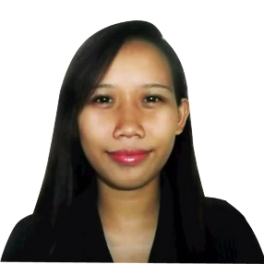

Eurika dela Paz

433 F. Llamas St. Tisa Cebu, City

[meeurika@yahoo.com](mailto:meeurika10@gmail.com/meeurika@yahoo.com)

09209678367

SUMMARY OF QUALIFICATION

1. Computer Literate MSOffice (MS Word, MS Excel and MS PowerPoint), Adobe Photoshop, Basic HTML
2. Good typing skills and communication
3. Knowledgeable in Basic Accounting
4. Can easily adapt to new work environment and can deal with people at all levels of the organization

EXPERIENCE

* On-Job-Trainee in S. Amistoso Printing Press

Subangdaku, Mandaue City

* On-Job-Trainee in D’ Fine Diners Trading an affiliate of M.Lhuillier group of companies

Kalubihan Talamban, Cebu City

EDUCATION

* Bachelor of Science in Information System (major in Accountancy and Management)

Asian College of Technology – Corner Leon Kilat & P. Del Rosario , Cebu City

* Abellana National School – Osmeña Blvd., Cebu City
* Tisa II Elementary School – Tisa, Cebu City

PERSONAL INFORMATION

DATE OF BIRTH : August 24, 1993

SEX : Female

CITIZENSHIP : Filipino

CIVIL STATUS : Single

NAME OF MOTHER : Charito Dela Paz

NAME OF FATHER : Benjamen Dela Paz