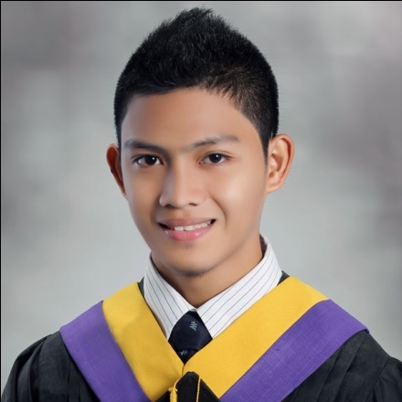

**CARLETTE RIEL Q. PADIOS**

J.S Alinsug Street.

Basak Mandaue City, Cebu

0923-284-2039

[carlettepadios@yahoo.com / carlettepadios@gmail.com](mailto:carlettepadios@yahoo.com%20/%20carlettepadios@gmail.com)

**PERSONAL BACKGROUND**

Age: 22 years old

Gender: Male

Date of Birth: April 08, 1992

Place of Birth: Cebu Maternity Hospital

Civil Status: Single

Nationality: Filipino

Religion: Roman Catholic

Language: Filipino, English

**CAREER OBJECTIVES**

To work in company that suits my qualification and To reach at the top level of technology by sheer hard work and constant adoption with the changing times.

**EDUCATIONAL ATTAINMENT**

**Tertiary:**

**University of Cebu – Banilad Campus**

Bachelor of Science in Information System

Banilad, Cebu City

2009 – 2014

**Secondary:**

**University of the Visayas – Mandaue (UV-M)**

Plaridel St. MandaueCtiy

2004 - 2008

**Primary:**

**Basak Elementary School**

Basak, Mandaue City

1998 - 2004

**EXTRA CURRICULAR**

**Organizations:**

* **Community Extension Service and Development (CESDEV)**

Volunteer/Officer

June 2010 – present

* **Philippine Society of Information Technology Students (PSITS)**

Member

June 2009 – present

**Summary of Skills:**

* Good in Communication Skills
* Displays a strong attention-to-detail and can work under pressure.
* Able to effectively collaborate with others
* Basic troubleshooting PC problems

**Computer Proficiencies:**

* Languages: SQL, C programming and Microsoft Visual Basic programming.
* Sufficient knowledge in CISCO
* Software: Microsoft Office, Open Office, Photoshop, Macromedia Flash.
* Web Development: HTML,CSS, PHP .
* Hardware: PC assembly and repair

**WORK EXPERIENCE**

-**Jollibee foods Corporation**

(Country Mall Branch)

Service Crew

February 2011

- **Great Circle Logistics**

(PagsabunganMandaue City)

On call helper

November 2010

-**Live2Sell Group of Companies (OJT)**

(Mandaue Branch)

Technical Support/Admin

July 2013

**CHARACTER REFERENCE**

**Mrs. GeorgettaManlosa**

ITInstructor

University of Cebu Banilad Campus

Banilad Cebu City

09157145980

(032) 233-8888 loc. 127

**Mrs. MarijoyYaun**

ITInstructor

University of Cebu Banilad Campus

Banilad Cebu City

09189594310

(032) 233-8888 loc. 127

**Mr. McJohn Cena**

Junior IT-Head

Live2Sell Group of Companies

Banilad, Mandaue City

09322384804

**Mr. Gerry Hiramis**

IT Head

Live2Sell Group of Companies

Banilad, Mandaue City

09232165591