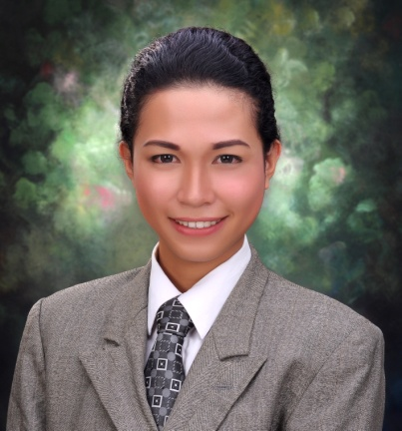**JIC MANDEL M. QUEBEC**

Sitio Santo Niño beside Jamestown Subdivision

Inayawan, Cebu City

6000 Philippines

Mobile: +639239714342

E-mail Addresses: [jackie14smart@yahoo.com](mailto:jackie14smart@yahoo.com)

[jackie14smart@gmail.com](mailto:jackie14smart@gmail.com)

**JOB OBJECTIVE**

♦ To seek a long term employment in an organization where I can grow professionally and further enhance my skills, knowledge and experience to face and overcome the challenges of today’s changing work environment

♦ To work as a part of dynamic team in a reputable firm where hardwork and sincerity are appreciated

**PERSONAL BACKGROUND**

Male; Single; Born on August 30, 1993 – Tagunol, Cogon Pardo, Cebu City, Philippines; Filipino citizenship; Roman Catholic; Has good communication skills; Has good command of English language – both written and spoken; Able to learn quickly; Flexible and patient; Hardworking and dependable

**EDUCATIONAL BACKGROUND**

**Tertiary** Bachelor of Arts in Mass Communication

Cebu Inctitute of Technology – University

N. Bacalso Avenue, Cebu City

(Cebu City Government Scholar, Academic Scholar)

Graduated 2014

**Secondary** Pardo National High School

Poblacion Pardo, Cebu City

Graduated 2010

**Elementary** Inayawan Elementary School

Inayawan, Cebu City

Graduated 2006

**HONORS AND AWARDS**

**2014** Magna Cum Laude

Outstanding Graduate

Bachelor of Arts in Mass Communication

Cebu Institute of Technology – University

**2010-2014** Consistent Parangal Awardee for Academic Excellence

Consistent Dean’s Lister

Consistent Academic Scholar

Bachelor of Arts in Mass Communication

Cebu Institute of Technology – University

**2010** 1st Honorable Mention

Pardo National High School

**2006** Top 9

Inayawan Elementary School

**AFFILIATIONS**

**2013-2014** Honorary Member

Rotaract Club of Metro Cebu – CIT University Chapter

Cebu City

Year Level Representative (4th Year)

Mass Communication Circle – CIT University

Cebu City

On-Air Announcer / News Editor

WildCat Radio – CIT University

Cebu City

Member

Cebu Alliance of Mass Communication Students

Cebu City

Member

Cebu City Government Scholars Society

Cebu City

**2012-2013** External Secretary

Rotaract Club of Metro Cebu – CIT University Chapter

Cebu City

Board Member

Cebu Alliance of Mass Communication Students

Cebu City

Member

Cebu City Government Scholars Society

Cebu City

**2011-2012** Auditor

Rotaract Club of Metro Cebu – CIT University Chapter

Cebu City

Member

Cebu Alliance of Mass Communication Students

Cebu City

Member

Cebu City Government Scholars Society

Cebu City

**2010-2011** Member

Rotaract Club of Metro Cebu – CIT University Chapter

Cebu City

Member

Cebu Alliance of Mass Communication Students

Cebu City

Member

Cebu City Government Scholars Society

Cebu City

**2009-2010** Editor-In-Chief

Balaba - School Paper of Pardo National High School

Cebu City

**WORK EXPERIENCE**

**November 2013 – March 2014**  Print Media Internship

Sun.Star Publishing, Inc. – Sun.Star Superbalita Cebu

P. del Rosario Street, Cebu City

**June – October 2013** Radio Broadcast Internship

DYHP Radio Mindanao Network – Cebu

Capitol Site corner Escario Street, Cebu City

**October 28, 2013** Volunteer Reporter

Misyon Boboto Ako 2013 – Barangay Election Coverage

DYHP Radio Mindanao Network – Cebu

Capitol Site corner Escario Street, Cebu City

**May 8-13, 2013** Volunteer Reporter

The Vote 2013 Special Midterm Election Coverage

DYMF Bombo Radyo – Cebu

People’s Broadcasting Services, Incorporated

Borromeo Street, Cebu City

**CHARACTER REFERENCE**

Mrs. Elsa J. Miral

Head, Students’ Affairs Office

Cebu Institute of Technology – University

Cebu City

+639-------------------

Prof. Joylynn Emily T. Paz

Chair, Department of Languages, Literature, and Communication

Cebu Institute of Technology – University

Cebu City

+639394365973

Mr. Dino O. Tabaña

Adviser, Mass Communication Department

Cebu Institute of Technology – University

Cebu City

+639164005767

Elaine F. Perfecio, Ed. D.

Faculty, Pardo National High School

Poblacion Pardo, Cebu City

+639239743726 / +639163898348

Jenette B. Castañares

Newsroom Assistant

Sun.Star Publishing, Inc. – Sun.Star Superbalita Cebu

P. del Rosario Street, Cebu City

+639088873194 / +639183768711 / 487-5581

I declare that the above information given is true and correct. I affix my signature as a proof.

**JIC MANDEL M. QUEBEC**

Applicant