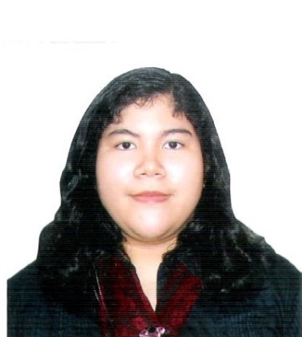**KATRINA U. MONTES**

WARD III, POBLACION, MINGLANILLA, CEBU

Philippines

Tel. No: 273-7080

Mobile No: 0926-6911358

Email Address: [champorado_kat@yahoo.com](mailto:champorado_kat@yahoo.com)

**PERSONAL DATA**

Age: 23

Date of Birth: January 31, 1991

Gender: Female

Civil Status: Single

Nationality: Filipino

Permanent Address: Ward III, Minglanilla, Cebu, Philippines

**EDUCATION**

**Education Level Name of School Year Attended**

Elementary St. Mary’s Catholic High School 1999 – 2003

High School Mary Help of Christians School 2003 – 2007

College University of the Philippines 2008 – 2011

Course Certificate in Fine Arts,

Major in Industrial Design

College University of the Philippines 2011 – 2013

Course Bachelor in Fine Arts,

Major in Industrial Design

**SKILLS**

* Computer literate
* Fluent in English, written and verbal
* Can draw and sketch
* Has knowledge on Adobe Photoshop, Adobe Illustrator, Adobe Flash and PaintTool SAI