**RESUME**

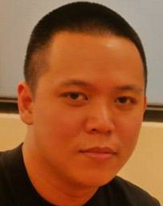

PERSONAL

NAME:

Ngosiok, Christopher James Cuenco

GENDER:

Male

CIVIL STATUS:

Single

BIRTH DATE:

October 11, 1982

NATIONALITY:

Filipino

ADDRESS:

21B Orchids St., Capitol Site, Cebu City

BLOOD TYPE:

A+

HOBBIES AND SPECIAL SKILLS:

Painting, Drawing, Article Writing (Poems, Blogs, Novels, Essays), Shooting

EDUCATIONAL:

|  |  |  |
| --- | --- | --- |
| Level | School | Year Attended |
| Primary | Sacred Heart School for Boys  (Currently – Ateneo de Cebu) | 1990-1996 |
| Intermediate | Sacred Heart School for Boys  (Currently – Ateneo de Cebu) | 1996 – 2000 |
| College | Cebu Doctors’ University  (BS-Nursing) | 2000 - 2004 |

WORK EXPERIENCE:

|  |  |  |
| --- | --- | --- |
| JOB DESCRIPTION | EMPLOYER | YEAR ATTENDEND |
| Clinical Instructor | USPF (University of Southern Philippines) | 2005 – 2006 |
| Staff Nurse | Vicente Sotto Memorial Medical Center | 2007 – until present |

REFERENCES:

|  |  |  |
| --- | --- | --- |
| NAME | RELATIONSHIP | CONTACT NUMBER |
| Juliemar Lloveras | Co-worker | 09232286154 |
| Doreen Cahilig | Sister in faith | 09199472828 |