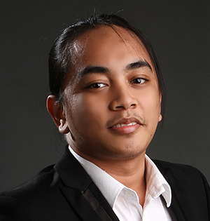Raymond Joseph F. Villegas

Phone: 0923 920 7966

E-mail: baygas1@gmail.com

Blk 5A Lot 1 Marian Village Tayud

Consolacion Cebu

Philippines 6001

#### Objective

**Armed with expertise in web programming, I intend to contribute to the growth of the organization.**

#### Experience

**Survey Programmer**

Survey Sampling International (SSI)

*March 2012 – Present*

* Program Web and Phone surveys using market research tools such as WIRE (SSI’s propriety software) and Confirmit (#1 online market research tool)
* Use back-end languages (PHP,Jscript.NET) to program the survey according to the specified logic/flow based on questionnaire
* Uses front-end languages (HTML, CSS, JavaScript, JQuery) to create a pleasing and interactive face of the survey
* Consults to Project Managers/Clients on how to improve survey experience with regards to survey flow and look-and-feel
* Process samples provided by the client using Excel and validates the database using MySQL

**Web Developer**

Ming’s World Business Center

*May 2011 – January 2012*

* Converts PSD designs/templates to HTML-CSS format (W3C Valid) and integrate it to Wordpress (Content Management System).

#### **Thesis Project as part of BS CompE Curriculum**

*March 2012*

#### Project Name: “Last Line of Defense: A Monitoring and Security Tool for Wireless Networks”

#### Description: Establish a secure wireless network for network intrusion detection and prevention of malicious attacks from intruders

Team Role: Software Developer

#### Technical

* Programming Languages : PHP, MySQL, HTML+CSS, JavaScript, JQuery, Jscript.NET, C, C#, ASM, VHDL
* Operating Systems : Windows, Windows Server, Ubuntu, Ubuntu Server
* Applications: MS Visual Studio, Notepad++, Adobe Photoshop, Microsoft Office
* Database: MySQL, phpMyAdmin

#### Education

College : 2005 – 2012

University of San Carlos

Nasipit, Talamban, Cebu City 6000

Bachelor of Science in Computer Engineering

Major in Computer Networks

High School : 2001 – 2005

St. Louis School of Mandaue

Sudlon, Maguikay, Mandaue City 6014

#### Activities

#### Robofesta-PH 2011

#### University of San Carlos, March 13, 2011

#### International Engineering Research Conference 2010 (IERC)

#### University of San Carlos, January 14-15, 2010

#### Character References

Gilbert Gutual

R & D Specialist, SSI Philippines, Inc.

0933 945 1925

Chona Mae Navarse

Project Manager, SSI Philippines, Inc.

0920 948 5446