OPUS Application setup in local using maven(3.21.) on Windows

Sourav Ghosh  
[sg0019@att.com](mailto:sg0019@att.com)  
05/25/2017

**Prerequisites –**

* **Install jdk1.7.0_91 (32 bit) [**JRE is not enough, Need the JDK to compile the app entirely**]**
* **Install Weblogic 10.3.6 [**We would need weblogic jars to compile the app**]**
* **Install maven 3.2.1** [Currently we are using the same version in prod]

Download and extract the maven from following location

<https://archive.apache.org/dist/maven/maven-3/3.2.1/source/>

**Local Build Setup Guidelines :**

**Step 1 : Update Environment variables as below –**

|  |  |
| --- | --- |
| Environment variables |  |
| Variable Name : M2_HOME  Variable value : C:\Software\apache-maven-3.2.1\apache-maven-3.2.1  *Note - Use your location where Maven is installed* |  |
| Variable Name : JAVA_HOME  Variable value : C:\Program Files (x86)\Java\jdk1.6.0_41  *Note – Set the JDK location where its been installed. Recommeded jdk install is 32 bit.* |  |
| Variable Name : MAVEN_HOME  Variable value : C:\Software\apache-maven-3.2.1\apache-maven-3.2.1  *Note - Use your location where Maven is installed* |  |
| Variable Name : *MAVEN_OPTS*  Variable value : *-Xmx1024m -XX:MaxPermSize=512m*  *Note - Set the maximum memory to run the maven and compile. MaxPermSize will help for PermGen memory issue. Increase this if you face any memory issue during local build* |  |
| Variable Name : WEBLOGIC_HOME  Variable value : C:\Oracle\Middleware\wlserver_10.3 |  |
| Variable Name : WL_HOME  Variable value : C:\Oracle\Middleware\wlserver_10.3 |  |
| Variable Name : *Path*  Variable value :  C:\ProgramData\Oracle\Java\javapath;C:\Program Files (x86)\RSA SecurID Token Common;%JAVA_HOME%\bin;%M2_HOME%\bin;%SystemRoot%\system32;%SystemRoot%;%SystemRoot%\System32\Wbem;%SYSTEMROOT%\System32\WindowsPowerShell\v1.0\;%systemroot%\System32\WindowsPowerShell\v1.0\;C:\Program Files\1E\NomadBranch\;C:\Program Files (x86)\Enterprise Vault\EVClient\ |  |

**Step 2a : Execute the bacth file which will automatically generate the** **following files.**



1. C:\Users\ATTUID\build.properties
2. C:\Users\ATTUID\.m2\settings.xml

**Step 2b : Alternative way of creating the required files -**

* **Add build.properties file -** If the batch is unable to create the above mentioned file, please create the files manually.  
  Create a new file “build.properties” and save it under “C:\Users\ATTUID”  
  Here is an example. Update the paths below as required.

|  |
| --- |
| ## OPUS WebLogic development instance related properties --  ##---------------------------------------------------------  #you may need the itservices.sbc.com for the global logon portion of OPUS to work.  c1.skip.appc=true  opus.host=GACDTL01SG0019.ITServices.sbc.com  weblogic.home=C:/JRebel-OPUSTest/wlserver_10.3  opus.weblogic.home=C:/JRebel-OPUSTest/wlserver_10.3  opus.java.home=C:/Program Files/Java/jdk1.7.0_80  maven.repo.remote=http://mavencentral.it.att.com:8084/nexus/content/repositories/legacy-m1 |

# Add Maven 2 settings.xml

Create a new text file “settings.xml” and save it under “C:\Users\ATTUID\.m2” directory  
Copy the below content in the file after updating maven repository location.

|  |
| --- |
| <?xml version="1.0" ?>  <settings>  <localRepository>/home/sg0019/.maven/repository</localRepository>  <interactiveMode>false</interactiveMode>  <mirrors>  <mirror>  <id>snapshots</id>  <mirrorOf>snapshots</mirrorOf>  <name>Nexu MavenCentral repository</name>  <url>http://mavencentral.it.att.com:8084/nexus/content/groups/opus</url>  </mirror>  <mirror>  <id>central</id>  <mirrorOf>central</mirrorOf>  <name>Nexus MavenCentral repository</name>  <url>http://mavencentral.it.att.com:8084/nexus/content/groups/opus</url>  </mirror>  </mirrors>  <profiles>  <profile>  <id>nexus</id>  <repositories>  <repository>  <id>central</id> <url>http://mavencentral.it.att.com:8084/nexus/content/repositories/central</url>  <releases>  <enabled>true</enabled>  <updatePolicy>never</updatePolicy>  </releases>  <snapshots>  <enabled>true</enabled>  <updatePolicy>always</updatePolicy>  </snapshots>  </repository>  </repositories>  <pluginRepositories>  <pluginRepository>  <id>central</id> <url>http://mavencentral.it.att.com:8084/nexus/content/repositories/central</url>  <releases><enabled>true</enabled></releases>  <snapshots><enabled>true</enabled></snapshots>  </pluginRepository>  </pluginRepositories>  </profile>  </profiles>  <activeProfiles>  <activeProfile>nexus</activeProfile>  </activeProfiles>  <pluginGroups>  <pluginGroup>org.sonatype.plugins</pluginGroup>  </pluginGroups>  </settings> |

**Step 3 : Check whether maven has been installed properly –**

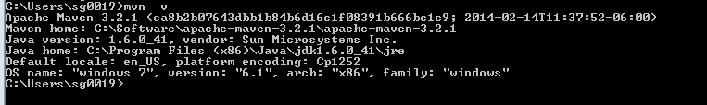

**Step 4 : Download Eclipse with maven plugin**If your eclipse doesn’t have maven plugin, please install it from eclipse marketplace.

**Step 5 : Check out entire opus code branch in local eclipse using SVN plugin**

**Step 6 : Update the eclipse.ini file like highlighted bellows**

|  |  |
| --- | --- |
| This is required to prevent your eclipse from Out of memory  -Xms512m  -Xmx1024m |  |

**Step 6 : Check the Classpath Variables in the Eclipse.**

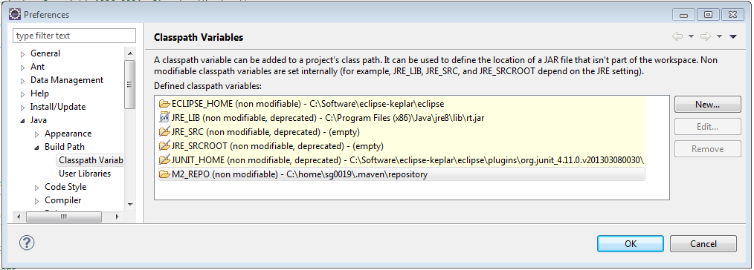

**Step 7 : Execute the build in eclipse –**This is basically dist of the entire OPUS application in Local. It will download all the required jars from the maven repository into your local and will build the application.

**Run -> External Tools -> External Tool Configurations..**Create a new Launch and provide the Location, Working Directory and Arguments as below. Execute the build with External Tool.

|  |  |
| --- | --- |
| **Location:**  **C:\Software\apache-maven-3.2.1\apache-maven-3.2.1\bin\mvn.bat**  **Working Directory: C:\Users\sg0019\workspace1109\opus_twl_1702**  **Arguments:**  ***-e***  ***-Dmaven.test.skip=true***  ***clean***  ***-Dweblogic.home=%WEBLOGIC_HOME%***  ***-Dbuild.env=development***  ***-P setupenvironment***  ***-P load-properties install*** |  |

**Step 8 : Create another External tool configuration with following Arguments for eclipse**This will create the all the OPUS projects individually with classpath mapped with repository. Execute the build-eclipse now.

|  |  |
| --- | --- |
| **Location:**  **C:\Software\apache-maven-3.2.1\apache-maven-3.2.1\bin\mvn.bat**  *(Update according to your maven directory)*  **Working Directory: C:\Users\sg0019\workspace1109\opus_twl_1702**  *(Update according to your working directory)*  **Arguments**  ***-e***  ***eclipse:eclipse*** |  |

**Step 9 : Import the created maven projects into workspace**

File -> Import -> Existing Maven Projects -> Select the Root Directory -> select the project one by one you are working on and click on Next.

|  |  |
| --- | --- |
|  |  |