Offshore Local environment setup :

1] Maven Setup :

Apache Maven Download Link :

<https://repo.maven.apache.org/maven2/org/apache/maven/apache-maven/3.2.1/>

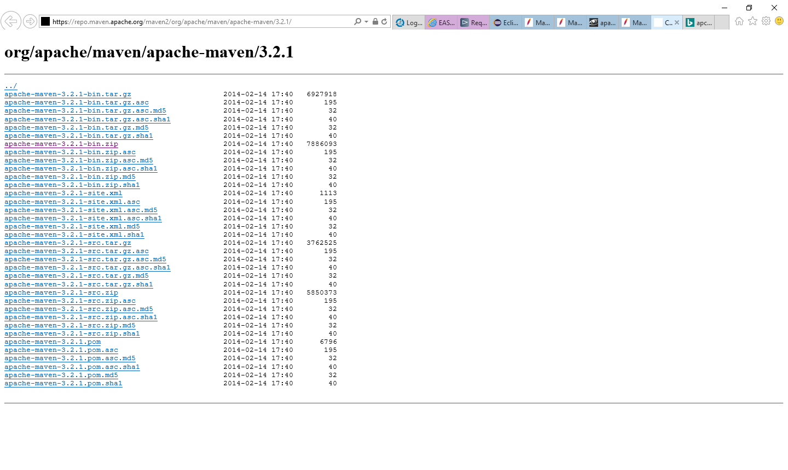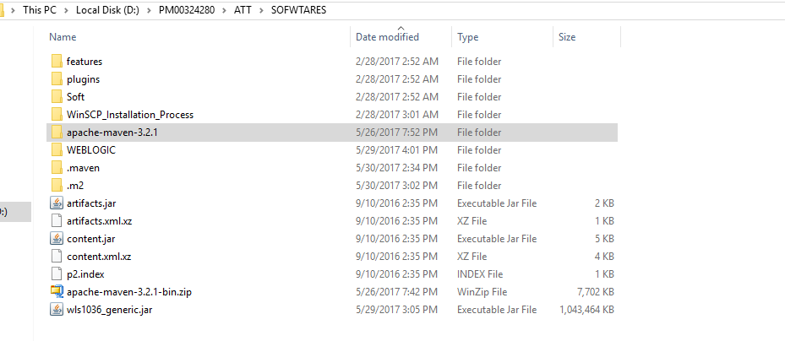

Download & extract maven folder as above. You can place it any accessible location on your machine.

2] Weblogic Installation :

<https://docs.oracle.com/cd/E24902_01/doc.91/e23434/install_config_10_3_6.htm#EOHLU180>

<https://docs.oracle.com/cd/E40519_01/studio.310/studio_install/src/tidi_studio_weblogic_install_weblogic.html>

Please follow screenshots given in above links.

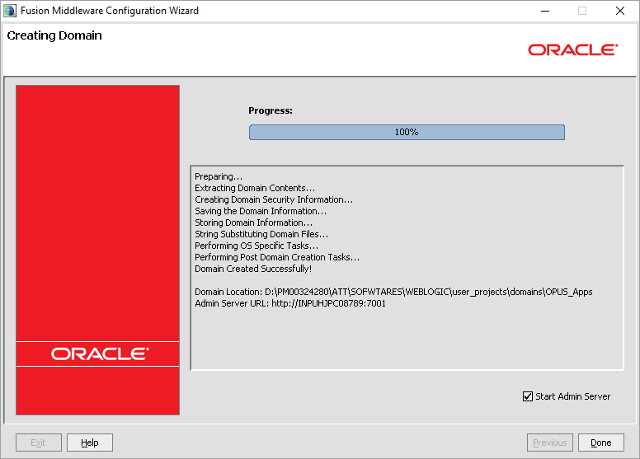

Done installing weblogic

3] Environment Variables setup : 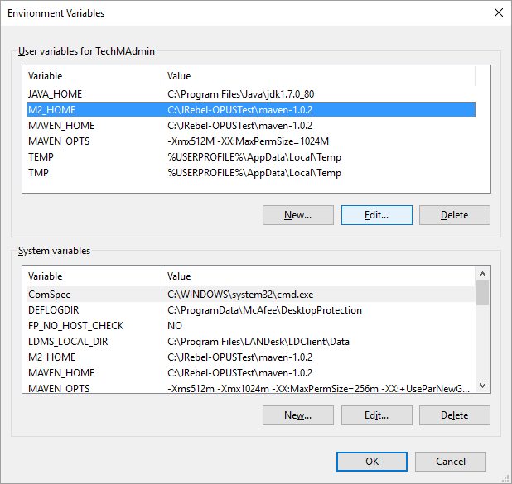

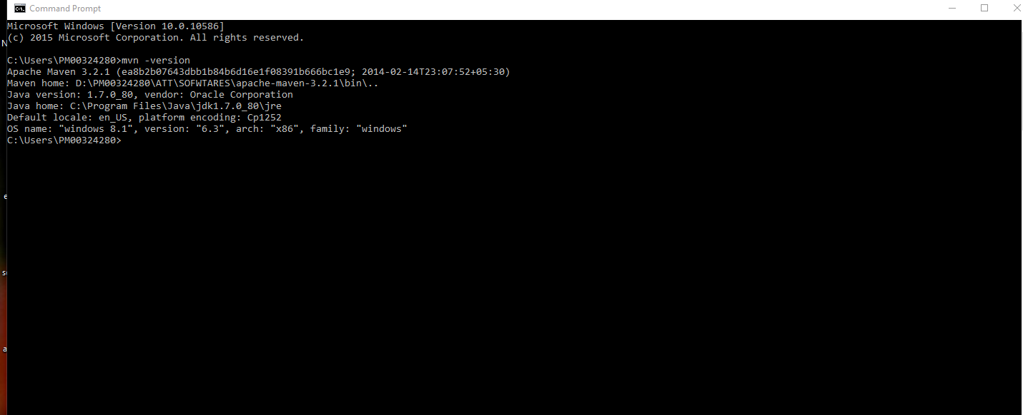

========== Successful Maven installation ===============================================

Microsoft Windows [Version 10.0.10586]

(c) 2015 Microsoft Corporation. All rights reserved.

C:\Users\PM00324280>mvn -version

Apache Maven 3.2.1 (ea8b2b07643dbb1b84b6d16e1f08391b666bc1e9; 2014-02-14T23:07:52+05:30)

Maven home: D:\PM00324280\ATT\SOFWTARES\apache-maven-3.2.1\bin\..

Java version: 1.7.0_80, vendor: Oracle Corporation

Java home: C:\Program Files\Java\jdk1.7.0_80\jre

Default locale: en_US, platform encoding: Cp1252

OS name: "windows 8.1", version: "6.3", arch: "x86", family: "windows"

C:\Users\PM00324280>

4] Required/Working Environment variables : 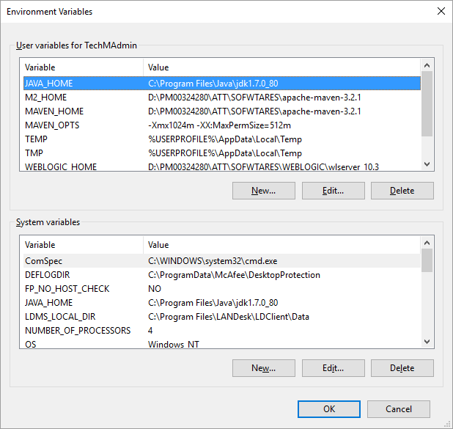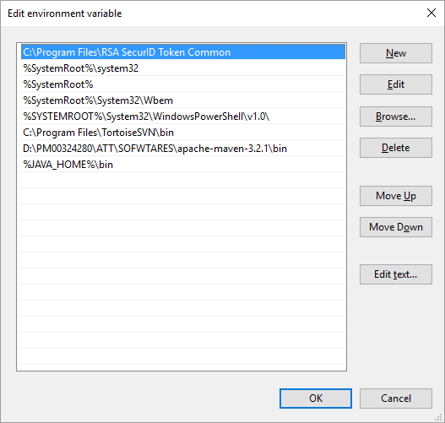

PATH=C:\Program Files\RSA SecurID Token Common;C:\WINDOWS\system32;C:\WINDOWS;C:\WINDOWS\System32\Wbem;C:\WINDOWS\System32\WindowsPowerShell\v1.0\;C:\Program Files\TortoiseSVN\bin;D:\PM00324280\ATT\SOFWTARES\apache-maven-3.2.1\bin;C:\Program Files\Java\jdk1.7.0_80\bin

5] Update maven settings in Eclipse : Go to your : M2_HOME/conf/ open settings.xml file

Change the default location of repository to yours like below :

<settings xmlns="http://maven.apache.org/SETTINGS/1.0.0"

xmlns:xsi="http://www.w3.org/2001/XMLSchema-instance"

xsi:schemaLocation="http://maven.apache.org/SETTINGS/1.0.0 http://maven.apache.org/xsd/settings-1.0.0.xsd">

<!--localRepository

| The path to the local repository maven will use to store artifacts.

| -->

<!--| Default: ${user.home}/.m2/repository -->

<localRepository>D:\PM00324280\ATT\SOFWTARES\.m2\repository</localRepository>

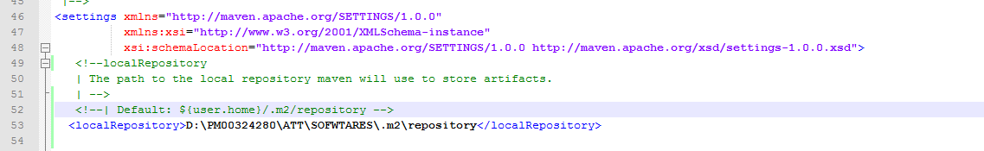

If you want to update your maven repository to something else – you can create your own repo by updating the location as shown above in /conf/settings.xml

Similarly in Eclipse do below changes :

i] Your classpath must be as below : (verify your maven repo M2_REPO)

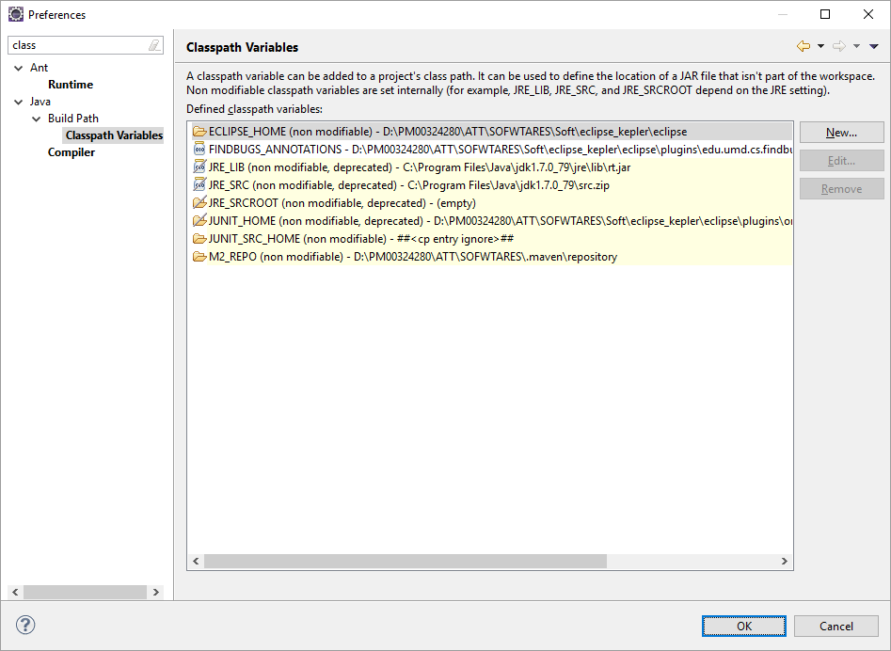

ii] Window-> Preferences-> Maven -> User Settings :

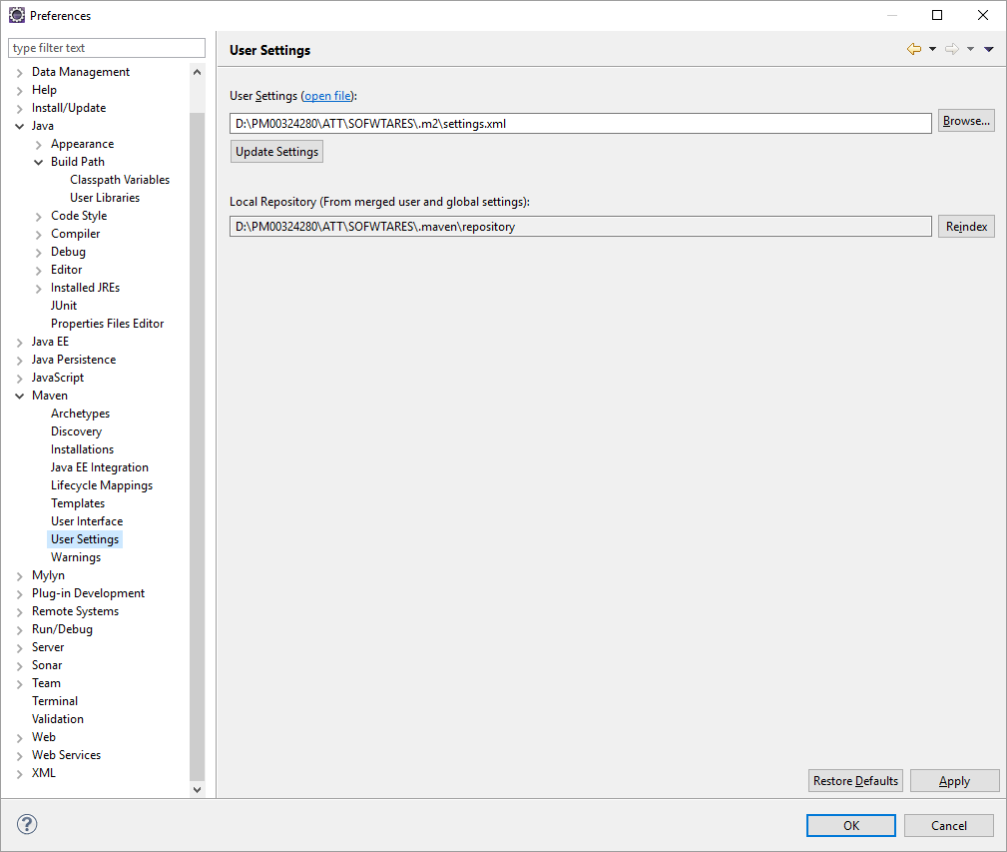

iii] .m2/settings.xml file as below : (verify your location details )



iv] Go to : **Run -> External Tools -> External Tool Configurations..**Create a new Launch and provide the Location, Working Directory and Arguments as below. Execute the build with External Tool.

(Right click Program in eclipse & click on New)

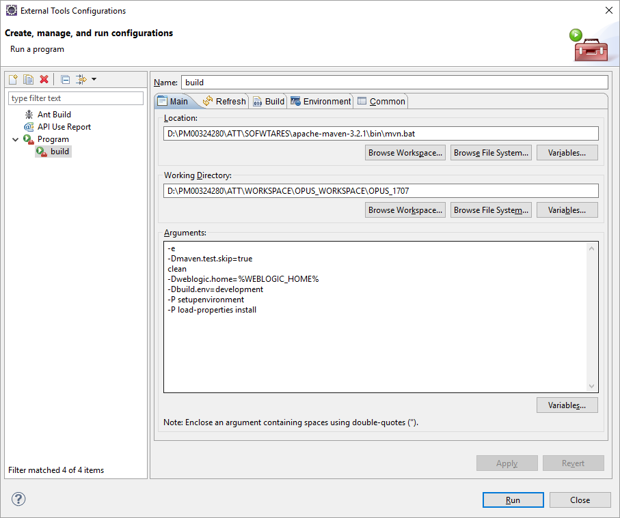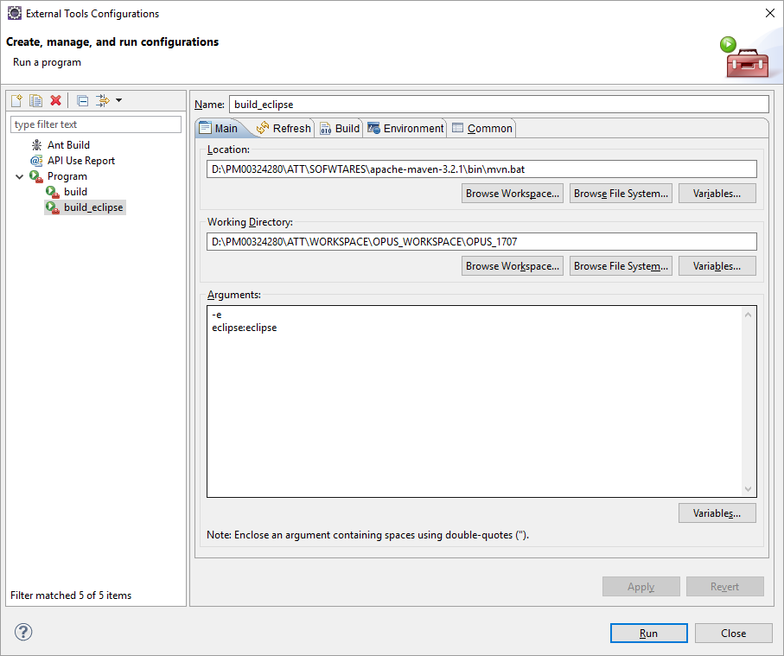

Now Run build :

start createmaster.groovy

Operating system=Windows 8.1

Loading properties from: C:\Users\PM00324280/build.properties

java home =C:\Program Files\Java\jdk1.7.0_80

weblogic home =D:\PM00324280\ATT\SOFWTARES\WEBLOGIC\wlserver_10.3

OPUS version: 1707 Weblogic version=10.3.6.0

Delete master properties file: false Create new master properties file: trueend createmaster.groovy

In case you face OutOfMemory in Eclipe while compiling the build do below steps :

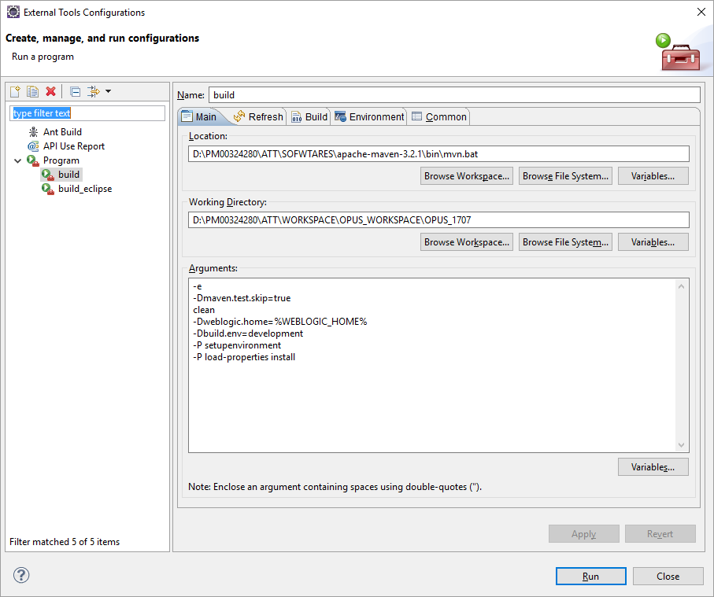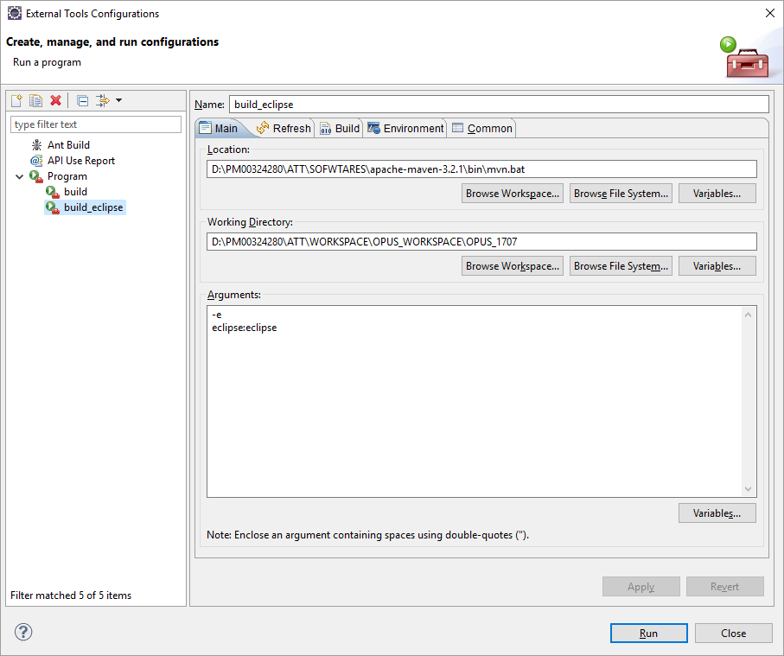

Perform same above steps in Run -> Run Configurations.

v] OPUS_1707\groovy\setupenv.groovy --- need to make 1 change in this to successfully perform Dist :

String userId= "pm545a" --(please mention your att uid)



6] Successful console in Eclipse as below :

[INFO] ------------------------------------------------------------------------

[INFO] Reactor Summary:

[INFO]

[INFO] OPUS Root Project ................................. SUCCESS [ 11.870 s]

[INFO] OPUS Encryption ................................... SUCCESS [  6.509 s]

[INFO] OPUS Common ....................................... SUCCESS [03:12 min]

[INFO] CSCR Interfaces ................................... SUCCESS [ 40.442 s]

[INFO] Insys Project ..................................... SUCCESS [01:01 min]

[INFO] OPUS Backend ...................................... SUCCESS [19:15 min]

[INFO] OPUS Frontend Core ................................ SUCCESS [ 22.679 s]

[INFO] MEI Cash Acceptor Applet .......................... SUCCESS [  0.682 s]

[INFO] JavaPOS Swipe Reader Applet ....................... SUCCESS [  3.343 s]

[INFO] JavaPOS Printer Data .............................. SUCCESS [  1.530 s]

[INFO] JavaPOS Printer Applet ............................ SUCCESS [  0.594 s]

[INFO] JavaPOS Scanner Applet ............................ SUCCESS [  0.250 s]

[INFO] Bill Dispenser Applet ............................. SUCCESS [  0.248 s]

[INFO] Coin Dispenser Applet ............................. SUCCESS [  0.219 s]

[INFO] JavaPOS Signature Capture MSR Applet .............. SUCCESS [  0.842 s]

[INFO] OPUS Login Applet ................................. SUCCESS [ 13.158 s]

[INFO] OPUS CTI Applet ................................... SUCCESS [  1.077 s]

[INFO] OPUS Screen Grab Applet ........................... SUCCESS [  0.979 s]

[INFO] OPUS DL Parser .................................... SUCCESS [  3.211 s]

[INFO] OPUS Self Service Application ..................... SUCCESS [04:03 min]

[INFO] OPUS Frontend ..................................... SUCCESS [09:59 min]

[INFO] RSAAuth Project ................................... SUCCESS [  8.958 s]

[INFO] STDI_ejb .......................................... SUCCESS [ 48.570 s]

[INFO] STDI_client ....................................... SUCCESS [  2.044 s]

[INFO] ------------------------------------------------------------------------

[INFO] BUILD SUCCESS

[INFO] ------------------------------------------------------------------------

[INFO] Total time: 40:20 min

[INFO] Finished at: 2017-06-20T16:14:42+05:30

[INFO] Final Memory: 494M/989M

[INFO] ------------------------------------------------------------------------