

School of Computing
SRM IST, Kattankulathur – 603 203

Course Code: 21CSC303J

Course Name: Software Engineering and Project Management

Experiment No | 1
Title of Experiment | To identify the Software Project, Create Business Case, Arrive at a  Problem Statement
Name of the candidate | Gaurang Jayant Mishra , Jayant Miglani , Mann Kumar Attri
Team Members | Gaurang Jayant Mishra , Jayant Miglani , Mann Kumar Attri
Register Number | RA2211033010205, RA2211033010201, RA2211033010202
Date of Experiment

Mark Split Up

S.No | Description | Maximum Mark | Mark Obtained
1 | Exercise | 5
2 | Viva | 5
Total |  | 10

Staff Signature with date
Aim
To Frame a project team, analyze and identify a Software project. To create a business
case and Arrive at a Problem Statement for the <title of the project>

Team Members:

S. No | Register No | Name | Role
1 | RA2211033010205 | Gaurang Jayant Mishra | Lead/Rep
2 | RA2211033010201 | Jayant Miglani | Member
3 | RA2211033010202 | Mann Kumar Attri | Member

Project Title: MOODIE ( A Mood tracking and enhancement website)

Project Description
The mental health website project is an innovative web-based platform designed to provide comprehensive mental health support and resources to users. This project focuses on creating a user-friendly and secure space where individuals can access educational content, engage with an AI-driven chatbot for mental health guidance, and track their emotional well-being through mood logging tools. The platform is intended to bridge the gap between self-care and professional mental health support by offering users practical, evidence-based tools for managing their mental health independently.

Problem Statement
Millions of individuals worldwide face mental health challenges, but many do not have the means or comfort level to access traditional therapy or in-person support. The lack of accessible, affordable, and stigma-free mental health resources poses a significant gap in the well-being ecosystem. Users need a reliable digital space where they can access mental health support, resources, and self-assessment tools without financial or logistical barriers.

BUSINESS CASE

THE PROJECT
• Lack of Accessible Mental Health Resources: Many individuals face challenges accessing traditional mental health services due to location, cost, or stigma.
• Stigma Around Mental Health: Fear of judgment prevents people from seeking in-person mental health support.
• Inadequate Self-Help Tools: Existing platforms may not provide comprehensive tools for independent mental health management.
• Limited Knowledge and Awareness: Users may not know where to find reliable, evidence-based information about mental health.

• Difficulty Tracking Emotional Well-being: Lack of tools for individuals to monitor and understand their emotional patterns over time.
THE HISTORY
• Rising Mental Health Challenges: There has been a significant increase in mental health issues globally, exacerbated by factors such as the COVID-19 pandemic, social isolation, and economic uncertainty.
• Limited Access to Traditional Services: Many people cannot access mental health professionals due to geographic limitations, high costs, or long waiting times.
• Growing Demand for Digital Solutions: Digital health platforms are increasingly being sought after as alternative or supplementary support for mental health needs.
• Lack of Comprehensive Online Tools: Existing digital mental health platforms may offer basic content but often lack interactive, personalized, or AI-driven support.

LIMITATIONS
• Market Competition: The presence of established mental health apps and websites could make it difficult to gain market traction.
• Technological Infrastructure: Dependence on reliable and scalable cloud infrastructure could be impacted by issues such as server outages or service interruptions.
• Data Collection Limitations: Difficulty in gathering sufficient user data to train and refine AI models effectively.
• User Trust Issues: Users may be reluctant to share personal mental health information due to concerns about data misuse or breaches.
• Cultural Sensitivity: The platform may need localization and cultural adjustments to effectively serve a global audience, adding complexity and cost

APPROACH
• HTML/CSS/JavaScript: For building the website structure, styling, and interactivity.
• Front-End Framework: Optional frameworks like React.js or Vue.js for building dynamic, responsive interfaces.
• Back-End (if needed): Use Node.js, Python (Flask/Django), or PHP for server-side functionality (e.g., storing assessments, user login).
• Database: MySQL, MongoDB, or Firebase for storing user data (if user authentication or data tracking is required).
• Responsive Design: Ensuring the website works on all devices (use of frameworks like Bootstrap or Material UI).

BENEFITS
• Increased Awareness: Helps raise awareness about mental health, reducing stigma and promoting better understanding.
• Employee Well-being: Provides employees or users with resources and tools to manage mental health, leading to a healthier workforce.
• Improved Productivity: By supporting mental health, employees can perform better, reducing burnout and absenteeism.
• Positive Reputation: Positions the organization as socially responsible and caring, improving its public image.
• Access to Resources: Offers easy access to mental health resources and emergency contacts, supporting individuals in need.
• Engagement: Encourages user engagement through interactive features like mood trackers, assessments, and blogs.
Result
Thus, the project team formed, the project is described, the business case was
prepared and the problem statement arrived.

School of Computing

SRM IST, Kattankulathur – 603 203

Course Code: 21CSC303J

Course Name: Software Engineering and Project Management

Experiment No | 2
Title of Experiment | Identification of Process Methodology and Stakeholder Description
Name of the candidate | Gaurang Jayant Mishra , Jayant Miglani , Mann Kumar Attri
Team Members | Gaurang Jayant Mishra , Jayant Miglani , Mann Kumar Attri
Register Number | RA2211033010205, RA2211033010201, RA2211033010202
Date of Experiment | 07/08/2024

Mark Split Up

S.No | Description | Maximum Mark | Mark Obtained
1 | Exercise | 5
2 | Viva | 5
Total |  | 10

Staff Signature with date

Aim
To identify the appropriate Process Model for the project and prepare Stakeholder and User
Description.

Team Members:

Sl No | Register No | Name | Role
1 | RA2211033010205 | Gaurang J Mishra | Rep/Member
2 | RA2211033010201 | Jayant Miglani | Member
3 | RA2211033010202 | Mann Kumar Attri | Member

Project Title: MOODIE : An all-in-one solution for mood tracking Selection of Methodology
Agile methodology is a flexible and iterative approach to software development. It emphasizes collaboration, customer feedback, and small, rapid releases. The key principles of Agile include:

Iterative Development: Development occurs in small increments called sprints, allowing for frequent reassessment and adaptation.
Customer Collaboration : Continuous involvement of stakeholders and customers to ensure the product meets their needs.
Responding to Change : Agile is designed to accommodate changes even late in the development process.
Cross-Functional Teams : Teams work collaboratively across different functions to deliver a functional product at the end of each sprint.

Agile is particularly suitable for the MOODIE project due to its flexibility and focus on user feedback, which is crucial for an app that aims to track and improve users' moods.

Incorporate information to below table regarding stakeholders of the project [Make use of below examples]

For Example

Result
Thus the Project Methodology was identified and the stakeholders were described.

School of Computing

SRM IST, Kattankulathur 603 203

Course Code: 21CSC303J
Course Name: Software Engineering and Project Management

Experiment No | 3
Title of Experiment | System, Functional and Non Functional Requirements of the Project
Name of the candidate | Gaurang Jayant Mishra , Jayant Miglani , Mann Kumar Attri
Team Members | Gaurang Jayant Mishra , Jayant Miglani , Mann Kumar Attri
Register Number | RA2211033010205, RA2211033010201, RA2211033010202
Date of Experiment | 07/08/2024

Mark Split Up

S.No | Description | Maximum Mark | Mark Obtained
1 | Exercise | 5
2 | Viva | 5
Total |  | 10

Staff Signature with date

Aim
To identify the system, functional and non functional requirements for the project.

Team Members:

S No | Register No | Name | Role
1 | RA2211033010205 | Gaurang J Mishra | Rep/Member
2 | RA2211033010201 | Jayant Miglani | Member
3 | RA2211033010202 | Mann Kumar Attri | Member

Project Title: MOODIE : An all in one solution for mood tracking System Requirements

Hardware Requirements:

- Server:
Processor: Quad core 2.5 GHz or higher RAM: 16 GB or more
Storage: 500 GB SSD or higher Network: Gigabit Ethernet connection

- Client Devices:
Smartphones: iOS 12.0 or later, Android 8.0 (Oreo) or later Tablets: iOS 12.0 or later, Android 8.0 (Oreo) or later Desktop: Any modern computer with internet access

Software Requirements:

- Server:
Operating System: Ubuntu 20.04 LTS or later Web Server: Nginx or Apache

Database: PostgreSQL 13 or later
Backend Framework: Node.js 14 or later / Django 3.2 or later Additional Software: Docker, Kubernetes for containerization

- Client Devices: Mobile App:
iOS: Xcode 12 or later, Swift 5 or later
Android: Android Studio 4.0 or later, Kotlin 1.4 or later Web App:
Browser: Latest versions of Chrome, Firefox, Safari, or Edge Frontend Framework: React 17 or later / Angular 11 or later

Development Tools: Version Control: Git
CI/CD: Jenkins or GitHub Actions Code Quality: ESLint, Prettier
Testing: Jest for unit testing, Cypress for end to end testing

Other Requirements:
API: RESTful API standards, GraphQL for specific queries Security: SSL certificates for HTTPS, OAuth 2.0 for authentication

Functional Requirements

- User Management:
User Registration: Users can sign up using email, phone number, or social media accounts. User Login: Secure login with username and password.
Profile Management: Users can update their personal information and settings.

- Mood Logging:
Mood Entry: Users can log their current mood using predefined categories (happy, sad, anxious, etc.) and add custom notes.
Mood Tags: Users can tag entries with keywords for better tracking (e.g., "work", "family").

- Historical Data:
Mood History: Users can view past mood entries in a timeline or calendar format. Search and Filter: Users can search mood entries by date, tags, or keywords.

- Data Visualization:
Mood Charts: Display mood trends over time using line graphs, bar charts, or pie charts.
Statistical Analysis: Provide insights such as average mood, frequency of mood types, and patterns.

- Reminders and Notifications:
Custom Reminders: Users can set reminders to log their mood at specific times. Notifications: Push notifications to remind users to log their mood or provide insights.

- Data Export and Sharing:
Export Data: Users can export their mood data in formats like CSV or PDF.
Sharing Options: Users can share mood logs with therapists or friends via email or social media.

Non Functional Requirements

- Performance:
Response Time: The app should respond to user actions within 2 seconds. Scalability: The system should support up to 100,000 concurrent users.

- Usability:
User Interface: The app should have an intuitive and user friendly interface.
Accessibility: Ensure the app is accessible to users with disabilities, adhering to accessibility standards.

- Reliability:
Uptime: The app should maintain 99.9% uptime.
Backup: Regular backups should be performed to prevent data loss.

- Security:
Data Encryption: All user data should be encrypted both in transit and at rest.
Authentication: Implement strong authentication mechanisms, including two factor authentication.

- Compatibility:
Platforms: The app should be compatible with iOS, Android, and major web browsers. Device Support: Ensure the app works on various device types, including smartphones,
tablets, and desktops.

- Maintainability:
Code Quality: Maintain high code quality with proper documentation and comments. Updates: The system should be designed to allow for easy updates and feature additions.

- Legal and Compliance:
Privacy: Comply with privacy laws and regulations, such as GDPR.
Data Retention: Implement policies for data retention and deletion in line with legal requirements.

Result
Thus the requirements were identified and accordingly described.



School of Computing
SRM IST, Kattankulathur – 603 203

Course Code: 18CSC303J
Course Name: Software Engineering and Project Management
Experiment No | 4
Title of Experiment | Prepare Project Plan based on scope, Calculate Project effort based on resources and Job roles and responsibilities
Name of the candidate | Jayant Miglani
Team Members | Jayant Miglani  Gaurang Mishra  Mann kumar atri
Register Number | RA2211033010201
Date of Experiment | 23-08-24

Mark Split Up

S.No | Description | Maximum Mark | Mark Obtained
1 | Exercise | 5
2 | Viva | 5
Total |  | 10

Staff Signature with date

Aim
To Prepare Project Plan based on scope, Calculate Project effort based on resources, Find Job roles and responsibilities

Team Members:
Sl No | Register No | Name | Role
1 | RA2211033010205 | Gaurang Mishra | Lead
2 | RA2211033010201 | Jayant Miglani | Member
3 | RA2211033010202 | Mann Kumar Attri | Member

Requirements

Project Management Plan
Integration Management:
- Governance Framework: Establishing clear guidelines for the development and maintenance of MOODIE, including regular updates and bug fixes.
- Team Structure: A dedicated project team with roles like Product Owner, Project Manager, UX Designer, Frontend and Backend Developers, and QA testers.
- Change Management: Implementing a streamlined process for handling change requests and issues to ensure the app remains up-to-date and user-friendly.
Scope Management:
- Scope Statement: MOODIE's primary function is mood tracking, providing users with an easy way to log their moods and analyze trends.
- Requirement Management: Continuously gather user feedback to refine and enhance the app's functionality and user experience.
- Deliverables: A fully functional mobile app with an intuitive interface, mood tracking capabilities, and insightful analytics.

Cost Per Hour:
- The cost per hour is related to the effort assigned to the team members working on MOODIE.
- Example breakdown:
  - UX Designer: 2 hours @ 500 INR/hour = 1000 INR.
  - Frontend Developer: 3 hours @ 500 INR/hour = 1500 INR.
  - Backend Developer: 4 hours @ 500 INR/hour = 2000 INR.
This cost estimation helps in budgeting the project and ensuring that resources are allocated efficiently.

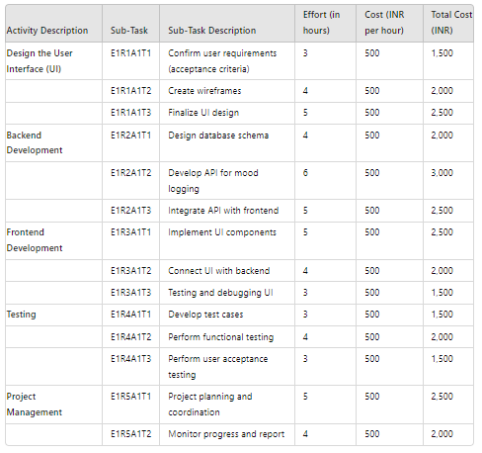

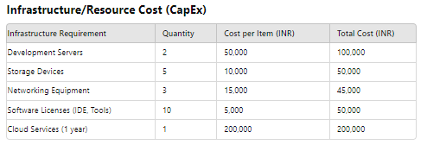
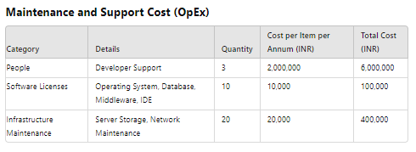

Project Team Formation

Identification Team members

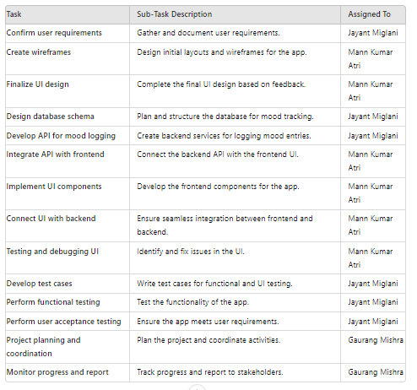

Responsibility Assignment Matrix

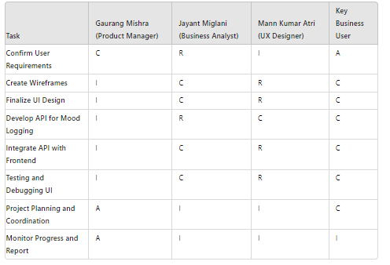
Result:

Thus, the Project Plan was documented successfully.

Project Management Plan
Describe the key issues driving the project. [Min 3 Focus Areas]
Focus Area | Details
Integration Management | Governance Framework  Project Team Structure  Roles & Responsibilities of Team  Change Management  (Change Control, Issue Management)  Project Closure
Scope Management | Scope Statement  Requirement Management (Gathering, Control, Assumption, Constraint Stakeholder)  Define Deliverable  Requirement Change Control  Activities and Sub-Tasks
Schedule Management | Define Milestones  Schedule Control
Cost Management | Estimate Effort  Assign Team  Budget Control
Quality Management | Quality Assurance: Quality assurance will be managed including governance, roles and responsibilities, tools and techniques and reporting  Quality Control: Specify the mechanisms to be used to measure and control the quality of the work products
Resource Management | Estimate and Manage the need  People: People & Skills Required  Finance: Budget Required  Physical: Facilities, IT Infrastructure
Stakeholder | Identifying, Analyzing, Engaging Stakeholders
Communication Management | Determine communication requirements, roles and responsibilities, tools and techniques. [Type of Communication, Schedule, Mechanism Recipient]
Risk Management | Identifying, analysing, and prioritizing project risks
Procurement Management | Adhering to organization procurement process

Estimation

Effort and Cost Estimation
Activity Description | Sub-Task | Sub-Task Description | Effort (in hours) | Cost in INR
Design the user screen | E1R1A1T1 (Effort-Requirement-Activity-Task) | Confirm the user requirements (acceptance criteria) | 3
Design the user screen | E1R1A1T2
Design the user screen | E1R1A1T3
Identify Data Source for displaying units of Energy Consumption |  | Go through Interface contract (Application Data Exchange) documents | 5
 |  | Document

Effort (hr) | Cost (INR)
1 | 500

Infrastructure/Resource Cost [CapEx]
< OneTime Infra requirements >
Infrastructure Requirement | Qty | Cost per qty | Cost per item
IR1
IR2

Maintenance and Support Cost [OpEx]
Category | Details | Qty | Cost per qty per annum | Cost per item
People | Network, System, Middleware and DB admin  Developer , Support Consultant | 3 | 2,000,000 | 6,000,000
License | Operating System  Database  Middleware  IDE | 10 | 10000 | 100,000
Infrastructures | Server, Storage and Network | 20 | 20000 | 400,000

Project Team Formation

Identification Team members
Name | Role | Responsibilities
 | Key Business User (Product Owner) | Provide clear business and user requirements
 | Project Manager | Manage the project
 | Business Analyst | Discuss and Document Requirements
 | Technical Lead | Design the end-to-end architecture
 | UX Designer | Design the user experience
 | Frontend Developer | Develop user interface
 | Backend Developer | Design, Develop and Unit Test Services/API/DB
 | Cloud Architect | Design the cost effective, highly available and scalable architecture
 | Cloud Operations | Provision required Services
 | Tester | Define Test Cases and Perform Testing

Responsibility Assignment Matrix
RACI Matrix | Team Members
Activity | Name (BA) | Name (Developer) | Name (Project Manager) | Key Business User
User Requirement Documentation | A | C/I | I | R

A | Accountable
R | Responsible
C | Consult
I | Inform

Reference
- https://www.pmi.org/
- https://www.projectmanagement.com/
- https://www.tpsgc-pwgsc.gc.ca/biens-property/sngp-npms/ti-it/ervcpgpm-dsfvpmpt-eng.html

School of Computing
SRM IST, Kattankulathur – 603 203

Course Code: 21CSC303J
Course Name: Software Engineering and Project Management
Experiment No | 5
Title of Experiment | Prepare Work breakdown structure, Timeline chart, Risk identification table
Name of the candidate | Jayant Miglani
Team Members | Jayant Miglani  Gaurang Mishra  Mann Kumar Attri
Register Number | RA2211033010201
Date of Experiment

Mark Split Up

S.No | Description | Maximum Mark | Mark Obtained
1 | Exercise | 5
2 | Viva | 5
Total |  | 10

Staff Signature with date

Aim
To Prepare Work breakdown structure, Timeline chart and Risk identification table

Team Members:
Sl No | Register No | Name | Role
1 | RA2211033010205 | GAURANG MISHRA | Rep
2 | RA2211033010202 | MANN KUMAR ATTRI | Member
3 | RA2211033010201 | JAYANT MIGLANI | Member

WBS
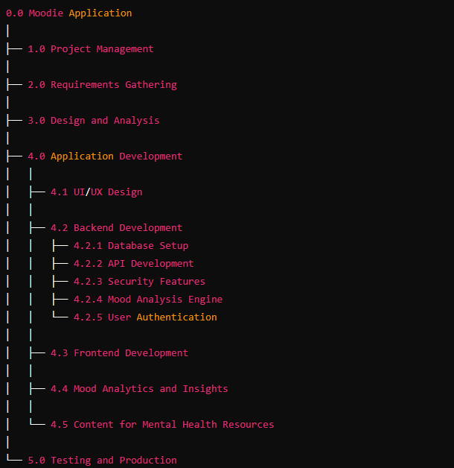

TIMELINE – GANTT CHART

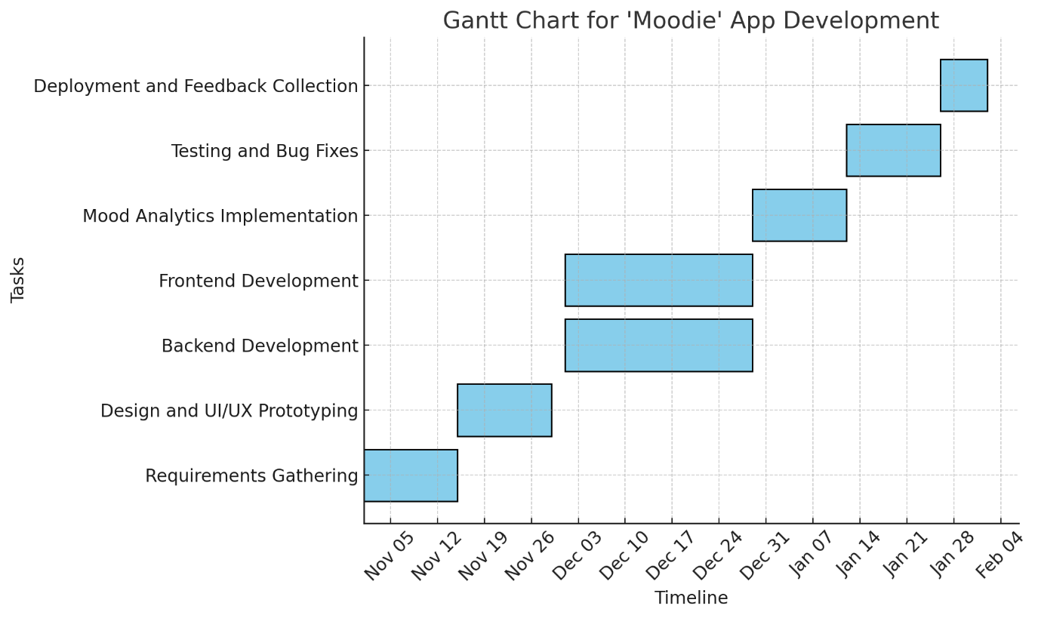

RISK ANALYSIS – SWOT & RMMM

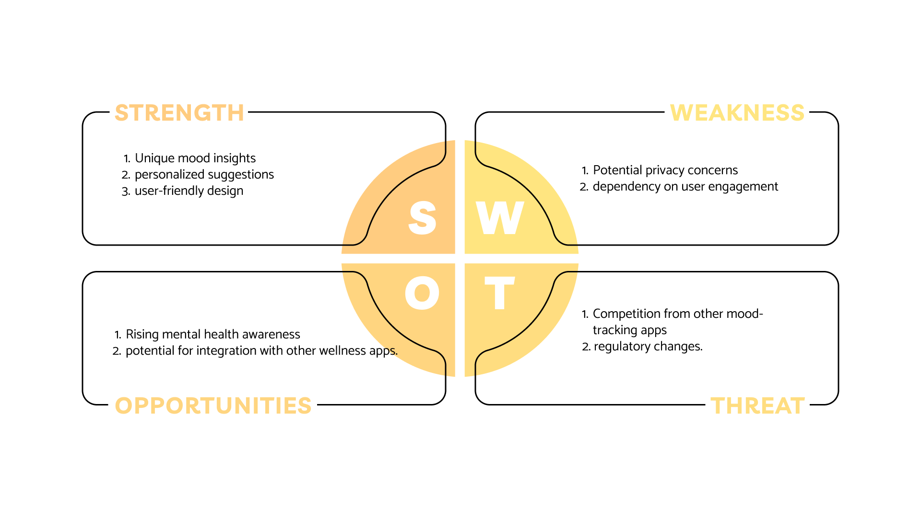

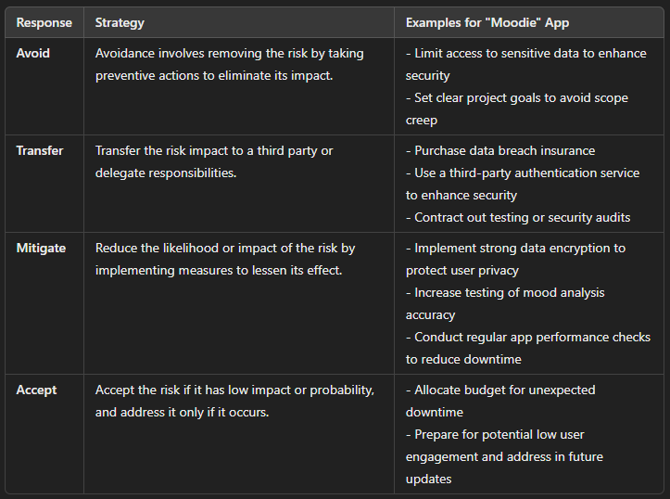
Result:
Thus, the work breakdown structure with timeline chart and risk table were formulated successfully.

WBS – Examples
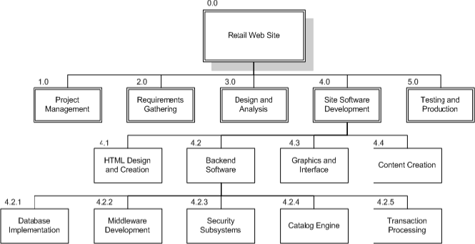

- 0.0 Retail Web Site
- 1.0 Project Management
- 2.0 Requirements Gathering
- 3.0 Analysis & Design
- 4.0 Site Software Development
  - 4.1 HTML Design and Creation
  - 4.2 Backend Software
    - 4.2.1 Database Implementation
    - 4.2.2 Middleware Development
    - 4.2.3 Security Subsystems
    - 4.2.4 Catalog Engine
    - 4.2.5 Transaction Processing
  - 4.3 Graphics and Interface
  - 4.4 Content Creation
- 5.0 Testing and Production

TIMELINE – GANTT CHART

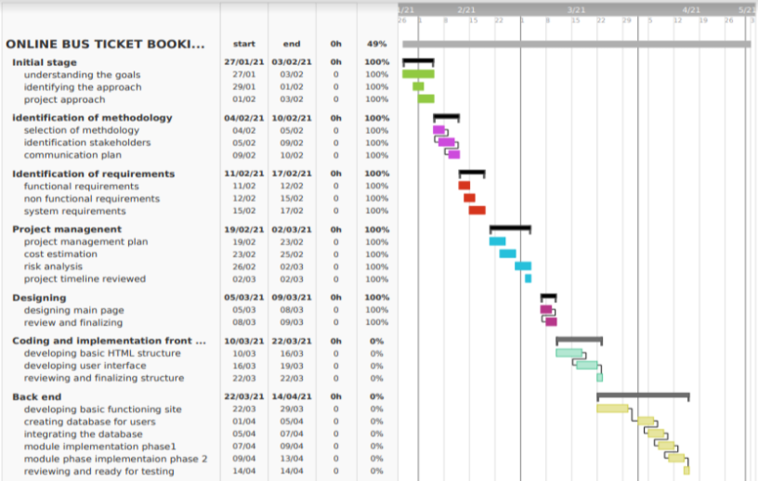

RISK ANALYSIS – SWOT & RMMM

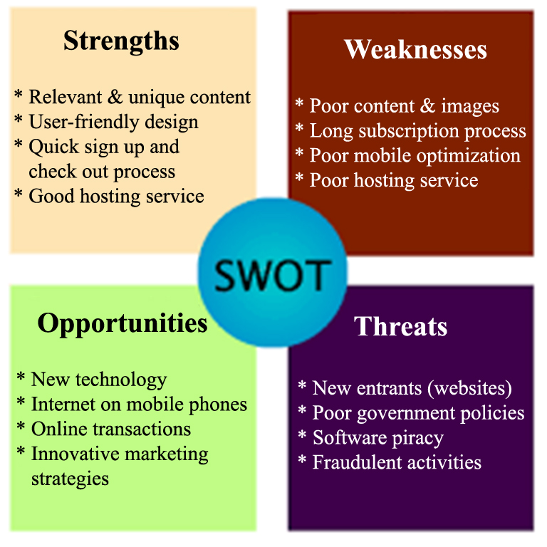

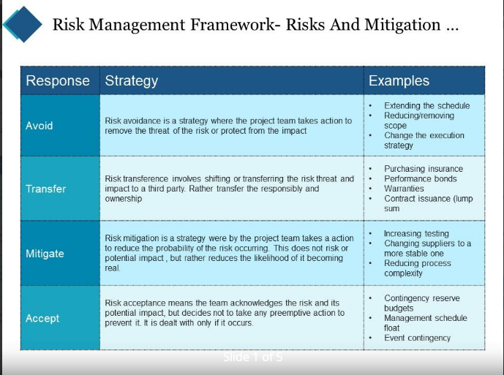

Functional Document………………………………….
1. Introduction:- The project is a comprehensive mental health website aimed at providing users with mental health resources, AI-based chat support, and personalized mood tracking.…..………………………………………………………………………………………………………..
2. Product Goal :- To create an accessible, supportive, and interactive platform where users can find mental health resources and engage with AI tools to enhance their well-being.
3. Demography (Users, Location)

Users: Individuals seeking mental health resources and support, ranging from teens to adults.

Location: Targeted for global usage with an emphasis on regions with high internet penetration.

4. Business Processes

User Registration and Authentication: Process to securely create and manage user accounts.

Content Access and Search: Allows users to browse, search, and filter articles, videos, and guides.

AI Chat Support: Provides real-time interaction with an AI chatbot for mental health queries.

Mood Tracking: Enables users to log their mood and view trends over time.

5. Features

Feature #1: User Authentication:

Description: Secure login and registration system.

User Story: “As a user, I want to securely log in and access my personalized dashboard.”

Feature #2: AI Chatbot:

Description: AI-driven support for answering mental health questions.

User Story: “As a user, I want to chat with an AI that provides mental health advice.”

Feature #3: Mood Tracking:

Description: A tool for users to log their mood and view trends.

User Story: “As a user, I want to track my mood over time to understand my mental health patterns.”

6. Authorization Matrix
Role | Access Level
Admin | Full access to user management and site settings
Registered User | Access to all features including mood tracking and AI chatbot
Guest User | Limited access to public articles and resources

7. Assumptions

The development team will have access to stable infrastructure and tools.

Users are comfortable with providing data for mood tracking and chatbot interactions.

MOODIE Architecture Document
1. Application Overview
MOODIE is a mental health and mood-tracking application aimed at improving user well-being through features like chatbot-based mood tracking, access to mental health statistics, guided meditation sessions, and games for stress relief.
2. Microservices Architecture
MOODIE is built using a microservices architecture to ensure scalability and independent functionality for each feature:
- Chatbot Microservice: Handles natural language processing (NLP) to interact with users, understand mood-related queries, and provide mood-based suggestions.
- Statistics Microservice: Manages and displays mental health disorder statistics based on the selected country and year (e.g., 2022) using visual charts and graphs.
- Meditation Microservice: Provides meditation timer functionality with selectable options (2, 5, 6, 10 minutes) and tracks user activity during sessions.
- Games Microservice: Manages access to various relaxation games like BlockRide, BlockSun, Tic Tac Toe, etc.
- Contact Us Microservice: Collects user input (username, email, phone, and address) and forwards it for follow-up by the support team.
3. Event-Driven Architecture
MOODIE uses event-driven architecture to ensure seamless interaction between the microservices. For instance:
- When a user submits a mood or interacts with the chatbot, an event triggers real-time mood tracking and response generation.
- The statistics service responds to country selection with updated data from the database.
4. Serverless Components
Certain MOODIE functions leverage serverless components to scale dynamically based on user interaction. For example:
- The chatbot uses serverless functions to handle bursts of user conversations efficiently without overloading resources.
- The statistics microservice can also use serverless queries for large datasets.
5. Database Design
MOODIE employs a NoSQL database to store unstructured data, including user mood history, chat logs, and meditation session logs, while relational databases are used to manage structured data like user profiles and contact form submissions.
- ER Diagram: The Entity-Relationship diagram connects user profiles with mood history, game history, meditation sessions, and contact requests.
- Schema Design: The database schema consists of:
  - Users: Stores user information (name, email, country, etc.).
  - Moods: Tracks mood entries and the time they were recorded.
  - Meditation Sessions: Logs meditation session durations and timers used.
  - Game History: Records games played and performance in each game.
  - Statistics: Contains global mental health disorder data for visual representation.
6. Data Exchange Contract
MOODIE defines clear contracts between microservices to ensure consistent data exchange and communication.
- Frequency of Data Exchanges:
  - The chatbot microservice exchanges data continuously during user conversations.
  - The statistics microservice updates data on-demand when the user selects a different country or year.
- Data Sets:
  - User Data: Includes profile information, mood history, and contact form details.
  - Statistics Data: Represents mental health data based on country and year.
  - Game Data: Tracks user participation and performance in games.
- Mode of Exchanges (API, File, Queue, etc.):
  - APIs handle data exchanges between the frontend (web or mobile app) and microservices.
  - Event queues trigger updates to the chatbot and meditation services when user inputs are received.

FUNCTIONAL TEST CASE
Feature | Test Case | Steps to Execute Test Case | Expected Output | Actual Output | Status | More Information
User Authentication | User sign-up and login | 1. Open the app.  2. Click on "Sign Up."  3. Enter email and password.  4. Submit.  5. Log in using the credentials. | User is able to sign up and log in successfully. | As expected | Passed | -
Mood Tracking | Log mood entry | 1. Log in.  2. Go to "Log Mood" section.  3. Select a mood from the list.  4. Add notes or tags if needed.  5. Submit. | Mood entry is saved and displayed in the history. | As expected | Passed | -
View Mood History | Access mood history | 1. Log in.  2. Go to "Mood History" section.  3. Select "List View" and "Calendar View" options. | Mood entries are displayed in both list and calendar views. | As expected | Passed | -
Notifications & Reminders | Receive daily mood reminder | 1. Log in.  2. Go to settings.  3. Enable daily mood reminders.  4. Wait until reminder time. | User receives a daily notification at the set time prompting them to log their mood. | As expected | Passed | Test notification functionality across devices
Personalized Insights | Generate weekly insights report | 1. Log in.  2. Track moods for a week.  3. Check "Insights" section after 7 days. | Weekly report with mood patterns and insights is generated based on user data. | As expected | Passed | Check report accuracy and relevance to mood data

