# ADAS (ADVANCED DRIVER ASSISTANCE SYSTEM)

## USE CASES:

1. Forward Collision Warning:

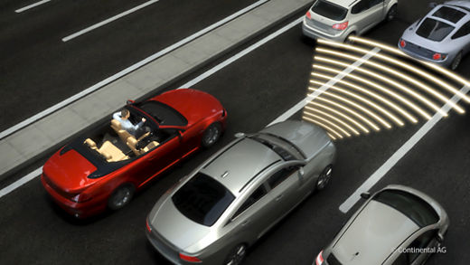

Using radar or cameras, the systems scans the road ahead to detect potential obstacles and warns the driver if there is a risk of a collision.

1. Lane Keep Assist:

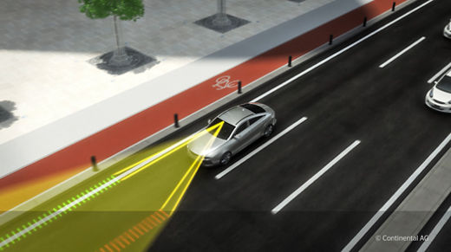

Key function of ADAS is lane keeping assist. This system uses cameras and sensors to detect lane markings and alerts the driver if the vehicle drifts out of its lane without signalling.

1. Parking Assistance:

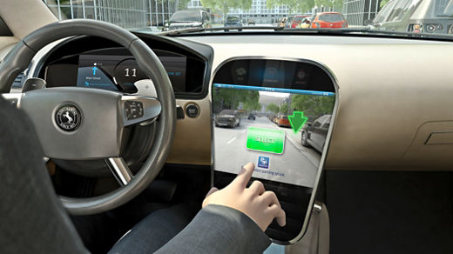

Parking assistance is another valuable feature of ADAS. This function utilizes sensors and cameras to assist drivers in parking their vehicles safely and accurately. Whether it's parallel parking or perpendicular parking, the system provides guidance and alerts to help drivers navigate into tight spaces.

1. Adaptive Cruise Control(ACC):

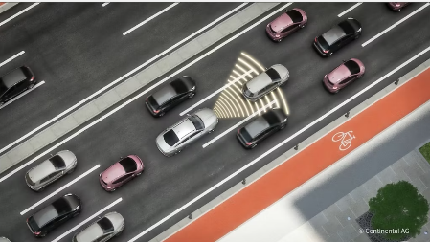

Adjusting the throttle and brakes ACC reduces the risk of rear end collision and automatically adjusts the vehicle's speed to maintain a safe distance from the vehicle ahead.

1. Blind Spot Detection:

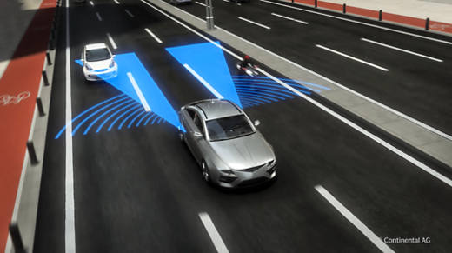

Blind spot detection uses sensors to monitor the vehicle's surroundings and provides visual or audible warnings if there is a vehicle in the blind spot zone.

1. Traffic Sign Recognition:

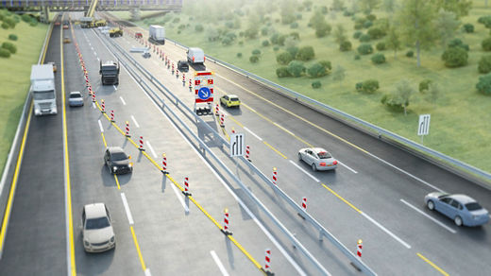

ADAS includes features such as traffic sign recognition, which uses cameras to read and display traffic signs, helping drivers to stay informed about speed limits, no entry signs, and other relevant information.

Continental offers both **software as a product and hardware components** to bind these use cases.

## Software as a product

* Parking Solutions: Data Processing in the concerned software stack can be done either using the continental leading sensor systems or on third party hardware.
* Blind Spot Information System: By fusing the input data from cameras and radars, this system helps in making the roads safer for everybody.
* Performance Solutions (ACC): This system fulfills the requirements for level 2 + cruising and enables hand-off driving on highways.
* Navigation Cruise System: This system helps in lane changing and include high-performance in all driving domains with greater scope for safety cruising and parking.

## Hardware as a product

There are a variety of products manufactured by continental among those we have a selection of our ADAS enablers.

* **ARS540**

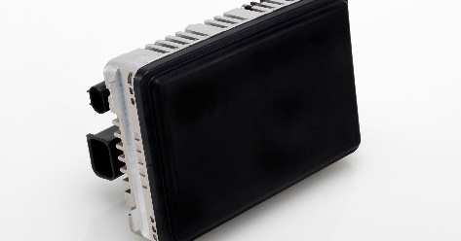

ARS540 is a high performance 4D premium long range radar sensor which enables highly automated driving in combination with other technologies. It provides best radar performance for critical use cases in urban and highway scenarios. The ARS540 provides high range and angular accuracy as well as improved processing power and algorithms compared to standard ARS5/6 radars.

* **MFC527**

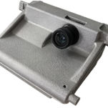

The latest camera generation MFC500 from Continental is a modular, scalable and connected camera platform. The 5th generation of Continental ADAS Cameras provides solutions ranging from advanced driver assistance functions (e.g. NCAP 2023) to Highly Automated Driving (HAD). The premium camera within the MFC500 family is the MFC527.

* **SVC300**

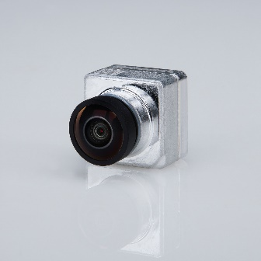

The new camera family SVC300 from Continental is a scalable surround-view camera platform. Is serves as an enabler for parking assistance functions, starting with visualization functions up to automated parking. Continental solution is a modular platform supporting multiple lenses and imager resolutions (from 1.3 up to 3Mpix).

# Zone control unit and zonal platform technical description

## Impact of market trends on vehicle architecture:

With the continues evolution and V2X and cloud integration the demand for revolutionizing the architecture increase. In the past our development process sequentially. If hardware changes then the developers must build all-new software for each new hardware platform.

Now the impact of cloud to the architecture result in the decoupling of hardware from the software, compute power got centralized and we have the independent hardware and software development cycles). Now the original equipment manufacturers tend to focus on hardware design and capability like speed and the selection criteria (sales criteria) for these OEM are based on software.

This led to the development of **server-zone architecture**. We have distributed architecture uptill now where we have hundreds of ECUs, limited power and functionality isolated in ECUs, lots of wires and limited cloud-based functionality.

### Server-zone architecture

* Compute power is distributed in few but high-performance computers.
* There is a coding layer that allow for more efficient communication between the hardware and the software (hardware abstraction).
* Always connected to the host servers.
* It results in the reduction of wires.
* Flexible vehicle functions update over lifetime (post-sale).
* Zones manage complexity, enable polymorphism, optimize power and reduce the total cost of the vehicle.
* Compute centralization decouples software from hardware, aid in the aftersales update and helps in the digital lifecycle management.

### Zone Control Unit

* It has three main functions acting as a communication gateway, input/output control, smart power distribution.
* Main interconnections with the ZCU include non-intelligent actuator sensor, local interconnect network actuator, controller area network ECU, high performance computer.

#### Continental Zonal Platforms:

* Medium Performance Controller (MPC): In this category we have Infineon TV-II CM4 Single Core TV-II CM7 Single Core TV-II CM7 Dual Core.
* Advanced Performance Controller 1.0 (APC): In this category we have Infineon Aurix TC3x + Cypress TV-II CM4.
* Advanced Performance Controller 2.0 (APC): In this category we have Infineon Aurix TC4x or Renesas RH850 U2B.

#### Main components of zonal platform integration process:

* Platform Backbone Selection
* Platform Module Selection
* Continental Function Library
* Customer/ 3rd Party Supplier Interface

# Infrastructure Functions:

## Voltage Mode Management

### Overview

Responsible for measuring the voltage of each supply line and determine out of it a voltage mode (Over Voltage, Under Voltage, Normal Voltage etc.) to provide this to the ECU specific subsystems for further processing. It is scalable and configurable.

### Features

* To sense and measure the supply line voltage (for both system and auxiliary modes).
* To determine the voltage mode.
* To determine the emergency recommendation, in order to bring the system in a safe state.
* To determine and provide modes of different criteria for each voltage classes.
* Provide failure status to application and other infrastructure functions.

## Output Control and Supervision (OCS)

### Overview

Output control and supervision provides the output fault status and output current in mA for the supported drivers to further application SWC (software components) to use.

### Features

* Output Current Sense in mA for SPOC+2 driver.
* Fault detection: The OCS module could detect open load, short circuit to GND/VBATT and SPI communication error the output in ON/OFF state.
* The fixed parameters for each output can be configured by OCS plugin.

## IO Port Expander

### Overview

It enables transfer of raw information of an input or output over an inter-node communication channel between microcontroller or even between ECUs without any functional interpretation. It is possible to realize and virtualize digital and analog inputs/digital PWM and PCM control request.

#### AUTOSAR

AUTOSAR is a blueprint to provides guidelines for how software components should be developed and interact with each other. This ensures that software from different manufacturers can work together seamlessly.

For example, consider a car’s braking system. One software component might be responsible for detecting when you press the brake pedal. Another might control the actual brakes. With AUTOSAR, these components can be developed independently, by different teams or companies, and you can be confident that they will work together correctly.

In addition, AUTOSAR makes it easier to update or replace components. If you want to upgrade the software that controls the brakes, you don’t need to change the software that detects the brake pedal. This makes the system more flexible and easier to maintain.

### Features

* IOPE can read digital as well as analog input ports and provide them via communication to remote units (ECUs)
* IOPE can control digital outputs, PWM outputs or even PCM outputs via communication in remote units (ECUs).
* The end-to-end protected sending and receiving of IOPE data with an AUTOSAR stack.
* In an automotive system, there are various events that can “wake up” or activate different parts of the system. These events are known as “wake-up sources”. For example, a wake-up source could be a signal from a sensor, a timer reaching a certain value, or a user action like turning the ignition key. let’s consider a scenario where the Aurix microcontroller (a key component in many automotive systems) is not ready to process these wake-up sources. This could be because the system is in a low-power mode, or the Aurix is busy with other tasks. In such a scenario, it’s important not to lose any wake-up events. So, the system takes a “snapshot” of the enabled wake-up sources. This snapshot is a record of which sources are enabled and could potentially trigger a wake-up event. Once the Aurix is ready, this snapshot is sent to it. The Aurix can then process the wake-up sources as needed. For example, if a sensor signalled that the engine temperature is too high, the Aurix can take appropriate action like activating the cooling system. This process ensures that no wake-up events are missed, even if the Aurix is not ready to process them immediately.

## Vehicle Mode Power Management (VMPM)

### Overview

It is an integration frame for the implementation of a power management of the backbones (multiple microcontrollers plus peripheral devices) to achieve synchronization, information forwarding, overall power management and error handling.

### Features

* Low power wakeup detection (DAWP, WUM): collect wakeup inputs via polling or interrupts and start up system accordingly.
* Synchronization between microcontrollers (SyncPM): information exchange and low power handling between two microcontrollers.
* Leveraging software platform assets: use of existing SWP assets as Moder Power Management (MPM) and handling of mode request from SWC via MPM.

#### Some important terms:

BSWM (Basic Software Mode Manager): BswM is responsible for controlling the modes of various BSW modules. It processes mode requests from the BSW modules and application layers, according to created rules, and performs a set of actions after processing the rules.

ICU (Input Capture Unit): The ICU Driver controls the input capture unit of the microcontroller. It provides features like high-time measurement, edge detection and notification, edge counting, edge time stamping, and wake-up interrupts.

DAWP (Diagnostic over IP): DoIP in AUTOSAR is a standardized solution for the diagnostic communication over Ethernet. It provides a transport protocol for diagnostic messages between a tester and an ECU.

SyncPM (Synchronized Time-Base Manager): The Synchronized Time-Base Manager in AUTOSAR provides a synchronized time-base for the entire system. It is responsible for synchronizing the local time bases of different ECUs in a network.

WUM (Wake-Up Manager): These modules handle events that can “wake up” or activate different parts of the system.

RTE (Run-Time Environment): RTE is at the heart of the AUTOSAR ECU architecture. It provides infrastructure services that enable communication between the AUTOSAR software components and acts as the core software modules for the AUTOSAR software components to access.

COM (Communication): COM sits between the RTE and the PDU Router. It defines all the signals used by the port in the Software component, and converts them from data structures into a PDU, and vice-versa.

## Smart Power Distribution on vehicle level

### Pre-Power distribution

* A single pre-power distribution is integrated in the vehicle.
* It supplies the ZCUs with power.

### Integrated Power Distribution in Zone

The ZCU controls the power of its own applications and of its connected ECUs, sensors and actuators in a dynamical way.

#### Advantages

* Enables fail operational use cases by reactivation of load in case of failure recovery possible.
* Predictive load balancing (temporary switch off of loads for compensation of other loads.
* Monitors the parameters (I,V,T) of the power stages for usage in central energy management.
* Controls power consumption decentralized in the zone (switching off suspicious devices which may lead to avoid chain reactions).

### Other Zones

* Amount on ZCUs depends on vehicle classification or size.

### Solutions for Smart Power Distribution

We have the realization with discrete components, smart FETs and smart fuses.

#### Standard fuse

* Once the standard fuse is blown, it has to be exchanged. No chance, to re-activate it again.
* All standard fuses of a vehicle have to be centralized in one single, accessible location of the car.
* I2t sensitivity of a standard fuse is static and limited compared to an electronical fuse. This results in a larger necessary diameter of the wire which is protected by the standard fuse.

#### Electronical fuse

* Act as a fuse to protect the wiring harness.

1. Cut off current flow in case of malfunction.
2. Reactivation of load in case of malfunction is not present anymore.

* Act as a switch to enable and disable loads on purpose.

1. eFuse can act as an ordinary switch and switch off loads in case of Low battery condition to keep essential functions alive.
2. Dynamic load balancing by switching off loads which are not used, and which would be active in static load balancing without eFuse.

## New technologies (Hypervisor Solution- Advantages)

It offers flexible, efficient resource sharing and dynamic resource allocation. It allows separation of virtual machines by allocation each virtual machine with physical or virtual cores, memory via MPU and Bus/ System MPU which manages bus master access to memories, physical or virtual peripheral and configuration registers. This allows multiple applications from different domains to be hosted into a single ECU thereby enabling ECU reduction within the vehicle.

# CoSmA (continental smartphone access)

### Pase (passive start entry)

* Energy management
* One car access
* Personal settings
* Environmental robustness

### CoSmA

* Multi car access
* Energy management
* Key sharing
* Configurable driving rights
* Environmental robustness
* Personal settings

## Pase system access system evolution

Mechanical key -> Remote keyless entry -> Immobilizer -> PASE -> Advanced PASE -> Digital Access

## Features

* Remote keyless entry key (RKE): remote lock/unlock
* PASE Key: Remote lock/unlock, hands free unlock, PASE convenience zones (welcome light, approach unlock, walk away locking)
* Bidirectional Key: Remote lock/unlock, hands free unlock
* Gateway key: remote lock/unlock, hands free unlock, PASE convenience zones, Smartphone Synchronization (remote climate control, vehicle position, vehicle status: fuel, tire pressure)
* CoSmA: Remote lock

*************