Got it 👍 Let me turn this into simple, exam-ready notes in points that you can quickly revise and write.

Failure Rate of Hardware (Bathtub Curve) 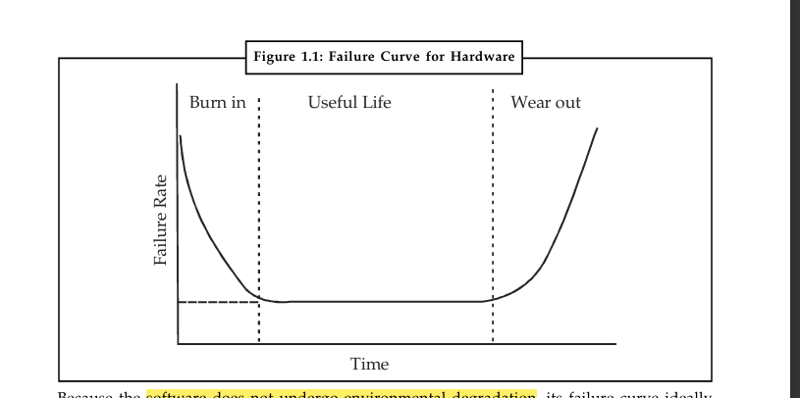
- The hardware failure curve is called the “bathtub curve”.
- Three phases in hardware failure rate:
  - Burn-in phase: High initial failure due to design/manufacturing defects.
  - Useful life phase: Failures reduce → curve flattens (steady rate).
  - Wear-out phase: Failures increase again due to dust, heat, aging, etc.
- Hardware wears out physically over time.

Failure Rate of Software
- Software does not wear out physically because it is not affected by environment (dust, temperature).
- Software curve should ideally flatten after initial defects are fixed.
  - Early phase: High failure due to undiscovered bugs.
  - Later phase: Curve should remain flat (stable).

Actual Software Failure Curve (Contradiction Explained)
- In reality, software failure rate does not stay flat.
- Reason: Software undergoes maintenance and updates throughout its life.
- Each change/maintenance activity may introduce new defects.
- This causes spikes in the failure rate.
- After fixing, curve stabilizes, but further changes again cause new spikes.
- Thus, software does not wear out but deteriorates due to continuous modifications.

👉 In short: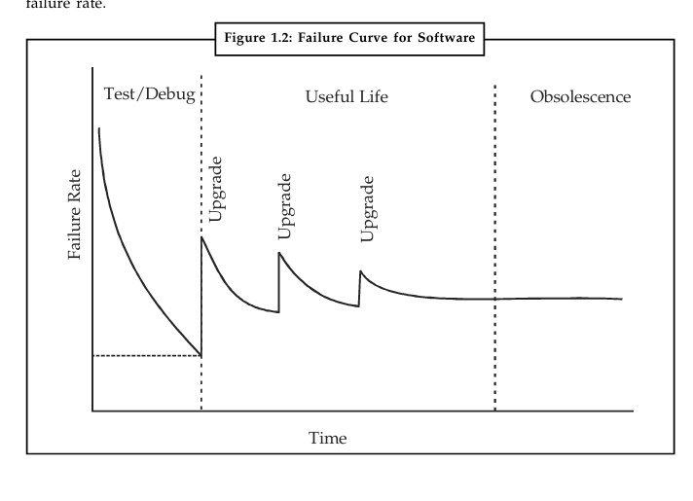
- Hardware: Burn-in → Stable → Wear-out (bathtub curve).
- Software: Initial failures → Stable → Spikes (due to updates/maintenance).

Do you want me to also make a small diagram in text form (like an easy sketch you can draw in exam) for both hardware and software failure curves?
Perfect 👍 I’ll simplify this into clear, exam-ready notes in points so you can revise quickly and write effectively.

Software Myths

General Software Myths
- Myth 1: Computers are more reliable than devices they replaced.
  - Reality: Software can fail due to errors (e.g., business accounts) → just like manual errors.
- Myth 2: Software is easy to change.
  - Reality: Changes are easy, but difficult to make without introducing new errors.
  - Every change requires re-verification of the whole system.
- Myth 3: Adding more programmers helps finish late projects faster.
  - Reality: Brooks’ Law → “Adding people to a late project makes it later.”
  - Reason: Training new members reduces productivity of existing team.
- Myth 4: Testing removes all errors.
  - Reality: Testing only shows presence of errors, not absence.
  - Goal: Design test cases to detect maximum possible errors.
- Myth 5: Software with more features is better.
  - Reality: Best programs are simple and focus on doing one task well.
- Myth 6: The aim is just to build working programs.
  - Reality: The aim is to deliver high-quality, efficient, maintainable software.

Types of Myths

1. Management Myths
- Managers often believe myths to reduce pressure of budget, time, and quality.
- Myth: A book of standards & procedures is enough.
  - Reality: Standards may exist but often are outdated, unused, incomplete, or not adaptable.
- Myth: Adding more programmers will help catch up (Mongolian Horde Concept).
  - Reality: “Adding people to a late project makes it later.” (Brooks’ Law).
- Myth: Outsourcing a project means managers can relax.
  - Reality: Without internal project control & management, outsourcing will also fail.

2. Customer Myths
- Customers also hold misconceptions, leading to false expectations.
- Myth: A general statement of objectives is enough to start coding.
  - Reality: Ambiguous requirements = recipe for disaster.
  - Clear requirements need continuous communication between customer & developer.
- Myth: Requirements change frequently but are easy to handle because software is flexible.
  - Reality: Cost of changes depends on when they are introduced:
    - Early stage → small cost.
    - Later stage → very high cost (design rework, extra resources, delays).

Key Takeaway
- Myths create wrong expectations, poor quality, high costs, and delays.
- This led to the rise of Software Engineering as a formal discipline.

👉 This is exam-ready.
Do you want me to also prepare a short mnemonic or memory trick so you can quickly recall all 6 general myths in the exam?
Perfect 👍 Let’s turn this into easy-to-learn, exam-ready notes in points.

Software Crisis

Main Issues
- Size
  - Software is becoming larger and more complex with growing expectations.
  - Example: Code in consumer products is doubling every 2 years.
- Quality
  - Many software products have poor quality (contain defects after release).
  - Example: On average, testing finds 25 defects per 1000 lines of code.
- Cost
  - Software development is very costly in terms of time and money.
  - Example: FAA’s Advanced Automation System cost $700 per line of code.
- Delayed Delivery
  - Software projects often face serious schedule overruns.
  - Example: 1 in 4 large-scale projects is never completed.

Major Cause of Software Crisis
- Computers have become extremely powerful, but programming has not kept pace.
- In simple words:
  - No computers → no programming problem.
  - Weak computers → mild problem.
  - Gigantic computers → huge programming challenge.

👉 Short memory trick for exam:
“S-Q-C-D” → Size, Quality, Cost, Delayed delivery.

Do you also want me to prepare a short 3–4 line definition of “Software Crisis” (so you can use as an intro in answers)?
Got it 👍 I’ll make this into short, clear, exam-ready notes for you.

Software Engineering Framework

Three-Layered Framework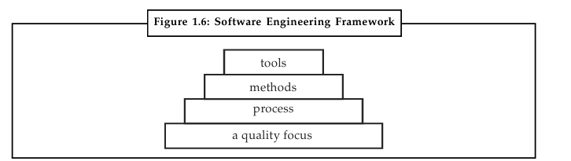
- Process Layer (Foundation)
  - Forms the base of software engineering.
  - Defines the framework for Key Process Areas (KPA).
  - Ensures rational and timely development of software.
- Methods Layer
  - Provides the technical know-how to build software.
  - Covers tasks such as:
    - Requirements analysis
    - Design
    - Program construction
    - Testing
    - Support
- Tools Layer
  - Provides automated or semi-automated support for processes & methods.
  - When tools are integrated, they form CASE (Computer-Aided Software Engineering) systems.

Quality Focus
- The entire framework rests on a quality focus → ensuring that the final product is reliable, maintainable, and efficient.

👉 Short memory trick: P-M-T-Q
- Process → Methods → Tools → Quality

Do you want me to also create a simple text diagram (like a pyramid or layered sketch) that you can easily draw in the exam for this framework?
Perfect 👍 I’ll break this down into exam-ready, simple notes in points for you.

Software Process

Definition
- A process is a series of steps involving activities, constraints, and resources to produce an intended output.
- In software: a software process is like a road map → predictable steps to build a timely, high-quality product.
- Focus in recent years: definition, implementation, and improvement of software development processes.

Examples of Software Processes / Standards
- ISO 9000
- SPICE (Software Process Improvement and Capability Determination)
- SEI Processes
- CMM (Capability Maturity Model) for software
- PSP (Personal Software Process)
- TSP (Team Software Process)

Generic Activities in All Software Processes
- Specification – Define what the system should do and its constraints.
- Development – Actual production (design + coding).
- Validation – Ensure software meets customer requirements (testing + verification).
- Evolution – Modify and improve software in response to changing demands.

👉 Memory trick for activities: S-D-V-E → “Some Developers Value Evolution”

Would you like me to also add a short 2–3 line definition of “Software Process” that you can use directly as an intro in exam answers?
Got it 👍 I’ll make this into easy, exam-ready notes in points so you can revise quickly.

Software Engineering – A Layered Technology

Layers of Software Engineering
- Process Layer
  - Acts as an adhesive for rational and timely development of software.
  - Defines the outline for Key Process Areas (KPA).
  - Ensures effective delivery of software technology.
- Method Layer
  - Provides technical knowledge for developing software.
  - Covers tasks like:
    - Requirements analysis
    - Design
    - Program construction
    - Testing
    - Support
- Tools Layer
  - Provides computerized or semi-computerized support for process & methods.
  - When integrated, tools form CASE (Computer-Aided Software Engineering) systems.
  - CASE = Software + Hardware + Engineering Database (similar to CAD for hardware).
  - Supports: analysis, design, code generation, debugging, testing.
  - Two prominent CASE technologies:
    - Application Generators
    - PC-based Workstations (graphics-oriented automation).

👉 Short Memory Trick: P-M-T (Process → Method → Tools)
- Process = Base/Glue
- Method = Know-how
- Tools = Automation (CASE)

Do you also want me to prepare a small layered diagram (text form) that you can easily draw in exams for this topic?
Perfect 👍 I’ll break this down into clear, easy exam notes in points for you.

2. A Process Framework

Definition
- A process = a method of doing something → involves steps, activities, constraints, and resources.
- In software: a software process = method of developing software (a roadmap).
- Goal → high-quality software at low cost.
- If a process cannot scale up to large projects or cannot produce quality → it is not suitable.

Processes Around Software
- Organizations have many processes (business, social, training, etc.).
- Only the software process deals with technical + management issues of software development.

Software Process = Many Component Processes
- Different activities handled by different people.
- Component processes have different objectives but work together.
- Example of component processes:
  - Development activities
  - Project management activities

Software Process Framework
- A set of guidelines, concepts, and best practices describing high-level processes in software engineering.
- It does not specify exact order/implementation.
- Provides abstract activities → each project implements them in detail via a project plan.

Relation: Process – Project – Product
- Software Process = Abstract framework (generic activities).
- Software Project = Implementation of process for specific needs.
- Software Product = Output of a project.
- Many projects can follow the same process, and each project can produce many products.

Example (Book Writing Analogy)
Generic Process (abstract):
- Set objectives (audience, marketing).
- Outline contents.
- Research topics.
- Literature survey.
- Write/compile content.
- Get expert evaluation.
- Proofread.
- Make corrections.
- Typeset.
- Print.
- Bind.
- Process = generic roadmap.
- Project Plan = specific details (e.g., writing a Software Engineering book with illustrations, deadlines, etc.).

Restriction of Process
- Process sets the boundaries (activities + order).
- Project plan works within these boundaries.
- A project plan cannot include activities outside the process.

Software Process Categories (Figure 2.2)
- Product Engineering Processes – define, design, implement software.
- Development Process – actual building of software.
- Project Management Process – planning, scheduling, monitoring.
- Process Management Process – defines and improves processes.
- Software Configuration Management Process – version control, change management.

👉 Short Memory Trick: P-D-P-P-S
(Product Engineering – Development – Project Management – Process Management – SCM).

Would you like me to also draw a simple text diagram for the relation Process → Project → Product so you can sketch it quickly in exams?
Great 👍 I’ll simplify this into short, exam-ready notes in points so you can revise and write easily.

Characteristics of a Software Process

Main Objectives
- Optimality – Produce high-quality software at low cost.
- Scalability – Should be applicable to large projects as well as small ones.

Key Characteristics
- Predictability
  - A process must give similar results when followed multiple times in similar projects.
  - Helps in cost, time, and quality estimation.
  - A predictable process is said to be under statistical control.
  - Example: If Project A uses same process as Project B, then results (cost, quality) should be comparable.
- Error Detection (Early Verification)
  - Errors should be detected in the same phase where they occur.
  - Waiting until testing stage makes correction costly and unreliable.
  - Each phase output should be verified before moving to next phase.
- Defect Prevention
  - Better than just detecting errors.
  - Goal → reduce number of defects introduced during development.
  - Defect prevention leads to:
    - Lower number of residual defects at delivery.
    - Lower defect removal cost.
  - Achieved by continuous learning & process improvement.

Cost of Correcting Errors (Figure 2.3)
- 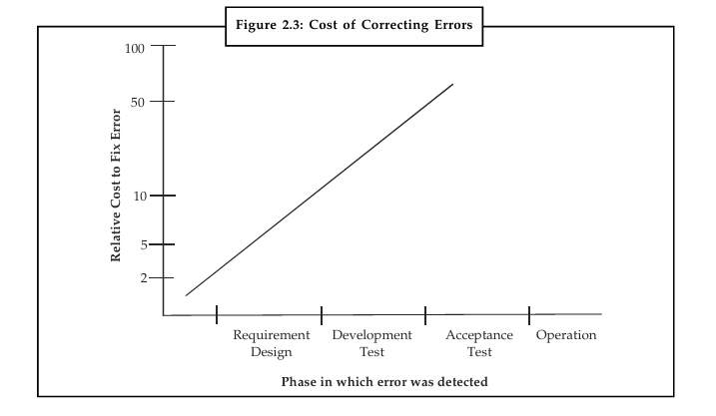Cost increases the later an error is found.
- Relative Cost Trend:
  - Requirements phase → Least costly
  - Design → Higher
  - Development → More
  - Testing → Very high
  - Acceptance → Maximum cost

👉 Memory Trick: P-E-D-C
- Predictability → Early error detection → Defect prevention → Cost saving

Do you want me to also create a small table (phase vs cost of fixing error) that you can directly copy in exam for better presentation?
Perfect 👍 I’ll make this into easy exam notes in points for you.

Software Development Life Cycle (SDLC)

Definition
- SDLC = A step-by-step process describing the phases in the development of software.
- Software goes through stages:
  - Conceived → Born → Developed → Operated → Maintained → Retired (dies).
- Purpose → to ensure quality, cost-effectiveness, and timely delivery.

Focus of SDLC
- Activities directly related to production of software:
  - Design
  - Coding
  - Testing

Role of Development Process
- A development process model specifies:
  - Activities to be performed.
  - Order in which they are performed.
- For cost, quality, and project management reasons, the process is phased.
- Development process = core of software process (because it covers development + QA activities).
- Management process is planned based on development process.

Models of Development Process
- Various SDLC models exist (e.g., Waterfall, Spiral, Incremental, Agile, etc.).
- Each specifies a sequence of steps/phases for software development.

👉 Key Point to Remember for Exams:
- SDLC = life journey of software.
- It provides a structured approach for design, coding, testing, maintenance, and management.

Would you like me to also make a simple diagram of SDLC phases (in text form) that you can quickly draw in exams?
Got it 👍 Let’s turn this long text into clear, short, exam-friendly notes in points.

Development Process – Steps, Work Products, Entry & Exit Criteria

1. Production Process (General Idea)
- A process = sequence of steps.
- Each step → performs an activity → output of one step becomes input for next.
- Goal = move closer to project objectives.

2. Verification & Validation (V&V)
- Verification = check consistency with inputs of the phase.
- Validation = check consistency with user needs.
- Done at end of each step to detect defects early.

3. Work Products
- Each step must produce a formal, tangible output (not just ideas).
- Called work products. Examples:
  - Requirements document
  - Design document
  - Code
  - Prototype
- These outputs are needed for V&V and as input for next phase.

4. Number of Steps
- Too many steps → too many documents → costly V&V.
- So, development process usually has a small number of major steps,
  - Each producing a clear objective & verifiable document.

5. Entry & Exit Criteria
- Entry Criteria = conditions that must be met before starting a phase.
- Exit Criteria = conditions that must be met to end a phase.
- Must be consistent between consecutive phases.
- Example:
  - Entry for Design Phase → “Requirements signed by client.”
  - Exit for Design Phase → “V&V completed satisfactorily.”

6. Management Information Flow
- Each step also produces summary information for project management.
- Information may include:
  - Resources spent
  - Schedule progress
  - Errors found in V&V
- Helps managers control and monitor the process without direct involvement.

👉 In Short (for exam):
- Process = sequence of verifiable steps.
- Each step → produces work product.
- Each phase → has Entry Criteria, Exit Criteria, and V&V.
- Information flows to management for control & monitoring.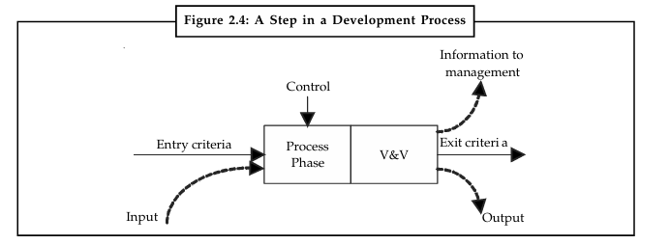

Would you like me to also make a simple text-based diagram of the step (like Fig. 2.4) that you can quickly sketch in exams?
Perfect 👌 Let’s break this into short, exam-ready notes on CMM (Capability Maturity Model).

Capability Maturity Model (CMM) – Notes

1. Definition
- CMM = methodology to develop and refine software development processes.
- Developed by SEI (Software Engineering Institute), USA in 1984, sponsored by U.S. DoD.
- Goal = improve process of developing, acquiring, and maintaining software systems.
- Widely applicable to software industry (not just defense).

2. Purpose
- Provides a 5-level evolutionary path of process maturity.
- Helps organizations assess current process and improve systematically.

3. Five Maturity Levels of CMM

Level 1 – Initial
- Process: ad hoc, chaotic, disorganized.
- Success depends on individual efforts.
- Not repeatable (lack of documentation/defined processes).

Level 2 – Repeatable
- Basic project management techniques established.
- Successes can be repeated.
- Processes are defined and documented.

Level 3 – Defined
- Organization has its own standard software process.
- Focus on documentation, standardization, and integration.

Level 4 – Managed
- Processes are monitored and controlled.
- Uses data collection and analysis for control.

Level 5 – Optimizing
- Processes are continuously improved.
- Uses feedback and innovative practices.
- Goal: serve organization’s needs better.

👉 In Short (for quick exam recall):
- CMM = Framework to improve software processes.
- Developed by SEI (1984).
- 5 Levels:
  - Initial → Chaotic, no standard.
  - Repeatable → Basic PM, documented.
  - Defined → Standard org-wide process.
  - Managed → Data-driven control.
  - Optimizing → Continuous improvement.

Do you want me to also create a memory trick / mnemonic to easily remember the 5 levels in order during exams?
Got it 👍 Let’s turn all this theory into clear, exam-ready notes in point form with simple examples.

📌 Waterfall Model – Notes (Easy to Learn)
🔹 Why it’s called Waterfall Model
- Phases flow downward in sequence like a waterfall (one after the other).
- Each phase must finish before the next begins.
- Example: Just like building a house → first design, then foundation, then walls, then roof. You can’t put the roof before walls.

🔹 Phases of Waterfall Model
- Requirement Analysis & Specification
  - Understand customer needs clearly.
  - Output: SRS Document (Software Requirement Specification).
  - Example: For a Library Management System – requirements like "Add Book", "Issue Book", "Generate Report".
- Design
  - Convert SRS into blueprint of software.
  - High-level design (system architecture) + detailed design (modules).
  - Output: SDD Document (Software Design Description).
- Implementation & Unit Testing
  - Actual coding of modules (programming).
  - Each module tested separately (unit testing).
  - Example: Test “Login Module” separately before connecting to database.
- Integration & System Testing
  - Combine all modules → test full system.
  - Ensure system works as per requirements.
  - Example: Check if Login + Database + Report generation all work together.
- Operation & Maintenance
  - Deliver software to customer.
  - Fix errors, update features, improve performance.
  - Example: Add “Online Payment” later in Library Software.

🔹 Project Outputs (Deliverables in Each Phase)
- Requirements Document (SRS)
- Project Plan
- System & Detailed Design Documents
- Test Plan + Test Reports
- Final Code
- User & Installation Manuals
- Review Reports
👉 Thus, outputs are not just the final program, but also all intermediate documents.

🔹 Perspective Modeling
- Waterfall is a perspective process model because it defines a standard sequence of activities (step-by-step).
- Activities are performed in linear order with certification (verification/validation) at the end of each phase.
- Example: Cannot start coding until design is approved → prevents skipping steps.

🔹 Limitations of Waterfall Model
- Rigid and inflexible – hard to go back to previous phase.
- Late product delivery – working software is seen only at the end.
- Poor at handling changes – requirements must be fixed at start.
- Risky for long projects – technology or user needs may change.
- High cost of error fixing – mistakes in early phase are found very late.
- Not suitable for unclear requirements – only works well if requirements are crystal clear.

🔹 When Waterfall Works Best
- For small, routine, or well-understood projects.
- Example: Payroll system, student record system (where requirements don’t change much).

✅ With these points, you can easily write short or long answers in exam.
Do you also want me to create a side-by-side comparison table of Advantages vs Limitations for quick revision?
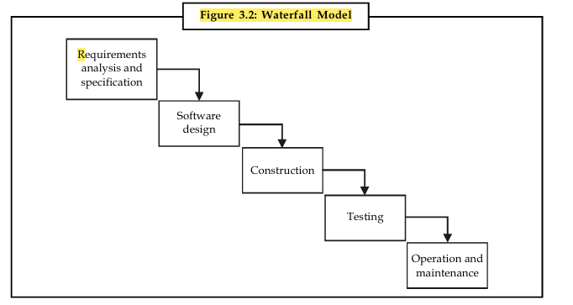
Perfect 👌 Let’s make exam-ready notes on the Incremental Process Model in a clear, short, and easy-to-learn format with examples.

📌 Incremental Model – Notes
🔹 Definition
- Incremental model = multi-waterfall approach.
- System is built in small increments (parts).
- Each increment goes through requirements → design → coding → testing.
- A working software is delivered in the first iteration, and more features are added in later increments.

🔹 Phases of Incremental Model
- Inception Phase
  - Defines purpose, scope, and business goals.
  - Similar to feasibility study.
- Elaboration Phase
  - Collect detailed requirements.
  - Decide system architecture.
  - Break requirements into increments (subsets of use cases).
- Construction Phase
  - Build increments using mini-waterfall cycle.
  - Includes analysis, design, coding, testing.
  - Produces production-quality working software (subset of features).
  - Different increments can be developed in parallel.
- Transition Phase
  - Final rollout to users.
  - Includes training, tuning, deployment, and maintenance.

🔹 Characteristics
- Iterative in nature (each cycle improves the system).
- Workflow inside one increment is sequential (like waterfall).
- Delivers basic functionality early, adds optional components later.
- Suitable when:
  - Requirements are clear.
  - Independent modules exist.
  - Team size is small (can’t build full system at once).

🔹 Advantages
✅ Working software delivered early.
✅ Flexible → scope & requirement changes are less costly.
✅ Easier testing & debugging (smaller increments).
✅ Risks handled better (risky parts built/tested early).
✅ Each increment is a milestone, easy to manage.

🔹 Disadvantages
❌ Each increment phase is rigid (no overlap).
❌ Full requirements not gathered at start → may cause architectural issues later.
❌ More management effort if too many increments.

🔹 Example (Easy to Remember)
📖 Suppose we are developing a Library Management System:
- 1st Increment → Book Issue & Return module.
- 2nd Increment → Student & Staff Records.
- 3rd Increment → Fine Collection.
- 4th Increment → Reports & Online Access.
👉 After the first increment, library can already issue/return books, and later features keep adding on.

✅ These points are enough for short answers, long answers, and examples in exams.
Do you want me to also prepare a comparison table between Waterfall Model and Incremental Model for quick revision?
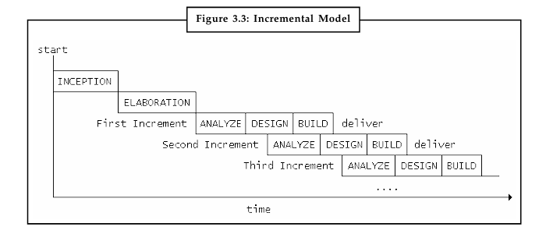
Great 👍 Let’s convert the RAD Model (Rapid Application Development) into easy, exam-ready notes in point form with an example.

📌 Rapid Application Development (RAD) Model – Notes
🔹 Definition
- RAD = linear sequential model with very short development cycle.
- Uses component-based construction + reuse of software components.
- Best when requirements are clear & project scope is limited.
- Focus = fast development + high quality software.

🔹 Key Features of RAD
- Requirement gathering through workshops & focus groups.
- Prototyping and early iterative user testing.
- Heavy use of reusable components.
- Rigid schedule → improvements moved to next version.
- Less formal communication (focus on speed).

🔹 Phases of RAD Model
- Business Modeling
  - Defines information flow in business functions.
  - Example questions:
    - What information drives the process?
    - Who generates it?
    - Where does it go?
    - Who processes it?
- Data Modeling
  - Collected business info → refined into data objects (entities).
  - Define attributes & relationships among entities.
- Process Modeling
  - Data objects transformed into workflows.
  - Define operations: add, modify, delete, retrieve data objects.
- Application Generation
  - Automated tools used for coding.
  - Uses 4th Generation Languages (4GL) and reusable components.
- Testing and Turnover
  - Many components already tested (reusable).
  - Only new components + interfaces tested.
  - Reduces overall testing time.

🔹 Advantages of RAD
✅ Fast development (short cycle time).
✅ Reusable components save time & effort.
✅ Modular approach → easier to manage.
✅ Early user feedback ensures higher quality.

🔹 Disadvantages of RAD
❌ Needs highly skilled engineers.
❌ Requires strong customer & developer commitment.
❌ Not suitable for large or complex projects that can’t be modularized.
❌ Works best when requirements are well defined.

🔹 Example (Easy to Remember)
📱 Mobile Banking App Development
- 1st Phase (Business Modeling): Define flows → customer logs in, checks balance, transfers money.
- 2nd Phase (Data Modeling): Entities = Customer, Account, Transaction.
- 3rd Phase (Process Modeling): Processes = Balance Inquiry, Money Transfer, Bill Payment.
- 4th Phase (Application Generation): Use pre-built login & payment modules.
- 5th Phase (Testing & Turnover): Test new money transfer feature + integrate with reused login system.
👉 Result: Working prototype in weeks instead of months.

✅ These notes are concise, structured, and perfect for writing in exams.
Would you like me to also prepare a comparison: RAD vs Incremental Model for quick last-minute revision? 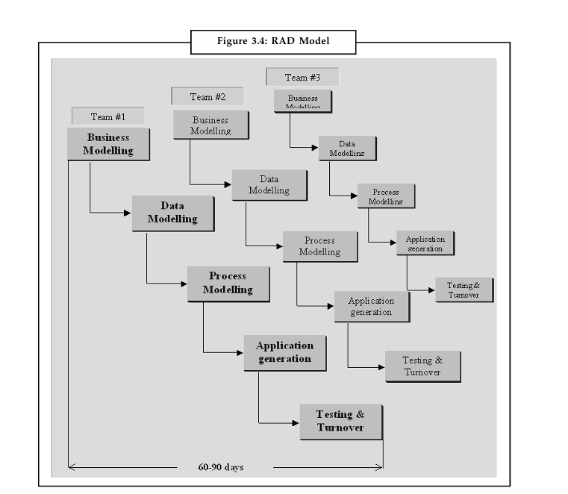

Got it 👍 Let’s convert this into easy, exam-ready notes in points for you.

✨ Evolutionary Process Model – Notes
🔹 Definition
- Iterative, activity-based software development model.
- After each iteration → an evolutionary prototype is produced.
- Prototype helps validate requirements for the next phase.
- Best suited when requirements are unclear or change frequently.

🔹 Types
- Prototyping
  - Prototype built to discover requirements.
  - Discarded once final system is ready.
- Exploratory Programming
  - Initial system is built and new functionality added iteratively.

🔹 Working
- Divides project into smaller, incremental waterfall cycles.
- Each cycle → working product delivered to users.
- Users give feedback → used for planning the next cycle.
- Cycles usually 2–4 weeks long.
- Continues until final product is complete.

🔹 Benefits
- Reduces project risks (early validation).
- Reduces costs by structured experimentation.
- Provides early working versions → helps marketing & documentation.
- Short, frequent cycles improve teamwork & motivation.
- Better fit to user needs & market requirements.
- Helps hit market windows faster.
- Early customer exposure → accelerates sales.
- Increases management visibility of project progress.

🔹 Limitations / Caution
- Can lead to patchwork of features (too many prototypes).
- Difficult to manage for large or complex projects.
- Works best for small/medium, dynamic projects.

🔹 Key Examples
- Prototyping Model (quick mockups, then real system).
- Spiral Model (risk-driven incremental model).

✅ Exam Tip: Write that Evolutionary Model = Prototyping + Spiral and is useful when requirements are not clear.

Do you also want me to make a comparison table (Evolutionary vs Waterfall vs RAD) for quick exam revision?
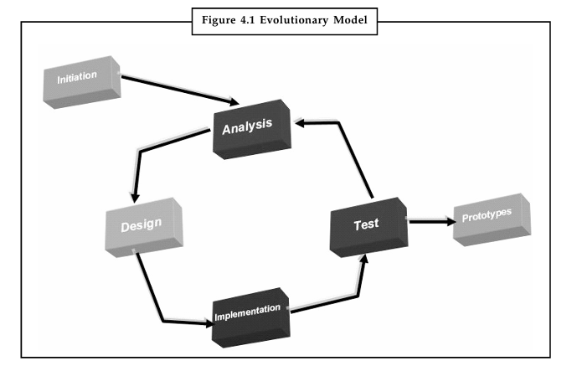
Perfect 👍 Let’s turn this into easy, exam-ready notes in points for the Prototyping Model. I’ll keep them short, clear, and structured — ideal for quick revision.

✨ Prototyping Model – Notes
🔹 Basic Idea
- Instead of freezing requirements first (like in Waterfall), a throwaway prototype is built.
- Prototype helps understand unclear requirements.
- After feedback, requirements become more stable and realistic.

🔹 When to Use
- Large or complex systems.
- When requirements are unclear or keep changing.
- When no existing system/manual process is available.
- To test feasibility of new/novel systems.

🔹 Process (Steps)
- Preliminary requirements → identify unclear needs.
- Build prototype (quick design, coding, minimal testing).
- Users test prototype and give feedback.
- Modify prototype based on feedback.
- Repeat steps 3–4 until requirements are clear.
- Discard prototype → finalize Software Requirement Specification (SRS).
- Develop actual production-quality system.

🔹 Key Features of Prototyping
- Cost kept low → only unclear features are prototyped.
- Minimal documentation (test plan/design docs often skipped).
- Minimal testing (just enough to demonstrate functions).
- Exception handling, recovery, standards → usually excluded in prototype.
- Prototype is throwaway (not used in final system).

🔹 Advantages
- Users are actively involved.
- Provides better understanding of system.
- Errors detected early.
- Quicker user feedback → better solutions.
- Requirements become more stable → fewer costly changes later.
- Reduces risks in unclear/novel projects.

🔹 Disadvantages
- “Build it twice” approach → may increase cost.
- May encourage quick-fix/repair style of building systems.
- Sometimes users mistake the prototype as the final system.
- Not suitable for projects with clear, stable requirements.

🔹 Example
- ATM Machine: Initially build a prototype with
  - Login, balance check, cash withdrawal.
  - Ignore receipt printing, exception handling.
  - Users test it, give feedback → final ATM system is built.

✅ Exam Tip: Write that prototyping is best when requirements are unclear or changing. Mention throwaway prototype, user feedback, and stable requirements.

Do you want me to also prepare a Prototyping vs Waterfall comparison table (2 marks type)?
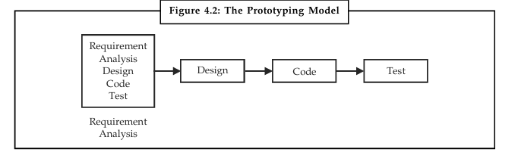
Here’s a clear, exam-ready notes version of the Spiral Model with simple points + example:

Spiral Model (Barry Boehm, 1986)
Definition
- Spiral model combines iterative development (prototyping) and systematic aspects of waterfall model.
- Activities are organized in the form of a spiral (cycles).
- Each cycle represents a phase of software development.

Key Features
- Each cycle has 4 quadrants:
  - (1) Identify objectives, alternatives, constraints
  - (2) Risk analysis & evaluation of alternatives
  - (3) Development & testing (prototype or product)
  - (4) Planning for next cycle
- Radial dimension → Cost (cumulative cost).
- Angular dimension → Progress (completion of phases).
- Risk-driven model – focuses on identifying and minimizing risks at every stage.
- Each cycle ends with a review (objectives, risks, deliverables, next plan).

Process (Step-by-Step)
- Cycle 0: Feasibility study (should we build the project?).
- Cycle 1: Define high-level requirements & concept of operation.
- Cycle 2: Define top-level requirements.
- Later cycles: Actual design, coding, testing, and deployment.
- The process continues until final system is delivered.

Advantages
✅ Risk analysis at each stage → lowers project failure.
✅ Flexible: can use waterfall, prototyping, or simulation as needed.
✅ Good for large, complex, high-risk projects (e.g., defense, aerospace, banking).
✅ Working software is produced early.
✅ Incorporates management + planning activities along with development.

Disadvantages
❌ Expensive (due to repeated risk analysis + prototyping).
❌ Requires expertise in risk management.
❌ Not suitable for small projects (overkill).
❌ Success depends heavily on correct risk identification.

Example
Suppose a company is building a flight control system:
- Cycle 1: Study feasibility → whether sensors & algorithms can meet accuracy.
- Cycle 2: Build prototype → test UI for pilots.
- Cycle 3: Develop performance modules → test safety risks.
- Cycle 4+: Full-scale development & integration.

✅ In short (exam answer line):
The Spiral Model is a risk-driven software development model where the project passes through repeated cycles (spirals) of planning, risk analysis, prototyping, development, and review until the final system is delivered.

Do you want me to also make a side-by-side comparison chart (Waterfall vs Prototyping vs Spiral) so it’s easier to revise before exam?

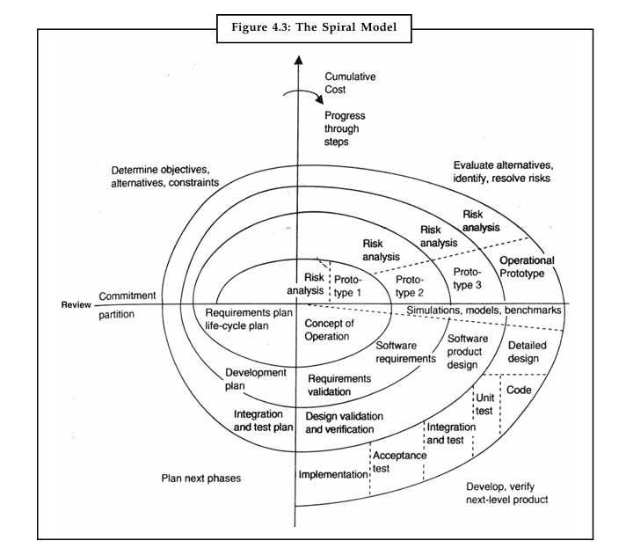
Feature |  | Waterfall Model |  |  | Prototyping Model |  | Spiral Model
Approach |  | Linear & sequential |  |  | Iterative (build prototype → feedback → refine) |  | Iterative + Risk-driven (spiral cycles)
Phases |  | Fixed sequence: Req. → Design → Code → Test → Deploy |  |  | Quick prototype → User feedback → Improve → Final system |  | 4 steps per cycle: Objectives → Risk analysis → Development → Planning
Focus |  | Documentation & planning |  |  | Early user interaction & feedback |  | Risk identification & reduction
Flexibility |  | Very rigid (no changes allowed once phase is complete) |  |  | Flexible (changes made based on feedback) |  | Very flexible (can combine waterfall, prototyping, simulation as needed)
Risk Handling |  | Poor (risks discovered late) |  |  | Moderate (user risk reduced, but technical risks remain) |  | Excellent (core feature is risk analysis at every cycle)
Cost |  | Cheaper initially but costly if changes occur |  |  | Moderate (extra cost for prototypes) |  | Expensive (due to repeated risk analysis & prototyping)
Time to Deliver Working System |  | Late in the cycle (at end of project) |  |  | Early prototype available quickly |  | Early prototypes/partial system in initial cycles
Best Suited For |  | Small, low-risk projects with clear requirements |  |  | Medium projects where requirements are unclear |  | Large, complex, high-risk projects (e.g., defense, aerospace, banking)
Example |  | Payroll system for small company |  |  | E-commerce website prototype |  | Flight control system, Banking security system
Feature / Model | Waterfall |  | Incremental | RAD (Rapid App Dev.) |  | Evolutionary |  | Prototyping | Spiral
Basic Idea | Linear, sequential phases |  | System built in parts (increments) | Fast dev. using components & reuse |  | Iterative cycles → evolving prototype |  | Throwaway prototype to refine requirements | Combines Waterfall + Prototyping + Risk analysis
Approach | One phase must finish before next |  | Each increment is mini-waterfall | Component-based, short cycles |  | Iterative, feedback-driven |  | Build prototype → refine → final system | Cyclic with 4 steps (Objectives, Risks, Dev, Planning)
When to Use | Requirements are clear & stable |  | Requirements clear but can be split into modules | Requirements clear, project small/medium, need speed |  | Requirements unclear, changing often |  | Requirements unclear, novel system | Large, complex, high-risk projects
User Involvement | Low (users see product at end) |  | Medium (users see partial system each increment) | High (workshops, feedback, prototyping) |  | High (feedback after each cycle) |  | Very High (users test prototypes) | Very High (reviews after each cycle)
Flexibility to Change | Very low (rigid) |  | Medium (easier to add changes in next increment) | Medium–High (new version for changes) |  | High (changes after every iteration) |  | High (changes during prototyping) | Very High (risks + changes handled each cycle)
Delivery of Working Software | Only at the end |  | Early (after 1st increment) | Very early (weeks) |  | Early (after each iteration) |  | Early (prototype, but not final) | Early (prototypes in cycles, partial system)
Risk Handling | Poor (errors found late) |  | Better (risky modules first) | Moderate (depends on scope) |  | Good (early feedback reduces risk) |  | Good (early errors found via prototype) | Excellent (risk-driven at every stage)
Cost of Error Fixing | Very high (found late) |  | Medium (each increment tested) | Low–Medium (reuse, early feedback) |  | Medium (errors caught earlier) |  | Low (prototype reveals early errors) | Low (risks identified & reduced early)
Examples | Payroll system, student records |  | Library Management (modules added step by step) | Mobile Banking App |  | Frequent requirement changes projects |  | ATM System (prototype for login, withdraw) | Flight Control System, Defense software
Advantages | Simple, structured |  | Early delivery, flexible, manageable | Very fast, user feedback, reuse |  | Flexible, user-driven, reduces risks |  | Clearer requirements, user satisfaction | Risk-driven, flexible, good for large projects
Limitations | Rigid, late delivery, poor with changes |  | More management effort, architecture issues | Needs skilled devs, not for large projects |  | Can become patchwork, hard for large projects |  | Build twice (extra cost), may confuse users | Costly, requires risk expertise, not for small projects
The Agile Model is a software development approach that focuses on flexibility, adaptability, collaboration, and customer satisfaction. Instead of following a rigid plan (like in the Waterfall model), Agile breaks the project into small, manageable parts called increments or iterations (often 1–4 weeks long). Each iteration delivers a working piece of software that can be tested, reviewed, and improved.

🔑 Key Features of Agile Model:
- Iterative & Incremental Development
  - The project is divided into small cycles (iterations).
  - Each cycle produces a usable version of the software.
- Customer Collaboration
  - Customers are involved throughout the process.
  - Regular feedback ensures the product meets real needs.
- Flexibility & Adaptability
  - Requirements can change at any stage.
  - Agile teams quickly adapt to new needs.
- Continuous Testing & Delivery
  - Testing happens in every iteration.
  - Ensures fewer bugs and better quality.
- Team Collaboration
  - Cross-functional teams work closely.
  - Daily meetings (e.g., stand-ups) are common.

🔄 Agile Process Flow:
- Requirement Gathering (user stories instead of heavy documentation)
- Planning Iteration (decide what to build in this cycle)
- Design & Development (build the features)
- Testing (ensure quality)
- Review & Feedback (customer + team feedback)
- Next Iteration (improve + add more features)

✅ Advantages:
- High customer satisfaction (due to involvement & feedback).
- Working software delivered early and continuously.
- Flexible to changes.
- Higher product quality due to continuous testing.
❌ Disadvantages:
- Requires experienced team members.
- Harder to predict time and cost.
- Documentation is often less detailed.
- Needs constant customer involvement.

📌 Example:
If you are developing a mobile app in Agile, instead of building the entire app at once, you might:
- Iteration 1: Build login & signup.
- Iteration 2: Add profile management.
- Iteration 3: Add chat feature.
- Iteration 4: Add payment integration.
At the end of each iteration, you have a working app with more features than before.

Would you like me to also compare Agile vs Waterfall models with a diagram for better understanding?
Aspect | Waterfall Model | Agile Model
Process | Linear, sequential | Iterative, incremental
Flexibility | Rigid, hard to change | Flexible, easy to adapt
Delivery | At the end of project | Continuous, after every iteration
Customer Involvement | Low | High
Documentation | Heavy | Lightweight
Best For | Stable requirements | Changing requirements
Got it 👍 You’ve listed key Scrum terms (all part of the Agile framework). Let me explain each clearly in a structured way so it’s easy to understand and revise.

🔹 Scrum Key Concepts
1. Scrum Product Backlog
- A list of all features, enhancements, bug fixes, and requirements for the product.
- Managed by the Product Owner.
- Items are written as User Stories (e.g., “As a user, I want to reset my password so that I can recover my account”).
- It is dynamic – can be updated anytime.

2. Scrum Master
- A facilitator/coach for the Scrum team.
- Ensures the team follows Scrum practices.
- Removes obstacles (called impediments) that block the team’s work.
- Not a boss → more like a guide/servant leader.

3. Scrum Backlog (Sprint Backlog)
- A subset of the product backlog, selected for the current sprint.
- Includes tasks the team commits to finish in that sprint.
- Owned and managed by the development team.

4. Scrum Board (Task Board)
- A visual board showing sprint backlog progress.
- Columns usually:
- To Do → In Progress → Testing → Done
- Helps the team and stakeholders track work daily.

5. Daily Scrum (Daily Stand-up)
- A short daily meeting (max 15 minutes).
- Each member answers 3 questions:
  - What did I do yesterday?
  - What will I do today?
  - Any blockers/impediments?

6. Sprint
- A time-boxed iteration (1–4 weeks, usually 2 weeks).
- At the end, the team delivers a potentially shippable product increment.

7. Sprint Review
- Happens at the end of the sprint.
- Team demonstrates what was built.
- Stakeholders give feedback.
- The product backlog is updated.

8. Sprint Retrospective (you didn’t mention, but important 🚀)
- After the sprint review.
- Team reflects: “What went well? What can we improve?”
- Helps in continuous improvement.

9. Poll System (I think you mean “Pull System”)
- In Scrum/Kanban, work is pulled by developers when they are ready (not pushed by managers).
- Ensures no one is overloaded.

📌 Scrum Flow (Step-by-Step)
- Product Backlog → created by Product Owner.
- Sprint Planning → select items → make Sprint Backlog.
- Sprint Execution (2–4 weeks) → work + Daily Scrums.
- Sprint Review → demo to stakeholders.
- Sprint Retrospective → team improvement discussion.
- Repeat with next sprint.

👉 Do you want me to make a neat diagram (Scrum cycle with backlog, sprint, daily scrum, review, retrospective) that you can use in your notes/presentation?
Great question 👍 Let’s now look at Kanban, another Agile method (often compared with Scrum).

🔹 Kanban Method
Kanban is a visual workflow management system that helps teams manage work-in-progress (WIP) and continuously deliver value.
It uses a Kanban Board with columns to represent the flow of work.

📌 Key Principles of Kanban
- Visualize Work → Represent tasks on a Kanban board.
- Limit Work in Progress (WIP) → Prevents team overload.
- Manage Flow → Track tasks as they move across stages.
- Continuous Improvement → Optimize efficiency over time.

📌 Kanban Board
Usually structured as columns:
To Do → In Progress → Review/Testing → Done
- Each task is written on a card (physical sticky note or digital card).
- Cards move across columns as work progresses.

📌 Key Features
- Pull System → Team members pull tasks when they have capacity.
- No Fixed Sprints → Unlike Scrum, Kanban doesn’t have fixed iterations. Work flows continuously.
- Flexible → Changes can be made at any time.
- Focus on Flow → Goal is to minimize bottlenecks and speed up delivery.

📌 Kanban vs Scrum (Quick Comparison)
Aspect | Scrum | Kanban
Time-box | Sprint (1–4 weeks) | Continuous flow (no sprint)
Roles | Scrum Master, Product Owner | No defined roles
Meetings | Daily Scrum, Sprint Review etc. | No mandatory ceremonies
Work Limitation | Based on sprint capacity | Based on WIP limits
Flexibility | Somewhat fixed during sprint | Very flexible, changes anytime

✅ When to Use Kanban:
- Support teams (IT, operations, customer service).
- Projects where tasks arrive unpredictably.
- When continuous delivery (not sprint-based delivery) is preferred.

👉 Do you want me to create a visual Kanban board example (with tasks/cards moving across To Do → In Progress → Done) so you can easily include it in your notes?
Got it ✅ I’ll now give you the same points fully in simple English so you can directly write them in the exam.

✦ Kanban
- Kanban is a visual project management tool.
- It uses cards for tasks and columns for stages (like To Do, In Progress, Done).
- It helps teams to see the workflow clearly.
- Work-in-progress (WIP) limits are used to avoid overload.

✦ Story Points
- Story points are a unit of measure to show the size or complexity of a user story.
- They are not hours or days, they show relative effort.
- Teams use story points for work estimation.

✦ Estimation
- Estimation means finding how much effort is needed to complete a user story.
- In Agile, estimation is mostly done using story points.
- It helps in planning and prioritization of tasks.

✦ Story Point Value
- Story point values are usually taken as 1, 2, 3, 5, 8, 13... (Fibonacci series).
- A small value means the task is easy and needs less effort.
- A large value means the task is complex and needs more effort.

✦ Sprint Velocity
- Sprint velocity is the total number of story points completed in one sprint.
- It shows the capacity and speed of the team.
- Example: If 30 story points are completed in a sprint, then the velocity is 30.
- It helps in future sprint planning.

✨ Now this is in clean, simple exam-ready English.
Do you want me to make this into a single-page exam answer format (with headings + short paragraph for each)?

