## The White Agency Java Coding Question - 2014

Please allow for 1 hour to complete this exercise.

Design and implement in Java. Given data describing a maze with diagonal walls, count the number of enclosed areas, and measure the size of the largest one. The maze pictured below has two enclosed area, the larger of which has an area of 8.

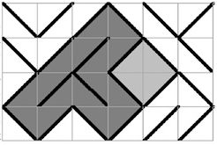

Data Type:

# Type 0 Type 1

#

# +----+ +----+

# | /| |\ |

# |0 / | | \ 0|

# | / 1| |1 \ |

# |/ | | \|

# +----+ +----+

Sample static data:

maze = [[1,0,0,1,1,0],  
 [1,0,0,0,1,1],  
 [0,0,1,1,0,1],  
 [1,0,1,0,0,0]]