Big data Analytics: ICP2

Madhuri Gopisetty

700768689

Q1. Explain the difference between Counter.count and self._count.

| **Variable** | **Type** | **Scope** | **Tracks** |
| --- | --- | --- | --- |
| Counter.count | **Class variable** | Shared by **all instances** of Counter | Total increments across **all objects** |
| self._count | **Instance variable** | Belongs to **each individual object** | Increments for **that one object** only |

What is the output of a.get_counts() and b.get_counts()?

Instance count: 2, Class count: 3

Instance count: 1, Class count: 3

How does the increment method affect both the class and instance variables?

• self._count tracks **how many times *this* object was incremented**

• Counter.count tracks **total increments made by all objects**

**Q2.**

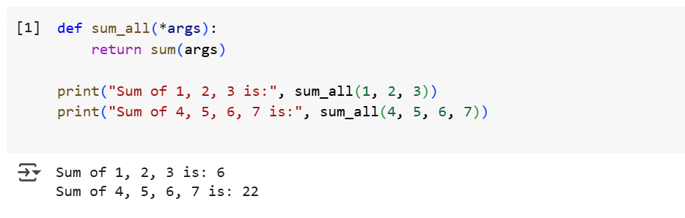

This defines a function named sum_all with one parameter args.

o to accept **any number of arguments**, the function should use: def sum_all(*args):

Q3.

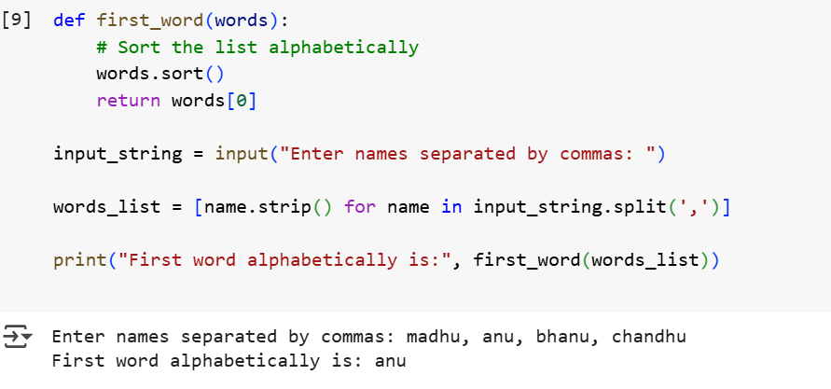

Q4.

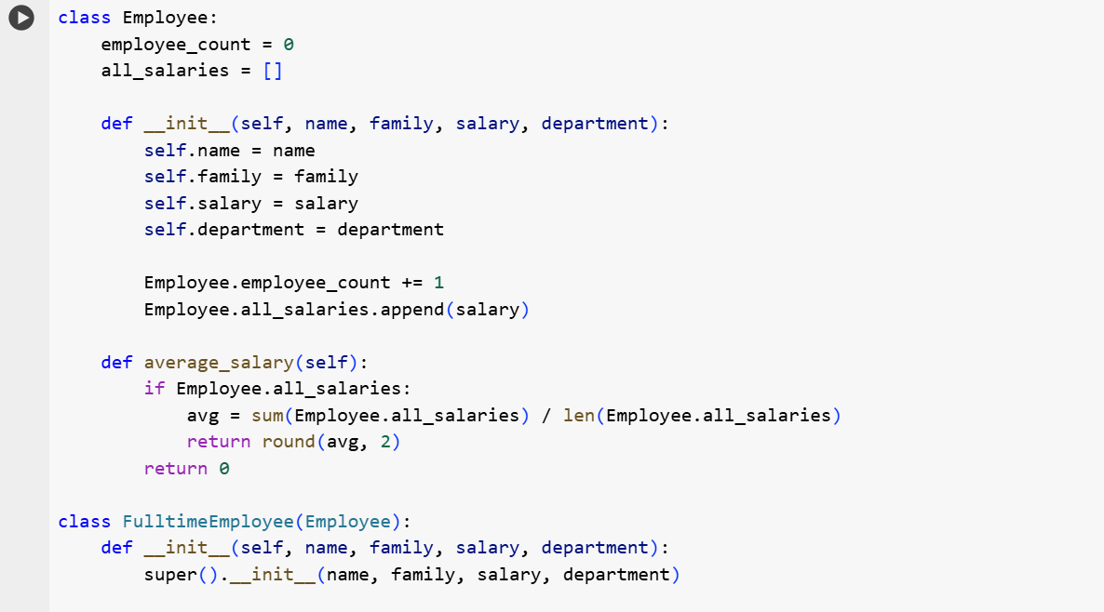

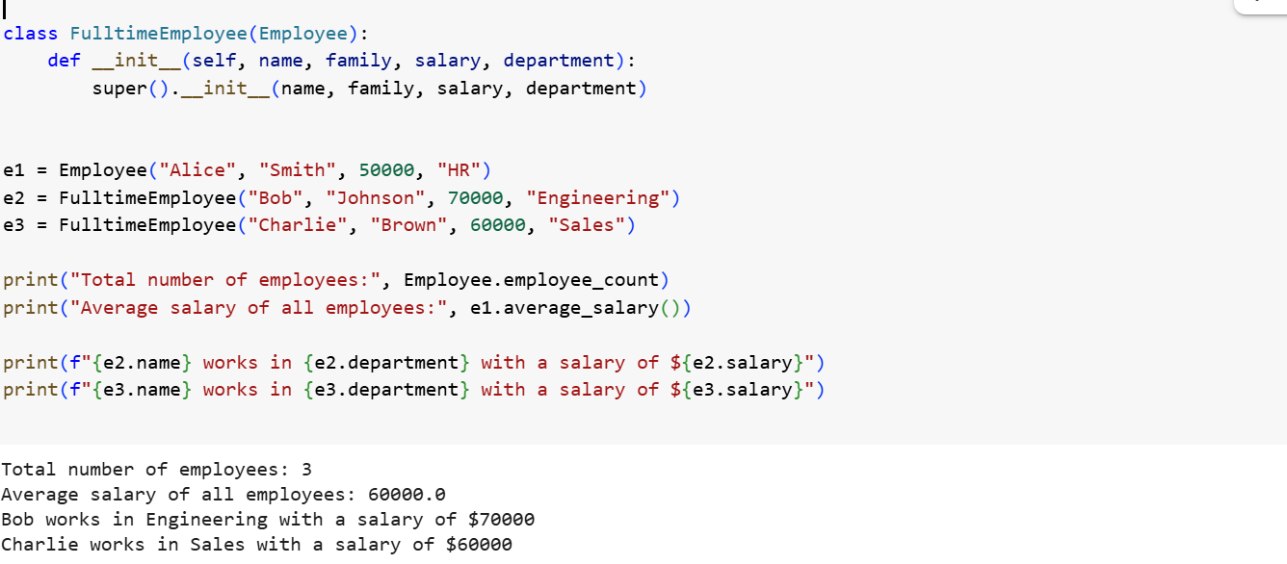

Link to video explanation:

<https://www.loom.com/share/9eb34b64294541959bd2a680acd35905?sid=dd8a6c00-62e9-44fd-ade4-1e69858774ed>

GitHub link:

<https://github.com/gmadhuri10/colab-python-tasks>