**INTRODUCTION**

SB3C2017

Summer Biomechanics, Bioengineering and Biotransport Conference

June 21 – 24, Tucson, AZ, USA

ACCELERATING Cardiovascular Segmentation with Convolutional Neural Networks

Gabriel D. Maher (1), Jameson M. Merkow (2), Alison L. Marsden (3)

(1) Institute for Computational and Mathematical Engineering,

Stanford University

Palo Alto, CA, USA

1. Electrical and Computer Engineering,

University of California San Diego,

San Diego, CA, USA

(3) Bioengineering, Pediatrics,

Stanford University

Palo Alto, CA, USA

In recent years, numerical simulations of cardiovascular hemodynamics have improved our understanding of cardiovascular biomechanics relevant to a range of clinical applications such as atherosclerosis [1] and coronary artery disease [2]. However, cardiovascular simulations require construction of accurate three dimensional patient-specific models of the cardiovascular anatomy based on medical image data [3]. Models are typically constructed from magnetic resonance (MR) or computed tomography (CT) scans.

SimVascular is an open-source software package with which users can perform patient-specific blood flow simulations [4][5]. SimVascular contains functionality to visualize and segment medical images, construct meshes for numerical simulations and perform cardiovascular fluid dynamics and fluid-structure interaction simulations. At present, to segment medical images with SimVascular, users often perform manual segmentation or use classical image processing methods such as thresholding [5] or active contours [6][7].

The image segmentation process often requires laborious user intervention, making the modeling process cumbersome and time-consuming, and preventing high-throughput model generation for large patient cohorts. It also introduces user variability. Medical image segmentation is thus a significant bottleneck in performing cardiovascular simulations. It is therefore desirable to find, or develop, cardiovascular medical image segmentation methods that can be used without significant user intervention across a range of medical images.

Convolutional Neural Networks (CNNs) are machine learning models tailored for processing visual data. Example medical image processing methods developed with CNNs include, among others, pancreas segmentation [8], brain lesion detection [9], brain tumor segmentation [10], kidney segmentation [11] and cardiovascular edge detection [12]. Segmentation methods developed with CNNs are typically parameter-free making them a promising approach for improving the patient-specific modeling process. Furthermore the Vascular Model Repository [14] is a repository that contains over 100 medical images and cardiovascular models segmented by users of SimVascular, and is a suitable source of data with which to train machine learning models for cardiovascular segmentation.

In this work we propose a CNN-based medical image segmentation method that can be used to construct accurate 3D cardiovascular models for numerical blood flow simulations. The method consists of (1) using CNNs to segment image patches extracted from medical images with user-annotated vessel centerlines, (2) extracting vessel boundaries from the segmentations, and (3) combining the extracted boundaries to form a solid model. We demonstrate that the CNN approach outperforms an active contour method when compared to manually segmented vessel boundaries.

**METHODS**

The proposed method for cardiovascular model construction in this work is based on the current model construction process available through SimVascular [5][7]. An outline of the model construction process is shown in Figure 1. In the first step users load a 3D medical image and annotate vessel centerlines by selecting (x,y,z) coordinates in the image. For the second step, segmentations can be produced along individual vessels, using an intensity probe that displays the image intensity along the vessel. During the third step solid models for each vessel are constructed by lofting the segmentations from step 2.

Centerline annotation and vessel segmentation are the most time consuming parts of the model construction process. The proposed method improves the vessel segmentation step. Our method takes a 2D cross sectional image along a centerline path as input to a CNN that has been trained for vessel segmentation. Vessel boundaries are then extracted from the segmentation with the marching squares algorithm. For CNN architectures we build a simple fully-convolutional CNN with both convolutional and fully-connected layers. Our CNN architecture localizes vessels close to the centerline, hence we denote it as Region-Selection Network (RSN). Further, we apply the object-boundary guided semantic segmentation method [14] to RSN and call the resulting CNN Object-Boundary Guided RSN (OBG_RSN). We compare our result to the Holistically-Nested edge-detection (HED) [15] and I2INet [12] architectures as these are state of the art for edge-detection and cardiovascular edge-detection respectively. In this case we have adapted the I2INet architecture to work on 2D image patches. The training, validation and test datasets consist of 17331, 3036 and 1831 64x64 image patches respectively. The data is split so that image patches from the same medical image are always in the same set. As a baseline classical image processing method we use the level set method available in SimVascular [7], with a fixed set of parameters tuned to produce accurate segmentations on a reference aorta model. To assess the quality of vessel boundaries produced by each method we computed the Jaccard distance error metric [16] (equation 1) with respect to user-produced vessel boundaries. *A* and *B* denote sets and *|A|* denotes cardinality of set *A*. *J(A,B)* is *0* if *A* and *B* are non-overlapping and 1 if they are the same. As such the Jaccard distance allows the similarity between vessel boundaries to be quantified.

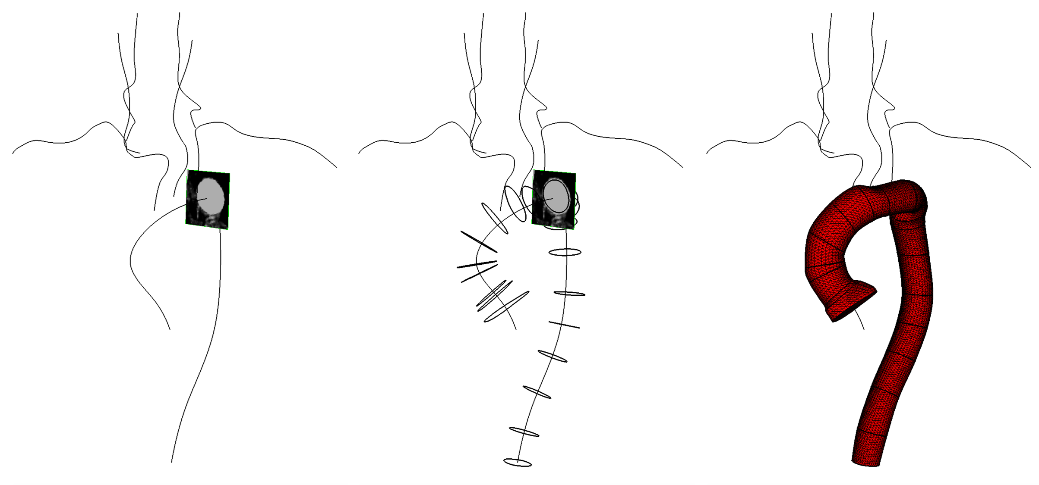

**Figure 1: Cardiovascular model construction process in Simvascular (from [3]**)**. Left: Vessel centerlines and medical image intensity probe, Middle: Vessel centerlines with vessel boundaries, Right: Solid model constructed from vessel boundaries.**

$J\left(A,B\right)=\frac{\left|A∩B\right|}{\left|A∪B\right|}$ (1)

**RESULTS**

Example vessel boundaries and error metric results for each method are shown in Figure 2 for example image patches. For large and clearly visible vessels, all methods produce a vessel boundary that resembles that segmented by the user. When the vessels are small, or ambiguous, the level set method is unable to produce the desired boundary. All CNN architectures are able to segment small vessels and infer reasonable boundaries in the ambiguous fourth image patch.

To quantify the performance of each method, we define the cumulative error distribution *F(x)* (equation 2), where *N* is the total number of image patches. For a given method, *F(x)* denotes the fraction of vessel boundaries with a Jaccard distance below *x*. Figure 3 shows the cumulative error distribution for each method. A larger area under a curve approximately indicates better performance. It is evident that all CNN-based methods have similar performance and improve on the level set. The level set underperforms due to failing to produce a vessel boundary on approximately 60% of image patches.

**DISCUSSION**

Our results provide evidence that CNN-based segmentation methods can be used to improve the patient-specific modeling process for cardiovascular models. However, the CNN-based method is conditional on the availability of medical images with accurate annotated vessel centerlines. The fact that all CNN-based methods performed similarly indicates that the precise CNN architecture is not crucial, as long as the CNN has enough capacity to model the data.

The underperformance of the level set method in this case is due to the fact that only one set of level set parameters was used for all images. The performance of the level set could be improved by using multiple parameter sets. This illustrates why the level set requires significant user intervention to be used across many images. Once the CNNs have been trained, the CNN-based method is parameter free and therefore requires significantly less user intervention.

$F\left(x\right)=\frac{\left|\left\{J_{i}:J_{i}≤x\right\}\right|}{N}$ (2)

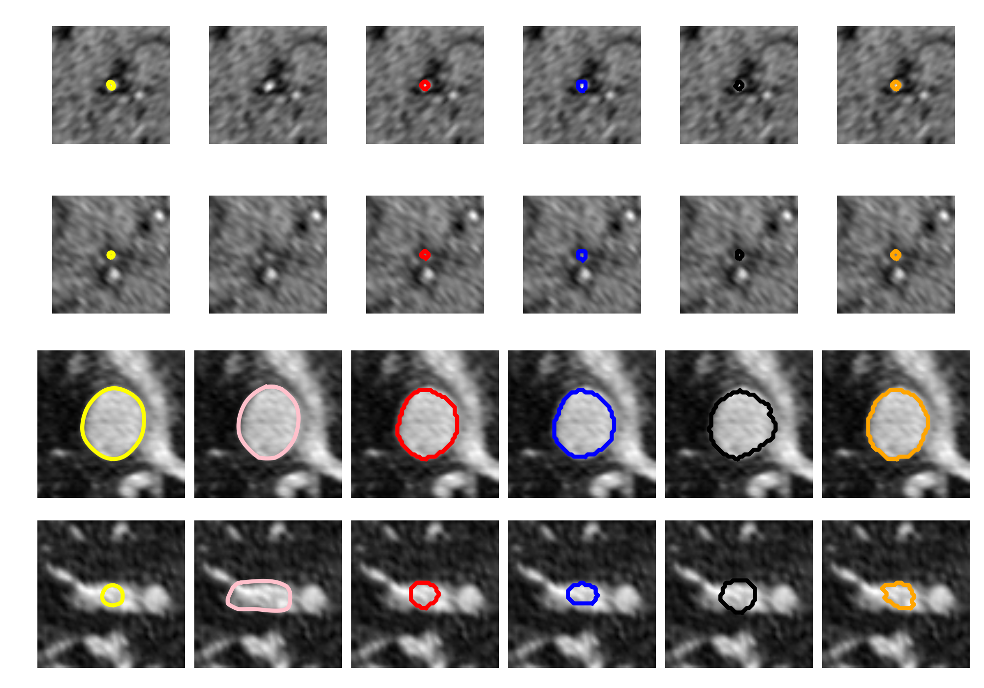

**Figure 2: Example image patches and corresponding vessel boundaries produced. Yellow: Manual segmentation, Pink: Level set, Red: RSN, Blue: OBG_RSN, Black: HED, Orange: I2INet**

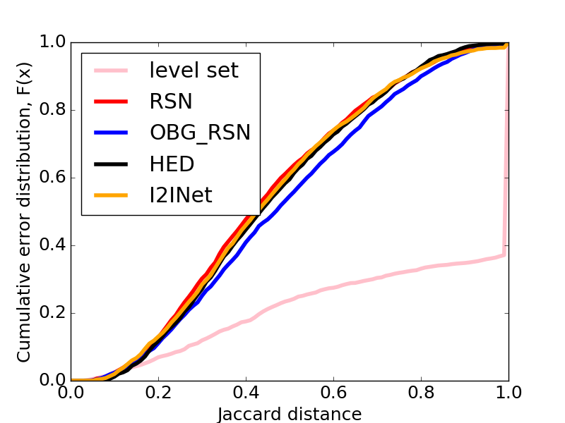

**Figure 3: Cumulative error distribution for CNNs and level set.**

**REFERENCES**

[1] Samady, H et al., Circulation, 124:779-788, 2011.

[2] Taylor, C A et al., JACC, 61:2233-2241, 2013.

[3] Taylor, C A et al., Annu Rev Biomed Eng., 11:109-134, 2009.

[4] <http://simvascular.github.io/>, accessed on 01/10/2017.

[5] Updegrove, A et al., Annals of Biomed Eng., 1-17, 2016.

[6] Osher, S and Sethian J A, JCP, 79:12-49, 1988.

[7] Wang, K C, PhD Thesis, Stanford University, 2001.

[8] Cai, J et al., MICCAI, 442-450, 2016.

[9] Kamnitsas, K et al., Medical Image Analysis, 36:61-78, 2017.

[10] Menze, B H et al., MICCAI-BRATS, 2015.

[11] Çiçek, Ö et al., MICCAI, 424-432, 2016.

[12] Merkow, J et al, MICCAI, 371-379, 2016

[13] <https://simtk.org/projects/cv-gmodels>, accessed on 01/10/2017.

[14] Huang, Q et al., arXiv:1603.09742, 2016

[15] Xie, S and Tu, Z, ICCV, 1395-1403, 2015

[16] Everingham, M, IJCV, 2:303-338, 2010