PLACEMENT TRAINING PROGRAM
BY
APT TRAINING RESOURCES

ASSESSMENT REPORT
Introduction about the assessment report:
We like to thank the college authorities for helping us successfully complete the placement training program for 10 days. As a conclusion to the same, we conducted multiple assessments on Oct 1st, 8th, 9th, 10th, 11th and 12th on various parameters like:
Online Aptitude Test,
Skill check on Grammar,
Communication skills,
Group Discussion and
Personal Interviews for the current final year students.
This report is designed to give you:
- The assessment parameters and difficult levels of Aptitude, Grammar, Communication skills, Group Discussion and Personal Interviews.
- Individual scores of each student in Aptitude, Grammar, Communication skills, Group Discussion and Personal Interviews
- Overall average percentage in Aptitude, Grammar, Communication skills, Group Discussion and Personal Interviews
- The Mode (The score that is maximum scored by the students) in Aptitude, Grammar, Communication skills, Group Discussion and Personal Interviews
- Overall Conclusion and Recommendations.

Assessment on Aptitude:
With regard to the Online Aptitude Test, a total of 90 students from various departments took the test. The test consists of nearly 30 questions conducted in two phases one in the morning and the next in the afternoon of Oct 1st. The questions varied from easy ones to moderate difficulty ones to the toughest questions. The maximum mark was 30 and their scores were converted to their respective percentages. They were tested upon:
- Quantitative Aptitude
- Analytical Reasoning
- Logical Reasoning
- Verbal Reasoning
- Non-verbal Reasoning and
- Verbal ability
Summary of the aptitude test:
- The overall percentage score stands at 51% clearly indicating that more seriousness should be shown by the students by preparing well for such exams.
- The modal score range is (50-59) % suggesting that maximum no. of students have scores in this range.
- CSE AND ECE departments are jointly leading with a maximum average percentage of 56 %
- IT and EEE departments have to do a lot better in this area.
Frequency distribution of the scores for Aptitude
S. No | SCORE (%) | FREQUENCY
1 | Less than 30 | 12
2 | 30-39 | 10
3 | 40-49 | 13
4 | 50-59 | 22
5 | 60-69 | 17
6 | 70 -79 | 10
7 | 80 and above | 6
 | TOTAL | 90

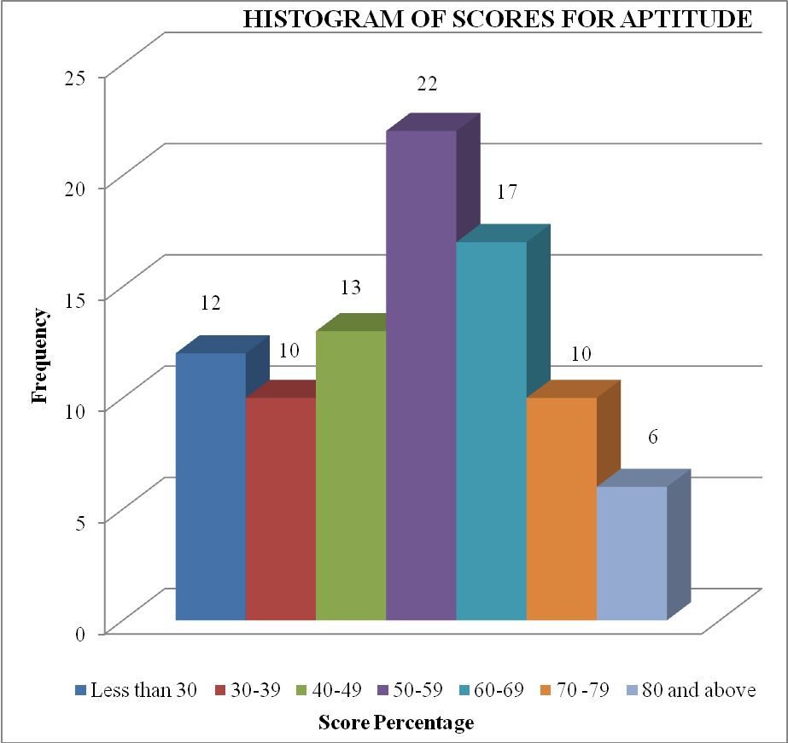
For better visualization, the same has been graphically presented in the form of a histogram.

Department-wise performance for Aptitude has been given below:
S. No | DEPARTMENT | NO. OF STUDENTS | AVERAGE  PERCENTAGE  SCORE
1 | IT | 3 | 33.3 %
2 | ECE | 38 | 56 %
3 | CSE | 16 | 56 %
4 | EEE | 10 | 36 %
5 | MECH | 23 | 48 %
 | TOTAL | 90 | 51 %

For better visualization, the same has been given in the form of a Bar chart to help us judge better.
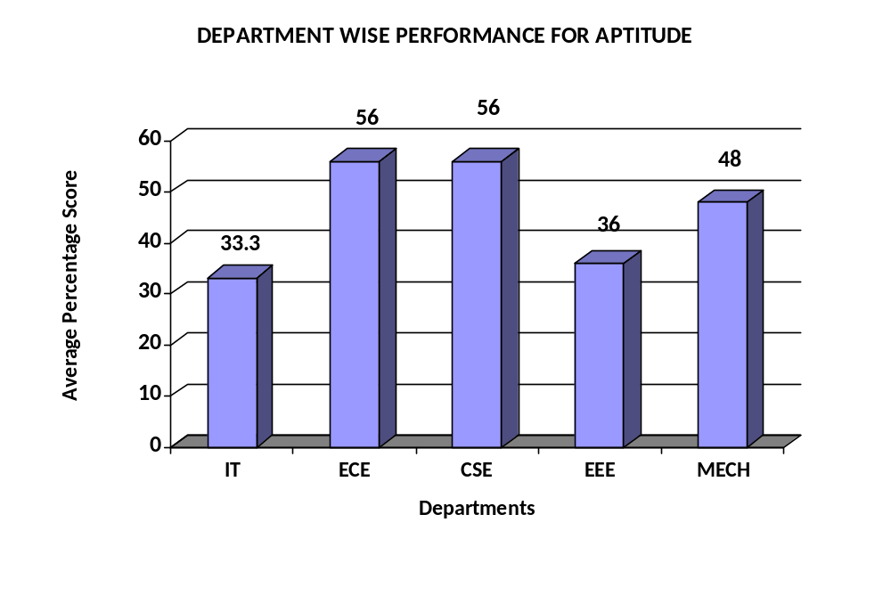

Assessment on Grammar focused on the following areas:
With regard to the check on Grammar, a total of 107 students from various departments were assessed. The maximum mark was 10 and their scores were converted to their respective percentages. They were tested upon:
- Parts of Speech
- Verbs: Regular, Irregular, Gerund & Infinitive.
- Question Tags
- Sentence pattern
- Tenses
- Speech: Direct & Indirect
- Concord: Error detection.
Summary of the assessment on Grammar:
- The overall percentage score stands at 41% indicating that students should be trained on Grammar needs to be imparted right from their 1st year.
- The modal score range is (30-39) % suggesting that maximum no. of students have scores in this range.
- CSE department is leading with a maximum average percentage of 49 %
- EEE department have to do a lot better in this area.

Frequency distribution of the scores for Grammar
S. No | SCORE (%) | FREQUENCY
1 | Less than 30 | 24
2 | 30-39 | 26
3 | 40-49 | 16
4 | 50-59 | 15
5 | 60-69 | 14
6 | 70 -79 | 10
7 | 80 and above | 2
 | TOTAL | 107

For better visualization, the same has been graphically presented in the form of a histogram.
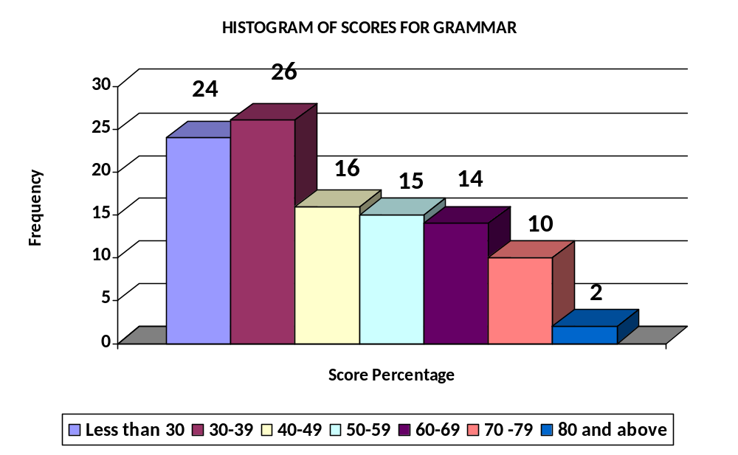

Department-wise performance for Grammar has been given below:
S. No | DEPARTMENT | NO. OF STUDENTS | AVERAGE  PERCENTAGE  SCORE
1 | IT | 3 | 37 %
2 | ECE | 47 | 43 %
3 | CSE | 16 | 49 %
4 | EEE | 5 | 26 %
5 | MECH | 36 | 37 %
 | TOTAL | 107 | 41 %

For better visualization, the same has been given in the form of a Bar chart to help us judge better.
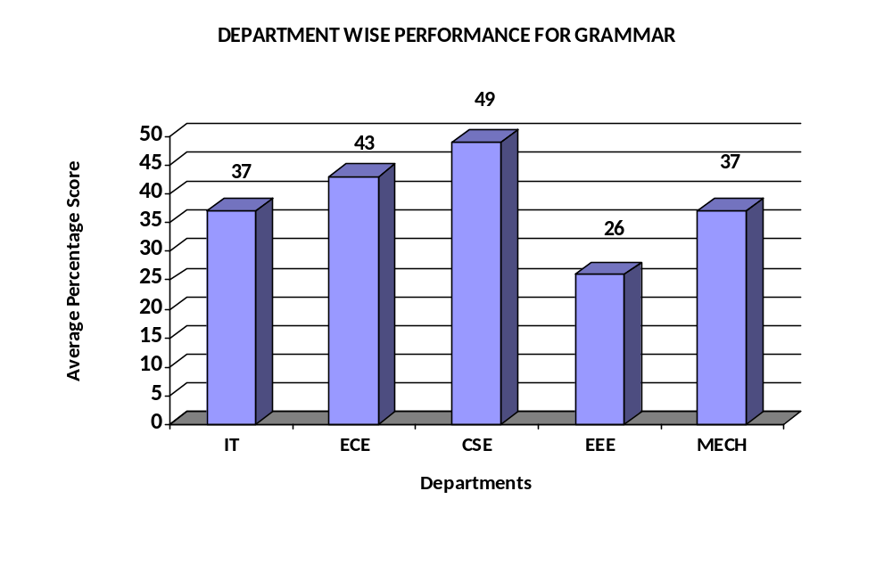
Assessment on Communication skills focused on the following areas:
With regard to the check on Communication skills, a total of 107 students from various departments were assessed. The maximum mark was 10 and their scores were converted to their respective percentages. They were tested upon:
- Listening, Speaking, Reading & Writing,
- Process of Communication
- Assertive Communication
- Debates
- Role-plays and
- Public Speaking skills
Summary of the Communication Skills assessment:
- The overall percentage score stands at 45% indicating that students should be trained on Communication skills right from their 1st year.
- The modal score range is (40-49) % suggesting that maximum no. of students have scores in this range.
- CSE department is leading with a maximum average percentage of 57 %
- EEE department have to do a lot better in this area.

Frequency distribution of the scores for Communication Skills
S. No | SCORE (%) | FREQUENCY
1 | Less than 30 | 17
2 | 30-39 | 19
3 | 40-49 | 22
4 | 50-59 | 13
5 | 60-69 | 15
6 | 70 -79 | 16
7 | 80 and above | 5
 | TOTAL | 107

For better visualization, the same has been graphically presented in the form of a histogram.
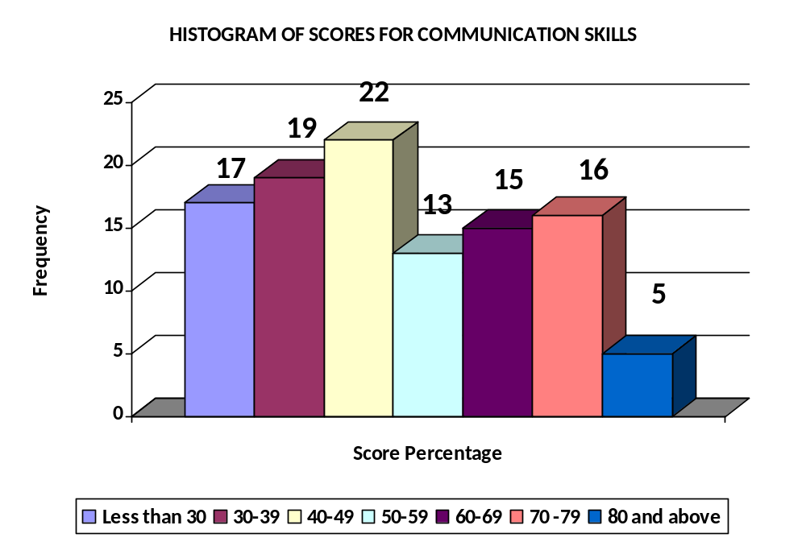

Department-wise performance for Communication Skills has been given below:
S. No | DEPARTMENT | NO. OF STUDENTS | AVERAGE  PERCENTAGE  SCORE
1 | IT | 3 | 43 %
2 | ECE | 47 | 48 %
3 | CSE | 16 | 57 %
4 | EEE | 5 | 30 %
5 | MECH | 36 | 40 %
 | TOTAL | 107 | 45 %

For better visualization, the same has been given in the form of a Bar chart to help us judge better.
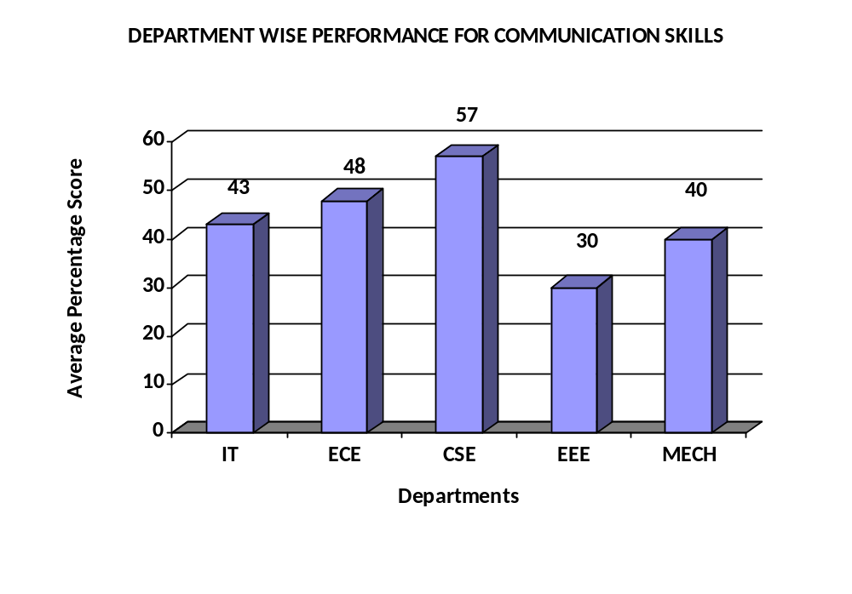

Assessment on Group Discussion focused on the following areas:
With regard to the assessment on Group Discussion, a total of 82 students from various departments were assessed. The maximum mark was 10 and their scores were converted to their respective percentages. They were tested upon:
- Whether the candidate started the discussion or not.
- The candidate listens actively and responds appropriately without going off topic.
- Candidate knows when to speak, does not interrupt other speakers.
- Gestures, eye contact within the group
- Assertiveness of the candidate to convince and tackle questions without trying to “win an argument”
- Ability of the candidate to express ideas without dominating, keep the discussion within topic and to motivate others to talk without putting them on the spot
- Ability of the candidate to understand the topic and follow the discussion

Summary of the assessment on Group Discussion:
- The overall percentage score stands at 53.3 % indicating that students should practice GD’s at the hostel rooms and due free hours. As GD can be effectively cleared only thru’ practice important that the do some practice before the final GD.
- The modal score range is (50-59) % suggesting that maximum no. of students have scores in this range.
- CSE department is leading with a maximum average percentage of 57 %
- EEE department students have done a mass bunk on that day while other department students have done competitively.

Frequency distribution of the scores for Group Discussion
S. No | SCORE (%) | FREQUENCY
1 | Less than 30 | 0
2 | 30-39 | 3
3 | 40-49 | 28
4 | 50-59 | 30
5 | 60-69 | 15
6 | 70 -79 | 5
7 | 80 and above | 1
 | TOTAL | 82

For better visualization, the same has been graphically presented in the form of a histogram.
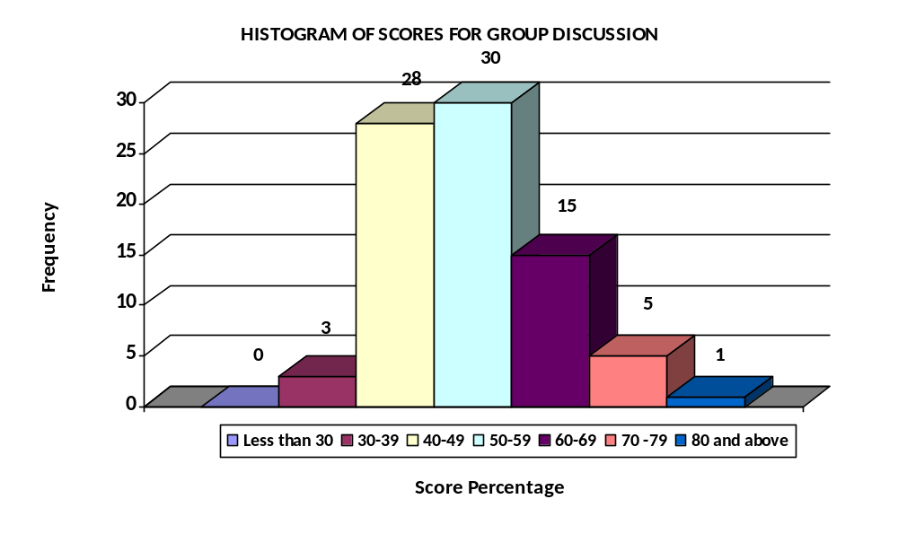
Department-wise performance for Group Discussion has been given below:
S. No | DEPARTMENT | NO. OF STUDENTS | AVERAGE  PERCENTAGE  SCORE
1 | IT | 2 | 56
2 | ECE | 46 | 53
3 | CSE | 12 | 57
4 | EEE | 0 | 0
5 | MECH | 22 | 52
 | TOTAL | 82 | 53.3 %

For better visualization, the same has been given in the form of a Bar chart to help us judge better.
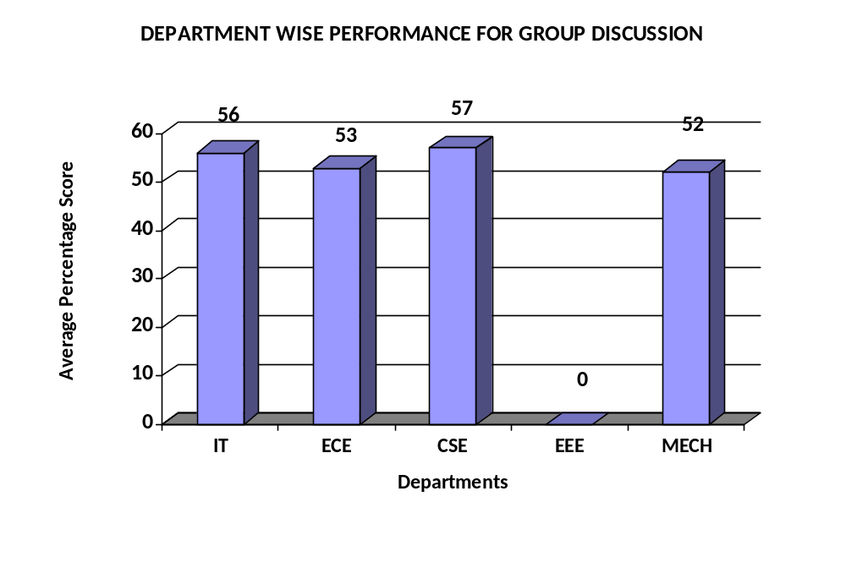
Assessment on Mock Personal Interviews focused on the following areas:
With regard to the Mock Personal Interview, a total of 106 students from various departments were assessed. The maximum mark was 10 and their scores were converted to their respective percentages. They were tested upon:
- Is the candidate able to communicate well?
- Does the candidate communicate with credibility and confidence?
- Is the candidate giving proper eye contact and body language?
- Is the candidate good at thought flow and sentence construction?
- Does the candidate possess positive attitude?
- Comments on dress code and grooming
- Any other peculiar habits that the candidate possesses either knowingly or unknowingly.

Summary of the assessment on Personal Interview:
- The overall percentage score stands at 61.36 % indicating that students are above average in the interview skills. A bit of home work about the companies visiting the campus should do the trick as far as the personal interview process is concerned. However, to prepare himself on computer skills and technical knowledge is also essential to get the coveted job.
- The modal score range is (60-69) % suggesting that maximum no. of students have scores in this range.
- ECE department is leading with a maximum average percentage of 64 %
- Almost all the department students have done fairly well.

Frequency distribution of the scores for Personal Interviews
S. No | SCORE (%) | FREQUENCY
1 | Less than 30 | 1
2 | 30-39 | 1
3 | 40-49 | 7
4 | 50-59 | 30
5 | 60-69 | 37
6 | 70 -79 | 21
7 | 80 and above | 9
 | TOTAL | 106

For better visualization, the same has been graphically presented in the form of a histogram.
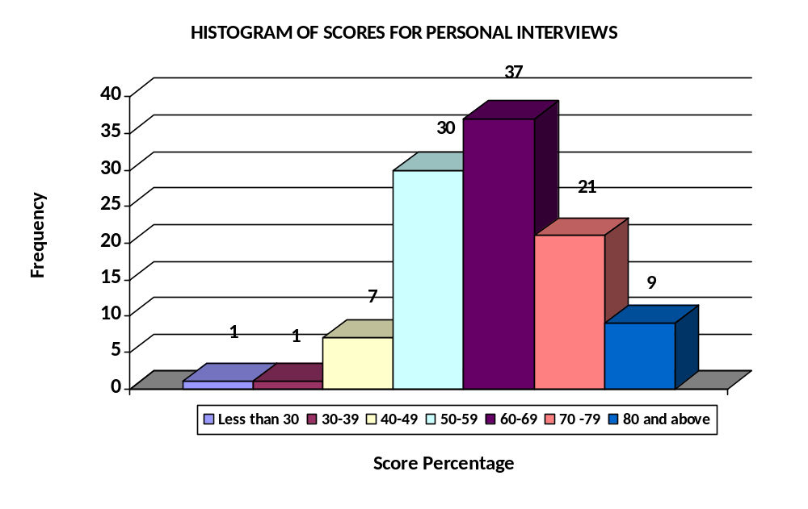
Department-wise performance for Personal Interviews has been given below:
S. No | DEPARTMENT | NO. OF STUDENTS | AVERAGE  PERCENTAGE  SCORE
1 | IT | 3 | 63.3 %
2 | ECE | 46 | 64 %
3 | CSE | 14 | 57.6 %
4 | EEE | 8 | 58.1 %
5 | MECH | 35 | 60 %
 | TOTAL | 106 | 61. 36 %

For better visualization, the same has been given in the form of a Bar chart to help us judge better.
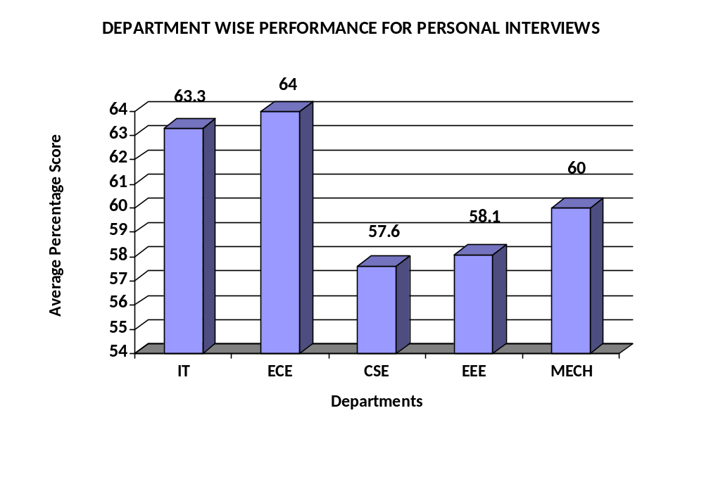
Overall Conclusion and Recommendations:
- It is rather difficult to conclude that the overall performance is satisfactory with even the best performer, CSE, not crossing 70 % in most of the categories.
- Among the departments, CSE AND ECE have been consistent in their performance while EEE has to improve a lot.
- A major contributory factor to this dismal performance could be the utter lack of seriousness by the students during the training and reluctant to do the homework thereafter.
- The above phenomenon in conjunction suggests the need for not only starting the training from the first year onwards but also discipline and sincere practice from the students end.
P.S: Please find attached the detailed individual scores for every student.
INDIVIDUAL SCORE & PERCENTAGE SCORE OF EACH STUDENT
CSE
S. No | Name | Scores / 16 | Scores in Percentage
1 | E.Jemimah | 8 | 50
2 | Aswin | 6 | 38
3 | Afrin | 7 | 44
4 | Dhanalakshmi | 9 | 56
5 | Anushya | 10 | 63
6 | Franklin Vinod | 5 | 31
7 | Kavudhami | 9 | 56
8 | Kamaludeen | 6 | 38
9 | Arun Prakash | 10 | 63
10 | Danima Ashiki | 7 | 44
11 | Gayathri | 8 | 50
12 | Dhivya | 6 | 38
13 | Geetha | 4 | 25
14 | Abhinaya | 5 | 31
15 | Elakkiya | 6 | 38
16 | Heera | 9 | 56
17 | V.Loeshwari | 10 | 63
18 | Ken Isaac | 6 | 38
19 | Aashika | 5 | 31
20 | S.Logeshwari | 7 | 44
21 | R.Ashwini | 7 | 44
22 | Elavarasan | 6 | 38
23 | Nagaraj Gautham | 5 | 31
24 | Kirthika | 6 | 38
25 | Gopinath | 4 | 25
26 | Sunny | 9 | 56
27 | Nishwanth | 7 | 44
28 | L.Vikneshwar | 8 | 50
29 | Mathimugan | 4 | 25
30 | Nitin Vashisth | 11 | 69
31 | Subin | 6 | 38
32 | Vikram Kumar | 10 | 63
33 | Siva Kumar | 11 | 69
34 | Ramprasad | 10 | 63
35 | R.Vignesh | 4 | 25
36 | Paul Chandran | 6 | 38
37 | R.M.Vigneshram | 4 | 25
38 | Santhoshram | 4 | 25
39 | Preetham Wilfred John | 10 | 63
40 | Sriram | 8 | 50
41 | P.vivekanandan | 4 | 25
42 | Vinitha Vardhani | 10 | 63
43 | Tamanna | 8 | 50
44 | Shri Lekha | 11 | 69
45 | Sindhuja | 9 | 56
46 | Pankaj Sorupa | 11 | 69
47 | Priya | 11 | 69
48 | Saranya | 9 | 56
49 | Vinmani | 8 | 50
50 | Ponnusamy | 6 | 38
51 | Roshan Ajay | 5 | 31
52 | Sathish Kumar | 8 | 50

IT
S. No | Name | Scores / 16 | Scores in Percentage
1 | S.Nandhini | 6 | 38
2 | N.Divya Rani | 8 | 50
3 | K.Ramya | 9 | 56
4 | G.Malini | 7 | 44
5 | G.Manisha | 10 | 63
6 | T.Shanmuga Priya | 10 | 63
7 | Vasantham | 9 | 56
8 | Kiruthika | 12 | 75
9 | P.Abirami | 8 | 50
10 | Priyadharshini | 10 | 63
11 | Silambarasan | 10 | 63
12 | Vignesh | 10 | 63
13 | Vigneshwar | 10 | 63
14 | Dinesh Kumar | 11 | 69
15 | Balakumar | 10 | 63
16 | Karnan | 11 | 69
17 | Ragupathi | 11 | 69
18 | Muthu | 6 | 38
19 | Gulshan | 8 | 50
20 | Gaurav Kumar | 8 | 50
21 | Jagnit Raj | 11 | 69

ECE
S. No | Name | Scores / 16 | Scores in Percentage
1 | Hanif Mohamed | 12 | 75
2 | Manikandan | 6 | 38
3 | Kevin Jose | 6 | 38
4 | Animesh Kumar | 9 | 56
5 | Dhinakaran | 6 | 38
6 | Jerome Edvin Raj | 9 | 56
7 | Jai Ganesh | 9 | 56
8 | Lokeshwaran | 7 | 44
9 | Harish Varma | 7 | 44
10 | Lakshmi Narayanan | 10 | 63
11 | Gowsik Kumar | 9 | 56
12 | Abhisek Pandey | 12 | 75
13 | Abdul Rahman | 7 | 44
14 | Chaitanya | 12 | 75
15 | Sai Krishna | 8 | 50
16 | Jeevana Reddy | 9 | 56
17 | Manoj Kumar | 7 | 44
18 | Hemanth Kumar | 8 | 50
19 | Janani | 7 | 44
20 | Malini | 7 | 44
21 | Kamalakkannan | 6 | 38
22 | Manoj Prabakaran | 7 | 44
23 | Joseph Felix | 6 | 38
24 | Lokesh | 5 | 31
25 | Vinotha | 6 | 38
26 | Vaidehi | 6 | 38
27 | Sangeetha | 8 | 50
28 | Parimala | 6 | 38
29 | Vivekanand | 8 | 50
30 | Saddam Hussain | 5 | 31
31 | Santhana Bhuvaneshwaran | 6 | 38
32 | Rajesh | 8 | 50
33 | Sathish Kumar | 8 | 50
34 | Chandrasekar Reddy | 6 | 38
35 | Narayanan | 5 | 31
36 | Ramprem | 5 | 31
37 | Pavith Gokul | 5 | 31
38 | Sivashankar | 3 | 19

EEE
S. No | Name | Scores / 16 | Scores in Percentage
1 | Thenmozhi | 10 | 63
2 | Baghya Lakshmi | 9 | 56
3 | Sruthi | 12 | 75
4 | Shiru Mathew | 8 | 50
5 | Arul Mozhi | 9 | 56
6 | Hemalatha | 9 | 56
7 | Kavitha | 7 | 44
8 | Nisha | 10 | 63
9 | Bharathi | 8 | 50
10 | Santhana Kumar | 7 | 44
11 | Subramaniam | 7 | 44
12 | K.Vignesh Kumar | 6 | 38
13 | B.Vignesh Kumar | 7 | 44
14 | N.Deepak Kumar | 8 | 50
15 | Sudharsan | 8 | 50
16 | Bhargav Ranjit | 10 | 63
17 | Ahamed | 4 | 25
18 | N.Sarath | 7 | 44
19 | Bhragadeeswaran | 10 | 63
20 | Mohd.Farhaan | 8 | 50
21 | Baskar | 7 | 44
22 | Somasundaram | 5 | 31
23 | K.Praveen | 10 | 63
24 | A.Praveen | 6 | 38
25 | Venkatraman | 8 | 50
26 | Venkatesan | 6 | 38
27 | Surya Kant | 6 | 38

Mech
S. No | Name | Scores / 16 | Scores in Percentage
1 | V.Arunachalam | 7 | 44
2 | Mohd.Saifullah Khan | 10 | 63
3 | Anish | 7 | 44
4 | Bharat Shankar | 11 | 69
5 | Chandran | 9 | 56
6 | Dhanraj | 12 | 75
7 | Godju | 10 | 63
8 | Gopinath | 11 | 69
9 | Govindarajan | 14 | 88
10 | Hameed | 9 | 56
11 | Joel Anthony Joy | 10 | 63
12 | Johnson David | 11 | 69
13 | M.Karthik | 10 | 63
14 | P.Karthik | 15 | 94
15 | Kathiravanam | 12 | 75
16 | Lingeswaran | 9 | 56
17 | Loganathan | 12 | 75
18 | Ajay Kumar | 10 | 63
19 | Chitrala Harish | 11 | 69
20 | Manoj nKumar | 7 | 44
21 | Giridharan | 12 | 75
22 | Gowri Shankar | 14 | 88
23 | Gunaselvan | 9 | 56
24 | Jagan | 10 | 63
25 | Ganesh Kumar | 10 | 63
26 | Gokula Kannan | 12 | 75
27 | Bala Gangadharan | 12 | 75
28 | Anand | 10 | 63
29 | Santhosh.S. | 10 | 63
30 | Ramakrishnan | 11 | 69
31 | Sabarigirisan | 9 | 56
32 | Sethuraja | 11 | 69
33 | Pushparaj | 7 | 44
34 | Udhaya Kumar | 7 | 44
35 | Sathya Narayanan | 16 | 100
36 | G.Santhosh | 10 | 63
37 | Vinay | 11 | 69
38 | Sathish Kumar | 12 | 75
39 | P.Prashanth | 13 | 81
40 | K.Varun | 8 | 50
41 | C.Saravanan | 13 | 81
42 | Yuvaraj.M. | 12 | 75
43 | Ramkumar | 13 | 81
44 | Pranav Shankar | 12 | 75
45 | Prabhu | 6 | 38
46 | Bharathi | 14 | 88

