University of Malta
Faculty of ICT

Otsu’s Thresholding
ARI2129: Principles of Computer Vision for AI
https://github.com/Pierre-Thos/otsus-thresholding

Submitted by Pierre Thos, Eliot Pechadre, Nathan Soulhol, Alexandre Stefel

Otsu’s thresholding is a fundamental computer vision technique which addresses a core issue; it is used to automatically separate an object in a grayscale image from its background. Otsu’s thresholding is a method in image processing. It helps separate an object from its background in a grayscale image. This is often the step in many computer vision tasks. An intensity value has to be chosen and every pixel is classified based on whether it is above or below that value. Brighter pixels are usually the foreground and darker pixels are the background. Working with real-world images adds another layer of complexity. Things like lighting, shadows and sensor noise make it hard to choose a single threshold value. This value needs to work across the entire image.

Manually choosing a threshold often leads to good results, which is especially true when working with datasets or images taken under different conditions. Otsu’s method provides a dependable solution: it uses the image’s properties to determine the threshold automatically. The method analyzes the histogram of pixel intensities. This shows how frequently each intensity value occurs in the image. Otsu’s method evaluates every threshold. It checks how well it separates pixels into two groups. The method uses a criterion. This measures how distinct the two groups are. The goal is to join pixels within each group to each other. The difference between the groups should be as large as possible. Otsu’s thresholding produces a data-driven threshold value. This makes it useful when manual tuning is impractical or prone to error.
In order to build an understanding of Otsu’s thresholding, it helps to think of an image’s histogram as a landscape with hills and valleys, where hills represent concentrations or clusters of pixel intensity values which occur within the image. In many cases, such as when the image contains a clear foreground object against a uniform background, a certain hill corresponds to background pixels while another will represent the object of interest, creating a shape resembling two peaks separated by a dip [4]. The thresholding algorithm’s goal is to identify a point, a dividing line, between the two peaks which is the lowest in this ‘valley’; this provides the best boundary for separating these two clusters of pixels [1].

Otsu’s thresholding method is able to automate what would otherwise be a visual inspection and manual estimation of this dividing line, which would be subjective and inconsistent. Instead, every possible threshold value is systematically tested in a precise mathematical procedure and evaluates how well each value is able to separate both pixel intensities into distinct classes. One can think of this process as one thinks of grading an exam where students’ grades can be separated into two groups, such as low and high scores; the task would be to determine an ideal pass mark that distinguishes best between the two groups, without misrepresenting too many students. Here, the ideal pass mark would lie somewhere between the groups of scores; Otsu’s algorithm performs the same task for different pixel intensities by calculating which threshold produces the clearest separation between the two groups.

The guiding principle backing Otsu’s method is the maximization of between-class variance; this refers to how different two groups of pixels are from each other when the image has been divided with a certain threshold value. Instead of attempting to reduce classification errors directly or to infer which pixels belong to the foreground and which to the background, Otsu’s thresholding method attempts to find the threshold which leads to the clearest possible separation between both classes. This means that pixels grouped in the same class should have similar intensity values, and that the difference in average intensity between two classes should be as high as possible. Thanks to this, maximization of the variance between classes mathematically corresponds to a minimization of the variation within an individual class, allowing the algorithm to find a threshold that produces the most accurate division of the image.
In terms of the process, a histogram of the grayscale version of the image is first computed and then normalized so the histogram values represent probabilities instead of raw pixel counts, which makes it easier to analyze the statistical distribution of the intensity values of the image. Every intensity value is assigned a probability which indicates how much that exact brightness value appears in relation to the number of pixels in the image. This probability distribution having been established, the algorithm divides the image into two groups in order to evaluate every possible threshold value: the first regroups all pixels whose intensities are less than equal to the threshold (constituting the background), while the second regroups pixels whose intensities are greater than the threshold (the foreground). Otsu’s method determines the threshold value which best distinguishes between the foreground and background most effectively by calculating how well each threshold separates the two groups.
Several quantities are calculated for each possible threshold. The first step is to determine the probability, also called weight, of each group, also called a class. These class probabilities are used to indicate how much of the image is occupied by the foreground or background respectively. After the probabilities are calculated, the mean intensity value of each class is computed by the algorithm, which describes the average brightness within each respective class. These values help to describe the characteristics of each class and enable us to compare how distinct the classes are from each other.
With these probability and mean values for the classes, the algorithm calculates the between-class variance, which is the main criterion in defining the quality of the threshold. The variance is used to measure the degree of separation between both classes by taking into account the difference between the mean intensities and the size of the classes within the image. The larger the between-class variance, the more the two groups are separated, meaning the better the algorithm is at distinguishing the foreground and background groups of pixels. The algorithm loops this process for every threshold value possible within the image’s intensity range and evaluates each threshold until the one that produces the maximum between-class variance is identified. This is selected as the optimal threshold as it represents the point at which the background and foreground are the most statistically distinct from each other.
Within real-world applications, Otsu’s thresholding is often used because it gives a simple, automatic, and fast way of separating important objects in an image with their background, and this without needing to manually adjust the parameters for each image. A common application of the technique is in the medical field and specifically in medical imaging. Accurate segmentation of images is often crucial for diagnosis and analysis of the medical images. Otsu’s method can, for example, be used to separate parts of images containing tumors, cells, or other structures from tissue. This allows doctors and researchers to view regions of interest in medical images more clearly prior to performing further analysis. Due to the fact that medical images often contain lots of data, making use of an automated thresholding method reduces the time and effort involved in preprocessing images.
Another use of Otsu’s method is in document processing as well as optical character recognition (OCR) systems; scanned pages must be converted into black-and-white images before their text can be extracted accurately. When applied to document processing, Otsu’s thresholding can help improve readability of scans and increase the accuracy of this OCR software. Yet another application is within industrial computer vision systems, where Otsu’s method can be used for things like defect detection, object counting, as well as quality control. Furthermore, the method has applications relating to satellite and remote sensing; it can help to distinguish land from water, identify regions with vegetation, or even separate human-made structures from surrounding terrain due to differences in pixel intensities. Its aptitude within these fields comes from the fact that Otsu’s method is easy to implement and produces reliable results without much manual intervention, alongside being computationally efficient.
Despite its advantages, there are many important limitations that affect the performance of Otsu’s method in certain complex imaging situations, specifically when the assumptions that back the method are not fully satisfied by the image. The first main assumption is for the image’s histogram to be bimodal, meaning for it to contain two clearly distinguished peaks corresponding to the foreground and background classes of pixels. Many real-world images are unable to produce clear histograms with these two peaks; images often contain many objects, shadows, textured surfaces or changes in lighting across the image. If an image contains such disturbances, there may be overlap between the intensity distributions of the foreground and background, making it more difficult for the algorithm to calculate a threshold that accurately separates both classes.
Another limitation of the method is its sensitivity to image noise and uneven lighting; both of these can distort the histogram and diminish the distinction between the two pixel classes. Noise may bring unexpected intensity values, while uneven lighting can cause different parts of the same object to have different brightness levels, which makes the use of a single global threshold more ineffective. In order to improve the algorithm’s performance with these conditions, preprocessing techniques like Gaussian smoothing are used prior to thresholding to reduce noise and hence create a cleaner histogram. Moreover, extensions of Otsu’s method have been found to better handle more complex segmentation tasks, such as multi-level thresholding approaches which segment the image into more than two classes instead of only separating the foreground from the background. While these variations of the method improve flexibility, they also increase computational complexity and require more consideration in the case that they are applied to large or very detailed images.

Essential Algorithms and Mathematical Foundations of Otsu’s Method

The process of finding the ideal threshold begins with the creation of a grayscale histogram of the original image. For an 8-bit grayscale image, for example, there are 256 intensity levels that range from 0 (black) to 255 (white). The histogram is a count of how many pixels are at each respective intensity level. These counts are normalized to create a probability distribution. Considering n_{i} represents the number of pixels with intensity i, and that N represents the number of pixels in the image, the probability of intensity level i is defined as:
$p(i) = \frac{n_{i}}{N}$

The above normalization converts the grayscale histogram into a probability mass function, allowing the algorithm to work with percentages and frequencies rather than absolute values.
For every threshold value t, the histogram is divided into two classes. The first class, class 0, contains pixels with intensities that are less than or equal to t, while the second, class 1, contains all pixels with intensities that are greater than t. The probabilities, or weights, of the classes are calculated by doing the following:
$ω_{0}(t) = \sum_{i=0}^{t}{}p(i)$
$ω_{1}(t) = \sum_{i=t+1}^{L-1}{}p(i)$
Where L is the number of intensity levels (often 256), the probability $ω_{0}$ represents the fraction of the image that belongs to class 0, and probability $ω_{1}$ represents the fraction of the image that belongs to class 1.
The mean intensity of each class is then computed. The means represent the average brightness of the background and foreground, respectively.
$μ_{0}(t) = \frac{\sum_{i=0}^{t}{}i p(i)}{ω_{0}(t)}$
$μ_{1}(t) = \frac{\sum_{i=t+1}^{L-1}{}i p(i)}{ω_{1}(t)}$
Where $μ_{0}$ is the mean intensity of class 0 (the background) and $μ_{1}$ represents the mean intensity of class 1 (the foreground). The global mean intensity of the image is also calculated:
$μ_{T} = \sum_{i=0}^{L-1}{}i p(i)$
The key principle behind Otsu’s method is the calculation of the between-class variance, a measure of how well separated both classes of pixels are. The variance is represented by:

$σ_{b}^{2}(t) = ω_{0}(t)ω_{1}(t){(μ}_{0}(t) - μ_{1}(t))^{2}$

Where $σ_{b}^{2}$ is the between-class variance. In this equation, the product of the class’ probabilities is multiplied with the difference of mean intensities of both classes. Since a higher between-class variance is desirable in order to obtain a threshold which accurately separates foreground and background, this means that a higher mean intensity is desirable.

On the other hand, an elevated within-class variance, a measure of the difference in pixel intensities within a class, is highly undesirable. Otsu’s method takes the path of maximizing between-class variance, instead of minimizing within-class variance, as both are intrinsically linked. This is illustrated by the following:

$σ_{T}^{2} = σ_{b}^{2} + σ_{w}^{2}$

Where $σ_{w}^{2}$ is the within-class variance and $σ_{T}^{2}$ is the total variance. Hence, as between-class variance increases, within-class variance decreases.

The reason why the calculation of between-class variance is prioritized is due to the fact that it is computationally easier to calculate. While between-class variance requires class probabilities and class mean intensities to be calculated, the within-class variance requires the computation of the spread of all pixel intensities for each respective class. This results in a greater computational complexity and higher costs of running the algorithm. The use of between-class variance is always warranted as demonstrated by the equation above, which demonstrates that the image’s total variance is fixed and both within-class and between-class variances amount to this total.

The total variance of the image is fixed and can be decomposed into within-class variance and between-class variance. Since these two quantities sum to a constant, increasing the separation between classes necessarily reduces the spread of intensity values within each class. As a result, maximizing between-class variance produces the same optimal threshold as minimizing within-class variance, which is why Otsu’s method focuses on maximizing between-class variance for computational efficiency.

Worked Numerical Example of Otsu’s Method

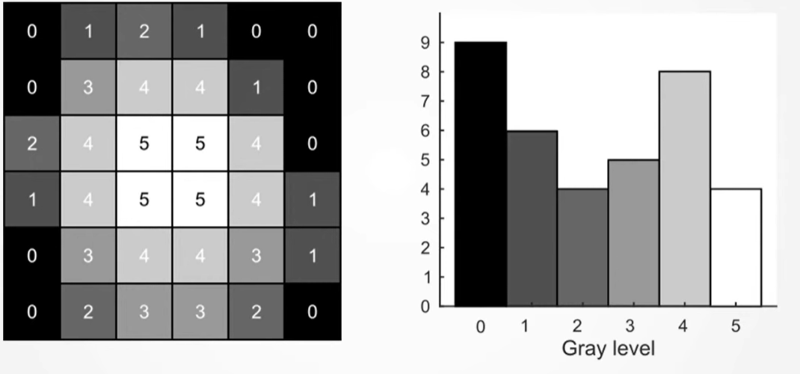
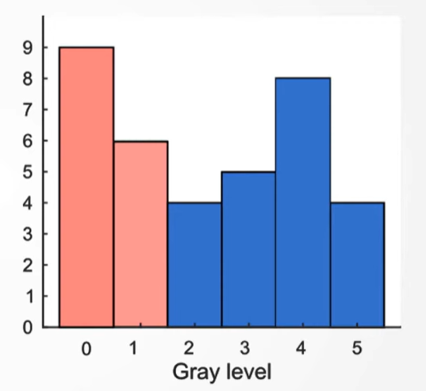
We’re going to see how otsu’s method works by using an example, here on the left we have an example image with six grays levels and these are labeled from 0 to 5. We compute the intensity histogram for this image. We then get a histogram that looks like what we have on the right. With Otsu’s method, the algorithm will first pick a value for the intensity threshold, such as for example 2.
In this case, any pixel with a value of less than 2 is considered a background pixel and any pixel with a value of 2 or greater is considered the foreground, labeled in red and blue. We can now compute the weights WB and WF (for background and foreground) remembering that the weights are simply the number of pixels in either foreground or background divided by the total number of pixels in the image.

$WB = \frac{9 + 6}{36} = 0.42$ $WF = \frac{4 + 5 + 8 + 4}{36} = 0.58$

We can now compute the average intensities $μ_{B}$ and $μ_{F}$; these are obtained by taking the height of each bar in the histogram and multiplying them by the gray level that they correspond to:

$μ_{B}= \frac{(9 * 0) + (6 * 1)}{9 + 6} = 0.4$ $μ_{F}= \frac{(4 * 2) + (5 * 3) + (8 * 4) + (4 * 5)}{4 + 5 + 8 + 4} = 3.57$

Now with the weights and the mean intensities computed, we can simply insert them into the equation and compute the between class variance:

$σ_{b}^{2} = ω_{B}ω_{F}{(μ}_{B} - μ_{F})^{2 }= 2.44$

$σ_{b}^{2} = 0.42 * 0.58(0.4 - 3.57)^{2}= 2.44$
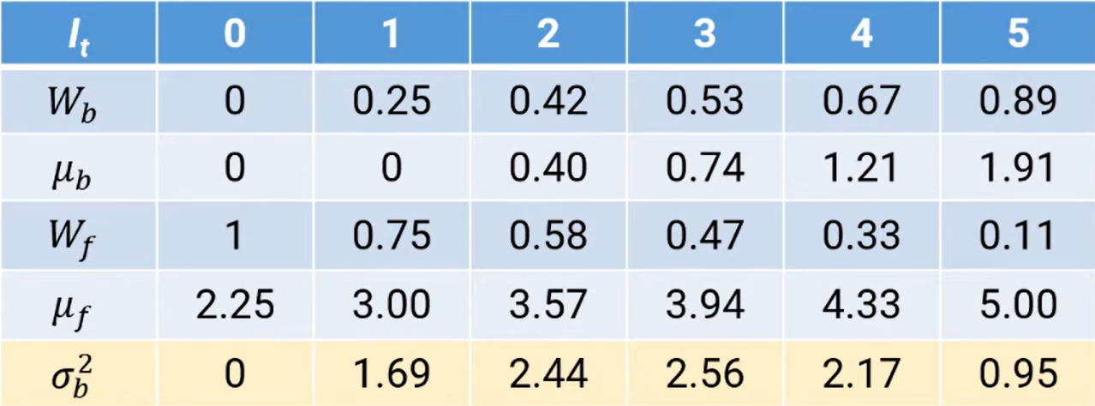
We now repeat this computation for every possible threshold intensity and get a list of between class variances $σ_{b}^{2} .$The optimal threshold intensity is the intensity that gives us the highest between class variance; in this case the highest between class variance is 2.56 which means a threshold value of 3 is the value which we will use.

Quick Reference

What is Otsu’s Thresholding?

- A global thresholding method that converts grayscale images into binary (black and white only) images
- Selects threshold value that best separates foreground pixel classes from background pixel classes
- Works by maximizing between-class variance of the two classes of pixels

Key concepts

- Thresholding
  - Converts grayscale image to binary image by selecting cutoff intensity value
- Histogram
  - Shows how often each grayscale intensity appears in an image
  - X-axis: intensity values from 0 to 255
  - Y-axis: frequency of respective intensities
- Class
  - A group of pixels created after thresholding
  - Class 0: background pixels
  - Class 1: foreground pixels
- Class probability
  - The fraction of the image which belongs to each respective class
  - Background probability:
$ω_{0}(t) = \sum_{i=0}^{t}{}p(i)$
- Foreground probability:
$ω_{1}(t) = \sum_{i=t+1}^{L-1}{}p(i)$
- Class mean
  - Average intensity of each respective class
  - Background mean:
$μ_{0}(t) = \frac{\sum_{i=0}^{t}{}i p(i)}{ω_{0}(t)}$
- Foreground mean:
$μ_{1}(t) = \frac{\sum_{i=t+1}^{L-1}{}i p(i)}{ω_{1}(t)}$

- Where p(i) is the probability of intensity i
- Where L is the number of intensity levels (usually 256)
- Between-class variance
  - Measure of how distinct both classes are
  - Represented by:
$σ_{b}^{2}(t) = ω_{0}(t)ω_{1}(t){(μ}_{0}(t) - μ_{1}(t))^{2}$
- Where $σ_{b}^{2}(t)$ is the between-class variance for threshold t
Key Papers

N. Otsu, “A Threshold Selection Method from Gray-Level Histograms,” IEEE Transactions on Systems, Man, and Cybernetics, vol. 9, no. 1, pp. 62–66, Jan. 1979, doi: https://doi.org/10.1109/tsmc.1979.4310076

Summary:
Nobuyuki Otsu’s 1979 paper introduces an automatic threshold selection method for grayscale image segmentation based on statistical analysis of image histograms. The method determines the optimal threshold thanks to the maximization of between-class variance, ensuring the clearest separation between foreground and background pixel classes. It was demonstrated in the paper that this approach is computationally efficient because maximizing between-class variance is equivalent mathematically to minimizing within-class variance, allowing for simpler calculations. The paper showed strong performance for bimodal histograms and established a robust, parameter-free thresholding technique. This work became foundational in digital image processing and remains one of the most widely used automatic image segmentation methods today.

Relevance:

This paper introduces the concept of and lays the mathematical foundation for Otsu’s thresholding method.

B. Sankur, “Survey over image thresholding techniques and quantitative performance evaluation,” Journal of Electronic Imaging, vol. 13, no. 1, p. 146, Jan. 2004, doi: https://doi.org/10.1117/1.1631315

Summary:

This paper presents a survey and quantitative evaluation of 40 image thresholding techniques used for image segmentation. The authors classify these methods into six categories: histogram shape-based, clustering-based, entropy-based, attribute-based, spatial, and locally adaptive approaches. They unify mathematical formulations under a common notation and compare performance using objective segmentation-quality metrics across document binarization and nondestructive testing (NDT) images. Results show that no single method dominates all cases, but some algorithms, especially Otsu’s clustering method, entropy-based methods, and adaptive local thresholding, perform consistently well. The study provides practical guidelines for selecting thresholding methods and highlights strengths and weaknesses for different application domains.

Relevance:

This paper helped to strengthen my mathematical understanding of Otsu’s method and the workings of other thresholding techniques.

J. W. Tay, “Otsu's Method,” YouTube, Sep. 21, 2020. [Online]. Available: https://www.youtube.com/watch?v=jUUkMaNuHP8
Summary:
This educational video provides a practical and mathematical breakdown of Otsu’s thresholding method for automated image segmentation. The presenter explains that the algorithm automatically finds the optimal threshold by searching for the intensity level that best separates an image into foreground and background classes. This is achieved by maximizing the between-class variance, which is determined through a mathematical formula involving class weights (the proportion of pixels in each class) and mean intensities.
Through a step-by-step example using a 6-gray-level histogram, the video demonstrates how the algorithm iteratively calculates variance for every possible threshold to select the highest value. Additionally, it provides a concrete implementation using MATLAB's imbinarize function, highlighting how to handle segmentation gaps with morphological operations like imfill. Finally, the video outlines the practical limitations of the method, noting that it requires a bimodal histogram distribution and can fail when foreground objects are too small, too dim, heavily affected by noise, or when the image suffers from uneven illumination.
Relevance:
This video acts as a step-by-step tutorial that bridges the theoretical mathematical formulas of Otsu's method with a concrete programming implementation.

J. Kittler and J. Illingworth, “On threshold selection using clustering criteria,” IEEE Transactions on Systems, Man, and Cybernetics, vol. SMC-15, no. 5, pp. 652–655, Sep. 1985, doi: https://doi.org/10.1109/tsmc.1985.6313443.

Summary: This paper analyzes limitations of Nobuyuki Otsu’s threshold-selection method and shows that it can fail when object and background pixel populations are highly unequal. The authors demonstrate that Otsu’s criterion is not always unimodal, contradicting earlier assumptions; it may become bimodal, causing the global maximum to produce incorrect thresholds. To address this, they propose a “valley check” correction, which evaluates candidate thresholds against histogram valleys to identify valid segmentation points. They also discuss implications for related iterative clustering methods, such as Ridler’s algorithm, and suggest improved initialization and validation strategies. The work extends thresholding reliability for images with unbalanced foreground-background distributions.

Relevance:

This paper helps to understand the concept of the two ‘valleys’ of an image’s histogram.
Works Cited

[1]
A. Murzova, “Otsu’s Thresholding with OpenCV,” LearnOpenCV – Learn OpenCV, PyTorch, Keras, Tensorflow with code, & tutorials, Aug. 05, 2020. https://learnopencv.com/otsu-thresholding-with-opencv/ (accessed May 17, 2026).

[2]
B. Sankur, “Survey over image thresholding techniques and quantitative performance evaluation,” Journal of Electronic Imaging, vol. 13, no. 1, p. 146, Jan. 2004, doi: https://doi.org/10.1117/1.1631315.

[3]
N. Otsu, “A Threshold Selection Method from Gray-Level Histograms,” IEEE Transactions on Systems, Man, and Cybernetics, vol. 9, no. 1, pp. 62–66, Jan. 1979, doi: https://doi.org/10.1109/tsmc.1979.4310076.

[4]
J. Kittler and J. Illingworth, “On threshold selection using clustering criteria,” IEEE Transactions on Systems, Man, and Cybernetics, vol. SMC-15, no. 5, pp. 652–655, Sep. 1985, doi: https://doi.org/10.1109/tsmc.1985.6313443.

[5]
Liu Jianzhuang, Li Wenqing, and Tian Yupeng, “Automatic thresholding of gray-level pictures using two-dimension Otsu method,” 1991 International Conference on Circuits and Systems, pp. 325–327, 2026, doi: https://doi.org/10.1109/ciccas.1991.184351.

[6]
J. W. Tay, “Otsu’s Method,” Youtube.com, Oct. 07, 2020. https://www.youtube.com/watch?v=jUUkMaNuHP8 (accessed May 18, 2026).

