Homework Q6

Gayatri Mainkar

1/30/2020

The below code chunk contains a function that analyzes protein drug interactions by reading in any protein PDB data and outputting a plot of the B-factor trend for the specified protein. Simply input the PDB identifier of the protein to obtain this plot.

Input: a single element character vector containing the four letter PDB identifier for online file access.

Output: Plot with the B-factor trend of the protein.

btrend <- function(x){  
   
 library("bio3d") #loads bio3d package  
 s <- read.pdb(x) #reads in specified protein  
   
 s.chainA <- trim.pdb(s, chain="A", elety="CA") #trims protein to subset of its atoms in chain A of type "CA"  
   
 s.b <- s.chainA$atom$b #assigns vector of b-factors of each atom to variable  
   
 plotb3(s.b, sse=s.chainA, typ="l", ylab="Bfactor", main = x) #plots the trend of the b-factor  
}

Test Case #1

btrend("4AKE")

## Note: Accessing on-line PDB file

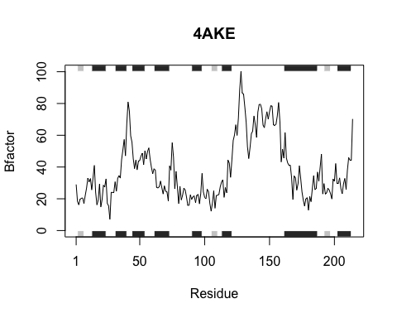

Test Case #2

btrend("1AKE")

## Note: Accessing on-line PDB file  
## PDB has ALT records, taking A only, rm.alt=TRUE

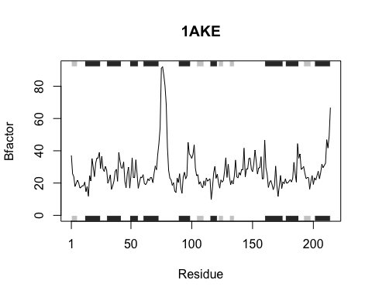

Test Case #3

btrend("1E4Y")

## Note: Accessing on-line PDB file

