Screenshot 1:
Docker Desktop
Containers Running (redis + web, port 8000:5000)
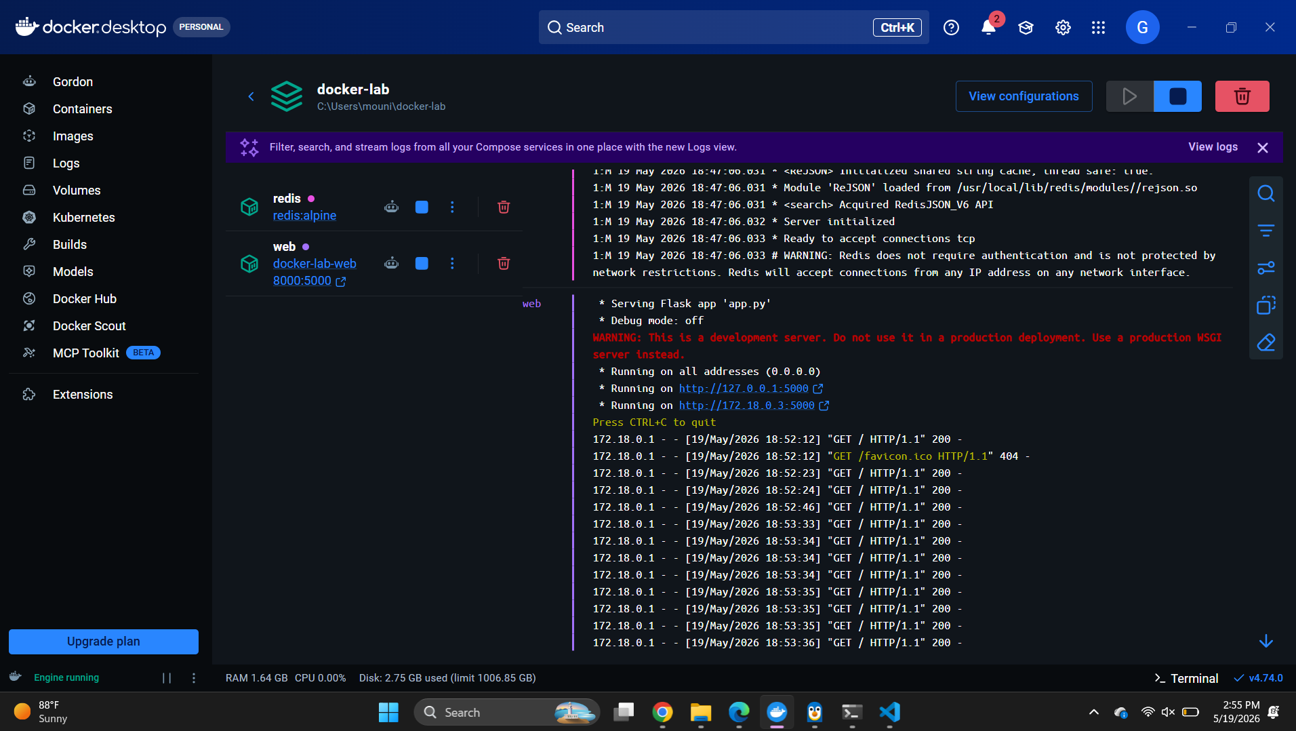
Browser Output — Flask App at localhost:8000 showing "Hello World! I have been seen 4 Times and 12 times."
