no2

emissions <- c(0.07,0.06,0.17,0.21,0.08,0.11,0.14,0.09,0.16,0.14,0.17,0.19,0.12,0.15,0.13,0.09,0.13,0.12,0.19,0.15,0.07,0.07,0.11,0.13,0.18,0.14,0.1,0.08,0.11,0.16)  
  
par(mfrow = c(1,2))  
boxplot(emissions)  
qqnorm(emissions)  
qqline(emissions)

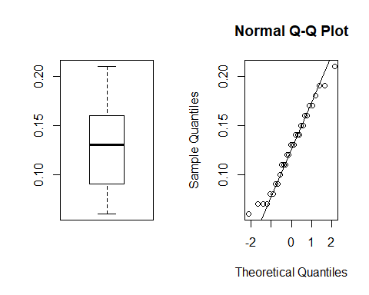

shapiro.test(emissions)

##   
## Shapiro-Wilk normality test  
##   
## data: emissions  
## W = 0.97033, p-value = 0.5482

t.test(emissions,conf.level = .95)

##   
## One Sample t-test  
##   
## data: emissions  
## t = 17.11, df = 29, p-value < 2.2e-16  
## alternative hypothesis: true mean is not equal to 0  
## 95 percent confidence interval:  
## 0.1121122 0.1425544  
## sample estimates:  
## mean of x   
## 0.1273333

e <- (0.1425544-0.1121122)/2  
e

## [1] 0.0152211