Lab2

source("http://www.openintro.org/stat/data/cdc.R")

names(cdc)

## [1] "genhlth" "exerany" "hlthplan" "smoke100" "height" "weight"   
## [7] "wtdesire" "age" "gender"

## Exercise 1: How many cases are there in this data set? How many variables? For each variable, identify its data type (i.e., nominal, ordinal, discrete numeric, or continuous numeric).

# Cases: 2000

# Variables: 9. GenHealth (ordinal),Exerany (ordinal), hlthplan (ordinal), smoke100 (discrete numeric), height (continuout numeric), weight (continuous numeric), wtdesire (continuous numeric), age (continuous numeric)

## Exercise 2: Generate 5-number summaries for both height and age (Hint: There should be 5 numbers in each summary, not 6), and compute the interquartile range for each.

# Height

quantile(cdc$height)

## 0% 25% 50% 75% 100%   
## 48 64 67 70 93

# Height Interquartile Range

quantile(cdc$height ,.75) - quantile(cdc$heightca ,.25)

## 75%   
## NA

# Age

quantile(cdc$age)

## 0% 25% 50% 75% 100%   
## 18 31 43 57 99

# Age Interquartile Range

quantile(cdc$age ,.75) - quantile(cdc$age ,.25)

## 75%   
## 26

## Exercise 2 continued: Compute and plot the relative frequency distributions for hlthplan and exerany. How many females are in the sample? What percentage of the people in this sample report being in good health?

barplot(table(cdc$hlthplan)/nrow(cdc))

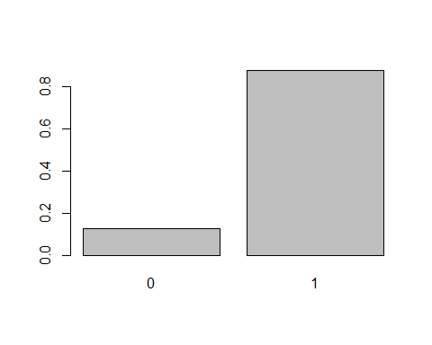

barplot(table(cdc$exerany)/nrow(cdc))

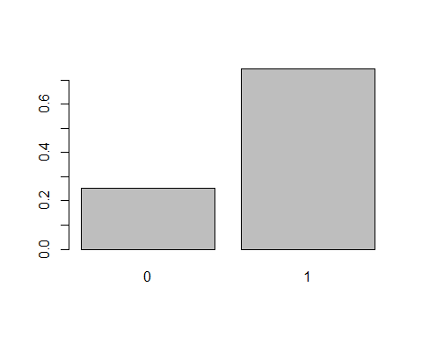

table(cdc$gender)

##   
## m f   
## 9569 10431

# There are 104321 females in the sample

(6972/(4657+5675+2019+611+6972)) * 100

## [1] 34.97542

# 34.97% report being in good health

## Exercise 3 What does your mosaic plot reveal regarding the association between smoking habits and gender?

mosaicplot(table(cdc$gender, cdc$smoke100))

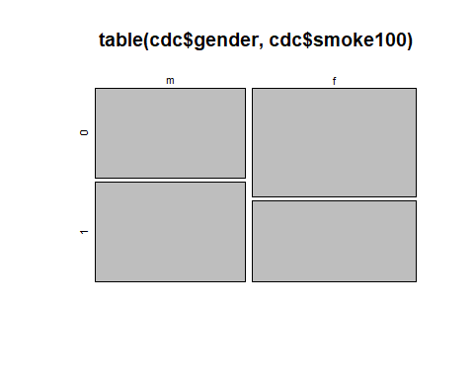 #There is a greater number of Men who have smoked at least 100 cigarettes. However there are more femailes who have no smokes at least 100 cigarettes

## Exercise 4: Create a new object called under23_and_smoke that contains all observations for respondents under the age of 23 who have smoked at least 100 cigarettes in their lifetimes. How many respondents are under age 23 and have smoked at least 100 cigarettes in their lifetimes? Include supporting R output as part of your answer to this exercise.

under23_and_smoke <- subset(cdc, cdc$smoke100 == TRUE & cdc$age < 23)  
nrow(under23_and_smoke)

## [1] 620

# 620 people under the age of 23 have smoked at least 100 cigarettes

## Exercise 5: What does this boxplot display suggest about the association between BMI and general health?

bmi <- (cdc$weight/cdc$height^2) * 703  
boxplot(bmi ~ cdc$genhlth)

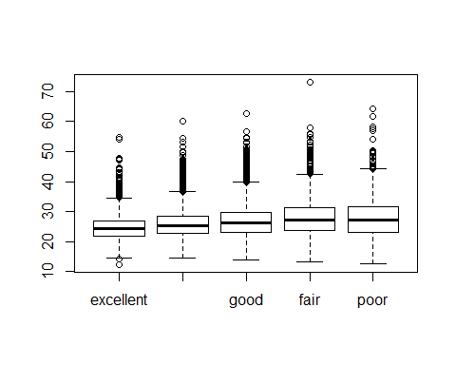 #The poorer a person is in health, the higher BMI they have.

## Exercise 5 continued: Pick another categorical variable from the data set and generate a boxplot display to see how it relates to BMI. State the variable you chose, explain why you might think it would have a relationship to BMI, and indicate what the boxplot display seems to suggest.

bmi <- (cdc$weight/cdc$height^2) * 703  
boxplot(bmi ~ cdc$gender)

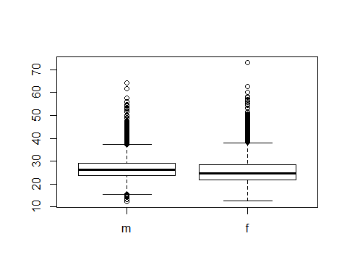 #Females generally have a lower average BMI than men. However, Females have a much larger outlier than men.

# Exercise 6: Note that you can flip between plots that you’ve created by clicking the forward and backward arrows in the lower right region of RStudio, just above the plots. How do these two histograms compare? Describe the shape of the BMI distribution. Include both histograms as part of your answer to this question. NEED TO FINISH

hist(bmi)

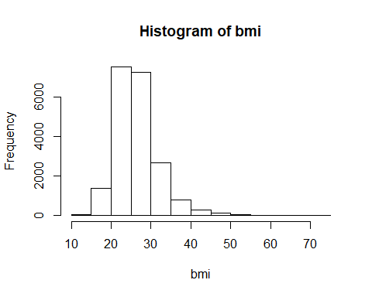

hist(bmi, breaks = 50)

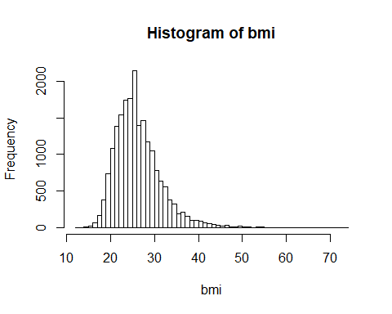

### Homework Assignment

## 1. . Make a scatterplot of weight (x) versus wtdesire (y). Describe the apparent relationship between these two variables.

plot(cdc$weight ~ cdc$wtdesire, main="Weight VS Desired Weight", xlab = "Weight", ylab="Desired Weight")

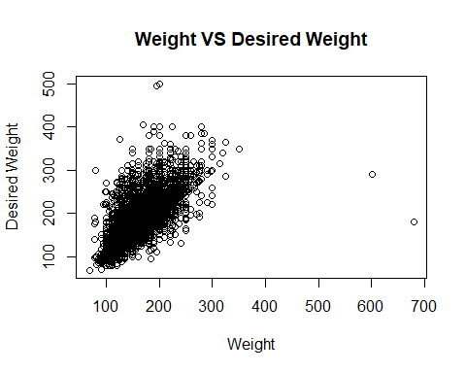 #There are people who want to lose weight

## 2 Let’s consider a new variable: the difference between desired weight (wtdesire) and current weight (weight). Create this new variable by subtracting the two columns in the data frame in the order I specified above and assigning the result to a new object called wdiff. Answer this question with the R code you used to create this variable.

wdiff <- cdc$weight - cdc$wtdesire

## 3.If an observed wdiff is 0, how do a person’s actual weight and desired weight compare? How do they compare if the wdiff is positive? Negative?

# If wdiff is 0 then there a person weighs at their desired weight. If positive, a person wishes to lose weight. If negative, they wish to gain weight

## 4. Describe the distribution of wdiff in terms of its center, shape, and spread. What does this information tell us about how people feel about their current weight? Include a histogram and summary statistics as part of your answer.

hist(wdiff)

