Lab3

download.file("http://www.openintro.org/stat/data/kobe.RData", destfile =  
"kobe.RData")  
load("kobe.RData")  
head(kobe)

## vs game quarter time  
## 1 ORL 1 1 9:47  
## 2 ORL 1 1 9:07  
## 3 ORL 1 1 8:11  
## 4 ORL 1 1 7:41  
## 5 ORL 1 1 7:03  
## 6 ORL 1 1 6:01  
## description basket  
## 1 Kobe Bryant makes 4-foot two point shot H  
## 2 Kobe Bryant misses jumper M  
## 3 Kobe Bryant misses 7-foot jumper M  
## 4 Kobe Bryant makes 16-foot jumper (Derek Fisher assists) H  
## 5 Kobe Bryant makes driving layup H  
## 6 Kobe Bryant misses jumper M

## R Markdown

kobe$basket[1:9]

## [1] "H" "M" "M" "H" "H" "M" "M" "M" "M"

### Exercise 1: What does a streak length of 1 mean (i.e., how many hits and misses are in astreak of 1)? What about a streak length of 0?

## Sreak of 1 means a H followed by a M. A streak of 0 is a M followed by a M/

### Exercise 2: Describe the distribution of Kobe’s streak lengths from the 2009 NBA finals.What was his typical streak length? How long was his longest streak of baskets?

kobe_streak <- calc_streak(kobe$basket)  
barplot(table(kobe_streak))

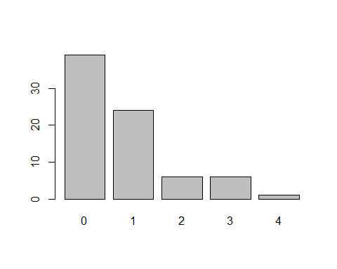 ##The distribution is right skewed.

summary(kobe_streak)

## Min. 1st Qu. Median Mean 3rd Qu. Max.   
## 0.0000 0.0000 0.0000 0.7632 1.0000 4.0000

## The typical streak is 0. The longest is 4.

### Exercise 3: In your simulation of flipping the unfair coin 100 times, how many flips came up heads?

outcomes <- c("heads", "tails")   
sim_unfair_coin <- sample(outcomes, size = 100, replace = TRUE, prob = c(0.2, 0.8))  
table(sim_unfair_coin)["heads"]

## heads   
## 17

## Heads was selected uhh 17 times.

### Exercise 4: What change needs to be made to the sample function so that it reflects ashooting percentage of 45%? Make this adjustment, then run a simulation to sample 133 shots. Assign the output of this simulation to a new object called sim_basket

outcomes_bball <- c("H", "M")   
sim_basket <- sample(outcomes_bball, size = 133, replace = TRUE, prob = c(.45, .55))

### Homework

## Produce a graph and describe the distribution of streak lengths for the independent shooter. What is the typical streak length for this simulated independent shooter with a 45% shooting percentage? How long is the player’s longest streak of baskets in 133 shots?

sim_streak <- calc_streak(sim_basket)   
barplot(table(sim_streak))

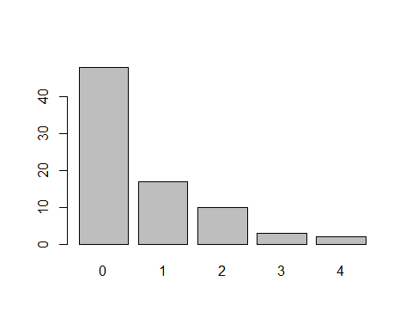

summary(sim_streak)

## Min. 1st Qu. Median Mean 3rd Qu. Max.   
## 0.000 0.000 0.000 0.675 1.000 4.000

# The typlical streak length is 0. The longes streak of baskets in 133 shots is 4

### If you were to run the simulation of the independent shooter a second time, how would you expect its streak distribution to compare to the distribution from the question above? Exactly the same? Somewhat similar? Totally different? Explain your reasoning.

# If the simulation was ran again, I would expect the results to be somewhat similar. The shooter will still take 133 shots and will still have a hit percentage of 45%

## How does Kobe Bryant’s distribution of streak lengths from page 2 compare to the distribution of streak lengths for the simulated independent shooter? Based on this comparison, do you have evidence that the hot hand model fits Kobe’s shooting patterns? Explain your reasoning.

# Both Kobe’s and the simulated shooter’s distribution model that could be described as right skewed and is very similar in distribution. The hot hand model is not likely to fit.