Lab4

download.file("http://www.openintro.org/stat/data/bdims.RData", destfile =  
"bdims.RData")  
load("bdims.RData")  
mdims <- subset(bdims, bdims$sex == 1)   
fdims <- subset(bdims, bdims$sex == 0)

## Exercise 1: Generate separate histograms of the men’s and women’s heights. Then, compare and contrast the center, spread, and shape of these two height distributions.

hist(mdims$hgt, main = "Men's Hight in CM", xlab = "Height(cm)")

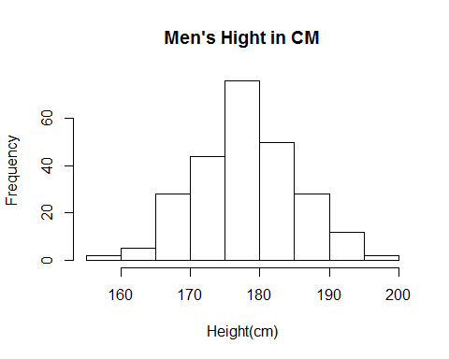

hist(fdims$hgt, main = "Women's Hight in CM", xlab = "Height(cm)")

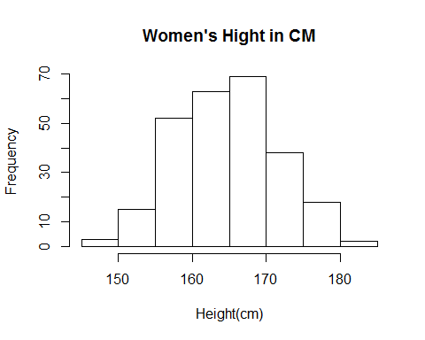

summary(mdims$hgt) # 5 Number Summary of Men's Height in cM.

## Min. 1st Qu. Median Mean 3rd Qu. Max.   
## 157.2 172.9 177.8 177.7 182.7 198.1

summary(fdims$hgt) # 5 Number Summary of Women's Height in cM.

## Min. 1st Qu. Median Mean 3rd Qu. Max.   
## 147.2 160.0 164.5 164.9 169.5 182.9