The dataset we used this project is **Skin Cancer ISIC**

Link: https://www.kaggle.com/datasets/nodoubttome/skin-cancer9-classesisic/data  
as the link is 825MB (a bit larger)

This dataset contains the subfolders as mentioned in the image

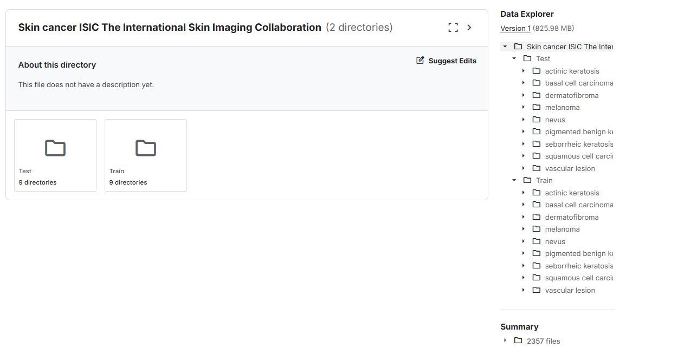

This dataset consists of 2357 images of malignant and benign oncological diseases, which were formed from The International Skin Imaging Collaboration (ISIC). All images were sorted according to the classification taken with ISIC, and all subsets were divided into the same number of images, with the exception of melanomas and moles, whose images are slightly dominant.

The data set contains the following diseases:

actinic keratosis

basal cell carcinoma

dermatofibroma

melanoma

nevus

pigmented benign keratosis

-seborrheic keratosis

squamous cell carcinoma

vascular lesion