The dataset we used this project is

Link: <https://www.kaggle.com/datasets/rashedoz/crowdai-plant-disease-dataset>  
  
as the link is 947MB (a bit larger)

This dataset contains the subfolders as mentioned in the image

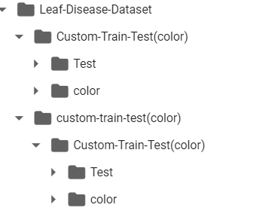

And in total there are 61,896 images