Начин на тестване: „Тестов план на Dcrt IVR 0.0.1“
Дата на провеждане: 18.01.2015 г.
Продължителност на теста: 100 000 обаждания, 96 едновременни
Извършил теста: Г. Манев
Резултат: УСПЕХ

------------------------------ Scenario Screen -------- [1-9]: Change Screen --
Call-rate(length) Port Total-time Total-calls Remote-host
10.0(0 ms)/1.000s 5080 13603.14 s 100000 212.36.11.23:5060(UDP)

Call limit reached (-m 100000), 0.000 s period 0 ms scheduler resolution
0 calls (limit 96) Peak was 96 calls, after 9 s
0 Running, 258 Paused, 0 Woken up
0 dead call msg (discarded) 0 out-of-call msg (discarded)
1 open sockets

Messages Retrans Timeout Unexpected-Msg
INVITE ----------> 100000 1 0
100 <---------- 99997 0 0 0
180 <---------- 0 0 0 0
200 <---------- E-RTD1 100000 0 0 0

ACK ----------> 100000 0
Pause [ 3000ms] 100000 0
[ NOP ]
Pause [ 10.0s] 100000 0
BYE ----------> 100000 11 0
200 <---------- 100000 0 0 0

------------------------------ Test Terminated --------------------------------

----------------------------- Statistics Screen ------- [1-9]: Change Screen --
Start Time | 2015-01-18 11:29:17:752 1421573357.752919
Last Reset Time | 2015-01-18 15:16:00:896 1421586960.896901
Current Time | 2015-01-18 15:16:00:897 1421586960.897068
-------------------------+---------------------------+--------------------------
Counter Name | Periodic value | Cumulative value
-------------------------+---------------------------+--------------------------
Elapsed Time | 00:00:00:000 | 03:46:43:144
Call Rate | 0.000 cps | 7.351 cps
-------------------------+---------------------------+--------------------------
Incoming call created | 0 | 0
OutGoing call created | 0 | 100000
Total Call created | | 100000
Current Call | 0 |
-------------------------+---------------------------+--------------------------
Successful call | 0 | 100000
Failed call | 0 | 0
-------------------------+---------------------------+--------------------------
Response Time 1 | 00:00:00:000 | 00:00:00:034
Call Length | 00:00:00:000 | 00:00:13:048
------------------------------ Test Terminated --------------------------------
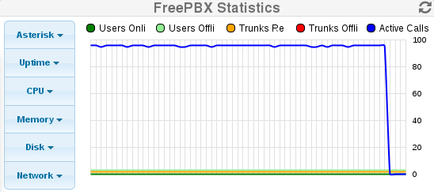
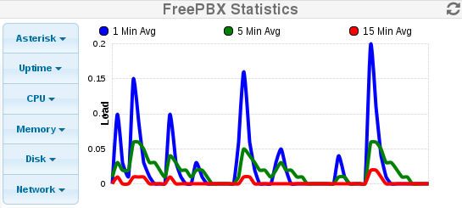

Всички посочени в тестовия план проверки са успешни.

