**Keshava Tech - Interngration Final Milestone Bug Tracking**

Note: Please document all the bugs that you find here so that we will have a consolidated bug report to send to Mani.

All my comments are in purple - Anirudh

# CSS StylingBugs

* In IE, there is a red border around the interngration logo and the inbox messaging envelope icon. Refer to the screenshot titled "styling_error_in_IE.png"[Anirudh - New Bug]Design issue**OK**

# Student Bugs

* + RSVP / My Application tracking not working on profile page.Want to discuss

What do we need to display under “Status” for My Application? [Anirudh] - The statuses should be:

1) Resume Received - This is when the recruiter receives the resumeFixed**Not tested yet.**

2) Resume Accepted - This is when the recruiter approves the resume to schedule an interview. Out of scope **<---- Since you have fixed the received and rejected. I don't understand on why “accepted” can't be fixed. We only want to know the acceptance. Please try to get this done. The scheduling of an interview is not part of this.**

3) Resume Rejected - This is when the recruiter rejects the resume and the candidate is unsuccessful in the job application.Fixed**Not tested yet.**

* The confirmation email after activation has some weird characters.

[Anirudh] - Please refer to the attached screenshot. This is the welcome e-mail a student gets when he successfully activates his account.[Anirudh - Now the activation link in the email is just "www.interngration.com". Shouldn't it be a unique string for each activation mail, like www.interngration.com/*<unique string>*"] Refer to the screenshot below:Fixed**OK**

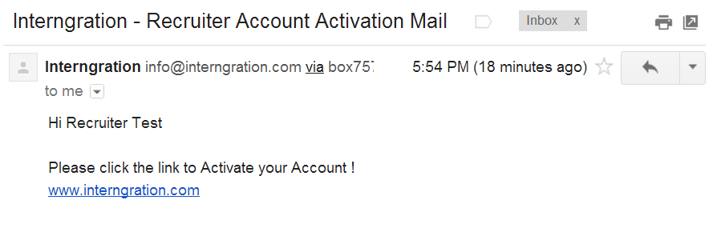

* The activation emails sometimes has a hyper link and sometimes it is just a link which we have to copy paste to the search bar. [Anirudh] - This seems to be a randomly recurring issue. It's only *some*e-mails that are getting affected. Will get back to you on this.[Anirudh -There is no link at all in the activation e-mails now, refer to the bug above.]Not FixedFixed**OK**

## Webinar + Applying for jobs:

* Should get a messagein my inbox or at-least an inbox message that an email has been sent to my email address.Want to discuss. Sent e mail to student. Inbox should have notification that e mail is sent.[Anirudh] - Will get back to you on this

## Sending / receiving messages:

* In IE when you compose a message and click on "Send" nothing happens. The message does not get sent.[Anirudh] - New BugDesign issue**OK**
* Cannot restore deleted messaged back to the inbox. Please elaborate[Anirudh - If I accidentally delete a message in my inbox, I need to be able to restore it back to my Inbox from the Trash]Fixed**Nope this hasn’t been fixed. Please fix !**
* When you get an inbox message and click on "Reply" or "Forward", the original message should be concatenated at the bottom of the message, just like an e-mail. Screenshot 1 shows the current behaviour. Screenshot 2 shows the desired behaviour.

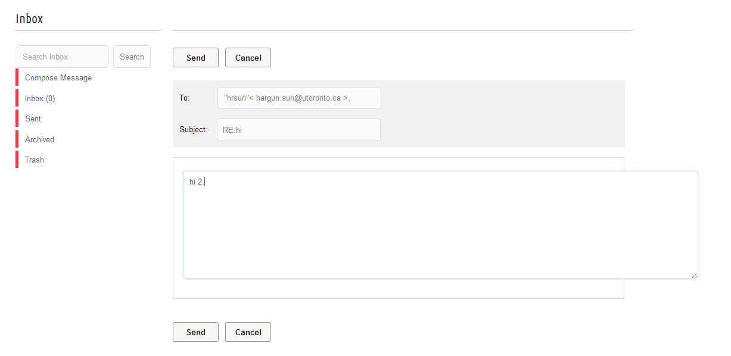

Screenshot 1: Current behaviour when you "Reply" to a message

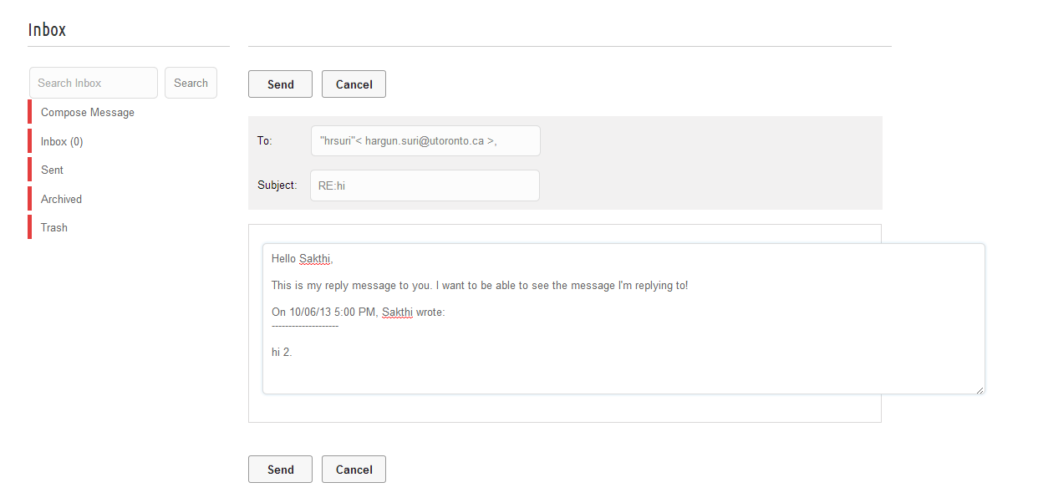

Screenshot 2: Expected behaviour when you "Reply" to a message

If you have a LinkedIn account, try forwarding or replying to an inbox message, you will know what I mean.[Anirudh - New Bug]Fixed**No this has not been fixed! Please fix.**

* Move the email notification icon to the side, it seems out of place. Want to discuss. Which side to move? What other pic you need?[Anirudh] - Can you move the inbox notification to the right of the "Welcome: User" and "Home" button at the top.Design issue**OK**

## Inviting friends:

* Facebook invite doesn’t work.Fixed[Anirudh] - The FB invite message now says "Recruit Faster, Hire Smarter. Register now for free webinar". We need to change this message, where can we do this? (This message was inside coding so if you want change please let us know.)[Anirudh - Which file is it under, I'll make the change]]student-registration-last.php, student-profile.php -should change both page the line is( message: 'Recruit Smarter Hire faster ! Register Today for Free Webinar.')**OK**

## Updating Info:

* For upload resume - there should be an option to remove as well. Also being able to upload more than one document. [Anirudh] - There should be functionality to remove the uploaded resume, in case the wrong file was accidentally uploaded etcFixed**Nope this hasn’t been fixed. Please fix.**
* Student should also be able to upload more than 1 file. for example: 1) Resume 2) Academic Transcripts 3) Recommendation Letter etc. Is it also possible to allow the student to add a short description of each file that he uploads. For example for the recommendation letter upload, he can add a description that says "Recommendation letter from my professor".Out of scope**OK**
* studentAccount.php, when you are updating your password. When you enter the wrong old password, the system still lets you change to a new password.Want to discuss. Please elaborateChecked in Bluehost server and it is working fine. Please verify and let us know if you still have issue.Not Fixed[Anirudh - To reproduce this bug, follow these steps:

1. Click on Account when logged in
2. Click on Edit
3. Click on the "New Password" field and enter a new password
4. Click on the "Confirm Password" field and confirm the new password you just entered
5. Now, click on the "Old Password" field and enter *anything*.
6. Click on Update

The system updates your password even though you entered a wrong "Old Password"Fixed**NOT fixed. Please fix. Updated in to client server**

# Recruiter Bugs:

## Received Job Applications:OK

Can you confirm - if the html pages can be removed if they can please remove them.Deleted unwanted html file

Also I want a quick notes on the following folders;

- **ajaxpages**--> what is the function of these pages.This has ajax function. Neededfor the project

-**alpha** --> has a favicon, is it being used?Not needed. Deleted from server.

- **cgi-bin** --> this is emptyNot needed. Deleted from server.

- **intern** --> why does this have copies of html pages? are they relevant ?Not needed. Deleted from server.

Me and Ani are refactoring the code , so we need as much information as we can on the files.

Another thing I noticed was that when you're logged in as a recruiter, in recruiter-home-page.php, the **"My Webinars"**section with the table is static. That means that this table does not update as new webinars are created/cancelled. Can you please ensure that this is going to be made dynamic please? Thanks.Fixed**Not tested.**