CprE 3810: Computer Organization and Assembly-Level Programming

Project Part 1 Report

Team Members: Gabe Mankowski

Blane Fullmer

Project Teams Group #: C_07

Refer to the highlighted language in the project 1 instruction for the context of the following questions.

[Part 2 (d)] Include your final RISC-V processor schematic in your lab report.
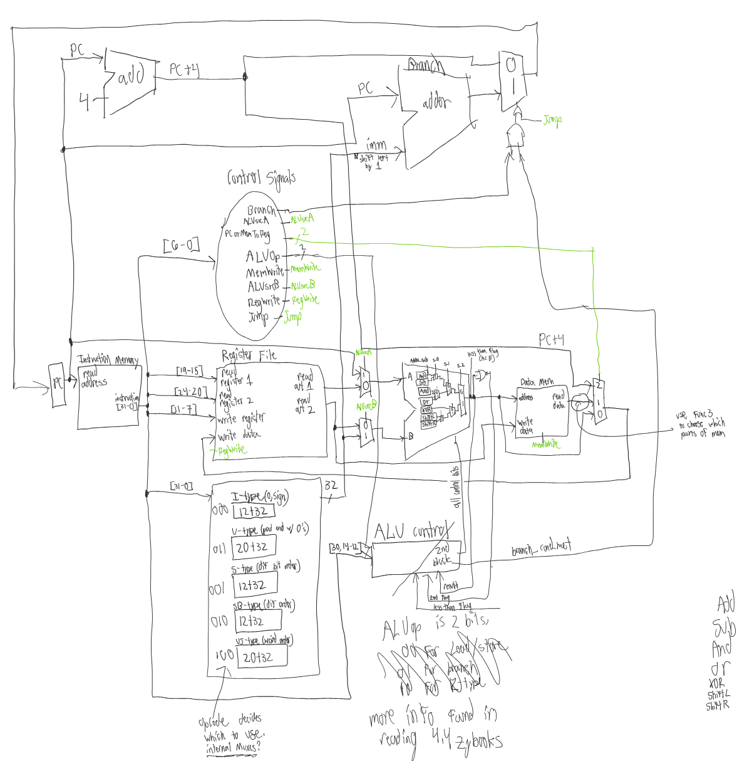
[Part 3.1.a.] Create a spreadsheet detailing the list of M instructions to be supported in your project alongside their binary opcodes and funct fields, if applicable. Create a separate column for each binary bit. Inside this spreadsheet, create a new column for the N control signals needed by your datapath implementation. The end result should be an N*M table where each row corresponds to the output of the control logic module for a given instruction.

A screenshot is included here:

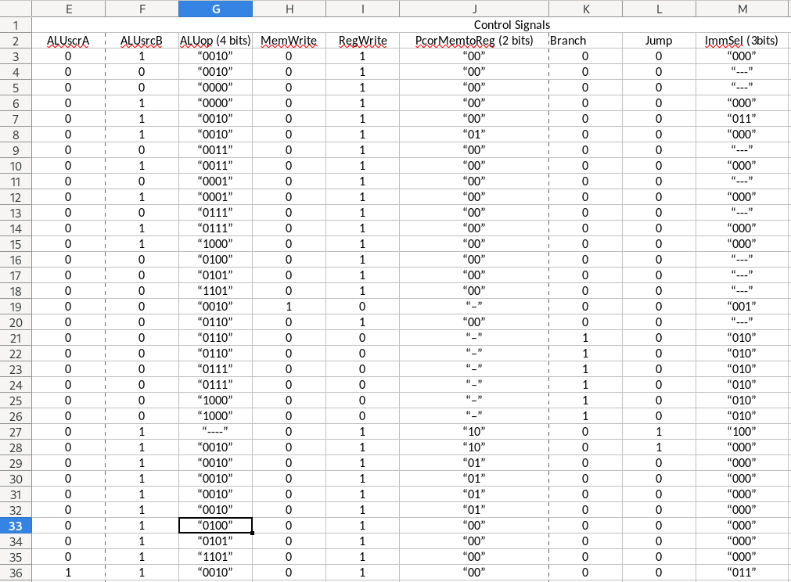

[Part 3.1.(b)] Implement the control logic module using whatever method and coding style you prefer. Create a testbench to test this module individually and show that your output matches the expected control signals from problem 1(a).

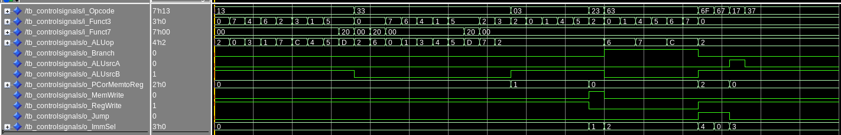

[Part 3.2. (a)] What are the control flow possibilities that your instruction fetch logic must support? Describe these possibilities as a function of the different control flow-related instructions you are required to implement.
There are two behaviors that the fetch module needs to implement based on a set of three control signals. First, it needs to take the value of the program counter, increase it by 4, representing a word, and then write that larger value back to the program counter. Secondly, it needs to be able to jump to an address in memory based on a calculated offset, which is supplied externally by the “extender”. In practice, this is done by wiring the output of the PC into the inputs of two different adder units. One adder is wired to always add 4, and the other is given that immediate offset value. The two modules are muxed, and selected between via a small assortment of logic gates operating on the control signals. This controlls which adder propagates back to the PC.

[Part 3.2. (b)] Draw a schematic for the instruction fetch logic and any other datapath modifications needed for control flow instructions. What additional control signals are needed?

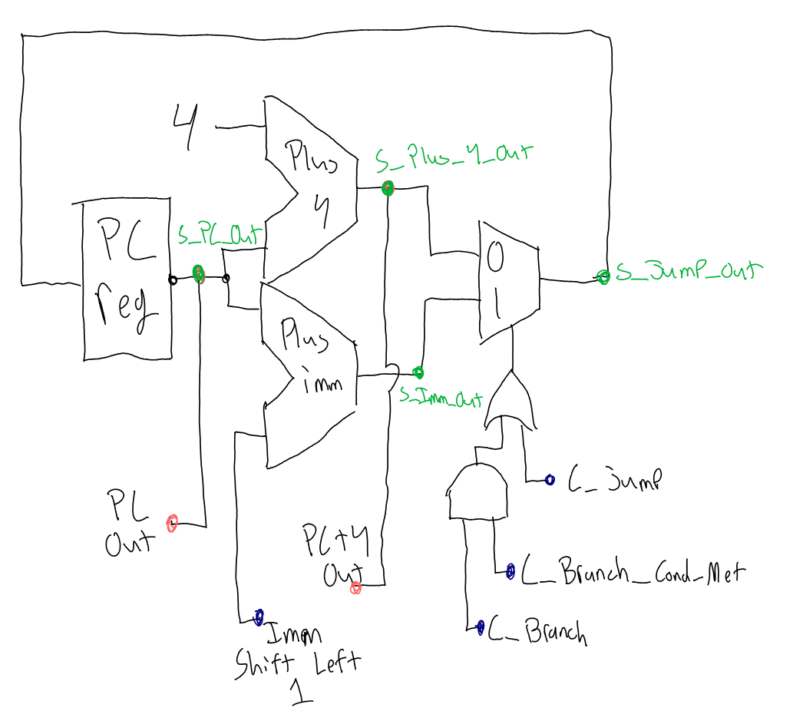

The Fetch functionality needs three control signals, all of which get sent to the select of the adder mux through a set of logic gates. This Boolean logic as written is
(C_Branch and C_Branch_Cond_Met) or C_Jump
This implements the functionality flawlessly. If there is a branch, and the condition to take it is met, then the mux propagates the imm-adder. If it is a jump instruction, the mux propagates the imm-adder. If neither are true, the mux propagates the +4 adder, and the program reads the next instruction.

[Part 3.2.(c)] Implement your new instruction fetch logic using VHDL. Use QuestaSim to test your design thoroughly to make sure it is working as expected. Describe how the execution of the control flow possibilities corresponds to the QuestaSim waveforms in your writeup.
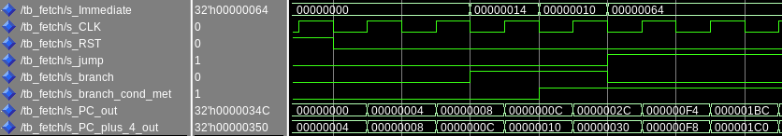
Only when the two branch controls were high, or when the jump control was high did the shifted value on the immediate line get added to the PC. All other times, the PC was incremented by 4, as is expected.

[Part 3.3.1.(a)] Describe the difference between logical (srl) and arithmetic (sra) shifts. Why does RISC-V not have a sla instruction?
Srl always shifts “in” a 0, to fill the most significant bit of the register. This is not ideal when you want to use the “division” property of shifting on a negative number, because the most significant bit is the sign bit. By replacing it with a zero, we have divided by two, and made it positive. Sra preserves the most significant bit, and shifts in it’s value, instead of only zero. There is no sla instruction, because this would not be a meaningful thing. It would amount to a x*2+1 macro.

[Part 3.3.1.(b)] In your writeup, briefly describe how your VHDL code implements both the arithmetic and logical shifting operations.
The code is looking at a control bit generated by the sra instruction, and the most significant bit. Instead of tying the empty “shift in” lines of my design to a constant source of zero, they are tied to an AND gate that is evaluating that control bit and the sign bit. If the instruction is not SRA, this control bit is zero, which propagates zero into the shifter.

[Part 3.3.1.(c)] In your writeup, explain how the right barrel shifter above can be enhanced to also support left shifting operations.
The ability two shift in both directions was accomplished by reversing the 32 bit register via a row of muxes, then shifting the backwards string to the right. The string of bits is then unreserved. This effectively implements the left shift.

[Part 3.3.1.(d)] Describe how the execution of the different shifting operations corresponds to the QuestaSim waveforms in your writeup.
The waveform correctly shows the shifter taking the value and shifting it left when the ALUOP = 0, shifting right logical when ALUOP = 1, and shifting right arithmetic when ALUOP = 9.

[Part 3.3.2.(a)] In your writeup, briefly describe your design approach, including any resources you used to choose or implement the design. Include at least one design decision you had to make.
Our design constantly executes all alu functions in parallel, and Muxes the desired output. We chose to not include a D-mux, because we felt that selecting between the parallel operations would be easier to visualize and implement.

[Part 3.3.2.(b)] Describe how the execution of the different operations corresponds to the QuestaSim waveforms in your writeup.
Our ALU is only made of three functional units. The barrel shifter, which is tested above, some 2 to 1 muxes, and an add-subtract unit. The add-sub unit contains all of the functionality needed to detect greater/lesser, carry out, and if the output is zero. A waveform for our add-sub test bench is included bellow.
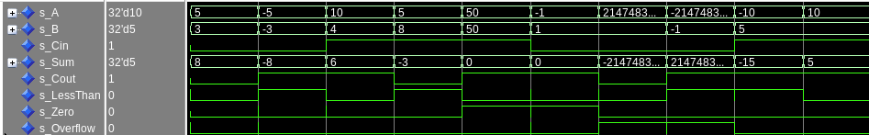
The tests correctly show the addition, subtraction, and comparison of the different input signals. s_Zero is high when the result of the add/sub is zero. The overflow signal is high only when overflow occurs.

[Part 3.3.3] Draw a simplified, high-level schematic for the 32-bit ALU. Consider the following questions: How is Zero calculated? How is slt implemented?
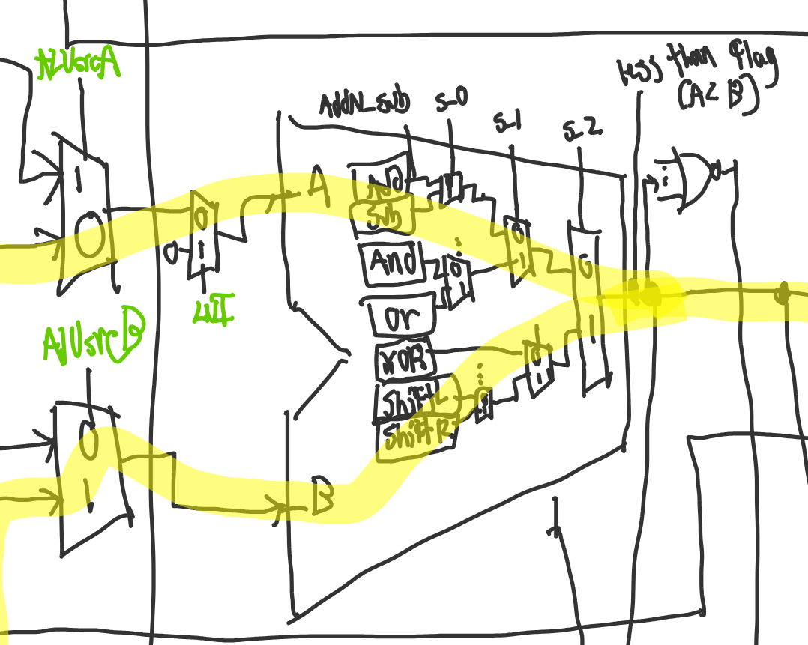
Zero is being calculated manually within the ALU by comparing the result signal to a constant hex mask of all zeros. This sets o_Zero to 1 when the result is all zero, and otherwise sets that output to 0 with an else statement.

Slt sets the result to one if i_A < i_B, and 0 otherwise. When the i_Control signal is 0111, the i_Control(2) bit is fed to the i_Cin port of the add sub unit, which sets it to subtract A -B. It then XORs the sign bit of result of the subtraction with the overflow flag. This works because if there is no overflow, the sign bit of the result is the output. If A-B is a negative value, the sign bit will be one, and we can conclude that B was larger than A. If overflow did occur, the sign bit will be the opposite of what we want, requiring a reversal via XOR.

[Part 3.3.5] Describe how the execution of the different operations corresponds to the QuestaSim waveforms in your writeup.
The test bench waveform correctly executes one of every operation the ALU is meant to perform. It checks every command that the ALU is meant to implement. The waveform is split into multiple chunks, and the explanation beneath shows that the outputs match the image.

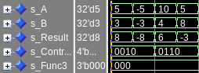
Test 1: ADD: 5 + 3 = 8
Test 2: ADD: -5 + -3 = -8
Test 3: SUB: 10 – 4 = 6
Test 4: SUB: 5 – 8 = -3
These instructions all give the correct numeric values on the result line.
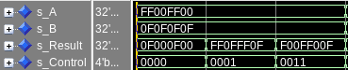
Test 5: AND: 0xFF00FF00, 0x0F0F0F0F: 0x0F000F00
Test 6: OR: 0xFF00FF00, 0x0F0F0F0F: 0xFF0FFF0F
Test 7: XOR: 0xFF00FF00, 0x0F0F0F0F: 0xF00FF00F
These instructions all give the correct masks on the result line.
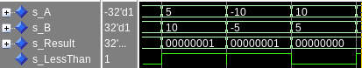
Test 8: SLT: 5 < 10: five is less than 10, result is 1, and the less than flag is high.
Test 9: SLT: -10 < -5: -10 is less than -5, result is 1. and the less than flag is high.
Test 10: SLT: 10 > 5: 10 is greater than 5, result is zero, and the less than flag is low.

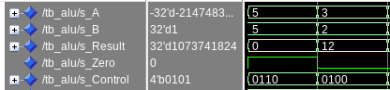
Test 11: SUB: 5 – 5 = 0: The zero flag is high
Test 12: SLL: 3 * 4 = 12: Shift left logical

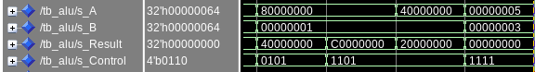
Test 13: SRL: 0x80000000, shifted right by 1, with a zero shifted in: 0x40000000
Test 14: SRA: 0x80000000, shifted right by 1, with a one shifted in: 0xC0000000
Test 15: SRA: 0x40000000, shifted right by 1, sign bit preserved: 0x20000000
Test 16: Invalid Operation: result is 0

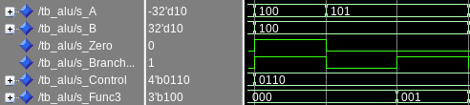
Test 17: BEQ: 100 = 100, zero flag is high, branch is high
Test 18: BEQ: 101 != 100, zero flag is low, branch is low
Test 19: BNE: 101 != 100, zero flag is low, branch is high

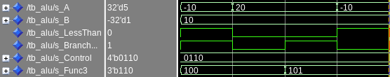
Test 20: BLT: -10 < 10, less than is high, branch is high
Test 21: BLT: 20 < 10, less than is low, branch is low
Test 22: BGE: 20 >= 10, less than is low, branch is high
Test 23: BGE: -10 < 10, less than is high, branch is low

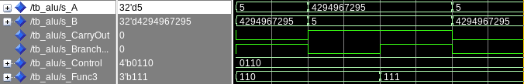
Test 24: BLTU: 5 < 4294967295, carry is low, branch is high
Test 25: BLTU: 4294967295 > 5, carry is high, branch is low
Test 26: BGEU: 4294967295 > 5, carry is high, branch is high
Test 27: BGEU: 5 < 4294967295, carry is low, branch is low

[Part 3.3.8] justify why your test plan is comprehensive. Include waveforms that demonstrate your test programs functioning.
The testing procedure demonstrates all instructions the ALU is meant to implement. It accurately shows the ALU correctly setting the different control flags for all relevant instructions.

[Part 4] In your writeup, show the QuestaSim output for each of the following tests, and provide a discussion of result correctness. It may be helpful to also annotate the waveforms directly.

[Part 4.a] Create a test application that makes use of every required arithmetic/logical instruction at least once. The application need not perform any particularly useful task, but it should demonstrate the full functionality of the processor (e.g., sequences of many instructions executed sequentially, 1 per cycle while data written into registers can be effectively retrieved and used by later instructions). Name this file Proj1_base_test.s.

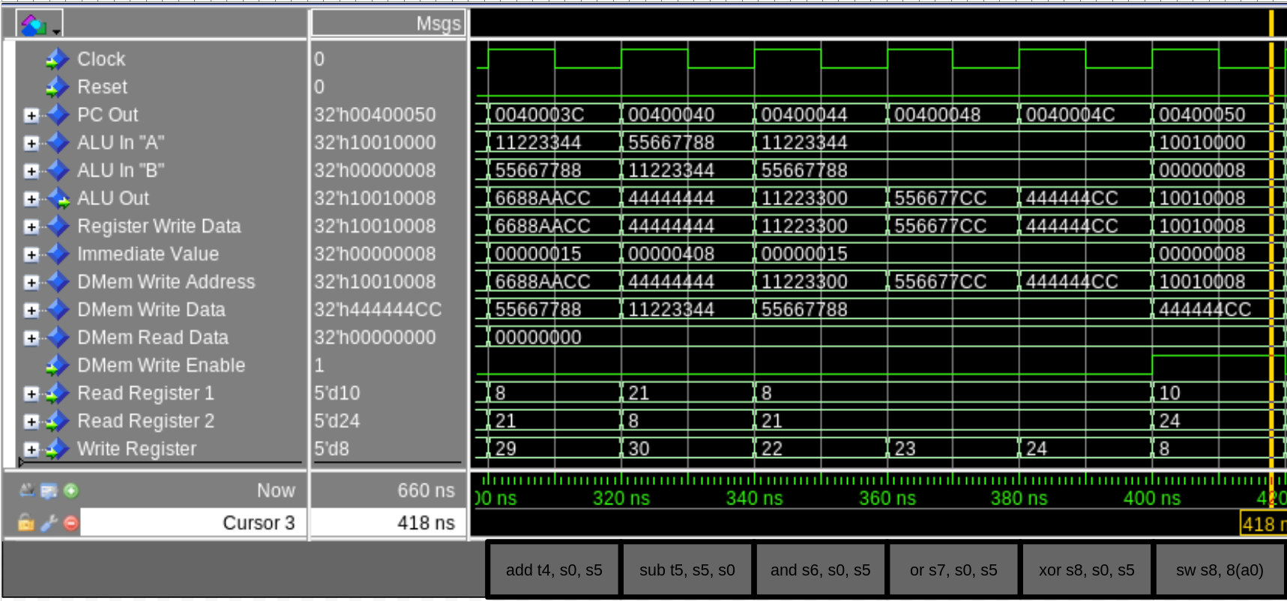
This snapshot shows the execution of the “Register-Register Arithmetic and Logic” section of the base test. Prior to this, various operations have filled the registers, and are now being accessed and modified by the processor. This screenshot correctly shows the different registers being accessed and written to, as well as a store word being used on the value created by the xor statement.

Lets trace the sw instruction. The base address is stored in a0, and is passed to the ALU on its “A” line. The offset of 8 is an immediate value, and is passed in on “B”. The output of the ALU is passed to the DMEM to be its write address. The data written is the output of the previous xor instruction, which was written to the 24th register. The 24th register is now the second read register.

[Part 4.b] Create and test an application which uses each of the required control-flow instructions and has a call depth of at least 5 (i.e., the number of activation records on the stack is at least 4). Name this file Proj1_cf_test.s.

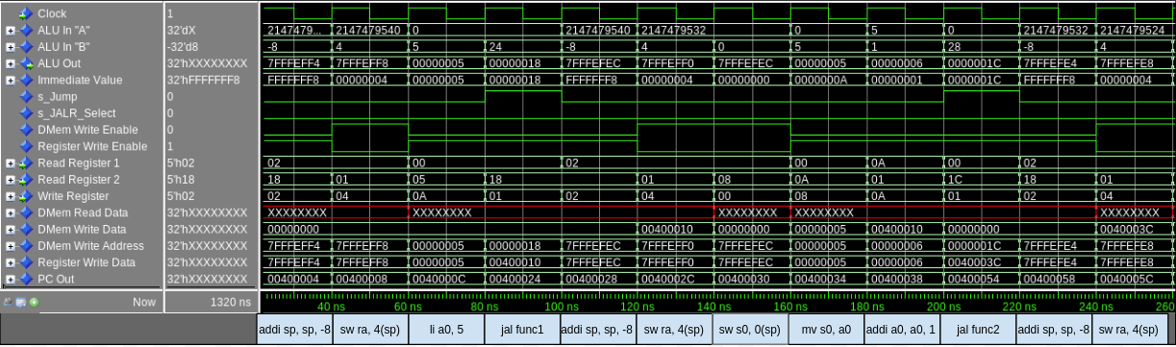
This first snapshot shows the beginning of the CF test, and demonstrates two jumps taking place. As you can see, the return addresses are being calculated and saved, and when jump is high, the PC jumps to the label and executes the instructions in that function.

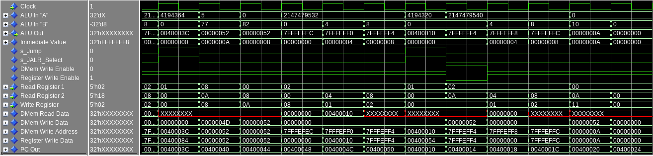
This second snapshot shows the collapsing of the telescope. When JALR_Select is high, that means a function has “returned”. The PC is set back to the return address, and the rest of main is executed sequentially.

[Part 4.c] Create and test an application that sorts an array with N elements using the MergeSort algorithm (link). Name this file Proj1_mergesort.s.

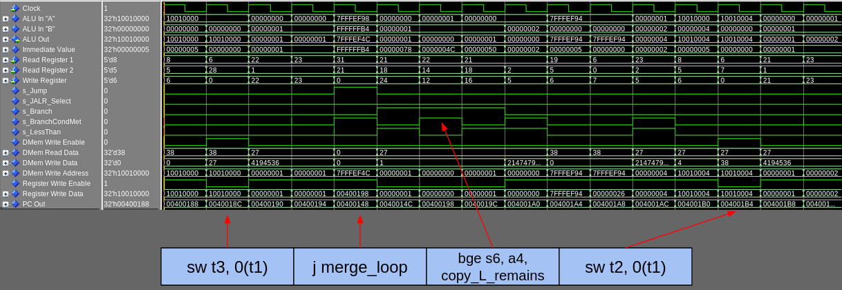
This screenshot of the merge sort waveform shows the moment where the first merge occurs. The values of 27 and 38 are being written back into the base address area, “32’h10010000”, but need to be swapped to correctly be sorted.

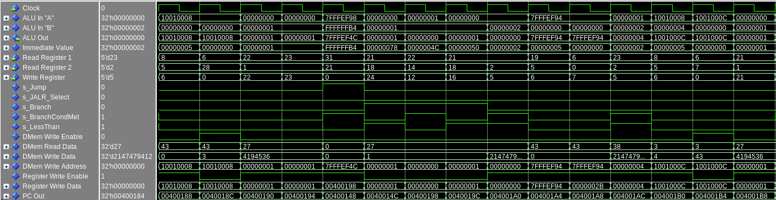
This pattern repeats itself during the second merge of the algorithm. When Dmem Write Enable is high, you can see the sw instructions where the 3 and 43 get swapped.

[Part 5] Report the maximum frequency your processor can run at and determine what your critical path is. Draw this critical path on top of your top-level schematic from part 1. What components would you focus on to improve the frequency?
Our maximum frequency reported after synthesis was 21.82mhz. The specific instruction being executed during this path was lw. The value is being propagated through our ALU, and because all operations are muxed, the operations have to be done and propagate even if they aren’t being selected through to the output. We can re design the ALU, and likely see a sharp increase in performance.
