**Synopsis**

2020_Q1_001

**Title:**

Harmonized Code Finder using voice assistant by applying ML/AI.

**Problem Statement:**

Application of machine learning in the harmonized code classification as required for international import and export for commodities. As per World Trade Organization (WTO), in the year 2018, World merchandise exports totalled US$ 19.48 trillion, up 10% from the previous year and its growing. When import and exports cross borders - World Customs Organization (WCO) plays a major role for the commodity classification which defines multipurpose international product nomenclature system call “HS” or “Harmonized System”. Over 98 % of the merchandise in international trade is classified in terms of the HS. It’s used internal taxes, trade policies, monitoring of controlled goods, rules of origin, freight tariffs, transport statistics, price monitoring, quota controls, compilation of national accounts, and economic research and analysis. So, the classification of commodities in the correct HS code is very much crucial.

The Harmonized Commodity Description and Coding System, also known as the Harmonized System (HS) of tariff nomenclature is an internationally standardized system of names and numbers to classify traded products. It came into effect in 1988 and has since been developed and maintained by the World Customs Organization (WCO), an independent intergovernmental organization based in Brussels, Belgium, with over 200 member countries.  
  
There are 8~14-digit numbers of a full code. The first 6 digits are global representation of the code and 7th to 14th digits are specific to a particular custom country and they are free to adopt standards based on their own custom rules. The hierarchical classification are organized as below –

Section (21 Sections)

* Chapters (97 Chapters) – 2 digit number
  + Headings – 4 digits (including 2 digits of chapter number)
    - Sub Headings – 6 digits (including 4 digits of headings)
      * Country specific digits – 6 to 8 digits for tariff item

Example –



So the HS classification is an essential international procedure for cross border imports and exports. Studies indicate that nearly 30% of all submitted HS codes are inaccurate as per . Providing proper Harmonized System (HS) codes efficiently for each traded product remains a challenging task and human expert are not readily available and it takes time for someone to become expert.

Harmonized Tariff Schedule (HTS) code classification is a surprisingly challenging machine learning problem - while at face value it is a simple multi-label classification, the real-world specifics are often deceptively intractable:

For starters, the quality of data available from most sources is rather poor, so automated decision-making systems have to learn to pull in external knowledge, and to develop a good understanding of understood norms.

In addition, target code classes change across geographies and with time, requiring algorithms to keep an eye out for stale data.

What's more, it's surprisingly difficult to have trained human annotators agree on what the right HS code for a given product should be - in datasets annotated by trained professionals, we usually see differing labels for the same product at least 30% of the time.

So building and automated systems that can deal with these challengesusing AI and machine learning methods with provision to search the correct HS code using voice command would be a leap step for smooth international shipping.

In absence of expert, generally shippers use to do below

* Search multiple websites for finding correct hs-code for the commodities
* Difficult to make correct decision many times
* Non-English search makes it difficult to find the right code
* Or spend money to get correct code from experts

**Objective and Scope:**

The objective is to provide PoC using google voice assistant to make user experience smooth to find the correct Harmonized Code for a commodity being shipped internationally. We will google AI/ML ecosystem (APIs) to build a prototype solution to achieve the objectives above.

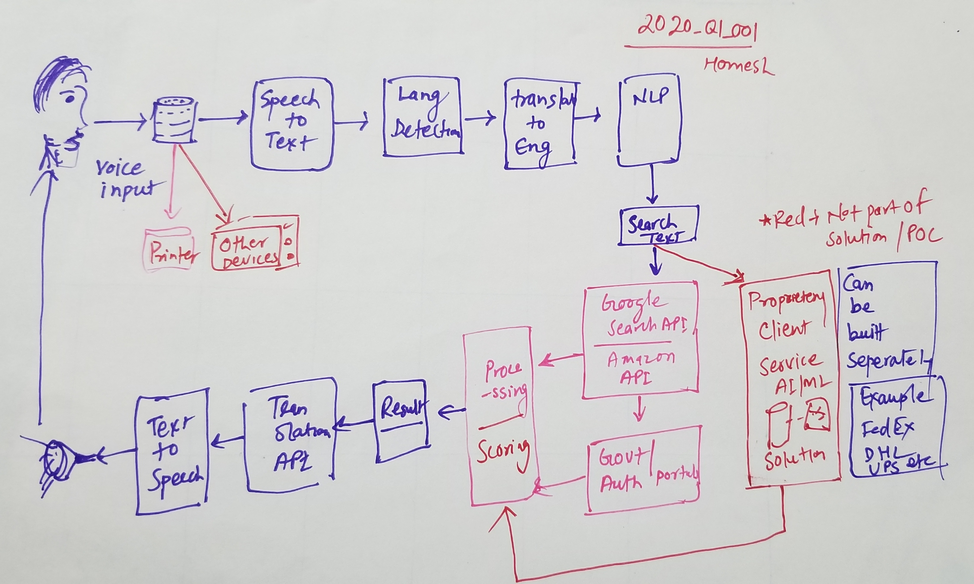

**Hardware used**

1. Voice Input Device (Example Google home or simple laptop voice input)
2. WorkStation with required softwares and internet connection

**Software Used:**

1. Python AI/ML packages to build core application
2. Google APIs (Language Detection, Transalation, classification, NLP, search etc)
3. Amazon APIs
4. DialogFlow (May be)

**How it is going to be useful:**

1. The App can be used as standalone or can be exposed as service to provide Harmonized code for given input via voice command
2. Also provide more explanation about the product for users knowledge and decision
3. This will be helpful for logistics company’s which will ship products/ items from one country to another country along with individual shippers
4. Can be plugged in with propriety applications built by customers but this is not part of the POC/solution as there is no customer permission to use or explore