Overworld Navigation

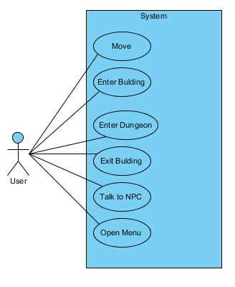

Use Case Description:

|  |  |
| --- | --- |
| **Use Case Name** | Move |
| **Use Case ID** | UC-001 |
| **Super Use Case** | Overworld Navigation |
| **Actor(s)** | User |
| **Description** | The user controls the main character for it to navigate freely through the map. |
| **Post-Conditions** | The user must be able to see in real time the character moving in the screen accordingly to player’s input. |
| **Flow of Events** | 1. The game is running in “Overworld”. 2. The User presses the corresponding key to the movement he/she desires to perform. 3. The screen is updated and the position of the character changes according to the keys pressed. |
| **Exceptions** | The character gets blocked between collision of obstacles and the map edges. |
| **Priority** | High |
| **Assumptions** | The user is using a Keyboard to play the game. |
| **Input** | “Up”, “Down”, “Left”, “Right” Keys in the Keyboard for movement. |
| **Output** | Updated position of the character in the screen. |
| **Non Behavioral Requirements** | Keyboard connected to computer. |

|  |  |
| --- | --- |
| **Use Case Name** | Enter Building |
| **Use Case ID** | UC-002 |
| **Super Use Case** | Overworld Navigation |
| **Actor(s)** | User |
| **Description** | The user moves the character to a building door and the map changes from “Overworld” to inside the building. |
| **Pre-Conditions** | 1. User must be able to move. 2. The user must collide directly with the building’s door. 3. The user must be outside the building. |
| **Post-Conditions** | The screen stops showing the “Overworld” and displays the view from inside the building room. |
| **Flow of Events** | 1. The user moves the character to the entrance of a building. 2. Collision between the character and the door is detected. 3. The “Overworld” view disappears and the view of the room inside the building is displayed. |
| **Exceptions** | 1. The character gets blocked between collision of obstacles and the map edges. 2. Collision is not detected. |
| **Priority** | High |
| **Input** | “Up”, “Down”, “Left”, “Right” Keys in the Keyboard for movement. |
| **Output** | Updated position of the character in the screen, and new view form inside the building. |

|  |  |
| --- | --- |
| **Use Case Name** | Enter Dungeon |
| **Use Case ID** | UC-003 |
| **Super Use Case** | Overworld Navigation |
| **Actor(s)** | User |
| **Description** | The user moves the character to a building door and the map changes from “Overworld” to inside the building. |
| **Pre-Conditions** | 1. User must be able to move. 2. The user must collide directly with the building’s door. |
| **Post-Conditions** | The screen stops showing the “Overworld” and displays the view from inside the building room. |
| **Flow of Events** | 1. The user moves the character to the entrance of a building. 2. Collision between the character and the door is detected. 3. The “Overworld” view disappears and the view of the room inside the building is displayed. |
| **Exceptions** | The character gets blocked between collision of obstacles and the map edges. |
| **Priority** | High |
| **Assumptions** | The user is using a Keyboard to play the game. |
| **Input** | “Up”, “Down”, “Left”, “Right” Keys in the Keyboard for movement. |
| **Output** | Updated position of the character in the screen. |
| **Non Behavioral Requirements** | Keyboard connected to computer. |

|  |  |
| --- | --- |
| **Use Case Name** | Exit Building |
| **Use Case ID** | UC-004 |
| **Super Use Case** | Overworld Navigation |
| **Actor(s)** | User |
| **Description** | The user moves the character to a building door and the map changes from inside the building view to the “Overworld” map. |
| **Pre-Conditions** | 1. User must be able to move. 2. The user must collide directly with the building’s door. 3. The User must be inside the building. |
| **Post-Conditions** | The screen stops showing the view from inside the building, and changes to the “Overworld” map view. |
| **Flow of Events** | 1. The user moves the character to the entrance of a building. 2. Collision between the character and the door is detected. 3. The inside the building view disappears and the view of the “Overworld” map is displayed. |
| **Exceptions** | 1. The character gets blocked between collision of obstacles and the map edges. 2. The collision is not detected. |
| **Priority** | High |
| **Input** | “Up”, “Down”, “Left”, “Right” Keys in the Keyboard for movement. |
| **Output** | Updated position of the character in the screen, and new view of the “Overworld” map. |

|  |  |
| --- | --- |
| **Use Case Name** | Talk to NPC |
| **Use Case ID** | UC-005 |
| **Super Use Case** | Overworld Navigation |
| **Actor(s)** | User |
| **Description** | The user interacts with NPC and a conversation is displayed at the bottom of the screen. |
| **Pre-Conditions** | 1. The Character must be right by the NPC. 2. The “Spacebar” key must be pressed first. |
| **Post-Conditions** | A conversation box appears in the bottom of the screen displaying messages to the player. |
| **Flow of Events** | 1. The user places the character close to the NPC. 2. The User presses the “spacebar” key to initiate the event to start the conversation. 3. The message from the NPC to the character is displayed in a conversation box at the bottom of the screen. |
| **Exceptions** | 1. The character is not close enough to the NPC 2. Collision is not detected. 3. No message is displayed. |
| **Priority** | Medium |
| **Input** | “Up”, “Down”, “Left”, “Right” Keys in the Keyboard for movement, “spacebar” to initiate conversation with NPC. |
| **Output** | Conversation box at the bottom of the screen. |

|  |  |
| --- | --- |
| **Use Case Name** | Open Menu |
| **Use Case ID** | UC-006 |
| **Super Use Case** | Overworld Navigation |
| **Actor(s)** | User |
| **Description** | The user is able to access the game menu from the game screen. |
| **Post-Conditions** | The menu screen is displayed for the user and the game is paused. |
| **Flow of Events** | 1. The user is in-game. 2. The User presses the key to enter the menu. 3. The game is paused. 4. The menu screen is displayed. |
| **Priority** | Low |
| **Input** | Menu key. |
| **Output** | Game menu screen. |

Dungeon Navigation

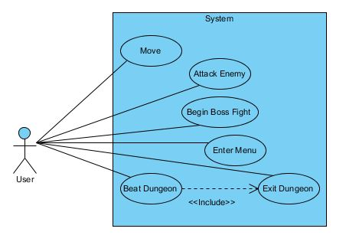

|  |  |
| --- | --- |
| **Use Case Name** | Move |
| **Use Case ID** | UC-007 |
| **Super Use Case** | Dungeon Navigation |
| **Actor(s)** | User |
| **Description** | The user controls the main character for it to navigate freely through the map. |
| **Pre-Condition** | Must be inside a Dungeon. |
| **Post-Conditions** | The user must be able to see in real time the character moving in the screen accordingly to player’s input. |
| **Flow of Events** | 1. The User is inside a Dungeon. 2. The User presses the corresponding key to the movement he/she desires to perform. 3. The screen is updated and the position of the character changes according to the keys pressed. |
| **Exceptions** | The character gets blocked between collision of obstacles and the map edges. |
| **Priority** | High |
| **Assumptions** | The user is using a Keyboard to play the game. |
| **Input** | “Left”, “Right” Keys in the Keyboard for movement. |
| **Output** | Updated position of the character in the screen. |
| **Non Behavioral Requirements** | Keyboard connected to computer. |

|  |  |
| --- | --- |
| **Use Case Name** | Attack Enemy |
| **Use Case ID** | UC-008 |
| **Super Use Case** | Dungeon Navigation |
| **Actor(s)** | User |
| **Description** | The user is able to attack enemies in the screen and defeat them. |
| **Pre-Condition** | Must be inside a Dungeon. |
| **Post-Conditions** | The defeated enemy disappears from the map. |
| **Flow of Events** | 1. The User moves close enough to the enemy to perform an attack. 2. The User presses the attack key. 3. Collision is detected and if the attack was within range the enemy is defeated and disappears. |
| **Exceptions** | The attack is out of range to be effective. |
| **Priority** | High |
| **Assumptions** | The user is using a Keyboard to play the game. |
| **Input** | “Left”, “Right” Keys in the Keyboard for movement and attack key. |
| **Output** | Attack animation and enemy is removed from the screen. |
| **Non Behavioral Requirements** | Keyboard connected to computer. |

|  |  |
| --- | --- |
| **Use Case Name** | Begin Boss Fight |
| **Use Case ID** | UC-009 |
| **Super Use Case** | Dungeon Navigation |
| **Actor(s)** | User |
| **Description** | The user starts a fight with a final enemy at the end of the Dungeon. |
| **Pre-Condition** | 1. Must be inside a Dungeon. 2. The player must reach the final stage of the Dungeon. |
| **Post-Conditions** | The fight begins and the User is not allowed to exit the room where the fight is taking place. |
| **Flow of Events** | 1. The User reaches the Dungeon’s Boss room. 2. Boss appears and the battle begins. |
| **Exceptions** | The Dungeon has already been cleared. |
| **Priority** | High |
| **Input** | “Left”, “Right” Keys in the Keyboard for movement and attack key. |
| **Output** | Dungeon Boss appears in the screen. |

|  |  |
| --- | --- |
| **Use Case Name** | Enter Menu |
| **Use Case ID** | UC-010 |
| **Super Use Case** | Dungeon Navigation |
| **Actor(s)** | User |
| **Description** | The user is able to access the game menu from the game screen. |
| **Post-Conditions** | The menu screen is displayed for the user and the game is paused. |
| **Flow of Events** | 1. The user is in-game. 2. The User presses the key to enter the menu. 3. The game is paused. 4. The menu screen is displayed. |
| **Priority** | Low |
| **Input** | Menu key. |
| **Output** | Game menu screen. |

|  |  |
| --- | --- |
| **Use Case Name** | Begin Dungeon |
| **Use Case ID** | UC-011 |
| **Super Use Case** | Dungeon Navigation |
| **Actor(s)** | User |
| **Description** | The User defeats the Dungeon Boss. |
| **Pre-Condition** | 1. User HP above 0 (zero). 2. Boss HP reaches 0 (zero). |
| **Post-Conditions** | 1. A member of the “Scrum Team” is released. 2. The state of the Dungeon changes to cleared. 3. New information about other dungeons becomes available to the user by the NPCs |
| **Flow of Events** | 1. The User decreases the HP of the Boss to 0 (zero). 2. Clear message is displayed. 3. Team member is rescued. 4. The character exits the Dungeon. |
| **Exceptions** | The User is defeated by the Boss. |
| **Priority** | High |
| **Output** | Dungeon Boss appears in the screen. |

|  |  |
| --- | --- |
| **Use Case Name** | Exit Dungeon |
| **Use Case ID** | UC-012 |
| **Super Use Case** | Dungeon Navigation |
| **Actor(s)** | User |
| **Description** | The User walks out of the dungeon or clears it. |
| **Pre-Condition** | 1. User must be inside a Dungeon. 2. User must be able to move. 3. The User collides with the Dungeon’s entrance. |
| **Post-Conditions** | The Dungeon side view changes to the up view inside a building room. |
| **Flow of Events** | 1. The User moves to the entrance of the Dungeon. 2. Collision is detected. 3. The side view of the Dungeon disappears and the view from inside the building room is displayed. |
| **Exceptions** | The Dungeon has already been cleared. |
| **Priority** | Medium |
| **Input** | “Left”, “Right” Keys in the Keyboard for movement. |
| **Output** | View from inside the building is displayed. |

Menu Navigation

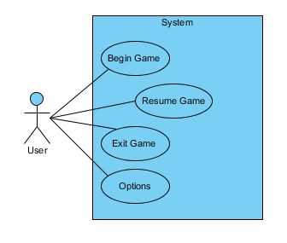

|  |  |
| --- | --- |
| **Use Case Name** | Begin Game |
| **Use Case ID** | UC-013 |
| **Super Use Case** | Menu Navigation |
| **Actor(s)** | User |
| **Description** | The game starts. |
| **Pre-Condition** | Game is being started for the first time. |
| **Post-Conditions** | The “Overworld” is displayed and the player is able to start playing. |
| **Flow of Events** | 1. The user starts the game program. 2. The menu is displayed in the screen. 3. The user clicks on “Start Game”. 4. The game starts. |
| **Exceptions** | The game has been started before. |
| **Priority** | Medium |
| **Input** | Accept key. |
| **Output** | Game “Overworld” screen view. |

|  |  |
| --- | --- |
| **Use Case Name** | Resume Game |
| **Use Case ID** | UC-014 |
| **Super Use Case** | Menu Navigation |
| **Actor(s)** | User |
| **Description** | The game resumes at the same state in which it was before the menu was opened from the game. |
| **Pre-Condition** | The game is paused and the menu is open. |
| **Post-Conditions** | Game resumes, and the player is able to control the character again and continue with the game. |
| **Flow of Events** | 1. The user selects the “Resume” option from the menu. 2. The menu closes. 3. The game screen is displayed. 4. The game resumes. |
| **Exceptions** | The game has been started before. |
| **Priority** | Medium |
| **Input** | Accept key. |
| **Output** | Game screen view. |

|  |  |
| --- | --- |
| **Use Case Name** | Exit Game |
| **Use Case ID** | UC-015 |
| **Super Use Case** | Menu Navigation |
| **Actor(s)** | User |
| **Description** | The game program closes. |
| **Flow of Events** | 1. The user selects the “Exit” option from the menu. 2. The game program closes. |
| **Priority** | Low |
| **Input** | Accept key. |

|  |  |
| --- | --- |
| **Use Case Name** | Options |
| **Use Case ID** | UC-016 |
| **Super Use Case** | Menu Navigation |
| **Actor(s)** | User |
| **Description** | The menu displays another menu to handle the options for the player regarding the game. |
| **Post-Conditions** | All changes save and are applied to the game. |
| **Flow of Events** | 1. The user goes into options in the game menu. 2. The menu is displayed in the screen. 3. The user performs changes to the settings. 4. Changes are saved and applied in the background. 5. The user can keep doing changes or go back to the game menu. |
| **Priority** | High |
| **Input** | Accept key. |

NPC Interaction

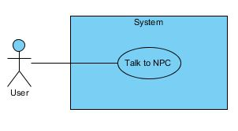

|  |  |
| --- | --- |
| **Use Case Name** | Talk to NPC |
| **Use Case ID** | UC-017 |
| **Super Use Case** | NPC Interaction |
| **Actor(s)** | User |
| **Description** | A message from the NPC is displayed in the bottom of the screen. |
| **Pre-Condition** | User must be in collision with the NPC. |
| **Flow of Events** | 1. The user starts the game program. 2. The menu is displayed in the screen. 3. The user clicks on “Start Game”. 4. The game starts. |
| **Exceptions** | The game has been started before. |
| **Priority** | Medium |
| **Input** | “Spacebar” key. |
| **Output** | Message from NPC |

Enemy Interaction

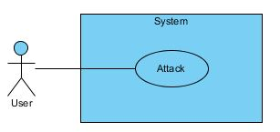

|  |  |
| --- | --- |
| **Use Case Name** | Attack |
| **Use Case ID** | UC-018 |
| **Super Use Case** | Enemy Interaction |
| **Actor(s)** | User |
| **Description** | Enemies try to attack the user. If the enemies are hit by the user they lose HP, and when the HP reaches 0 (zero) the enemy disappears. |
| **Pre-Condition** | User must be in a Dungeon that hasn’t been clear. |
| **Flow of Events** | 1. Enemy is in range of attack from the user. 2. Damage to both user and enemy are applied. 3. Enemy HP reaches 0 (zero) and disappears. |
| **Exceptions** | The user HP reaches 0 (zero) |
| **Priority** | High |
| **Input** | Attack key |
| **Output** | Enemy and attacks in the screen |

Overworld Navigation Activity Diagram

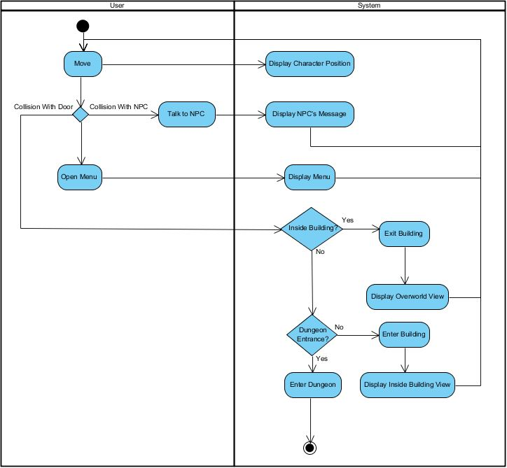

Dungeon Navigation Activity Diagram

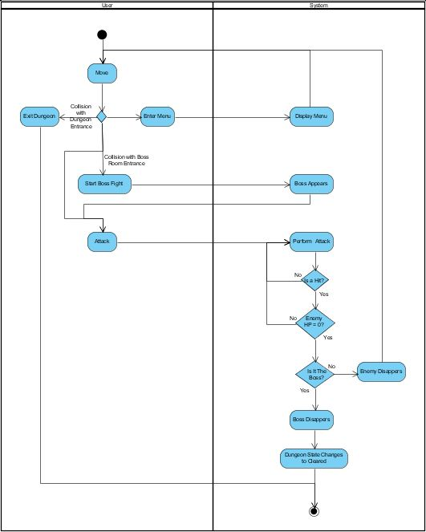

Menu Navigation Activity Diagram

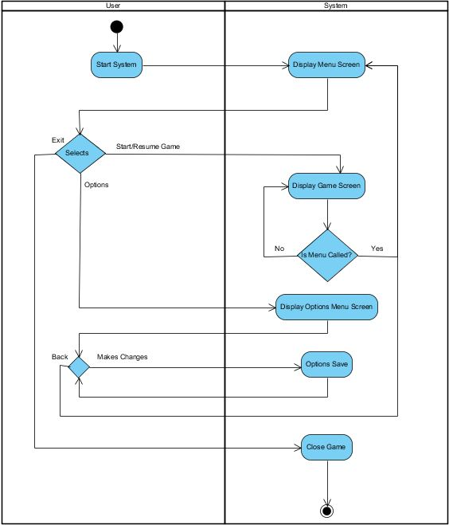

Enemy State Diagram

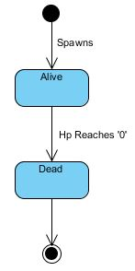

Team Members State Diagram

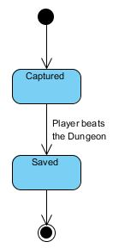

Dungeon State Diagram

