Report on Instrument Deployment Robotics Arm

Justin Leung

Garrette Marcotte

Bill Pang

MAE345 Midterm Project

November 20th, 2009

Abstract

* Major approach and findings

Table of Contents

Introduction

* Background and motivation
* Purpose of robot
* Way in which it functions
* Organization of paper

Robotics Arm Configurations

* Size, weight, volume, shape, structure description, etc.

Material

* Physical properties.

Sensors and Actuators

* Detailed list of parameters

Mechanism of Action

A core part of action mechanism is to figure out what angles each joint needs to be at each moment in time in order to reach the reference position for a given rock surface positioned at

(x, y, z). The first step in this procedure is to figure out the FINAL angles we need each joint to have, when the arm is AT the reference position.

This part is non-trivial, and is analyzed below. For the matlab code implementing the ideas presented below, see Appendix A.

Step 1: Ignore y coordinate (vertical) for now. Using only the x and z coordinates of rock surface, we can already determine the neck yaw angle (φ) needed, as well as the “radius”, which is defined as the (axial) distance from base of arm to rock *as if there were no lateral displacement*. It is drawn in the diagrams below. Also, lateral displacement occurs in 2 parts, 1 on the connector between upper arm and lower arm, which has length 4, the other on the connector between lower arm and manipulator, which has length 8. So total lateral displacement = 12cm in this design. In the derivations to follow, we combine these 2 displacement into 1 equivalent lateral displacement, d.

Thus the current problem is: given x, z, d, find φ and radius.

We break the situation down into 3 cases because each case has a slightly different geometry: z >0 (case 1), z=0 (case 2), z<0 (case 3).

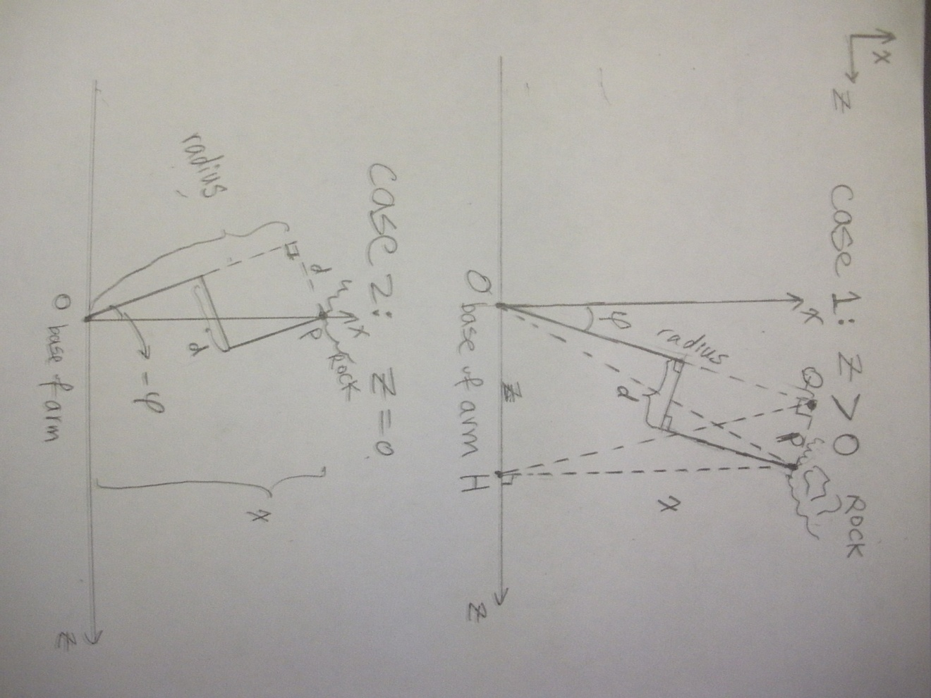

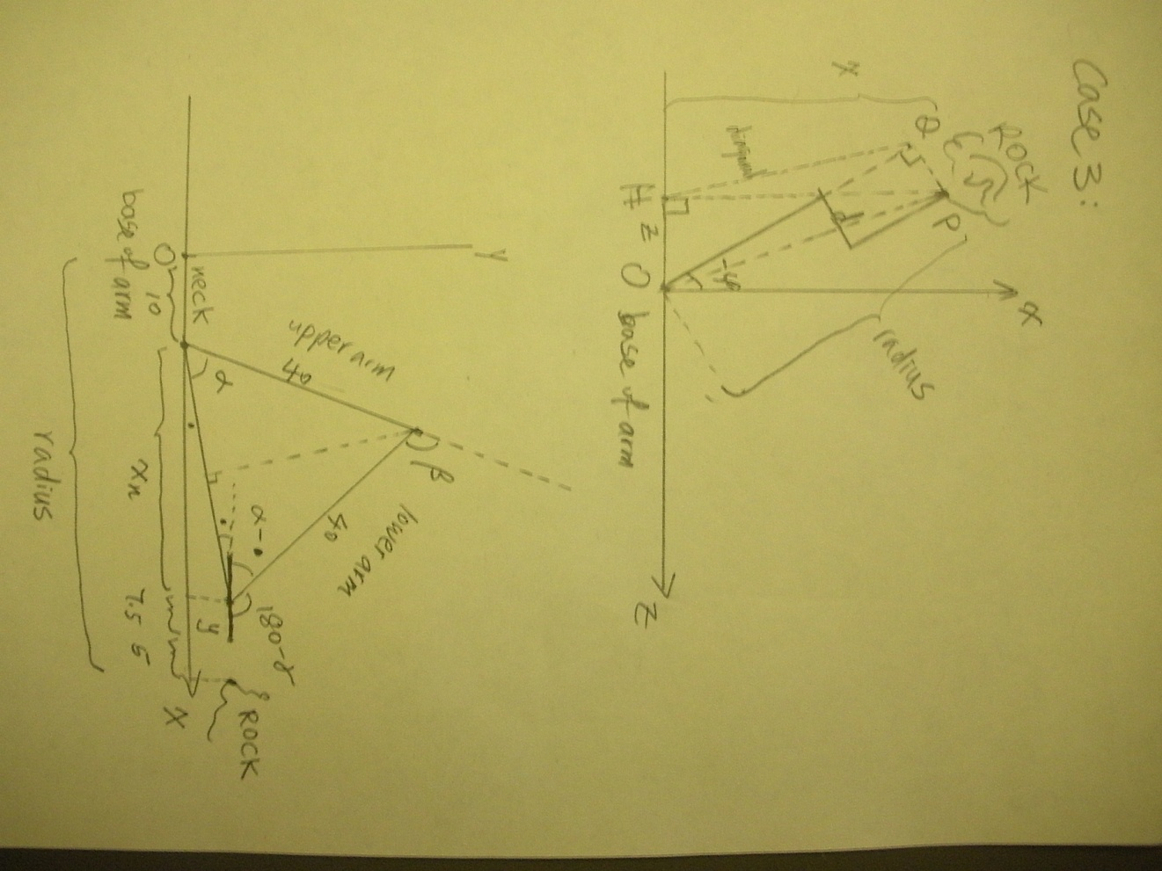

In case 3, we have z to the left of the x axis, so much of the calculation remains the same, but some signs we reversed:

Again we have OHPQ is a cyclic

Quadrilateral, because of the 2 right angles at Q and H. We first find radius OQ, then apply Ptolemy’s Theorem and Cosine Law to find φ, which is negative, because we (or matlab) has defined the axis and rotation such that when the arm is pointing along x axis, φ is 0, and when it turns to the left, φ is negative. We have:

And radius is given by the same formula.

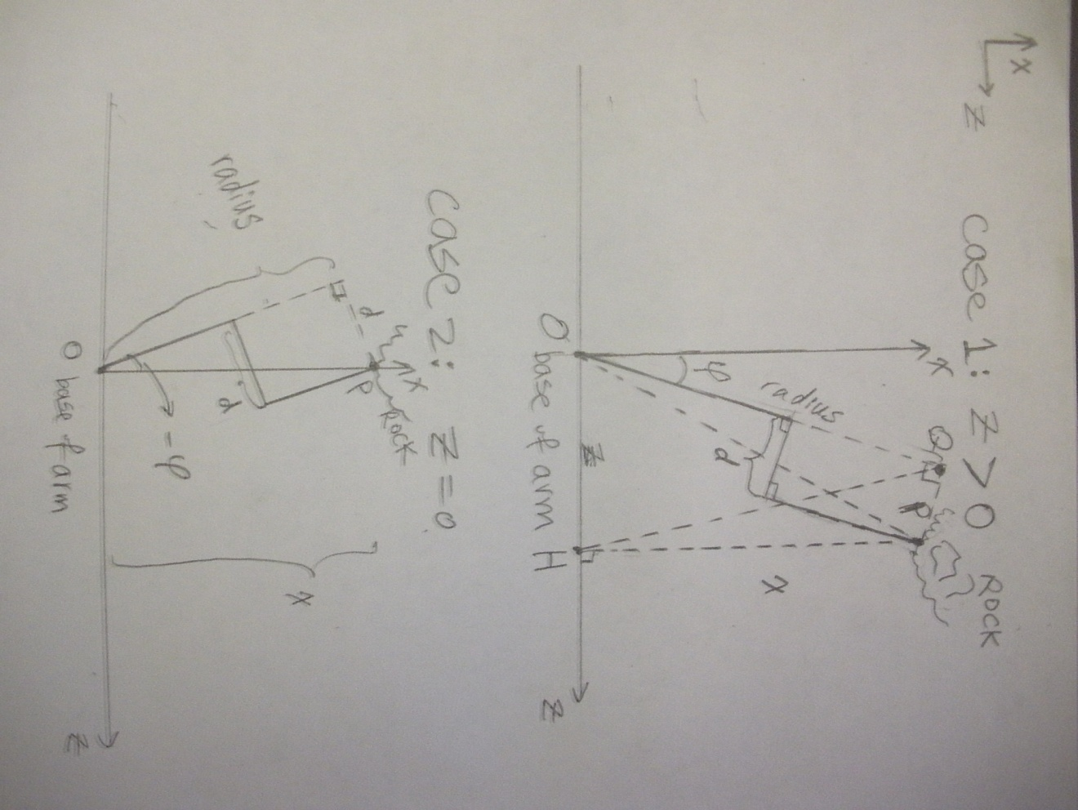The second case is when z = 0. Notice that we can no longer divide by z, as is done in the formula above. The geometry is the following:

Step 2: Now having settled yaw angle and radius, we look at the vertical (x-y) plane at the yaw angle, and see what angles of the other joints are required to have the drill head reach reference position. Firstly, we recognize that the radius calculated is the distance “along” the arm in the forward direction, but includes the length of the neck piece, half the length of the manipulator, and the 5 cm from reference position to the rock. So we subtract these out to find the *net* x-distance, called xn: xn = radius – 10cm – (15/2)cm – 5 cm = radius – 22.5 .

Refer to diagram on the next page.

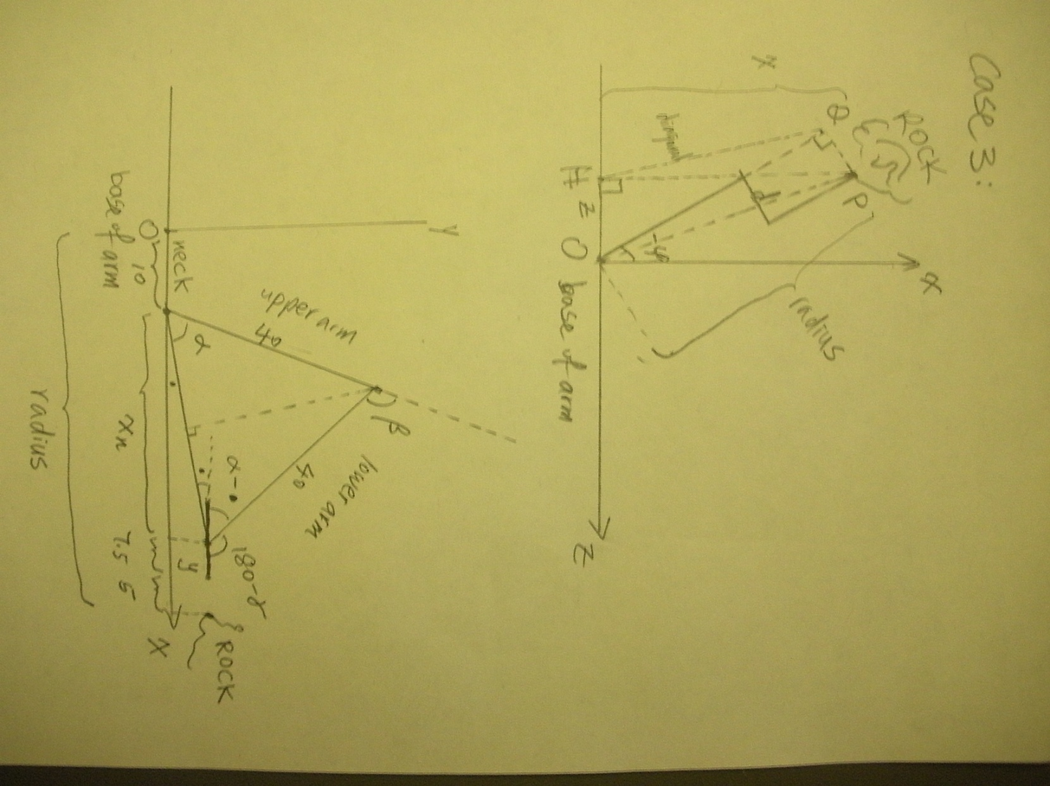

Note: in this diagram, the x axis is NOT the same x axis as before; it is simply the axis ALONG the direction of the arm. It is only equal to the x axis when neck yaw angle = 0. It is called the x axis here, perhaps confusingly, because most of the time we are dealing with arms pointing straight forward, and it is convenient to decompose motion into components of “along the arm” and “perpendicular to it”. As the reader will see, this different definition of x axis makes no difference in the calculations to follow.

We subtracted all these components off radius to get xn, because xn is what’s relavant in calculating angles of the upper arm, lower arm, and manipulator.

It is important to note how the radius in this diagram corresponds to the radius defined and calculated in the previous part. Convince yourself that they are indeed the same distance.

So the problem at this stage is: given xn, y, and arm lengths, find joint angles .

The result immediately follows from the diagram:

So

Note: is the angle labelled with a dot in the diagram.

So for given coordinate of rock position (x, y, z) relative to base of arm, we have caluclated the required joint angle at the end position. Now the question is how to reach there, from the curled up position.

We need to take into account the phyiscal limit on movements of links. But even then, there are multiple feasible plans. We came up with the motion plan described below to transfer the arm from its curled up position to the reference position with angles just caluclated, with the following considerations in mind:

* This transfer plan is modular: each joint moves into position sepaerately to the extent possible, so easy to control.
* This transfer plan does not involve any part of the arm going too low in the y direction, which would mean hitting the ground.
* This transfer plan avoids hitting the vehicle too.

Transfer plan: The arm will start from the curled position, extend out to engage target, drill into rock, take pictures, then curl back up, in 40 seconds. This time interval can be easily changed as need arises.

Stage 1: arm rotates outward to face forward, in the x-direction. This correpsonds to only a neck yaw movement form 90 degrees to , at uniform speed, from t = 0 to 5 sec.

Stage last: this is the complement of stage 1; the arm rotates inward back underneath the rover. This means a neck yaw from to 90, at uniform speed, form t = 35 to t = 40 sec.

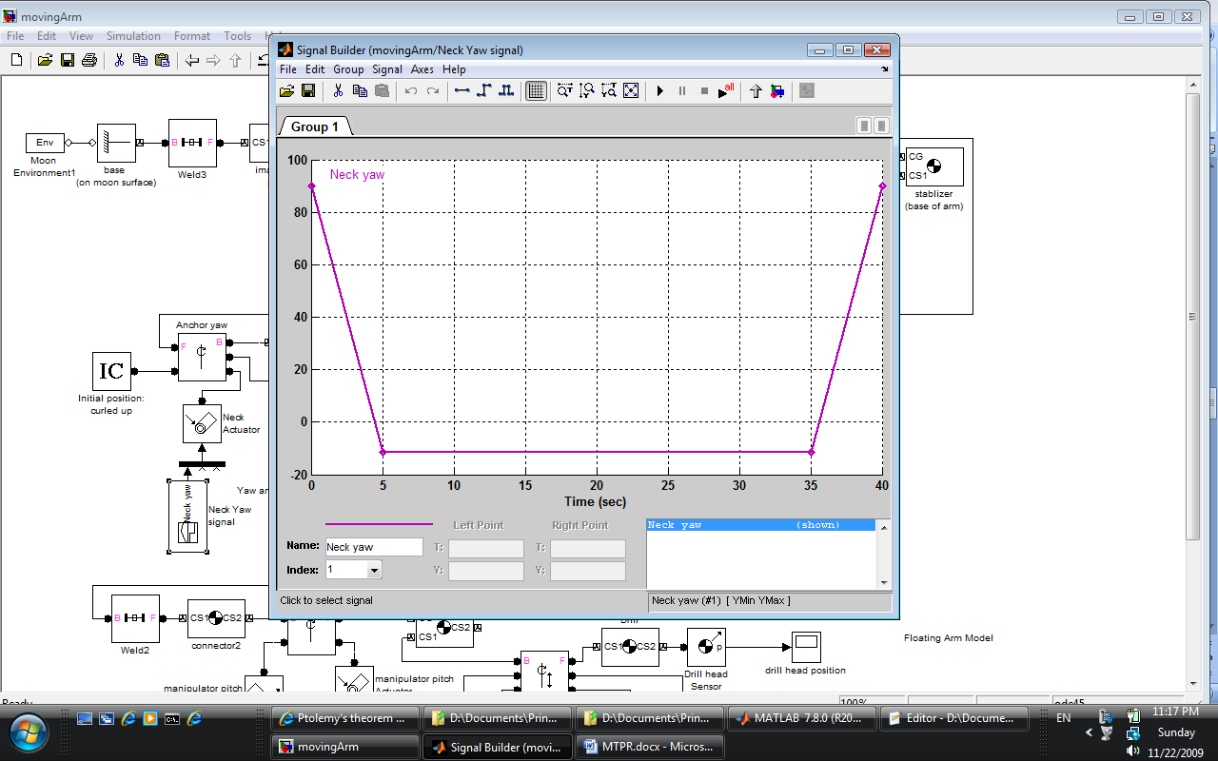The required yaw angle for the neck yaw joint for the 40 sec duration is displayed below:

Stage 2: upper arm raises from flat to 70 degrees up, to facilitate later extension of lower arm (without hitting the ground). This occurs at uniform speed from time 5 to 10.

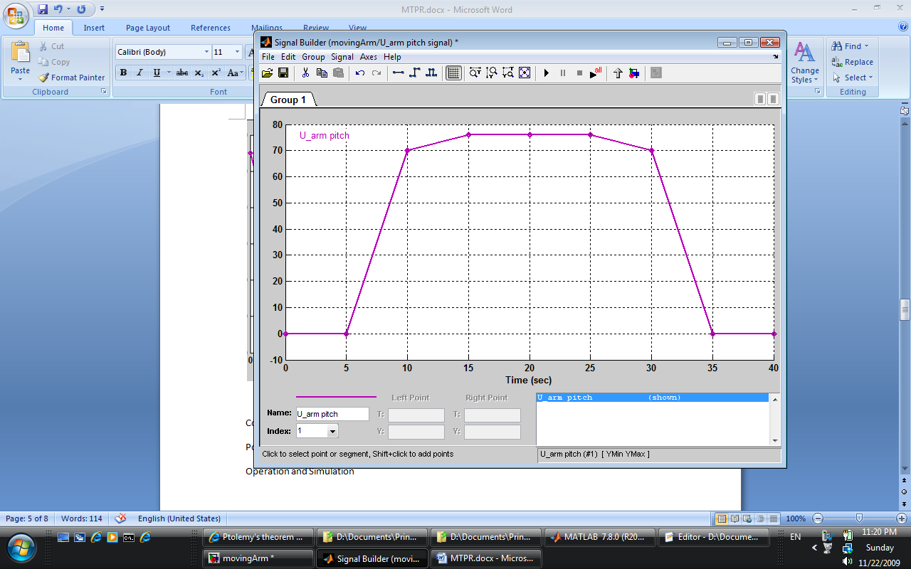

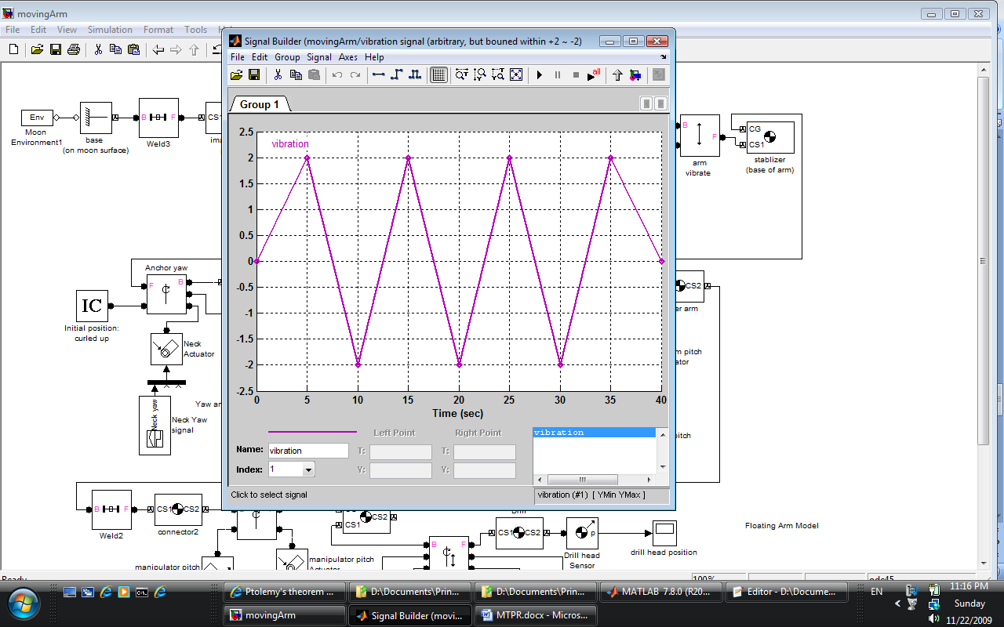

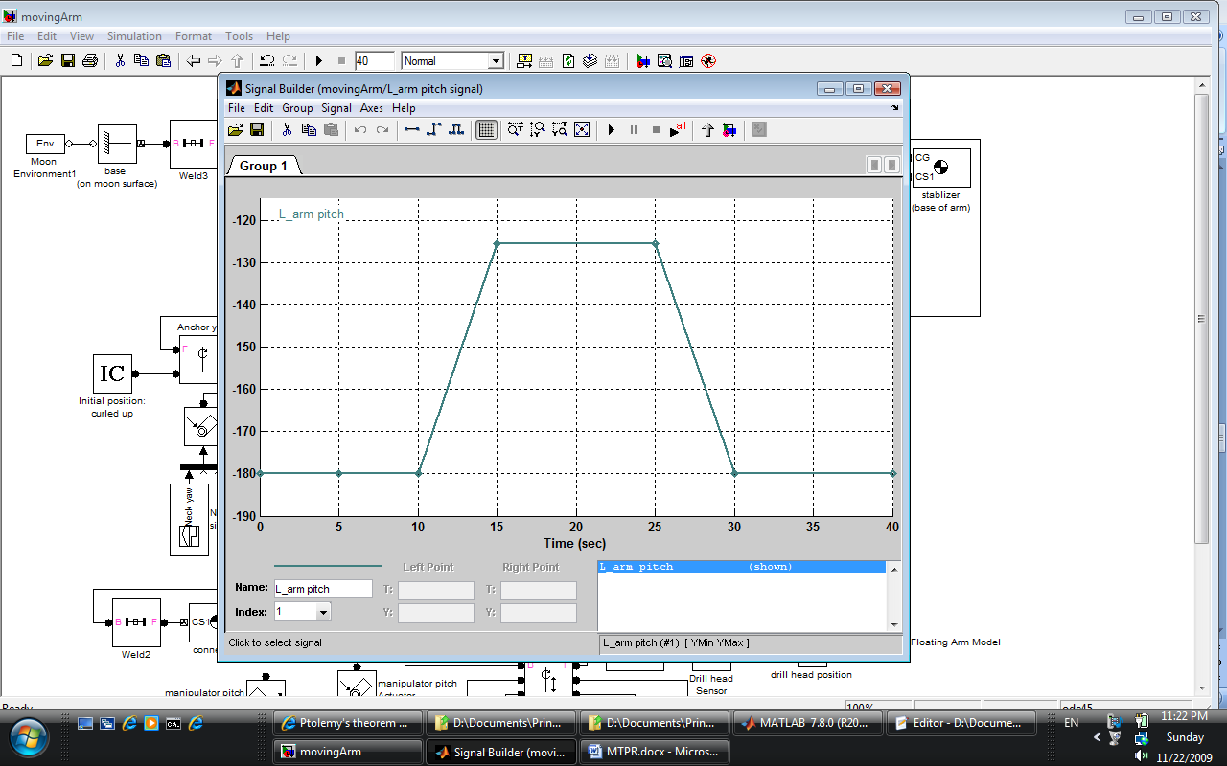

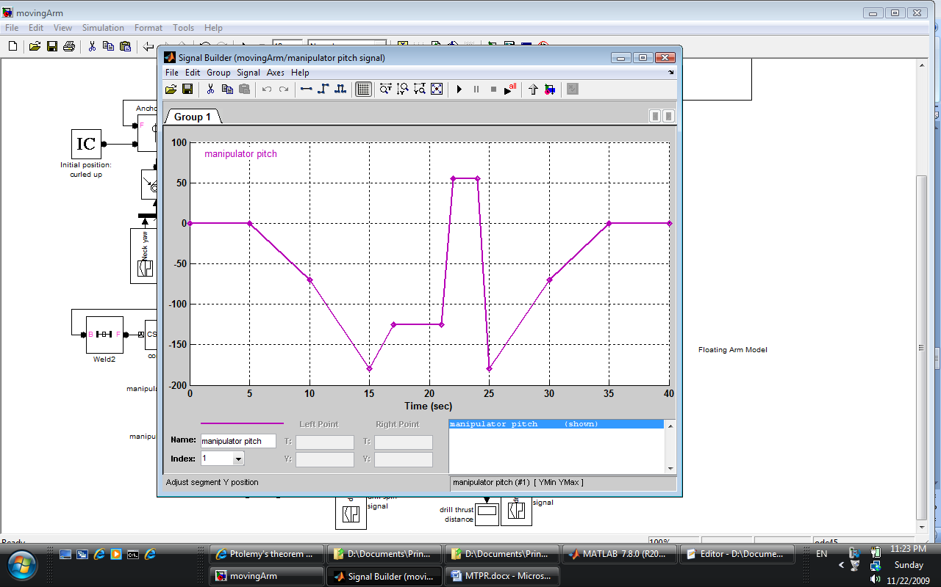

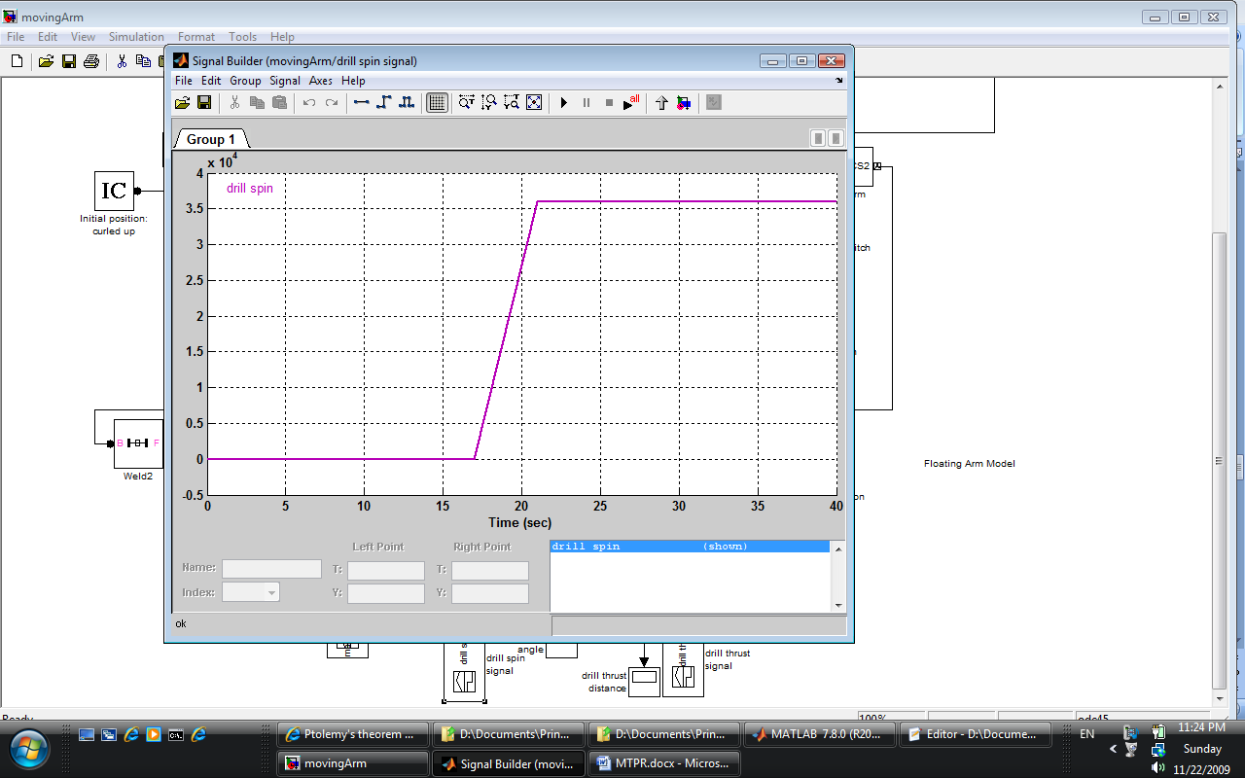

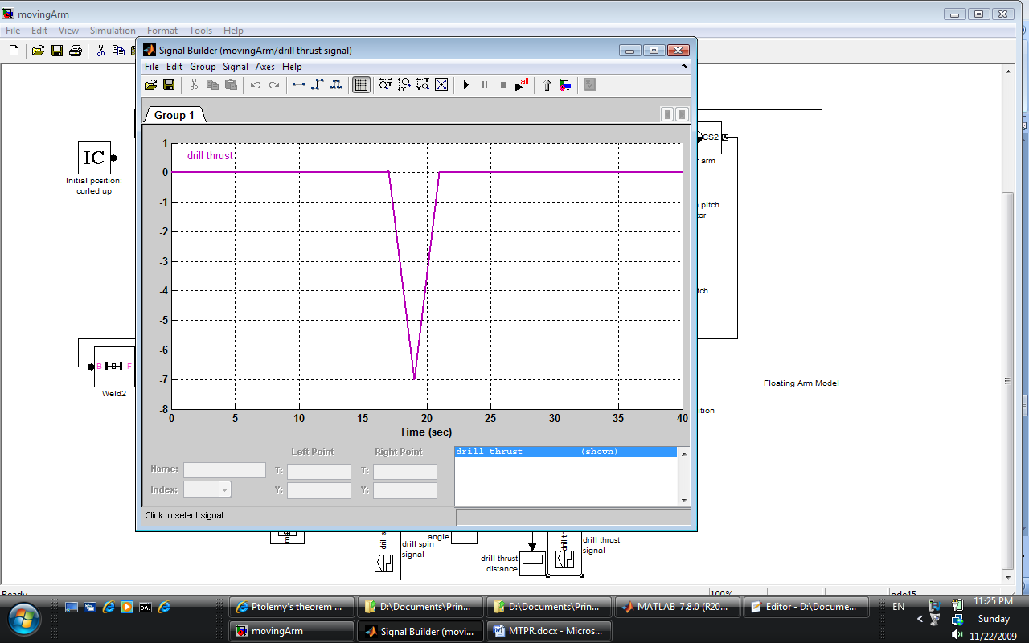

Control Logic

Power Consumption

Operation and Simulation

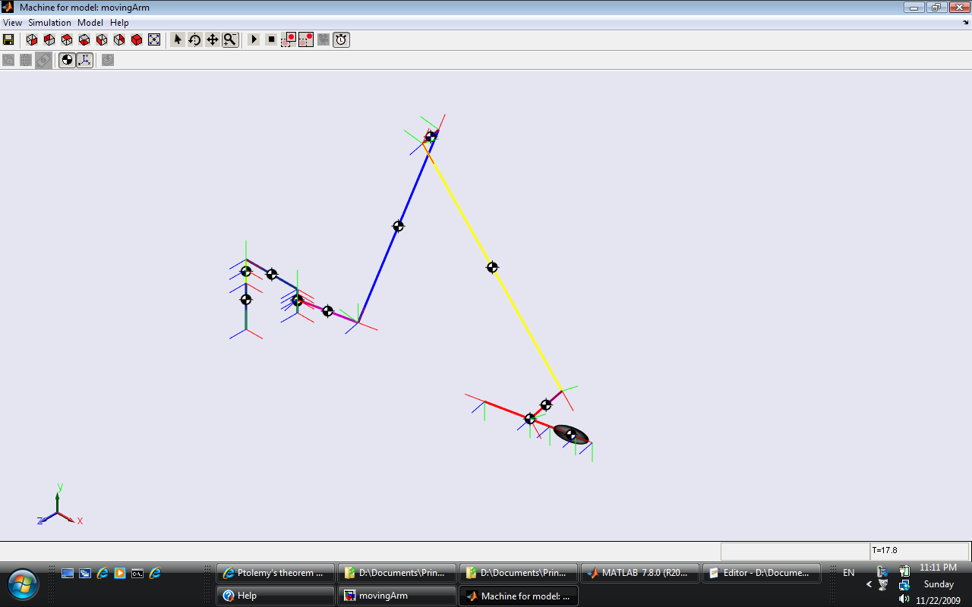

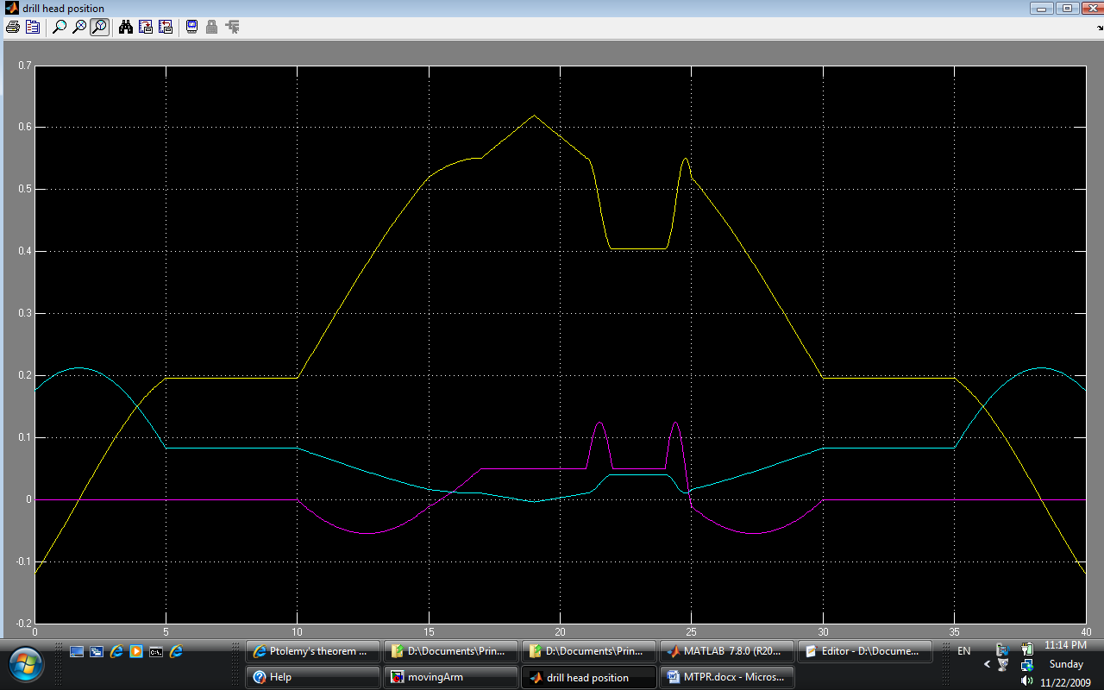

Major Pitfalls

Feasibility and Future

(use equations, figures, tables, graphs, citations, and animations)

(cite all tables/equations/graphs borrowed. )

(format tables/graphs in appropriate manner to make information easy to understand. Explain their significance. )

(no babbling)

Conclusion`

Works Cited

Appendix A: Matlab code for angle calculator

function [alpha beta gamma phi] = CalAngle(x, y, z)

%% x = forward distance from base of arm to rock surface

%% y = vertical distance from base of arm to rock surface

%% z = lateral distance from base of arm to rock surface

% alpha = inclination of neck-upperarm joint

% beta = bending down of upper-lower arm joint

% gamma = angle between lower arm and manipulator

% phi = yaw of anchor joint

% L = length of upper arm and lower arm

% N = length of neck

% R = distance from CG of manipulator to tip

% REF = 5 cm, specified in the problem

% OFFSET = lateral offset of the tip of drill from arm base

L = 40;

N = 10;

R = 7.5;

REF = 5;

OFFSET = 12;

radius = (x^2+z^2-OFFSET^2)^0.5;

xn = radius - N - R - REF;

beta = -180 + 2\*asin((xn^2+y^2)^0.5/2/L)/pi\*180

alpha1 = atan(y/xn);

alpha2 = acos((xn^2+y^2)^0.5/2/L);

alpha = (alpha1 + alpha2)/pi\*180

gamma = (alpha2 - alpha1)/pi\*180

diagonal = (x\*radius + OFFSET\*z)/(x^2 + z^2)^0.5;

if z > 0

phi = 90 - acos((radius^2 + z^2 - diagonal^2)/(2\*radius\*z))/pi\*180

elseif z == 0

phi = -asin(OFFSET/x)/pi\*180

else

phi = acos((radius^2 + z^2 - diagonal^2)/(2\*radius\*abs(z)))/pi\*180 - 90

end

end