React Programming Notes
Notes by George Marcotte
updated 2020-11-12

Table of Contents
Introduction 3
Documentation 3
Environment 3
Installing dependencies. 4
Developer tools 5
Using Visual studio code 5
Install extensions on Vscode 6
Getting started 7
Examples 7
Hello world program 7
The counter example 8
Addition game example 11
JSX 13
Components 15
Type checking 17
PropTypes 17
Formatting types 18
Styled components 18
Managing state in class based components 20
State Change Example 21
Managing state with functional object using hooks 22
Rendering Dynamic list of components 23
uuid 23
Form input controls 25
FormData 25
Uploading files in a form 25
File picker control 26
Async and Sync, 28
Promises 28
Lifecycles 29
componentDidMount 29
componetDidUpdate 29
componentWillUnmount 29
Redux 29
Ramda 30
Build Environment 31
Installing the initial code base: 31
Extensions for visual studio code: 31
Deployment 32
Deploying to github pages 32
Interview questions 33
Differentiate between Real DOM and Virtual DOM. 33
What is React? 33
What are the features of React? 33
List some of the major advantages of React. 33
What are the limitations of React? 33
What is JSX? 33
What do you understand by Virtual DOM? Explain its working 34
Why can’t browsers read JSX? 34
How different is React’s ES6 syntax when compared to ES5? 34
How is React different from Angular? 34
What do you understand from “In React, everything is a component.” 34
Explain the purpose of render() in React. 34
How can you embed two or more components into one? 35
What is a state in React and how is it used? 35
How can you update the state of a component? 36
What is arrow function in React? How is it used? 36
Differentiate between stateful and stateless components. 36
What are the different phases of React component’s lifecycle? 36
Explain the lifecycle methods of React components in detail. 37
What is an event in React? 37
References 38

Introduction

React is a front end scripting language/framework based on JavaScript to support web interfaces to REST back-end. It is like angular but easier and it is more popular (2019-20)

React has/is
- Declarative – this is what we want the web to look like, instead telling the web what to do.
- JSX – based on JavaScript. This is extension of JavaScript that adds cool features like Html code can be a value in variables.
- Components – you can build some very nice self contained components that can be plugged into the web page and shared across multiple pages and projects.
- State

React programming revolves around components

Related YouTube Videos: Redux Crash Course - https://www.youtube.com/watch?v=93p3L... React Context API Project - https://www.youtube.com/watch?v=NDEt0... React Hooks - https://www.youtube.com/watch?v=mxK8b... Learn The Mern Stack - https://www.youtube.com/watch?v=PBTYx...

https://www.youtube.com/watch?v=Ke90Tje7VS0 ← newer

Very popular JavaScript Library that is more like a frame work.

React tends to put everything into components. Components isolate the code so you dont have this bit monster of a monolith.
Components can have state which is an object with values.
Application level state – data accessible from all the components in the application. This can be managed by Redux or the context API. Redux is more involved.

Documentation
Website: https://reactjs.org/

Environment
There are some base libraries we need:
React
ReactDOM – inserting components into the
Babel – translates to JavaScript.

Adding libraries references into the <head></head> section of web page:

<script src=”https://unpkg.com/react@16/umd/react.development.js” crossorigin></script>

<script src=”https://unpkg.com/react-dom@16/umd/react-dom.development.js” crossorigin> </script>

<script src=”https://unpkg.com/babel-standalone@6/babel.min.js”></script>

Installing dependencies.
This section is about creating a local version of he react libraries and dependencies.
Need nodejs
https://nodejs.org/en/
download LTS version
unzip it
move it some where like ~/bin.lib/
create links
cd ~/bin.lib
node12 → node-12-* node12
cd ../bin
node -> ../bin.lib/node12/bin/node
npm -> ../bin.lib/node12/bin/npm
npx -> ../bin.lib/node12/bin/npx

install react developer tools for chrome.
Install the create-react-app see https://github.com/facebook/create-react-app
$ npx create-react-app my-app
$ cd my-app
$ npm start

Developer tools
Chrome: Install extension: react developer tools. This is really helpful.

Using Visual studio code
Install visual studio code for ubuntu
change the settings to lite (dark mode is too hard to see for me)
open a directory to start a new project.
Open a terminal
use commands
$ npx create-react-app .
$ npm start

the following structure is created
drwxrwxr-x 1000 findev findev 36864 10月 30 14:26 node_modules
… heaps of dependent modules
-rw-rw-r-- 1 findev findev 616 10月 30 14:26 package.json
-rw-rw-r-- 1 findev findev 531789 10月 30 14:26 package-lock.json
drwxrwxr-x 2 findev findev 4096 10月 30 14:26 public
-rw-rw-r-- 1 findev findev 2891 10月 30 14:26 README.md
drwxrwxr-x 2 findev findev 4096 10月 30 14:26 src
src
├── App.css
├── App.js
├── App.test.js
├── index.css
├── index.js
├── logo.svg
└── serviceWorker.js

Install extensions on Vscode
search for “simple react snippets”
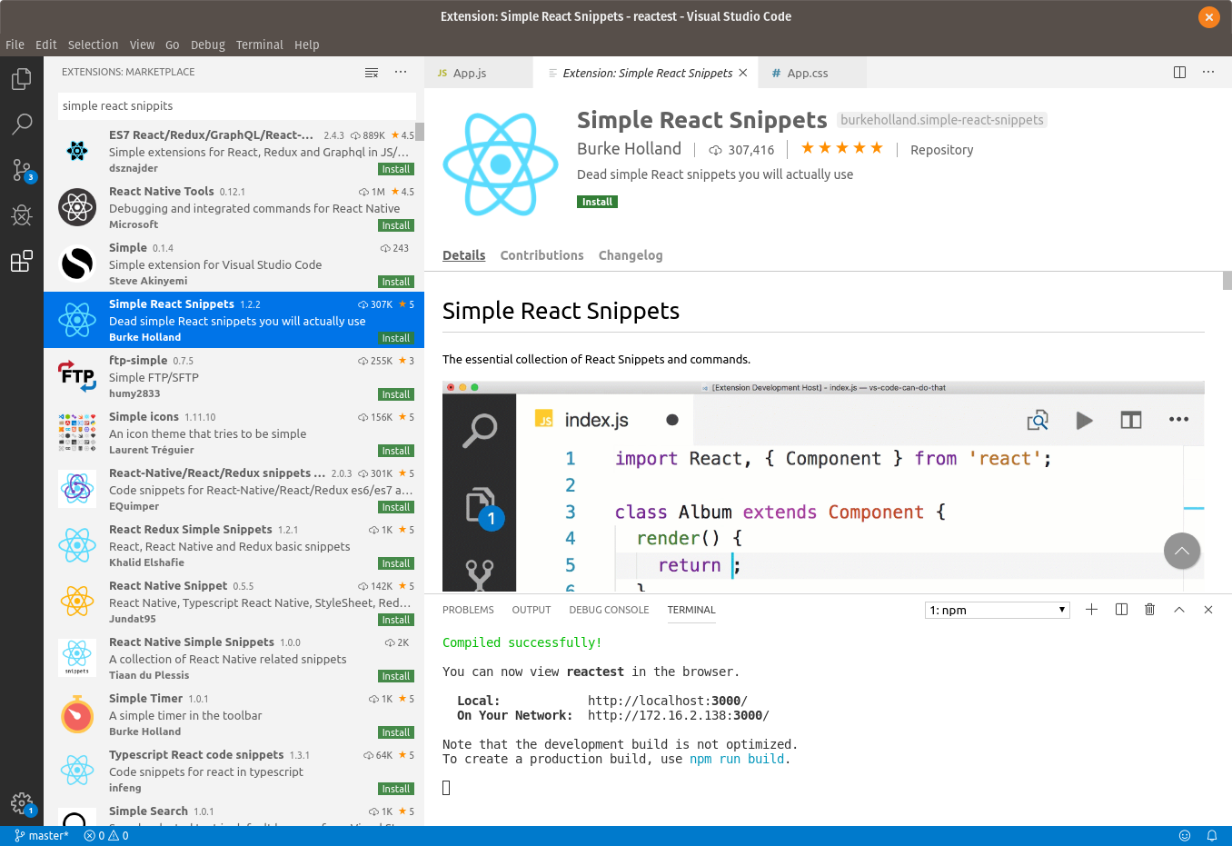
also install prettier
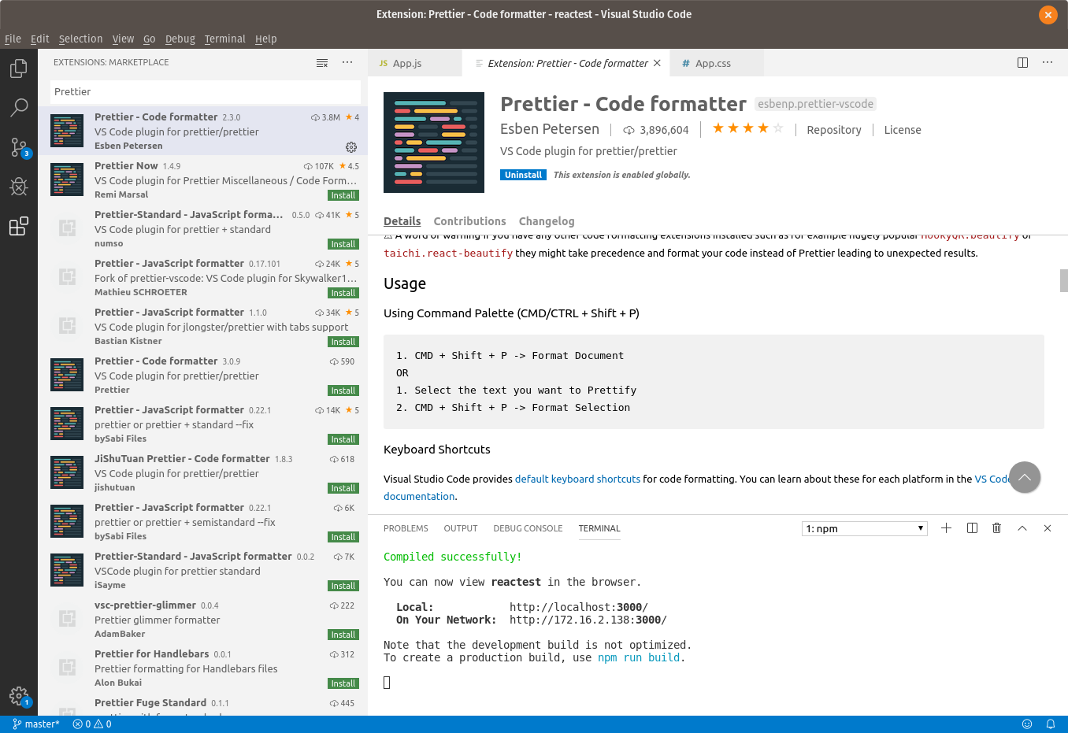
will help reformat the code.

Getting started
React is all about building components and placing these components in the web page. Libraries of these components can be easlily packaged and then reused in the project and shared with other projects.

Examples

Hello world program
create an html file with this content:

<!DOCTYPE html>
<html>
<head>
<script src="https://unpkg.com/react@16/umd/react.production.min.js"></script>
<script src="https://unpkg.com/react-dom@16/umd/react-dom.production.min.js">
</script>
<script src="https://unpkg.com/babel-standalone@6.15.0/babel.min.js"></script>
<title>hello1</title>
</head>
<body>
<div id="app"></div>
<script type="text/babel">
class Hello extends React.Component {
render() {
return (
<h1>
Hello {this.props.name || "DuFuss"}
</h1>
);
}
}

class App extends React.Component {
render() {
return (
<div>
<Hello name="Einstine" />
<Hello name="Archamedes"/>
<Hello name="Newton"/>
<Hello name="Gallio"/>
<Hello name="Keplar"/>
<Hello />
</div>
);
}
}

ReactDOM.render(<App />, document.querySelector("#app"));
</script>
</body>
</html>

the script tags in the header import all the scripts we need for this application.
The script tag in the body tag will create a component, every component needs to implement the render function. In this case we have the component that just says hello to one specified name, and the other calls the first several times.

The counter example
<!DOCTYPE html>
<html>
<head>
<script src="https://unpkg.com/react@16/umd/react.production.min.js"></script>
<script src="https://unpkg.com/react-dom@16/umd/react-dom.production.min.js"></script>
<script src="https://unpkg.com/babel-standalone@6.15.0/babel.min.js"></script>
<title>counter</title>
</head>
<body>
<div id="app"></div>
<script type="text/babel">

// a react componet, normall we would define this in an alternate
// file which would be compiled then included in the web page.
class Counter extends React.Component {
constructor(props) {
super(props);
this.state = {
count : 0
};
}

// all react componets must define this function so it knows how
// to render itself
render() {
return (
<div>
<h1>{this.state.count}</h1>
<button onClick={this.increment}>Increment</button>
<button onClick={this.decrement}>decrement</button>
</div>
)
}

// funny function def, its more like we are using a variable
// that points to a function and we are changing the function every time
// thgere is a mouse click.
increment = () => {
this.setState(oldState => ({
count: oldState.count + 1
}));
}

decrement = () => {
this.setState(oldState => ({
count: oldState.count - 1
}));
}
}

// a placement componet.
class App extends React.Component {
render() {
return (
<div>
<Counter />
<Counter />
<Counter />
</div>
);
}
}

ReactDOM.render(<App />, document.querySelector("#app"));
</script>
</body>
</html>

In this example we have a button actions that increment/decrement state data on the web page
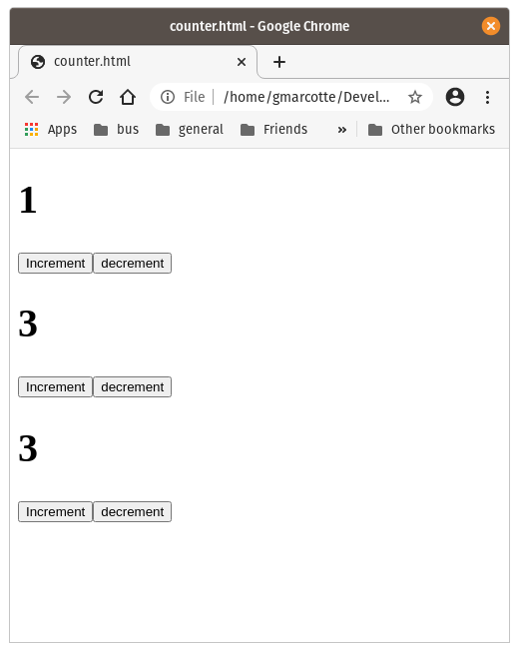
There is no back end code making this happen. The only funny thing in this code is the setState() function. This function is used to handle asynchronous code updates from changing state in a inconsistent manor.

Addition game example

<!DOCTYPE html>
<html>
<head>
<script src="https://unpkg.com/react@16/umd/react.production.min.js"></script>
<script src="https://unpkg.com/react-dom@16/umd/react-dom.production.min.js">
</script>
<script src="https://unpkg.com/babel-standalone@6.15.0/babel.min.js"></script>
<title>addition</title>
</head>
<body>
<div id="app"></div>
<script type="text/babel">
class App extends React.Component {
constructor(props) {
super(props);
this.state = {
num1: 1,
num2: 1,
score : 0,
wrongCount: 0,
response : ""
}
}

render() {
return (
<div>
<h1> { this.state.num1} + {this.state.num2} </h1>
<input onKeyPress={this.inputKeyPress}
onChange={this.updateResponse}
value={this.state.response} />
<div>
Score is {this.state.score}
</div>
</div>
);
}

updateResponse = (event) => {
this.setState( {
response: event.target.value
})
}

// check for hitting return if return then check the answer
inputKeyPress = (event) => {
if (event.key === "Enter") {
// check the answer here ------------------
const iresponse = Math.floor(this.state.response);
console.log("iresponse=" + iresponse);
if ( iresponse === this.state.num1 + this.state.num2) {
console.log("got it write");
// the answer is correct.
this.setState( oldState => ({
score: oldState.score + 5,
num1: Math.floor(Math.random() * 10),
num2: Math.floor(Math.random() * 10),
wrongCount: 0,
response: ""
}));
} else {
// The answer is wrong. lower the score and get butal if
// they keep gussing.
// alert("Wrong you fool get out the slide ruler!!!! minus
// points for you");
this.setState(oldstate => ({
response: "",
score : oldstate.score - (oldstate.wrongCount + 1),
wrongCount: oldstate.wrongCount + 1
}));
}
}

};
}

ReactDOM.render(<App />, document.querySelector("#app"));
</script>
</body>
</html>

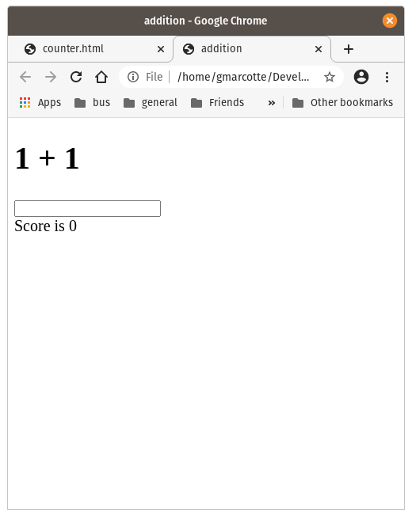
In this example we are using onEvents to control the display of the user’s response and to process the guess when user hits the return key.

JSX
JSX is a language that combines html with JavaScript. A program called babel will convert it from JSX to JavaScript that the browser can understand.
On-line version of babel is available to see the conversion:
https://babeljs.io/repl

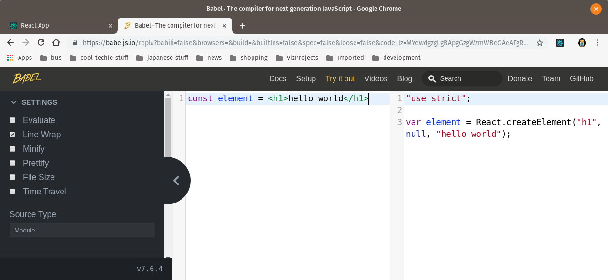
this website can be used to see what the JSX translates to. Very useful.

Some react code without the JSX
<!DOCTYPE html>

<html>
<head>
<meta charset="UTF-8" />
<title>Demo 3 - Jsx 2 Exercise</title>
<script src="https://unpkg.com/react@16/umd/react.development.js"></script>
<script src="https://unpkg.com/react-dom@16/umd/react-dom.development.js"></script>

<!-- Don't use this in production: why - babel should be run before you upload code to the web page. -->
<script src="https://unpkg.com/@babel/standalone/babel.min.js"></script>

</head>
<body>
<div id="rootme">
<h1>Jsx 2 Exercise</h1>
<h2>Some usseless text generated by React</h2>
<div id="marry">Lorem ipsum dolor sit amet, consectetur adipisicing elit. Ad necessitatibus sed fuga earum aliquid minima. Quasi dolores iure rerum, adipisci ex porro fugiat iusto vel voluptatibus molestiae soluta mollitia consectetur.</div><br />
<div id="people">Nobody sees this coming</div><br />
<div id="mykids">nore this</div><br />
</div>
<script type="text/babel">
class Hello extends React.Component {
render() {
return React.createElement('div', null, `${this.props.messagetxt}`);
//besure to use ` and not '
};
}

ReactDOM.render(
React.createElement(Hello,
{ messagetxt:
'marry had a little lamb chop whose fleas were as white as snow. And every where marry went the smell was sure to follow'
}, null),
document.getElementById('marry')
);

// some more useless text
ReactDOM.render(
React.createElement(Hello,
{ messagetxt:
'people will generally do the right thing ... after exhausting all the other possibilities'
}, null),
document.getElementById('people')
);

// some even more useless text
ReactDOM.render(
React.createElement(Hello,
{ messagetxt:
'when my kids start whining about something I tell them "Harden up mate! or you will never be THE MAN your monther was"'
}, null),
document.getElementById('mykids')
);
</script>

</body>
</html>

Modules
Breaking up the code in modules
https://flaviocopes.com/cannot-assign-readonly-property-export/
in a module you can define a function using the ES modules syntax:
const myfunction = () => {}
export default myfunction

then you import the exported function in your calling code:

import myfunction from './myfunction'

you can export multiple functions:
const myfunction1 = () => {}
const myfunction1 = () => {}

export {
myfunction1,
myfunction2
}

then import them:
import { myfunction1, myfunction2 } from './myfunctions.js'

Components
React is all about components. There are two types of components (actually two forms of the same thing): Class and function.

Example of both here:
<DOCTYPE html>
<html>
<head>
<meta charset="UTF-8" />
<title>MyFirstApp</title>
<script src="https://unpkg.com/react@16/umd/react.development.js"></script>
<script src="https://unpkg.com/react-dom@16/umd/react-dom.development.js"></script>
<!-- Don't use this in production: why - babel should be run before you upload code to the web page. -->
<script src="https://unpkg.com/@babel/standalone/babel.min.js"></script>
</head>
<body>
<table>
<thead>
<tr>
<th>Name</th>
<th>Ticker</th>
<th>Price</th>
<tbody id="root"></tbody>
</tr>
</thead>
</table>
<script type="text/babel">

/*
// function version of a component instead of the class version below
//
// in any function that has a block {} it must have a return statement
// if the function is to return a value.
function Coin(props) {
return (
<tr>
<td>{props.name}</td>
<td>{props.ticker}</td>
<td>{props.price}</td>
</tr>
)

}
*/

// arrow function version of a component instead of the normal
// function version above
//
// we use const because we are not going to change the reference
// variable "Coin" with another function or assign anything else to
// it (that would be bloody confusing)
//
// since there are no multiple member function in side this Coin
// object we dont need the {} and the Return() we use the () to
// group all the code to the function return.
/*
const Coin = (props) => (
<tr>
<td>{props.name}</td>
<td>{props.ticker}</td>
<td>{props.price}</td>
</tr>
);
*/

// we can replace props with {name, ticker, price} then we
// dont need to use props. notation.
const Coin = ({name, ticker, price}) => (
<tr>
<td>{name}</td>
<td>{ticker}</td>
<td>{price}</td>
</tr>
);

/* the class version of a componet.
class Coin extends React.Component {
render() {
return (
<tr>
<td>{this.props.name}</td>
<td>{this.props.ticker}</td>
<td>{this.props.price}</td>
</tr>
)
}
}
*/

// Also we encase any JSX tags in a fragment <> </> or <React.Fragment>
// </React.Fragment> tags so the structure comes out as one rooted
// HTML tag in the end. If we only have one tag in the end then
// we dont need to do this is in this example where we return a single
// <tr> tag
ReactDOM.render(
<React.Fragment>
<Coin name="Bitcoin" ticker="BTC" price="$50000.00" />
<Coin name="Oshirieum" ticker="ETH" price="$5000.00" />
</React.Fragment>,
document.getElementById('root')
)
</script>
</body>
</html>

The function version is the same as class but class is more like syntax sugar to make the function look like other Object oriented class languages. The best use case for class is when you have a number of member functions and you want to inherit functionality from a base class.
The function way:
// arrow function version of a component instead of the normal
// function version above
//
// we use const because we are not going to change the reference
// variable "Coin" with another function or assign anything else to
// it (that would be bloody confusing)
//
// since there are no multiple member function in side this Coin
// object we dont need the {} and the Return() we use the () to
// group all the code to the function return.
/*
const Coin = (props) => (
<tr>
<td>{props.name}</td>
<td>{props.ticker}</td>
<td>{props.price}</td>
</tr>
);
*/

// we can replace props with {name, ticker, price} then we
// dont need to use props. notation.
const Coin = ({name, ticker, price}) => (
<tr>
<td>{name}</td>
<td>{ticker}</td>
<td>{price}</td>
</tr>
);

Best practices with components
first a directory structure should be used
rootDirectOfProject.
+-components
+ MyGreatComponent
+ MyGreatComponent.jsx
+ MyGreatComponent.css

this way all the code of a component is in a single directory.
When you import the component you use import command like:

import Coin from './components/MyGreatComponent/MyGreatComponent';

Type checking
Short of using typeScript which is another language.

PropTypes
import React, { Component } from 'react'
import './Coin.css';
import PropTypes from 'prop-types';

export default class Coin extends Component {
render() {
return (
<tr className="coin-row">
<td>{this.props.name}</td>
<td>{this.props.ticker}</td>
<td>${this.props.price}</td>
</tr>
)
}
}

Coin.protoType = {
name: PropTypes.string.isRequired,
ticker: PropTypes.string.isRequired,
price: PropTypes.number.isRequired
}
In this case we change the price to be a number and we made everything required.

Formatting types
Formatting the number types can be done with the function toLocaleString
value = n.toLocaleString('en-US', {minimumFractionDigits:2});

adding the formatting to the class:
// options for formatting currency. this is used by the toLocaleString()
export default class Product extends Component {
...
currencyOptions = {
minimumFractionDigits: 2,
maximumFractionDigits: 2,
}

// This method is created by assigning an arrow function to a class property.
// Without using the arrow function, this method would create a new this
// binding, which would interfere with the current this binding and introduce
// a bug into our code.
getTotal = () => {
return this.state.total.toLocaleString(undefined, this.currencyOptions)
}

…
}

Styled components
Styled components are used by many web sites. These let you style the component without having a separate css file.
https://styled-components.com/ ← for more information.
Install with this option
$ npm install --save styled-components

import React, { Component } from 'react'
import PropTypes from 'prop-types'
import './AccountBalance.css'

import styled from 'styled-components'
const Section = styled.section`border: 1px solid red;`;

export default class AccountBalance extends Component {

constructor(props) {
super(props);
this.state = {
amount: this.props.amount
}
}

currencyOptions = {
minimumFractionDigits: 2,
maximumFractionDigits: 2,
}

getAmount = () => {
return (
this.state.amount.toLocaleString(undefined, this.currencyOptions)
);
}

// render function with a styled component
render() {
return (
<Section>
${this.getAmount()}
</Section>
)
}
}

AccountBalance.protoType = {
amount: PropTypes.number.isRequired
}
`

Managing state in class based components
The official React documentation encourages developers to adopt React Hooks to manage state with functional components when writing new code, rather than using class-based components. But we are going to talk about the class based components first.
import React, { Component } from 'react';
import './Product.css';

const products = [
{
emoji: '🍦',
name: 'ice cream',
price: 5
},
{
emoji: '🍩',
name: 'donuts',
price: 2.5,
},
{
emoji: '🍉',
name: 'watermelon',
price: 4
}
];

export default class Product extends Component {
// The state property is a standard class property,
// which means that it is accessible in other methods,
// not just the render method.
state = {
cart: [],
total: 0
}

// As mentioned in the getTotal() method comments, this will ensure
//(by defining as arrow function), the function will have the proper this
// context when running the update.
// This updates the current state using arrow function that uses the current
// state and builds a new state replacing the existing state.
add = (product) => {
this.setState(state => ({
cart: [...state.cart, product.name],
total: state.total + product.price
}))
}

// using the setState function so we are updating the state so when we
// remove an item it will subtract out the product price from the total cost.
//
// o avoid mutating the state object, you must first make a copy of it using
// the spread operator. Then you can splice out the item you want from the
// copy and return the copy in the new object. By copying state as the first
// step, you can be sure that you will not mutate the state object.
remove = (product) => {
this.setState(state => {
const cart = [...state.cart];
cart.splice(cart.indexOf(product.name))
return ({
cart,
total: state.total - product.price
})
})
}

// options for formatting currency. this is used by the toLocaleString()
currencyOptions = {
minimumFractionDigits: 2,
maximumFractionDigits: 2,
}

// This method is created by assigning an arrow function to a class property.
// Without using the arrow function, this method would create a new this
// binding, which would interfere with the current this binding and introduce
// a bug into our code.
getTotal = () => {
return this.state.total.toLocaleString(undefined, this.currencyOptions)
}

render() {
return(
<div className="wrapper">
<div>
Shopping Cart: {this.state.cart.length} total items.
</div>
<div>Total: ${this.getTotal()}</div>
<div>
{products.map(product => (
<div key={product.name}>
<div className="product">
<span role="img" aria-label={product.name}>{product.emoji}</span>
</div>
<button onClick={() => this.add(product)}>Add</button>
<button onClick={() => this.remove(product)}>Remove</button>
</div>
))}
</div>
</div>
)
}
}

State Change Example
Example of changing state (price) every 10 seconds. It uses componetDidMount to run after the component is ready.
...
export default class Coin extends Component {
constructor(props) {
super(props);
this.state = {
price: this.props.price
}
}
// this will run when the class is loaded, sortof like the onLoad thing for page loads.
componentDidMount() {
const callback = () => {
// set the sate to anew random percent change
const randomePercentage = 0.995 + Math.random() * 0.01;

// update the state
// don’t do this:
//this.state.price = this.state.price * randomePercentage;

// you can do this, and should do this every thing in the block {} will
// safe from other threads changing the state half way though an update.
this.setState( function (oldstate) {
return { price: oldstate.price * randomePercentage}
});

// or this if you have only one small thing to do.
//this.setState({price: oldState.price * randomePercentage});
};

setInterval( callback, 10000); // call the callback every 1000 m sec
}
...
}
}
...

Managing state with functional object using hooks
Hooks where added in React 16.8. They let you use state and other React features without a class.
import React, { useState } from 'react';

function Example() {
// Declare a new state variable, which we'll call "count"
const [count, setCount] = useState(0); // the initial value is set here

return (
<div>
<p>You clicked {count} times</p>
<button onClick={() => setCount(count + 1)}>
Click me
</button>
</div>
);
}

How do we store state in class-based components?
We use the setState() function and this pointer and we have to be carefule about binding etc etc.
How do we store state in functional components?
We use hooks in this case useState.
What does useState return?
It returns a pair of values: the current state and a function that updates it. This is why we write const [count, setCount] = useState(). This is similar to this.state.count and this.setState in a class, except you get them in a pair. If you’re not familiar with the syntax we used, we’ll come back to it at the bottom of this page.

Rendering Dynamic list of components
So we have a table of coins how to render the table from a list of coins (coin[])?
render() {
return (
<div className="App">
<header className="App-header">
<img src={logo} alt="react logo" className="App-logo" />
<h1 className="apt-title">Coin Exchange</h1>
</header>
<div>
<AccountBalance amount={this.state.balance} />
</div>
<table className="coin-table">
<thead>
<tr>
<th>Name</th>
<th>Ticker</th>
<th>Price</th>
</tr>
</thead>
<tbody>
{this.state.coinData.map( value =>
<Coin key={value.ticker}
name={value.name}
ticker={value.ticker}
price={value.price} />
)
}
</tbody>
</table>
</div>
);
}
the map creates a loop like a for loop ( foreach ( value : coinData) {} ). when an extra property called key. This is important if we want React to repaint the screen properly. It needs to be able to find the item in the dom. The key should be unique. In this case we used ticker.
You could shorten this code to
{this.state.coinData.map( ({name, ticker, price }) =>
<Coin key={ticker}
name={name}
ticker={ticker}
price={price} />
)
}

uuid
It is common practice to just assign a unique key and you can do this with a uuid
$ npm install uuid
in the code you would:
import {v4 as uuidv4} from ‘uuid’;
then when you need a uuid use
uuid4()
for example we would set the state variables like this:
this.state = {
balance: 10001,
coinData: [
{
key: uuidv4(),
name: 'Bitcoin',
ticker: 'BTC',
price:9999.99
},
...
]
}

Form input controls
Really good documentation on dealing with form inputs can be found at https://reactjs.org/docs/forms.html

FormData
[FormData free code camp]
FormData is simply a data structure that can be used to store key-value pairs. Just like its name suggests it's designed for holding forms data i.e you can use it with JavaScript to build an object that corresponds to an HTML form. It's mostly useful when you need to send form data to RESTful API endpoints, for example to upload single or multiple files using the XMLHttpRequest interface, the fetch() API or Axios.

Uploading files in a form
The following snippit shows how to send a single file to a POST endpoint using a form with an input with type=file.
[FormData free code camp]
<!DOCTYPE html>
<html>
<head>
<title>Parcel Sandbox</title>
<meta charset="UTF-8" />
</head>

<body>
<div id="app"></div>
<script src="index.js">
</script>
</body>
</html>

and then the script index.js
document.getElementById("app").innerHTML = `
<h1>File Upload & FormData Example</h1>
<div>
<input type="file" id="fileInput" />
</div>
`;

const fileInput = document.querySelector("#fileInput");

const uploadFile = file => {
console.log("Uploading file...");
const API_ENDPOINT = "https://file.io";
const request = new XMLHttpRequest();
const formData = new FormData();

request.open("POST", API_ENDPOINT, true);
request.onreadystatechange = () => {
if (request.readyState === 4 && request.status === 200) {
console.log(request.responseText);
}
};
formData.append("file", file);
request.send(formData);
};

fileInput.addEventListener("change", event => {
const files = event.target.files;
uploadFile(files[0]);
});

File picker control
I created this file picker control (still needs better styling current styling has been copied from on-line examples). The control’s caller will pass a onSubmit handler via the properties passed to the component.
import React, {useState} from 'react';
import './FilePicker.css';

/**
* file picker component. This component manges state using the new functional component
* useState options.
*
* The component and all CSS files, images are in this directory.
*
* This is a single file selection
*
* @param {} props
*/
export default function FilePicker(props) {
const [selectedFile, setSelectedFile] = useState(null);
const [loadedFiles, setLoadedFiles] = useState(0);

/**
* Handle the file selection button event.
* we save the file name in local state.
* @param {*} event
*/
const onChangeHandler=event=>{
setSelectedFile(event.target.files[0]);
}

/**
* handle the submit (upload) button
*/
const onClickHandler = () => {
if ( props.onSubmitFile === null) {
alert("no submit handler");
}

const data = new FormData()
data.append('file', props.selectedFile)
props.onSubmitFile(data);
}

// render part here.
return (
<div className="upload-container">
<div className="row">
<div className="formupload">
<form method="post" action="#" id="#">
<div className="form-group files">
<label>Upload Your File </label>
<input type="file" accept="csv" name="file" onChange={onChangeHandler} />
</div>
<button type="button" class="btn btn-success btn-block"
onClick={onClickHandler}>Upload</button>
</form>
</div>
</div>
</div>
)
}

Async and Sync,
When you want some thing to run in synchronous manor you can use the async and await options:
/**
* This runs after the component is loaded. it will rerieve the top
* COIN_COUNT coins from coinpaprika.com (listed by order of ranking).
* this function makes an REST call to coinpaprika and retrieves the coins.
* updates the state. It takes a little time to run.
*
* change the function to a async function si I could use the await
* option on axios.get() This way I program synchronously. it does not mater
* because this code is already blocking in the background and running on
* a seperate thread.
*/
componentDidMount = async () => {
let response = await axios.get('https://api.coinpaprika.com/v1/coins');
let coinData = response.data.slice(0,COIN_COUNT).map(function(coin) {
return {
key: coin.id,
name: coin.name,
ticker: coin.symbol,
balance: 0,
price: 0,
};
});
this.setState({ coinData});
}

Promises

var node = document.querySelector('.js-container');
var text = [];

Promise.all([
axios.get('https://api.coinpaprika.com/v1/tickers/btc-bitcoin'),
axios.get('https://api.coinpaprika.com/v1/tickers/xrp-ripple')
]).then(
(coinResponses) => {
const coins = coinResponses
.map(response => `
<li>
${response.data.name} (${response.data.symbol}) &nbsp;
${response.data.quotes['USD'].price}
</li>` )
.join('');
node.innerHTML = `<ol>${coins}</ol>`;
}
)

Lifecycles

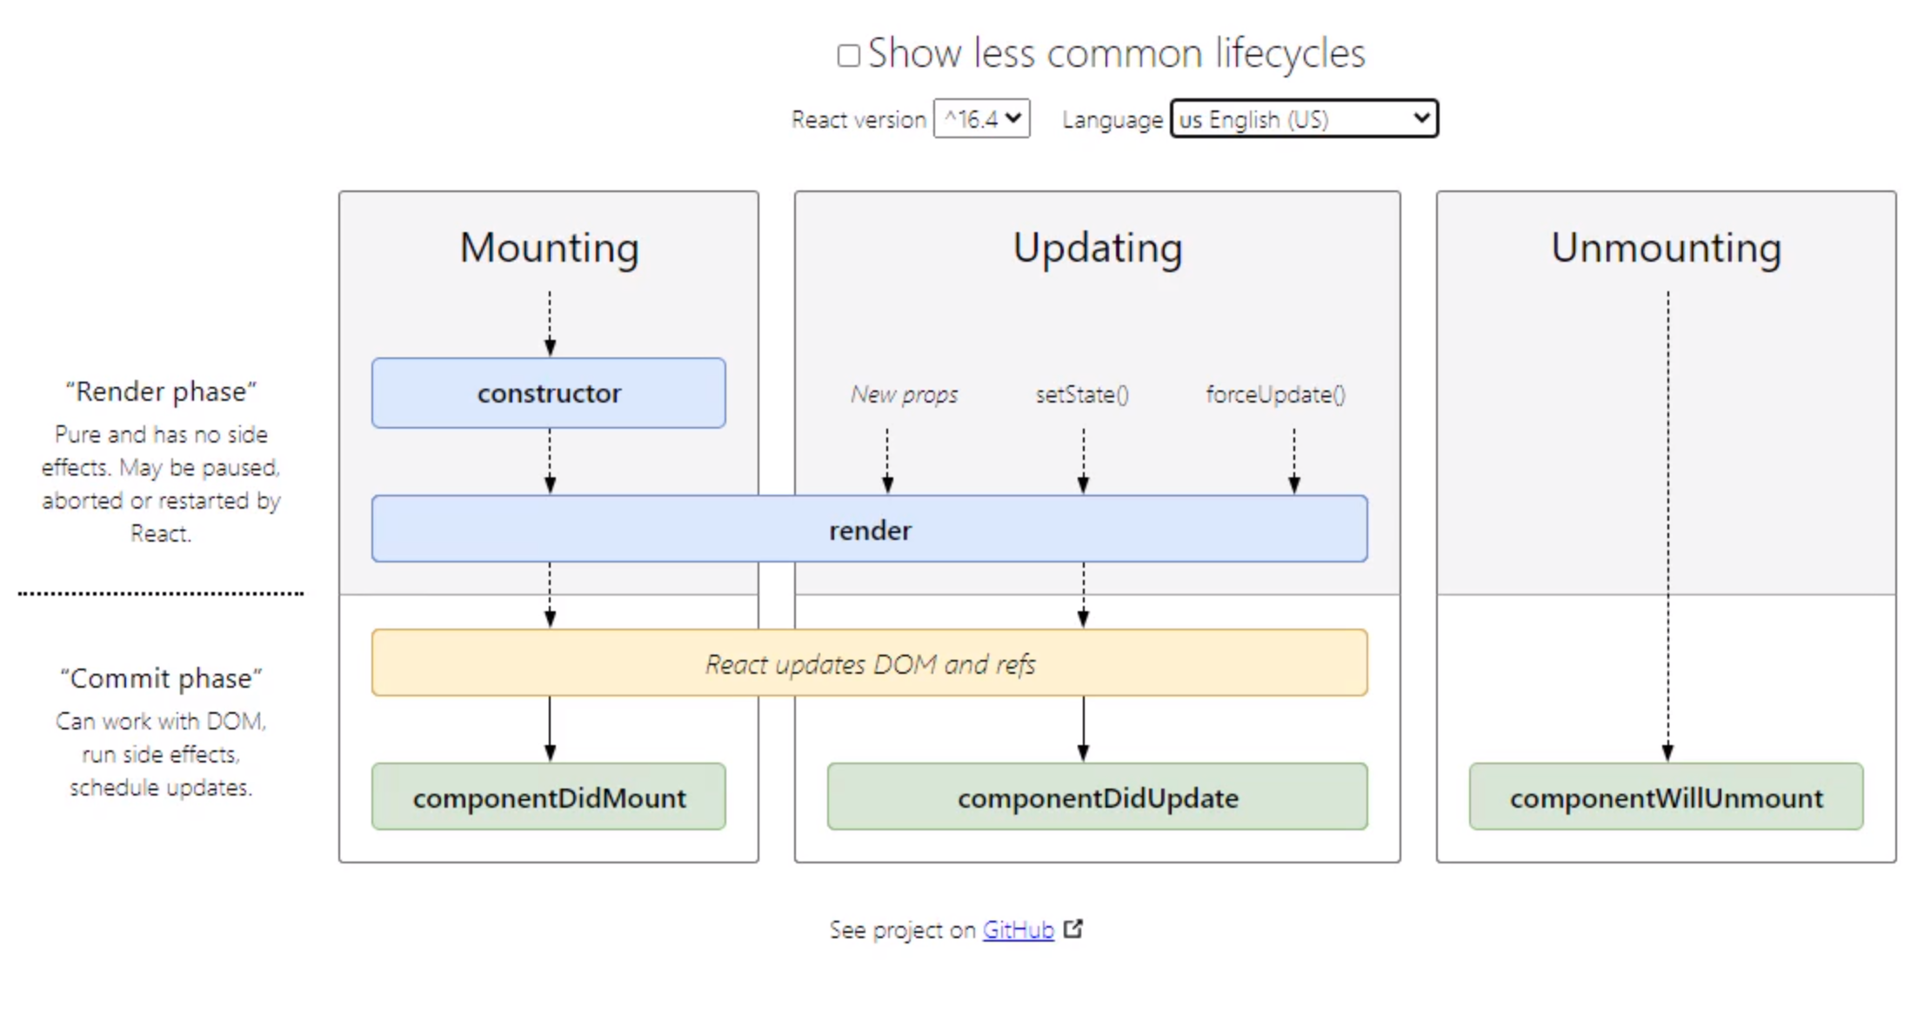
componentDidMount

componetDidUpdate

componentWillUnmount

Redux
https://redux.js.org/introduction/getting-started
https://redux.js.org/tutorials/fundamentals/part-1-overview ← excellent docs about Redux must read!!
Redux is a pattern and library for managing and updating application state, using events called "actions". It serves as a centralized store for state that needs to be used across your entire application, with rules ensuring that the state can only be updated in a predictable fashion.

Redux helps you manage "global" state - state that is needed across many parts of your application.
Building a react app with redux
npx create-react-app redux-essentials-example --template redux

Ramda

Build Environment
When in production we don't want to be including the react files from the net some where on the internet:
<script src="https://unpkg.com/react@16/umd/react.development.js"></script>
<script src="https://unpkg.com/react-dom@16/umd/react-dom.development.js"></script>

<!-- Don't use this in production: why - babel should be run before you upload code to the web page. -->
<script src="https://unpkg.com/@babel/standalone/babel.min.js"></script>
These links are called CDN links (Content Delivery Network). The problem with these is they have to be download every page reload and you have to trust the source has not been hacked.
We like to build the dependencies locally on the server where the application is running.
Facebook created the React. Tools for setting up react project live on github at facebook/create-react-app
If you are running on a brain dead OS like windows then you should use git for windows has a bash shell.

Installing the initial code base:
$ npx create-react-app my-app
$ cd my-app
$ npm start

Extensions for visual studio code:
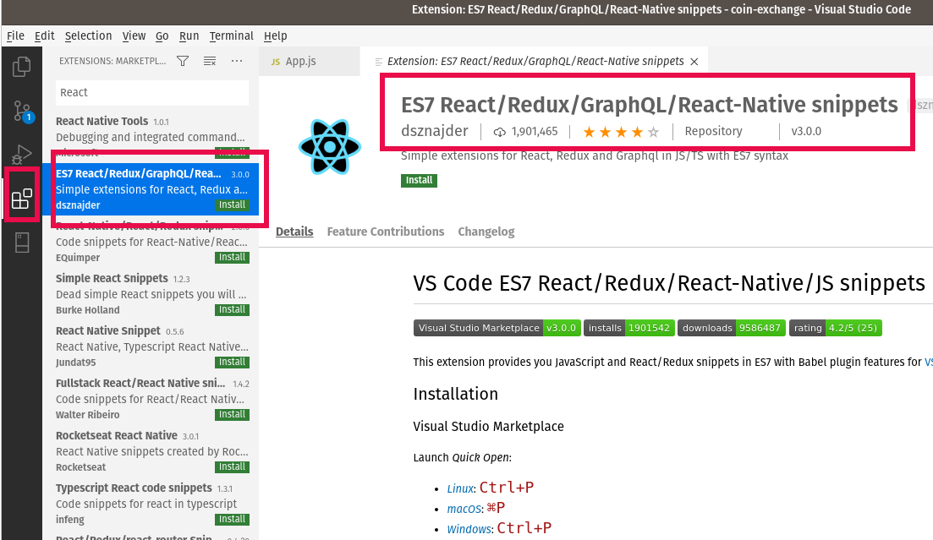

Deployment
https://create-react-app.dev/docs/deployment/

$ npm run build
will create a build directory with a production build of your application.

To server this you can use the serve program installed by npm:
$ npm install -g serve

this install command above adds the serve command to your installation of nodejs. In my case it put server here:
$ cd ~
$ find . -name serve
./bin.lib/node-v12.18.3-linux-x64/bin/serve
./bin.lib/node-v12.18.3-linux-x64/lib/node_modules/serve

then I created a link to the command so I could use it as a command:
$ cd ~/bin
$ ln -s ~/bin.lib/node-v12.18.3-linux-x64/bin/serve

then copy the build directory to where you want it deployed.
$ serve -s <path to build>

basically this serve command is creating a web server to server the contents of the build directory. I renamed the build directory to my application-name and moved it to where I was going to deploy it. Theoretically I should be able to move it to a sub directory of an Apache web server document root directory. So the serve command is acting like a simple web server.

Deploying to github pages
https://create-react-app.dev/docs/deployment/#github-pages

Interview questions

Differentiate between Real DOM and Virtual DOM.
Real DOM: updates are slow, can directly update HTML. Creates a new DOM if element updatres, DOM manipulation is very expensive, Too much of memory wastage.
VDOM what is it: is a virtual “ideal DOM” in memory that is a representation of real DOM. It is synced with the real DOM in a process called reconciliation.
VDOM is implemented by the libraries in JavaScript of the browser API. A shadow
DOM is a browser technology designed for scoping variables and CSS in web components.

What is React?
React is a front-end JavaScript library developed by Facebook in 2011. It is a component based approach for building UI components.

What are the features of React?
It uses the virtual DOM instead of the real DOM. It uses server-side rendering. It follows a uni-directional data flow or data binding.

List some of the major advantages of React.
It increases the application’s performance
It can be conveniently used on the client as well as server side
Because of JSX, code’s readability increases
React is easy to integrate with other frameworks like Meteor, Angular, etc
Using React, writing UI test cases become extremely easy

What are the limitations of React?
React is just a library, not a full-blown framework
Its library is very large and takes time to understand
It can be little difficult for the novice programmers to understand
Coding gets complex as it uses inline templating and JSX

What is JSX?
It is a mix of JavaScript and html (JavaScipt XML)
render(){
return(

<div>

<h1> Hello World from Edureka!!</h1>
</div>
);
}

What do you understand by Virtual DOM? Explain its working
A virtual DOM is a lightweight JavaScript object which originally is just the copy of the real DOM. When ever there is changes to the data the web page is re-rendered using the VDOM, the difference between the Real DOM and the VDOM are calculated and then only the differences are updated to the Real DOM.

Why can’t browsers read JSX?
Browsers can only read JavaScript objects but JSX in not a regular JavaScript object. Thus to enable a browser to read JSX, first, we need to transform JSX file into a JavaScript object using JSX transformers like Babel and then pass it to the browser.

How different is React’s ES6 syntax when compared to ES5?
The new version are using more React syntax where the old version were JavaScript syntax. Using import instead of require, using export default Component instead of module.exports = Component
and ES6 uses class extended from React.Component instead of the React.createClass() function.

How is React different from Angular?
React is from facebook and angular is from google.
Angular uses the Real DOM, has two-way data binding, has run-time debugging, client-side rendering.
React uses VDOM (faster), has one-way data binding. Compile-time debugging, Server-side rendering

What do you understand from “In React, everything is a component.”
Components are the building blocks of a React application’s UI. These components split up the entire UI into small independent and reusable pieces. Then it renders each of these components independent of each other without affecting the rest of the UI.

Explain the purpose of render() in React.
Each React component must have a render(). It returns a single React element which is the representation of the native DOM component. If more than one HTML element needs to be rendered, then they must be grouped together inside one enclosing tag such as <form>, <group>,<div> etc. This function must be kept pure i.e., it must return the same result each time it is invoked.

How can you embed two or more components into one?
We can embed components into one in the following way:
class MyComponent extends React.Component{
render(){
return(
<div>

<h1>Hello</h1>
<Header/>
</div>
);
}
}

class Header extends React.Component{
render(){
return
<h1>Header Component</h1>
};
}

ReactDOM.render(
<MyComponent/>, document.getElementById('content')
);

What is a state in React and how is it used?
States are the heart of React components. States are the source of data and must be kept as simple as possible. Basically, states are the objects which determine components rendering and behavior. They are mutable unlike the props and create dynamic and interactive components. They are accessed via this.state().

How can you update the state of a component?
State of a component can be updated using this.setState().
class MyComponent extends React.Component {
constructor() {
super();
this.state = {
name: 'Maxx',
id: '101'
}
}
render()
{
setTimeout(()=>{this.setState({name:'Jaeha', id:'222'})},2000)
return (
<div>
<h1>Hello {this.state.name}</h1>
<h2>Your Id is {this.state.id}</h2>
</div>
);
}
}
ReactDOM.render(
<MyComponent/>, document.getElementById('content')
);

What is arrow function in React? How is it used?
Arrow functions are more of brief syntax for writing the function expression. They are also called ‘fat arrow‘ (=>) the functions. These functions allow to bind the context of the components properly since in ES6 auto binding is not available by default.
//General way
render() {
return(
<MyInput onChange={this.handleChange.bind(this) } />
);
}
//With Arrow Function
render() {
return(
<MyInput onChange={ (e) => this.handleOnChange(e) } />
);
}
The arrow function is much cleaner in this example.

Differentiate between stateful and stateless components.
Stateful can save the state, they track the state in memory and can send prop change to stateless components. Stateless components calculate the state internally.

What are the different phases of React component’s lifecycle?
There are three different phases of React component’s lifecycle:
- Initial Rendering Phase: This is the phase when the component is about to start its life journey and make its way to the DOM.
- Updating Phase: Once the component gets added to the DOM, it can potentially update and re-render only when a prop or state change occurs. That happens only in this phase.
- Unmounting Phase: This is the final phase of a component’s life cycle in which the component is destroyed and removed from the DOM.

Explain the lifecycle methods of React components in detail.
Some of the most important lifecycle methods are:
- componentWillMount() – Executed just before rendering takes place both on the client as well as server-side.
- componentDidMount() – Executed on the client side only after the first render.
- componentWillReceiveProps() – Invoked as soon as the props are received from the parent class and before another render is called.
- shouldComponentUpdate() – Returns true or false value based on certain conditions. If you want your component to update, return true else return false. By default, it returns false.
- componentWillUpdate() – Called just before rendering takes place in the DOM.
- componentDidUpdate() – Called immediately after rendering takes place.
- componentWillUnmount() – Called after the component is unmounted from the DOM. It is used to clear up the memory spaces.

What is an event in React?
In React, events are the triggered reactions to specific actions like mouse hover, mouse click, key press, etc. Handling these events are similar to handling events in DOM elements. But there are some syntactical differences like:
- Events are named using camel case instead of just using the lowercase.
- Events are passed as functions instead of strings.
The event argument contains a set of properties, which are specific to an event. Each event type contains its own properties and behavior which can be accessed via its event handler only.

References
[React-CS250 Beyond 2019 – you tube]
This is CS50, Harvard University's introduction to the intellectual enterprises of computer science and the art of programming.

[managing state in class based components]
https://www.digitalocean.com/community/tutorials/how-to-manage-state-on-react-class-components

[hooks]
https://www.youtube.com/watch?v=dpw9EHDh2bM&feature=youtu.be&t=1172

[intro to hooks]
https://reactjs.org/docs/hooks-intro.html

[interview questions]
https://www.edureka.co/blog/interview-questions/react-interview-questions/

[styled components]
https://www.smashingmagazine.com/2020/07/styled-components-react/

[coin info API at coinpaprika.com]
https://api.coinpaprika.com/

[form input controls]
https://reactjs.org/docs/forms.html

[FormData free code camp]
https://www.freecodecamp.org/news/formdata-explained/

[deployment docs]
https://create-react-app.dev/docs/deployment/

