Crypto currency 101
updated 2021-04-15

Table of Contents
Crypto currencies 2
Important characteristics of crypto currencies 2
Wallets 2
Types of wallets 2
Popular wallets 3
Wallet security 5
Best practices with wallets 5
Exchanges 7
Centralized exchanges 7
Distributed Exchanges DEX 8
Other services 8
Unstoppable domains 8
DeFi 9
BlockFi 9
Alt-coins 10
How To examples 14
Creating a wallet 14
Receiving coin 14
Sending coin 14
Creating a paper wallet 14
Bitcoin paper wallet 14
Dash paper wallet 14
Etherum paper wallet 14
Using a hardware wallet 16
Using a Trezor hardware wallet 16
Using Exodus wallet with Trezor hardware wallet 17
Books you must read 19
References 20

Crypto currencies
BitCoin is the first distributed crypto currency that solves the double payment problem without using a central service for the ledger. The ledger is in the network distributed though all the computers.

Important characteristics of crypto currencies
- Decentralized distributed ledger instead of a centralized database.
- Censorship resistant. - since no one government or bank, corporation controls this system. No one can stop a transaction without shutting down the internet.
- Permission-less access – there is no permission to access the system. All that is needed is an internet connect at some point. No KYC (know your customer)
- No central control or ownership. – the control is spread over the network. To hack the network you must overpower more than half all the computers on the network instead of hacking one bank computer. Government can’t control the network by pressuring the company that controls the network.

Wallets
Crypto coin wallets are really a key store. The keys to locks on the block chain are stored in a wallet. With the key you can sign a transaction moving value from one address on the block-chain to another.
All bitcoin are stored on the block-chain in public addresses. Anyone can send bitcoin to any address. Only the owner of the address can create a transaction sending bitcoin out of the address.
So wallets manage two things: public addresses and the corresponding private keys. Access to the private key means ownership of the money. Same as physical control of cash.

Types of wallets
- web-wallet – a wallet that exist on a web server, an exchange, or corporation. It is the same as putting money in a bank. They control the keys and if they get hacked you loose. See Mt. Gox https://en.wikipedia.org/wiki/Mt._Gox and more recently coincheck in Japan http://fortune.com/2018/01/31/coincheck-hack-how/. The company the controles the web wallet server must follow government regulation and can be pressured by government to freeze, confiscate or refuse service to any one they dont like. See wikileaks: https://www.forbes.com/sites/andygreenberg/2011/07/08/visa-shuts-down-card-payments-to-wikileaks-again/#f3f50ee1ba28
- User controlled wallets – the keys are stored on users desktop or mobile phone. They can be protected with a password but can be hacked if the phone or computer is hacked (ie key loggers).
- paper wallets – a print of the public and private keys. These printout can consist of the q-code (2d bar code image and the hexadecimal character string of the public and private keys. The private key can even be password protected (when you scan the q code the software will ask for a password to decrypt the image to the real private key value). Very safe if you never let the private key touch the internet and have a save place (physical safety ie fire safe lock box, in a secure location)
- Hardware wallets – a hardware device that keeps the keys on the device and can be used to sign transactions and send money. This kind of system can even be used on a hacked system because it avoids the key-logger from recording the correct pin number for access, never exposes the private keys to the host computer or network. You and backup the system so if the hardware is lost or stolen you can still recover.

Popular wallets
- Jaxx https://jaxx.io/ android, iphone, Linux, mac, pc. This is a multi coin wallet with support a large number of coins (Bitcoin, Bitcoin-cash, Etherium, Etherium-classic, dash, Zcash, litecoin, and others). Used this one for a time but now not using it so much.
- electrum (https://electrum.org/#home) for bitcoin and is supported on Linux, PC, Mac OSX, android.
- Exodus https://www.exodus.io/ Linux, Pc, Mac. This is a desktop wallet good for managing trading/investing. This is a multi coin wallet with support for Bitcoin, Bitcoin-cash, Etherium, Etherium-classic, dash, Zcash, litecoin, ERC20 tokens and others. This wallet software is updated once or twice a month (not automatically you have to down load and install it) It runs on PC, Mac, Linux and I think they have a android version coming out (I would keep heaps of money on a phone wallet)
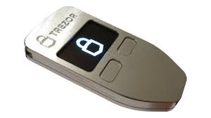
- TREZOR https://trezor.io/ you control the private key in this wallet. The private keys are stored in a hardware device. The private keys never leave the device. You can conduct transaction with this device using software that creates a transaction that the device will sign. The device can be restored (buy a new one and use the backup restore words to restore the key) so if it is lost, damaged or stolen you can quickly recover. This one is great so far for me. I also got the Model T now.
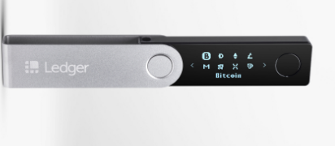
- Ledger https://www.ledger.com/ Another hardware wallet like the Trezor. (I haven't used this one yet)

- coinomi (https://www.coinomi.com) This wallet available on mobile Android, Apple IOS, Linux, Pc, Mac. Multi currency wallet : BTC, BCH, DASH, Litecoin, Zcash, monero, Nem, ETH, and others.
- Edge wallet (mobile) – multi currency wallet: (BTH, BCH, ETH, Monero, Litecoin, EOS, DASH, zcoin and others) . Edge wallet creates the private key by having the (username + password) the encrypted wallet is backed up to their servers to sync to other devices. The username/password is not stored on the servers.
Don’t know how the security works need more study to see that it is save. (I dont recommend this wallet because there is no wallet words)
- infinito wallet (mobile) – I have not used this one much still evaluating
- Bitcoin cash (mobile) – BCH, has (will have one shortly) built in coin join feature for better privacy
- samurai wallet (mobile) – this wallet supports BTC bitcoin. Has a coin join feature so its more private. The pen code keypad is random every time it shows up so key loggers are not effective in stealing your pen code. This means the position of the numbers on the screen keypad changes so you actually have to know the pen code to access the wallet.

- Metamask https://metamask.io/ is a brower extension for chrome and firefox. When setting it up it will provide two options restore wallet create new wallet. Creating a new wallet will generate 12 wallet words. (you need to write this down and save in a secure place). This wallet will let you interact with websites that have payment systems. When sending money you will have to sign in to open the wallet. When transaction is done what happens is the web site will send the request to the wallet, the wallet creates the transaction then asks you to signok the transaction. Private keys are not stored on any server.

Wallet security
most wallets support a backup phrase (wallet words). It consists of 12 to 24 English words in order. It is possible to remember these words in your head if needed (using a technique called a memory palace). They can be written down on paper and put the paper in a secure place (lock box or safe).
You should always create a password for the wallet. This password should be used to encrypt the wallet so some one who copied your disk drive wont be able to see/use the wallet without the password.
Be very careful where you get the wallet software from. Some wallets are malware just waiting for you to put lots of money on then so the hacker can take it off you.

Best practices with wallets
- Never store crypto on an exchange. Only store the crypto that you are currently using in trades. Like you would not carry your life savings as cash in your wallet. Using exchange for buying and selling crypto (not day trading) you should deposit fiat buy crypto then withdraw crypto to external wallet. Selling crypto: send crypto to exchange sell it, withdraw fiat back to your bank account, (be a good boy/girl and figure out what your tax should be and report/pay)
- use different addresses for each transaction. This helps with the privacy and also easer to track cap gains on individual transactions. Some of the multi coin wallets dont make this easy.
- Set up 2factor authentication for exchanges if possible (all the good ones have it and its required). Google authenticator (https://www.google.com/landing/2step/) is a good one. It can be installed as app from android phone. Iphone ?
- Don’t store more money then you are going to spend on your phone wallets. Just as you would not carry your life savings in your regular wallet. Phone wallets are the most likely to get hacked. Or the phone got stolen and if you were dumb enough to not use a password to protect the wallet then your money is gone. A password on the wallet will slow them down enough for you to move the money by creating a new wallet from the backup (wallet words)
- Use cold storage system. But the large percent of your investments for long term on cold storage system. A cold storage system is paper wallet, a computer that is not ever connected to the internet or a hardware wallet. These wallets should be physically stored in a secure place.
- Keep your backup phrase (wallet words) secure. Never share your private key or backup phrase with anyone. Never store it on line or on a computer. Write it down on paper. Store it off line in encrypted form. Save the backup off line in a secure place. Store the paper records in a fire safe (fireproof lock box) in a secure location.
- https://electrum.org/#homeDon’t create a wallet in a place whttps://electrum.org/#homehere cameras are around watching you type, or on a public computer system used by others.
- It is best to have a computer that is only used for crypto work and do your gaming, dodgy web browsing, and your kids playing on another computer.
- Don’t store your wallet files or backups on the cloud.
- Double check the source and verify signature hash of all wallet software you install. Some are just malware copies of the real thing.
- Don’t brag about how much bitcoin you have.
- Never too young to do some estate planning. (hopefully you have kids some day)

Exchanges
All centralized exchanges operate in some government jurisdiction and therefore under the boot of the FATF (international enforcement arm of the criminal central banks). They require KYC, AML regulation same as bank accounts are. If you have large amounts of money you will get a lot more scrutiny than smaller transactions. If you are a US citizen you will be exclude from some of these exchanges. Note these guys are criminal HSBC laundered 700B in 10 years of the Mexican drug money, countless other examples of big bank crime that goes unpunished.

Centralized exchanges
Coinbase – (https://www.coinbase.com/) San Francisco company. Only us banks can put money into the accounts only good for USA for fiat transactions. However there are starting to be foreign branches of this exchange happening. Still good for crypt to crypto transactions.
easy crypto (https://www.easycrypto.nz/) an exchange that you can send money to via New Zealand bank payment or (poli bank payment) and they will buy crypto and send it to your external wallet. This is not a trading platform they do not hold any money for customers.
my crypto saver (https://mycryptosaver.com/) (they were originally called my bitcoin saver). You can set up a regular payment via on-line banking and they will buy coin and send it back to your external wallet. Very much like easy crypto. They got stopped by their bank but managed to come back and are still operating.

Binance – ( https://www.binance.com/) originally in Hong Kong but they have moved to Malta. They have trading pairs for more crypto to crypto than anyone. Exclude US customers but they are opening a special branch for the US with limited service (no privacy coins)
Bitflyer (https://bitflyer.com/en-jp/) one of the larger Japanese exchanges. It is great if you have a Japanese bank account to convert fiat to crypto. I think you can still do bank transfers to get money into the system (I have never done this). We use this one a lot but we only done it though a Japanese bank.
Coincheck. Japanese exchange that got hacked. Not sure if they ever managed to get the Japanese licence to operate yet. There still around but I havent used them since they were hacked.
Other Japanese Exchanges. There are 16 (in 2019) that have full licenses and more than 200 are applying. Some of these can take foreign deposits (USD mostly). All require heaps KYC. Problem with the Japanese Exchanges are they de-list privacy coins
shapeshift https://shapeshift.io/#/coins – a crypto to crypto exchange that does not require a login. No KYC crap involved. This exchange is integrated into the Jaxx and Exodus wallets. This exchange was create by Erik Voorhees. The exchange does not operate (user must use vpn to escape NY) in state of New York because of the stupid regulations their. Its a good thing they didn’t go along with New Yorks KYC requirements because a few months later they got hacked. Criminals got a way with only the exchanges money because no customers hold money on the exchange. If KYC requirements were met the criminals would have all the customer’s info as well.
Shapeshift as been forced to go to an account model. There are still ways around this. I think if you use a wallet with built in shapeshift integration it will work for small amounts. The fact that the government was able to force shapeshift to the account model shows the need for cross chain atomic swaps at the protocol level.

Distributed Exchanges DEX
The best DEX right now is Uniswap which works on the Ethereum block chain. Al you need is metamask wallet and you can swap between any Ethereum based tokens. Some of these are rapped version of other coins like bitcoin. At this time 2021-Mar-April the Ethereum gas fees are so high that only really big trades make sense. I believe this will change by the end of the year (2021) with Etherium 2.0 and other chains. Already there are alternatives like pankake swap and cardano will have a smart contract running in Aug 2021. I think uniswap will be ported to other chains and in particular cardano chain.

Other services

Unstoppable domains
https://unstoppabledomains.com This is like buying a domain name. At the time of this writing it was about $40 USD. You buy the domain then you claim the domain with a wallet like metamask. See the website for a tutorial on how.
In general the steps are:
- install metamask wallet it will make it easer when you claim the domain. Send some money to this new wallet.
- Go to unstoppable domains (https://unstoppabledomains.com/r/f752f11ba5b04e1) create an account there. There will be an email varify
- Search for your domain like myname.crypto if its free a message to that effect will show up. Click on add to shopping cart and pay for the domain. Payment methods are the usiual ones but also crypto payment options are available.
- Once paid you can then claim the domain. This is done on the manage domains page. Once you click clame domain it will ask for some transaction (with gas(ETH) fee), you can use the metamask wallet from the browser for this.
- Once the site is done then you can add crypto receive address on the payment maintenance screen (under the manage my domains page) doing this will again require some gas (ETH tokens)

you should go to the website and see more up to date directions.
Advantages of the unstoppable domains: the domain is on the blockchain not in a server farm where it is subject to company or government take downs. You can host a web site that is also distributed storage. These sites are very important with all the attacks on free speech on the internet.

DeFi
Decentralized finance. Basically we are “Forking” the bank. If the bank is not paying interest on deposits or providing small business loans then these companies and (even better ) smart contracts are providing this new service. Warning this is all new and scams are every where. You need to check out the people your dealing with before investing.

BlockFi

Alt-coins
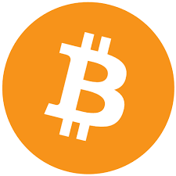
Bitcoin – the first block chain. First created by Satoshi Nakamoto (who ever that is). They have the largest share of the crypto market cap. Bitcoin is a deflationary currency because it has a maximum supply of 21Million bitcoin and no more will be created. Currently there are 18M in existence. The currency started out with zero amount and increases with a block reward every cycle. Every 4 years the block reward is cut in half. It is currently at 12 bitcoins and will be cut to 6 in May 2020. A good porsion of the existing bitcoin have been lost due to people losing the private keys. Without the keys the coin can not be spent. There is no way to recover a lost private key.
Bitcoin development is open source project currently controlled by the core-developers. The community has been locked in a scaling debate since 2015 and finally came to a head in 2017 when bitcoin cash forked off. The user community is rather toxic spending a lot of time saying all other coins are shtcoin. Originally the transaction cost were very low and transaction processing was quick. But in December 2017 and January 2018 the transaction cost were pushing north of $40 and some lower fee transactions took a week to process.
There were two main enhancements (un-enhancements) that kills bitcoin core as a payment system for small amounts: locking the block size to 1 Mbyte and allowing the blocks to become too full. And the second and worse change was the replace by fee thing. The replace by fee allowed a transaction stuck in mempool to be replaced by a different transaction with a higher fee. This created way to double spend. You pay one person x and a low fee. Then you pay a different person X for a higher fee using the same bitcoin. The minors will take the higher fee transaction and the lower fee transaction will be rejected. If the first payee does not wait for 6 conformations they cant be sure the transaction is solid. Waiting for 6 conformations can take 1 hour or more.
Bitcoin transaction rate is 3 to 4 transactions per second. It should be able to handle 7 transaction per second. But this is no where near enough when we need more like 1 million transaction per second to handle world wide money transactions.
[https://en.bitcoin.it/wiki/Address] A Bitcoin address, or simply address, is an identifier of 26-35 alphanumeric characters, beginning with the number 1,3or bc1that represents a possible destination for a bitcoin payment. Addresses can be generated at no cost by any user of Bitcoin. For example, using Bitcoin Core, one can click "New Address" and be assigned an address. It is also possible to get a Bitcoin address using an account at an exchange or online wallet service.
There are currently three address formats in use:
- P2PKH which begin with the number 1, eg: 1BvBMSEYstWetqTFn5Au4m4GFg7xJaNVN2. This is legacy address or the original bitcoin address format.
- P2SH type starting with the number 3, eg: 3J98t1WpEZ73CNmQviecrnyiWrnqRhWNLy. A segwit address format.
- Bech32 type starting with bc1, eg: bc1qar0srrr7xfkvy5l643lydnw9re59gtzzwf5mdq. Another segwit address format.
Also see https://support.exodus.io/article/1178-bitcoin-addresses-legacy-vs-segwit for description how these are used in the exodus wallet.

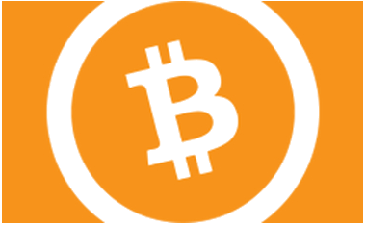
Bitcoin cash – fork of bitcoin caused by a break-down between two groups in bitcoin. Bitcoin cash wanted lower transaction fees and used big blocks to do this short term. They seem to be more inline with the original concept. Still they don’t have a functional governance system and don’t have an formal self funding system (So no improvement over bitcoin-core on that point). User community is less toxic than bitcoin but they still seem to spend a heap of time claiming they are the “true bitcoin”
bitcoin cash block-size are flexible so the blocks don’t fill up. The result is bitcoin cash can handle a higher volume of on-chain transactions. Bigger blocks will require more server capacity to handle the load. For now block sizes up 8Mbytes are very do-able and would support pay-pal level of transaction throughput. Other technical solutions to scaling problem are being developed in crypto currencies in general and like the internet technology will find a way.
[https://support.exodus.io/article/664-bitcoin-cash-address-format] bitcoin cash address come in two formats the legacy address that matches the bitcoin-core address format from the split and the new q address format. Both can be used to send/receive bitcoin cash. One can be converted to the other if the wallet does not support one format over the other.
This one works well in Japan. Its fast and low fees. The merchant adoption is getting better. Better than bitcoin core.

Ethereum – second generation coins, first to create the concept of smart contracts. Created by and is still lead by Vitalik Buterin. Actually bitcoin had some of the programming functions that Vitalik wanted to use for smart money programming but core-developers were stultifying this development so Vitalik and Charles Hoskinson created Ethereum . Later Ethereum split into Ethereum and Ethereum-classic.

Ethereum is the second largest crypto currency after bitcoin. It is not a fixed currency but has a constant inflation rate. Its primary use case is smart contracts. It has been used for tokenisation such as the creation of non-fungible coins, stable coins and capital funding ICOs (many of these were complete scams but some were good). There is a very big financal services technology being built on Ethereum

Zcash – privacy focus opt-in privacy. First showed up 2015-2016 time frame
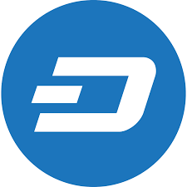
Dash – a fork of Bitcoin focused on payment, instant conformations, privacy, and the first functional DAO (distributed autonomous organization). They have self funding model that allows the network to pay for development, marketing, integrations and many other normal business orations without being centrally controlled. The user community is very active and friendly. They are very focused on the payment solution. Used heavily in Venezuela and other south American countries. Gaining popularity in south East Asia, Australia and many countries of Africa. Its big in new Hampshire (the live free or die state)
Privacy is done the same way it is done in bitcoin and bitcoin-cash by mixing the transaction on a second layer. In Dash the mixers are part of the master-node second layer. In Japan the government as stupidly designated dash zcash and monero as privacy coins and thinks this is bad so they pressure exchanges to de-list these. In the case of Dash and Zcash these are voluntary privacy options. And Dash privacy is a simple mixer to provide better fungibility. Monero there is an argument about too much privacy in that it is hard to validate the total supply of the currency to prove there is no artificial inflation happening.
https://www.dash.org/ ← dash organization
https://www.dash.org/downloads/ ← wallets

Ripple - https://ripple.com/ This is designed for the banks to replace the current intonational banking money exchange. They are still trying to sell this idea to the banks. Some success in the Asian markets. It is more centralized than other cryptos. I personalty dont like this one too chummy with banks.
NEM – (https://nem.io/) very popular in Asia. It has been rebuilt from ground up block-chain. Not so sure about this one. I would use it buy stuff only. The wallets they came up with were shit. But now its supported in a number of multi coin wallets.

Cardano – (https://www.cardano.org/en/home/) one of the 3d generation cryptos. Created by Charles Hoskinson – was a Co-founder of Etherium and now founder of Cardano (ADA). This currency is backed by https://iohk.io of Honk Kong but also in based in Europe. Very academically oriented with research and pier review of the technology and mathematics used in implementation. They have also studied and using aspects of Dash’s governance model with some improvements involving things like liquid democracy and different consensus algorithms.
Cardano is called the Etherium of Japan. It will support multiple languages to implement smart contracts and data contracts. The base code is developed in Haskel.
There network has just started late 2017, major developments expected though out 2018,8-20. They still havent gone fully centralized yet (Shelly release is in test net now, should be out in late 2020?).
https://www.cardano.org/en/the-daedalus-wallet/ ← the core wallet implementation. This wallet is getting better but sill slow and clunky. This is a full node wallet so needs to store the full block chain on the server.
Other wallets for Cardano: Ledger NanoS,Trezor Mondel T,infinito wallet, AdaLite.

EOS (https://eos.io/) is a 3d generation crypto. Like cardano another Etherium replacement. Is created by block.one, a Cayman Islands exempted company, is building the EOS.IO Software. The main person is Daniel Larimer who also did bitshares, and steemit. It is due to launch the network in June 2018. They had an ICO that is used for funding.
Eos is not as decentralized as I would like. There is some privacy concerns with this coin. I would stick with ETH for now or Cardano later.
Hedera (https://www.hederahashgraph.com/) This is 3d generation crypto using a hashgraph created by Leemon Baird and his company swirlds (https://www.swirlds.com/about/). The hashgraph is patient by swirlds. The Hedera is the public hashgraph, white paper talks about the patents being defensive (they will try to kill any forks), about governance rotating via small group. The hashgraph says they scale much better than current payment systems like visa network.
Hedera (public hashgraph) should go live some time in 2019. Not as decentralized as I would like. Seems like this one is a bit hyped up. Keep an eye on this it may be good some time in the future.

Monero is a super privacy currency. It is private by default and always private. How ever the wallet owner can pass a audit key to be used to show all transaction history. Monero hides the transaction from/to addresses and the transaction amount. <need more editing work>
https://www.getmonero.org/ ← organization web site.
https://web.getmonero.org/downloads/ ← wallets

How To examples

Creating a wallet
Most wallet software will have two modes when they startup for the first time: create new wallet and restore wallet.

Receiving coin
Basic function of a wallet there is a mode where you can display a 2d barcode on the screen and some one you is sending you money can scan this address into the send part of their wallet.
<work in progress>
checkout videos on the exodus wallet home page. Explains everything.

Sending coin

Creating a paper wallet

Bitcoin paper wallet
Go to bitaddress.org and down load the web page. Then use the web page on a off-line computer. The web page has a JavaScript client that can create the public-private key pairs print pretty bar-codes for each.
I would run the web page on a booted usb computer with the network disabled.
Generate the wallets. Use password protected wallets.
Print the paper with the public/private key text and bar-code to a dumb printer. Save a copy as pdf another usb storage that is never plugged into a computer that is on the Internet. Better yet we should encrypt the pdf and save these on backup drives

Dash paper wallet
same procedure as bitcoin but you get the webpage from https://paper.dash.org/

Etherum paper wallet
this one is different.
You already have a lot of great answers here, but I want to share another very easy non technical way for cold storage.
  - Go to https://www.myetherwallet.com/
  - Follow the directions! (Super simple)
  - Print out your public/private keys and QR codes (They format nicely and look great once you print it out).
  - Deposit funds to your public key.
  - Check https://etherchain.org/ for your account balance by entering in your public key in the search box.
  - **optional (HODLLLLL) ;)

A modification to the above procedure to increase security. After going to myetherwallet.com click on help and find how to run off-line. Basically it will point you to github account were you can down load the distribution and run the web-wallet off line.

This webwallet is actually a functioning wallet. You can reload the backup and then spend the coins later when you enable the networking.

Using a hardware wallet

Using a Trezor hardware wallet
Setup the trezor wallet by following the instructions that come with the Trezor in its sealed tamper resistant packaging (make sure the packaging is secure (you are the first person to open the package) before you start)
Follow the backup wallet words instructions (write down the recovery phrase (wallet words) on paper with ink and save in a safe place like water/fire proof safe)

you should verify your backup phrase to make sure it works. There are two ways to do this. 1) Have two trezors and try to restore the first trezor wallet on the second trezor wallet. 2) there is a verify backup proceedure where you can test the backup without effecting your device (see the instructions for trezor wallet) This is a very good idea as I tried to verify one of my trezor wallets and found out that one of the wallet words was the wrong. If anything happened to the hardware wallet device I would not have been able to restore it on a new trezor device.

You should enable the Bip39 hidden wallet option. What this does is create sub wallets that are accessed by a password you create. This can be great for using the Tresor to store your main holdle coins using no password or “” password. And a sub wallet for your children protected with a password like “number1Son”, “littleJane2005” etc.. This way the main wallet backup phrase could be used to restore the wallet but without the extra password the sub wallets are unknown and not accessible.

Sub wallet also make it hard for people to steal your funds using the $5 wrench attach (https://cryptosec.info/wrench-attack

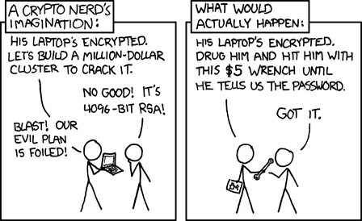
Anther way to solve this problem when crossing unfriendly boarders (like china, iran, california and new york) is to factory reset your trezor so there is nothing on it.

The trezor device itself is protected by a pen code. If some one is trying to guess the code the device will create longer and longer wait periods between failed attempts. If some one finds the wallet recovery phrase (wallet words) then they can steal the money without stealing the trezor device because all they need to do is get a new trezor and restore it with the backup phrase and they have your wallet.

Using Exodus wallet with Trezor hardware wallet

Using a Trezor hardware wallet with Exodus desktop wallet makes for a very nice portfolio management system. You can keep your short term trading moneys in the exodus side and the holdle long term moneys in the Trezor wallet. You can also easily move moneys from one to the other or even send/receive money from the trezor wallet using exodus.
Connecting the Trezor is easy just plug in when you have the Exodus wallet open. Exodus will detect the trezor. Use the pen code to unlock the trezor. If you enabled the Bip39 secrete hidden wallets. Exodus will ask for the additional password (entering nothing gets you to the main wallet, entering the sub wallet password gets you to the hidden wallet). Each sub wallet password is a different trezor wallet from Exodus’s point of view. It will “pair” the wallet. This pairing means that exodus will know the public addresses of the wallet and can show you the balances of each coin. Exodus CAN NOT spend any of the coins without the hardware device connected and the correct pen and hidden wallet password to unlock the wallet.
Reviewing trezor coin balances is easy. Once the wallet has been paired you don’t need the trezor device connected and unlocked to review balances or receive coins. You only need the trezor connected if you want to send coins from the trezor or exchange coins on the trezor wallet.
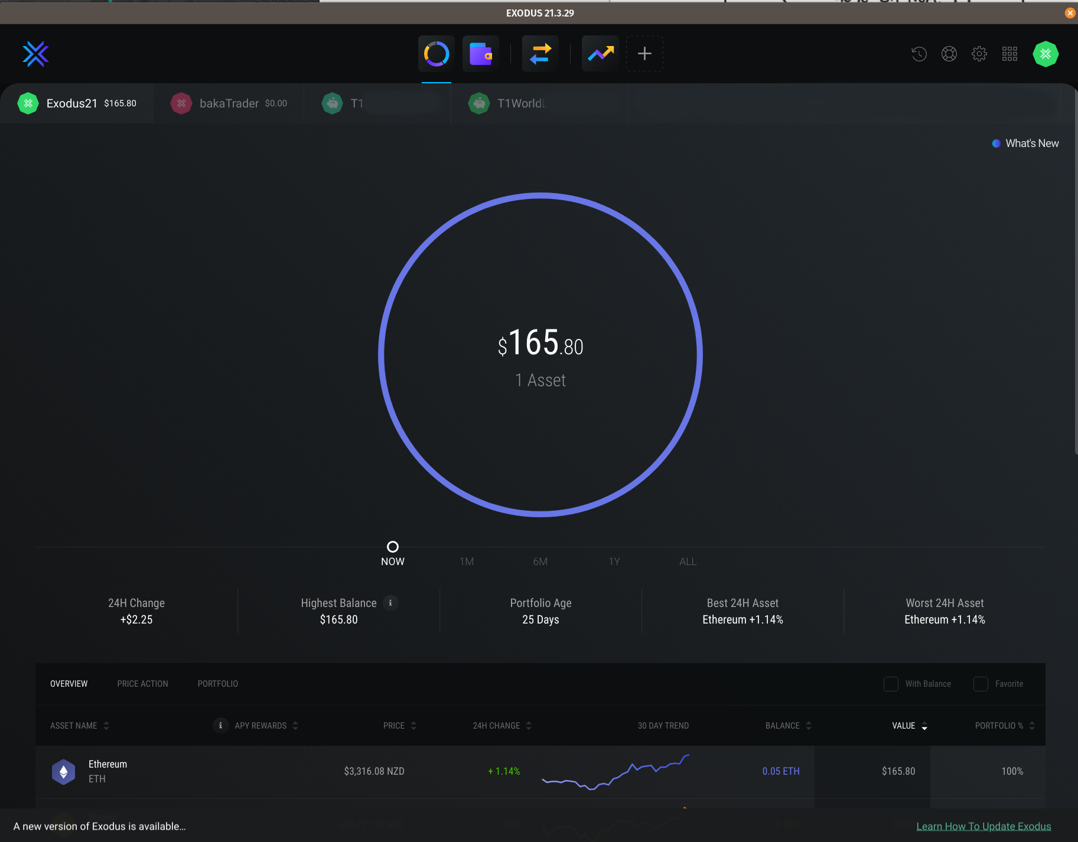
You can view each trezor wallets (even multiple trezor devices). When you first pair the wallet it puts the wallet into a “portfolio” it is a good idea to change the name of this portfolio especially if you have multiple trezors and/or sub wallets
please review the current Exodus documentation:
https://support.exodus.com/article/1114-getting-started-with-exodus-and-trezor

Books you must read
The value of crypto currency lies in the fact that the current monetary system is so so so so broken. You can’t realize this unless you do some basic study. The following is a list of books that are easy to read (Economics is not rocket science and the people making economic difficult to understand are trying to hide a scam)

“The Creature from Jekyll Island” by G. Edward Griffin ← most excellent book on how the FED came into existence and the slimy politics that got it passed. The continued abuse of the US tax payers and small businesses that are screwed by this system from New York. https://www.amazon.com/Creature-Jekyll-Island-Federal-Reserve-ebook/dp/B00ARFNQ54
“Economics in One Lesson” by Henry Hazlitt ← very basic easy to understand as economics should be. Out lines some of the common fallacy that are taught in school. https://www.amazon.com/Economics-in-One-Lesson/dp/B00005459Y/ref=sr_1_1?keywords=Economics+in+One+Lesson&qid=1578792347&s=digital-text&sr=1-1
https://www.youtube.com/results?search_query=Hidden+Secrets+of+Money ← Mike Maloney is a gold bug so his point of view is only real money is gold. However he has recently discovered bitcoin and now invests in this too. (he was exclusively a gold silver guy before). He has a really good series about the fiat currencies and how they work (and why they are so bad).
He has free books you can down load from the internet or buy if you want a physical book from amazon.

“America’s Great Depression” by Murray N Rothbard and Tom Weiner ← excellent book about how it came to be and what happened. https://www.amazon.com/Americas-Great-Depression/dp/B001BC2O8C/ref=sr_1_1?keywords=America%E2%80%99s+Great+Depression+by+Murray+N+Rothbard&qid=1578792724&s=audible&sr=1-1
“End the Fed” by Ron Paul ← excellent book about why we should get rid of this criminal organization. https://www.amazon.com/End-Fed-Ron-Paul/dp/0446549177/ref=sr_1_1?crid=98O8WN6GNMEB&keywords=end+the+fed+by+ron+paul&qid=1578792965&sprefix=End+the+fed+by+r%2Caudible%2C372&sr=8-1

“Cryptoasset Inheritance Planning” by Pamela Morgan, ESQ.
May 1, 2018 ISBN: 978-1-947910-11-9

References
https://www.youtube.com/results?search_query=Andreas+Antonopoulous ← Andreas Antonopoulous is network export and strong advocate of crypto currencies. His youtube series and books are a must view/read to learn about cryptos in general.
https://www.youtube.com/watch?v=93_oc4tWWbE ← Andreas Antonopoulous talked about why KYC and bank secrecy act is worse than useless.

https://en.wikipedia.org/wiki/2012%E2%80%9313_Cypriot_financial_crisis ← about the Cypriot financial crisis and what happened to their bank accounts.

https://www.youtube.com/results?search_query=Hidden+Secrets+of+Money ← Mike Maloney is a gold bug so his point of view is only real money is gold. However he has recently discovered bitcoin and now invests in this too. (he was exclusively a gold silver guy before). He has a really good series about the fiat currencies and how they work (and why they are so bad).

https://www.youtube.com/watch?v=iFDe5kUUyT0 ← this is the 4th video in the secrets of money by Mike Maloney where he explains the big fraud that is the US central banking system. This is a must view to see how these criminals that run our world are doing it.

https://www.youtube.com/results?search_query=the+daily+decrypt ← youtube videos run by Amanda B Johnson – creator of the youtube channel “the daily decrypt”. A strong supporter of the Dash block-chain network. For a while she worked for the Dash doing promos and educational video. She is still doing work in this area. She has been un-banked for some time living on Dash.

Wendy-McElroy – Writes a number of political articles about the importance of privacy and freedom. She wrote a series called the “Satoshi revolution”. The writing is every well done and insightful. A must read!! google search(Wendy McElroy)

https://www.youtube.com/results?search_query=Charles+Hoskinson ← Charles Hoskinson youtube videos on crypto currencies. Very good reference on next generation of crypto.

https://www.investopedia.com/articles/personal-finance/050515/how-swift-system-works.asp ← what is SWIFT, international payment system that is slow, old, tired, expensive and being used as a weapon by Washington.

[https://en.bitcoin.it/wiki/Address] ← bitcoin core address structure.
[https://support.exodus.io/article/664-bitcoin-cash-address-format] ← bitcoin cash addresses.

[Exodus wallet]
https://support.exodus.com/article/1114-getting-started-with-exodus-and-trezor

[the $5 wrench attack]
(https://cryptosec.info/wrench-attack

