**Assignment 11.1**

Author

Affiliation

Course

Instructor

Due Date

**Assignment 11.1**

**Introduction**

With its energetic and varied population, New York City provides an abundance of wellness resources to encourage holistic well-being among its citizens. THE WELL New York and myTherapyNYC, two well-known wellness resources in New York City, are examined in this paper. Different services are offered by each resource to treat different facets of well-being, such as mental, emotional, and physical health.

**Resource One: The WELL New York**

**Services Offered**

THE WELL New York is a full-service wellness facility that approaches health holistically. It provides a range of services aimed at nourishing the body, mind, and soul. Among the services provided are the following:

* Massages: Qualified masseurs offer deep tissue, therapeutic, and relaxation massages.
* Beauté Recherche Facials: Customized facials made using premium skincare ingredients.
* Fitness Classes: A variety of classes in yoga, pilates, and strength training are available.
* IV Therapy Drips IV nutrition therapy for energy, immune system support, and hydration.
* Acupuncture Sessions: Harmonious energy flow using traditional Chinese medicinal practices.

**Cost of Services**

Depending on the particular service consumed, THE WELL New York's costs vary. Sessions may cost anywhere from $60 to $375 or more, with the possibility of savings through package offers and membership choices. For example, the cost for integration massage and pre-and post-natal massage ranges between $235 and $375 while that of foot rub ranges between $60 and $110 (Bodywork & Massage NYC | THE WELL New York, n.d.). The facility’s pricing strategy is competitive to ensure that clientele gets the most value for their money.

**Eligibility**

Anyone looking for holistic wellness solutions is welcome to apply to THE WELL New York. The programs are available to people of all ages and backgrounds, and there are no special requirements for eligibility. With the booking procedure available online, the facility is open for use for locals within New York City and other service consumers across the globe. For customers joining with a friend, the facility charges only half the intro fees.

**The WELL New York page**

***Source: Bodywork & Massage NYC | THE WELL New York***

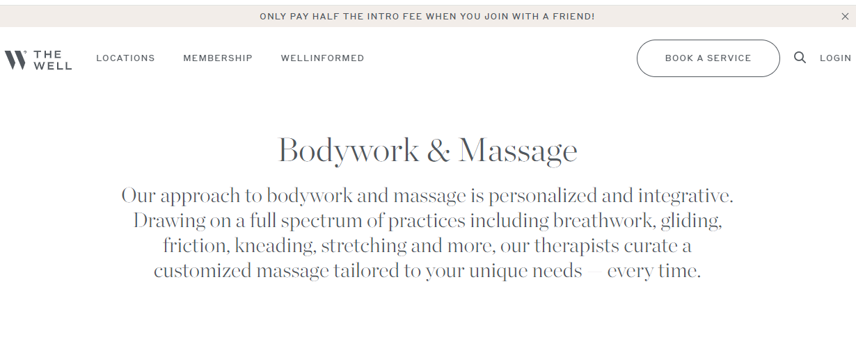

The discount pricing tendencies shown in the image above echo the ideas shared by Li et al., (2020) who argue that discounts attract new clients allowing organizations to win their loyalty. Essentially, The WELL New York engages in sustainable competitive practices.

**Resource Access**

People from all over the world can go to THE WELL New York’s physical facilities, to use the resources that are offered by the organization. You can schedule an appointment for services by phoning the reception desk directly or online via their website. Furthermore, THE WELL New York periodically conducts public wellness events and workshops, offering additional avenues for participation.

**Resource Two: myTherapyNYC - Counseling & Wellness**

**Services Offered**

MyTherapyNYC is a mental health services provider that serves both single people and couples. They specialize in relationship counseling, trauma, LGBT difficulties, depression, and anxiety. The following are services offered at the organization.

* Individual counseling: This involves the provision of tailored treatment plans to deal with mental health issues.
* Couples counseling: The facility assists in resolving conflicts in a relationship.
* Support for LGBTQ+ People: The facility prioritizes the provision of a secure environment for LGBTQ+ people coping with a range of problems.
* Trauma Therapy: This involves the provision of expert counseling for people who have experienced trauma.
* Anxiety and Depression Management: Techniques for managing depression and anxiety that are supported by evidence are also offered.

**Cost of Services**

Depending on the type of therapy and length of sessions, there are different costs associated with myTherapyNYC services. Therapy sessions, depending on the kind, range from $75 to $300 (myTherapyNYC - Counseling & Wellness, 2024). For example, individual therapy sessions typically cost between $160 and $250 a session, however, couples therapy sessions cost between $200 and $300.

**The myTherapyNYC page**

***Source: myTherapyNYC - Counseling & Wellness***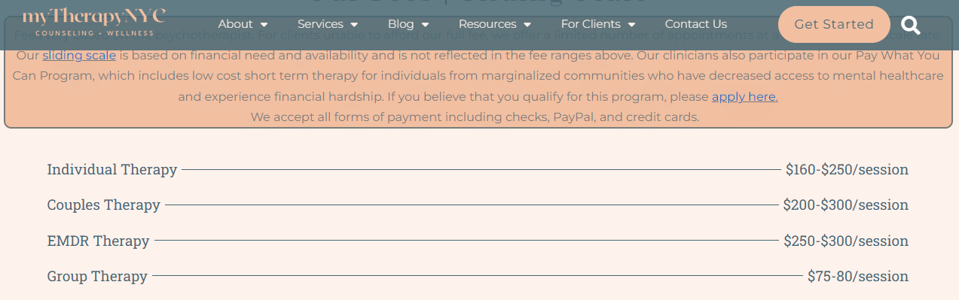  
**Eligibility**

Individuals and couples looking for mental health help and therapy are eligible to use myTherapyNYC’s services. The services are available to a broad spectrum of people in need of assistance because there are no particular eligibility requirements based on income levels or demographics.   
**Resource Access**

Interested customers can make an appointment by calling or emailing the myTherapyNYC office directly to use the services that are offered. Furthermore, mental health practitioners or healthcare providers may refer patients to myTherapyNYC (Meetup, 2024). Individuals are made to feel safe and at ease during the therapy process by providing a supportive and confidential setting during sessions.

**Conclusion**

In summary, New York City provides a wide range of wellness resources to support its citizens’ overall health. New York’s two prominent examples of wellness centers that offer beneficial services ranging from physical rejuvenation and relaxation to mental health support and counseling are the WELL New York and myTherapyNYC. Through providing easily accessible and all-inclusive services, these organizations support the general health and well-being of people and communities all around the city. Having access to these resources can enable people to put their health first and lead happy lives.

**References**

*Bodywork & Massage NYC | THE WELL New York*. (n.d.). <https://www.the-well.com/new-york/service/bodywork-massage?l=7257fb2b-3878-4d85-bd70-3669721f0a7c&m=4f8b70a3-ee72-44c0-8bbe-0d9f88fc02f4#book>

Li, C., Chu, M., Zhou, C., & Zhao, L. (2020). Two-period discount pricing strategies for an e-commerce platform with strategic consumers. *Computers & Industrial Engineering*, *147*, 106640.

Meetup. (2024, March 1). *MyTherapyNYC Mental Health & Wellness Events | MeetUp*. https://www.meetup.com/mytherapynyc/

myTherapyNYC - Counseling & Wellness. (2024, January 12). *In-network NYC Therapists with Aetna & Blue Cross | Sliding Scale*. <https://mytherapynyc.com/fees-insurance/>