**Drug Abuse and Addiction**

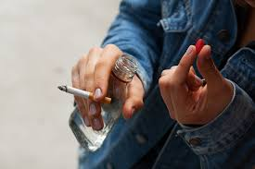

**What is Drug Abuse? And Position**

Drug abuse-Consumptions of substances (legal and illegal) that alter mood, perception, and behavior.

**1.9 to 2.4 million** minors have drug abuse issues in the United States (*Juvenile crime and Substance abuse, n.d.)*.

**Position**-Solution requires multifaceted approach because merely punitive measures are not effective

**The Cycle of Addiction**

1. Experimentation: Curious juvenile youths end up using drugs.
2. Regular use: Juvenile become regular users for pleasure and as a coping mechanism.
3. Dependence: The juvenile’s body cannot function without the substance
4. Addiction: Associated with craving and harmful consequences.

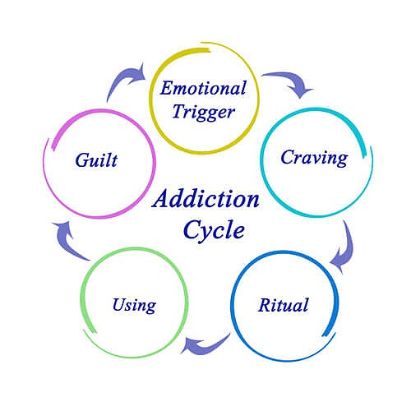

**75% of high schoolers drop out due to addiction**

**Trauma exposed juveniles are 200% likely to abuse drugs (*Consequences of youth substance abuse, n.d.)***

**Impact on Youth**

* Brain development: Juveniles are more likely to abuse drugs because their brains are still developing (***Consequences of youth substance abuse, n.d.)***.
* Peer pressure: Juveniles are easy target of influence from friends and social cycles
* Emotional struggle: Juvenile stress, for example, from studies forces some to self-medicate leading to abuse.

**Pros and Cons**

**Pros**

Temporary relief since juveniles feel short-term ease from emotional suffering. Also, drug abuse has been known to create a platform for social bonding.

**Cons (Outweigh pros)**

Health risk: Juveniles’ mental and physical health decline due to drug abuse.

Social isolation: This happens because of strained relationships.

Others: Financial burden and legal consequences.

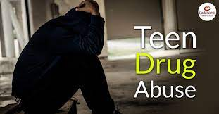

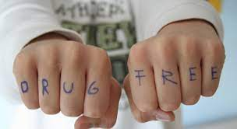

**Prevention and Support**

Education and Campaigns: There is a need to raise awareness among the juveniles on the cons of drug abuse while teaching them on alterative ways of creating social bonds.

Early Intervention: Drug abuse cases among juveniles must be identified early to prevent escalation to dependence and addiction.

Treatment: Where juveniles become addicts, treatment options such as rehabilitation should be pursued.

**References**

*Consequences of youth substance abuse*. (n.d.). <https://ojjdp.ojp.gov/sites/g/files/xyckuh176/files/pubs/drugid/ration-03.html>

*Juvenile crime and Substance abuse*. (n.d.). Child Crime Prevention & Safety Center. <https://childsafety.losangelescriminallawyer.pro/juvenile-crime-and-substance-abuse.html#:~:text=It%20is%20estimated%20that%201.9,options%20where%20available%20and%20appropriate>.