Community Gardens (New York City)
This story is about urban decay and restoration in New York City’s Bowery District. A fiscal crisis in city government during the 1960s precipitated the negative tipping point: a reduction in services (e.g., police and fire protection) in the already depressed Bowery. A system of interconnected and mutually reinforcing vicious cycles was set in motion by the cascade of effects that followed:

- Reduction in public services led to a deterioration of public infrastructure and safety, causing people to move away.

- Fewer people on the streets and more vacant properties led to garbage dumping, criminal activity, and homeless beggars, with further deterioration of public safety and more people moving away.

- Less income for local businesses and less tax revenue for city government led to even less expenditure by city government, landlords, and local businesses for maintenance of buildings and other infrastructure. Buildings and streets fell into disrepair, contributing to further neighborhood deterioration, and more people moved away.
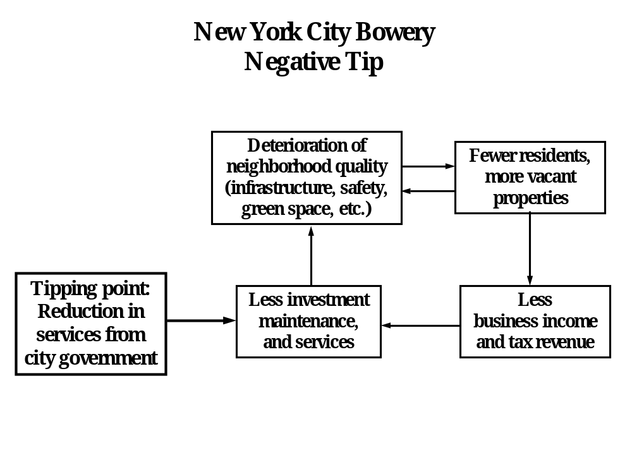

Diagram for students to fill in:
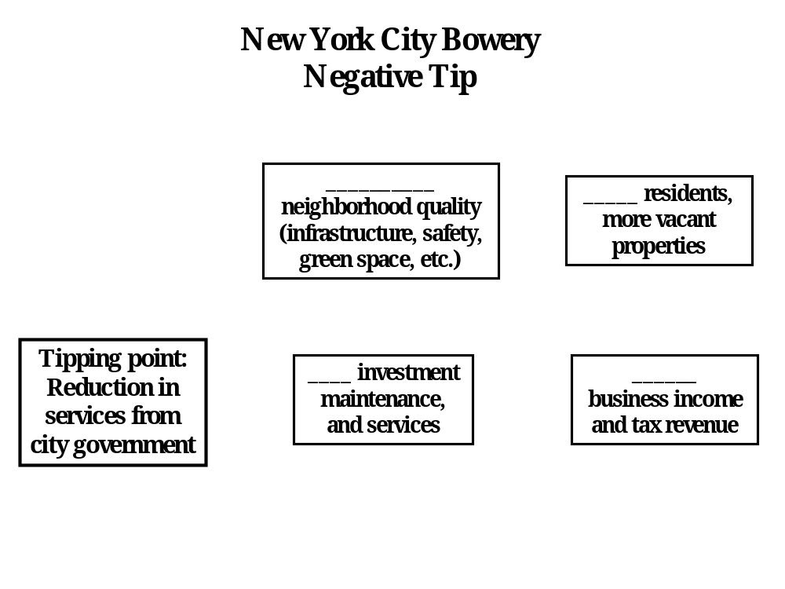
The positive tipping point began in 1973 when a young artist named Liz Christy saw a small boy playing in a trash-filled, rat-infested vacant lot and she decided to do something about it. She organized some friends to haul out the garbage and truck in soil to establish the Bowery Houston Community Farm Garden.

At first skeptical, the mostly African-American and Hispanic neighbors began to pitch in, and within a few months they were taking home armloads of tomatoes and cucumbers. Besides displacing rats and drug dealers, and creating a much needed green space, the garden also became an “outdoor community center.”

As can be seen in the diagram below, the garden served as the EcoTipping Point that reversed the vicious cycles described above. The vicious cycles of the negative tip were transformed into virtuous cycles (shown in black below):

- The improvement in neighborhood quality – public safety, buildings and other infrastructure, visual attractiveness, and community spirit – attracted people to move into the neighborhood. More residents meant even more people on the streets and even greater public safety.

- More residents and fewer vacant properties meant more business income and tax revenue, leading to investment in neighborhood restoration.

- More income and tax revenue also increased public and private services, further contributing to neighborhood quality.

- At the same time, a new virtuous cycle of “success breeds success” (shown in blue) arose around the garden, which served as a symbol for improving the neighborhood. The success of the garden, experience with managing it, and improvements in neighborhood quality instilled awareness, pride, and commitment to improving both the garden and the neighborhood even further.

Once news of the garden’s success spread, an entire movement developed. Neighboring neighborhoods established gardens, and in 1978 the city parks department began the Green Thumb program which offered plants, tools, expertise, and $1-per-year leases to community groups. By the late 1980s New York City was home to over 800 community gardens. They even attracted international attention, with people from as far away as China and Sweden visiting to learn how to start community gardens.
Most important, new virtuous cycles “locked in” the benefits. When property values in neighborhoods with gardens increased, the city government tried to sell garden lots for development. However, the pride and commitment of neighborhood residents, as well as experience and organizational capacity they acquired in the course of developing the gardens, enabled residents to take on the city bureaucracy, consolidating the legal tenure of the gardens.

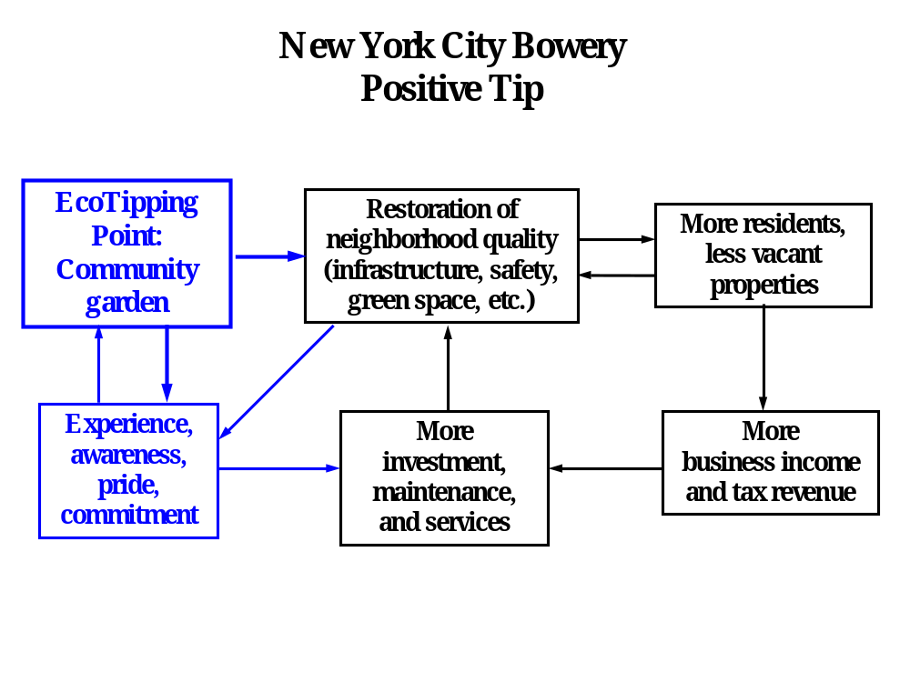

Diagram for students to fill in:
