RedHat OpenShift Virtualization Services
Number: | Local Document |  | Status: |  | Draft
Owner: | Adrian Pohancanik |  | Effective: |  | 01. Apr 2026
Doc.- type: | Design |  | Revision |  | 0.1
Comments:
[Authorized by:  (Optional, delete if not required)] | [Name] | [Name] |  | [Name] |  | IT-MIO-INFRASTRUCTURE ENGINEERING
[Authorized by:  (Optional, delete if not required)] | [Department] | [Department] |  | [Department] |  | IT-MIO-INFRASTRUCTURE ENGINEERING

Table of Contents

1. Purpose 1

2. Scope 1

3. Summary 1

4. IT Infrastructure Service Definition 1
4.1 Service Description 2
4.2 OpenShift Virtualization Requirements 2
4.3 Service Levels 4
4.4 Service Level Agreements 5
4.5 Service elements included 5
4.6 Server Tier Classes 6
4.7 Additional Availability Group Option 7
4.8 Server Sizes 8
4.9 Server Data Disks 9
4.10 Server Operating Systems 9
4.11 Storage 10
4.12 Storage Availability Classes 10
4.13 Storage Performance Classes 11
4.14 Backup 11

5. Security Concept 12

6. RBAC / Access Concept 12

7. Contacts 13

8. Definition / Terms and Abbreviations 13

9. Employee Roles and Responsibilities 14

10. Related Documents / References 14

11. History 14

Purpose
The purpose of this document is to provide the set of minimal requirements which go together to define an IT Infrastructure Service. This is to provide additional guidance when services are created.

Scope
The scope of this document is limited to the IT-MIO-INFRASTRUCTURE ENGINEERING.

Summary
This document provides a definition of an IT Infrastructure Service. It is intended for IT infrastructure teams responsible for designing, configuring, and delivering services. Each block includes a clear purpose, detailed description, and proposal implementation requirements. This ensures consistency, security, compliance, and operational excellence across all infrastructure services.

IT Infrastructure Service Definition

4.1 Service Description
OpenShift Virtualization is an add-on to OpenShift Container Platform that allows you to run and manage virtual machine workloads alongside container workloads.
As an integrated component of OpenShift, OpenShift Virtualization allows organizations to deploy and operate traditional Linux and Windows virtual machines through the same Kubernetes API and OpenShift console used for containers.
Based on KubeVirt and KVM
The solution is powered by the upstream open-source KubeVirt project, built on the KVM hypervisor included in Red Hat Enterprise Linux. Each VM runs within a POD, controlled via container-native tools.
An enhanced web console provides a graphical portal to manage these virtualized resources.
The configuration is defined via YAML files that manage the lifecycle and hardware state of the virtual machine.
Instance types comprise of varying combinations of CPU, memory, storage, and networking capacity and give the flexibility to choose the appropriate mix of resources.

Each instance type includes one or more instance size, allowing you to scale your resources to the requirements of your target workload. The DN Service offering for Managed OS includes several different standard sizes. These can be extended with additional CPU and/or RAM. The following Table shows the combination of the Types and the VM properties such as vCPU, vRAM and OS. In general, the table provides an overview about the baseline level of CPU. The Performance values for the VM are defined in the row by number of vCPU, vRAM per OS and furthermore by the Storage classes.
The customer starts with an Instance type and can scale up and down if necessary. The OS types on offer are Linux and Windows. The Availability Class Extension "+" for Silver+, Gold+ covers DR functionality.
The owner of the service belongs to the customer; however the customer is prohibited to change the settings of the operating system, nor is allowed to store data to system drives.

4.2 OpenShift Virtualization Requirements
- Tenant / Customer
- Firewall rules
- Network / Security zones / VLAN

Environment | VMware vCenter Server | Location | Powered On |  |  |  | Total
Environment | VMware vCenter Server | Location | VMs count | vCPUs | RAM in GB | Disk in GB | vCPU | RAM in TB | Disk in TB
CIO | cnsz1cipwvc1v.ad.diebold.com | China | 14 | 46 | 145 | 21600 | 48 | 0.14 | 21
CIO | USNCVC02.ad.diebold.com | India Mumbai | 546 | 1930 | 5330 | 260024 | 2315 | 6.20 | 361
CIO | USNCVC02.ad.diebold.com | Orchard | 23 | 94 | 266 | 25556 | 102 | 0.28 | 27
CIO | depb3civa1lvp.ad.diebold.com | India Hyderabad | 14 | 46 | 128 | 2602 | 66 | 0.17 | 3
CIO | inbl1vivca1lvp.ad.diebold.com | India Bengaluru | 8 | 28 | 96 | 24636 | 32 | 0.11 | 24
CIO | depb3civca2lvp | North Canton | 1 | 4 | 4 | 1024 | 4 | 0.004 | 1
CIO | USNCVC02.ad.diebold.com | North Canton | 1149 | 4346 | 14552 | 593874 | 5106 | 16.36 | 633
CIO | USMA2CIVCA1LVP.ad.diebold.com | Manassas DR | 119 | 568 | 2062 | 30066 | 676 | 2.28 | 36
CIO | depb3civa1lvp.ad.diebold.com | Paderborn DC3 | 1044 | 4565 | 14732 | 584956 | 5195 | 16.50 | 592
CIO | desl4civca1lvp.ad.diebold.com | Salzkotten DC4 | 339 | 1281 | 4978 | 86492 | 1561 | 5.53 | 92
CIO | depb3civa1lvp.ad.diebold.com | Warsaw, Poland | 5 | 10 | 30 | 2150 | 12 | 0.04 | 2.5
CIO | depb3civca2lvp | Warsaw, Poland | 0 | 0 | 0 | 0 | 2 | 0.004 | 0.11
CIO | depb3civca2lvp | Berlin, Germany | 3 | 6 | 52 | 1159 | 8 | 0.054 | 1.23
CIO | depb3civca2lvp | Ilmenau, DE | 5 | 21 | 74 | 790 | 23 | 0.076 | 0.84
CIO | depb3civa1lvp.ad.diebold.com | Kuala Lumpur | 3 | 8 | 28 | 4428 | 10 | 0.03 | 5.42
CIO | Standalone | Kuala Lumpur | 2 | 6 | 20 | 500 | 6 | 0.019 | 0.48
CIO | depb3civca2lvp | Istanbul, Turkey | 2 | 4 | 20 | 720 | 4 | 0.019 | 0.70
CIO | depb3civa1lvp.ad.diebold.com | UK Bracknell | 11 | 27 | 66 | 9448 | 156 | 0.48 | 22
CIO | Standalone | Philippines | 5 | 16 | 32 | 4862 | 16 | 0.03 | 4.74
CIO | USNC1CIVC1LVP.ad.diebold.com | VxRail-DC | 95 | 377 | 850 | 36204 | 425 | 0.93 | 41
MS India | depb3civca2lvp | India Hyderabad | 4 | 14 | 34 | 566 | 14 | 0.033 | 0.55
MS India | inmu2civca1lvp.dieboldservices.local | IDC-MS | 23 | 74 | 242 | 29546 | 82 | 0.26 | 29
MS Americas | USTXVC02.dieboldservices.local | Richardson TX | 465 | 1889 | 7728 | 230982 | 2119 | 8.22 | 245
MS Americas | USVAVC02.dieboldservices.local | Manassas VA | 361 | 1397 | 4698 | 101500 | 2197 | 7.40 | 114
EMEA | de03mgtlapp001.dnpcloud.dieboldnixdorf.com | DNPC Germany | 58 | 322 | 1103 | 20530 | 344 | 1.13 | 20
EMEA | de03mgtlapp002.dnpcloud.dieboldnixdorf.com | DNPC Germany | 954 | 3725 | 13256 | 230446 | 3755 | 13.03 | 226
EMEA | depb3givca1wvp.ad.diebold.com | MS Paderborn | 351 | 988 | 3243 | 65662 | 1421 | 4.18 | 85
EMEA | desl4givca1wvp.ad.diebold.com | MS Salzkotten | 263 | 926 | 4059 | 74851 | 1090 | 4.37 | 84
EMEA | ktwvcenterps.dieboldnixdorf.com | Katowice | 344 | 1255 | 3895 | 68742 | 2910 | 8.60 | 102
EMEA | plwawvcenter01.proview.pl | Warsaw | 66 | 178 | 648 | 8000 | 221 | 0.78 | 8.65
EMEA | PRG_PCIDSS | Prague CZ | 383 | 1446 | 3539 | 92233 | 1658 | 3.89 | 96
EMEA | PRG_nonPCI | Prague CZ | 186 | 601 | 1324 | 38718 | 647 | 1.39 | 39

Virtualization Capacity in an OpenShift Cluster

CPU overcommit ratio requirements 1:4
Enabled NUMA nodes

Capacity Breakdown for 5000 vCPUs
- 40 worker nodes
- Each with 64 physical cores
- Total physical cores = 2560
- With 1:2 oversubscription → 5120 vCPUs

Virtual Machine NUMA alignment , CPU Pinning (CPU Affinity)

CPU Hot Plug
RAM Hot Plug
Hardware virtualization
IO MMU
VBS is enabled

4.3 Service Levels

Operating time
​Gold & Gold+ | ​Monday - Sunday 7x24h (00:00-24:00)
​Silver & Silver+ | ​Monday - Sunday 7x24h (00:00-24:00)
​Bronze | ​Monday - Sunday 7x24h (00:00-24:00)

Service Tier | Region | Service time | On call Support
​Gold & Gold+ | EMEA  US  APAC | ​08:00-17:00 Monday to Friday  08:00-13:30 Monday to Friday  06:00-00:00 Monday to Friday | In the off Business hours and weekends. On call person will handle the incidents also approved changes.
​Silver & Silver+ | EMEA  US  APAC | ​08:00-17:00 Monday to Friday  08:00-13:30 Monday to Friday  06:00-00:00 Monday to Friday | In the off Business hours and weekends. On call person will handle the incidents also approved changes.
​Bronze | EMEA  US  APAC | ​08:00-17:00 Monday to Friday  08:00-13:30 Monday to Friday  06:00-00:00 Monday to Friday | No On call support for this service tier.

​Service Class Values ​ ​ ​ ​
Class | Availability ​ | Dtpm | Dtpi | ​#Fail/y | RPO​
​​Gold-Scale+ | 99.8 %​ | ​1.44h | 1.44h​ | 4​ | 15min
​Gold+ | 99.8 %​ | ​1.44h | 1.44h​ | 4​ | 30min
​Silver+ | ​99.5 % | 2.06h​ | ​2h | ​8 | ​1h
​Bronze | ​98.0% | ​4.60h | ​4h | ​12 | ​-
Dtpm = Downtime per month, Dtpi = Downtime per incident, #Fail/y = Failures per year, RPO = Recovery Point Objective

(*) Overview of the scope of service and service levels. For a detailed description please see the statement of work.

4.4 Service Level Agreements

Service Level Agreements
Metric | Bronze, Bronze+ | Silver | Silver+ | Gold | Gold+ | Definition / Notes
Platform Availability (per month) | ​98.0% | 99.5 %​ | 99.5 %​ | 99.8 % | 99.8 % | Excludes approved maintenance windows
Incident Response – P1 | Within 2 business hour | 1hour on working days; on-call for off-hours | 1hour on working days; on-call for off-hours | 30 minutes (business hours); on-call for off-hours | 30 minutes (business hours); on-call for off-hours | Time to acknowledge
Incident Restore – P1 | Best effort | 4 hours (target) | 4 hours (target) | 2 hours (target) | 2 hours (target) | Time to service restoration or workaround
Incident Response – P2 | 4 business hours | 2 business hours; on-call for off-hours | 2 business hours; on-call for off-hours | 1 hour (business hours); on-call for off-hours | 1 hour (business hours); on-call for off-hours | Acknowledgement time
Change Lead Time (Std) | Best effort | ≥ 7 business days | ≥ 7 business days | ≥ 14 business days | ≥ 14 business days | From approved RFC to implementation
Problem Management RCA | Within 10 business days | Within 7 business days | Within 7 business days | Within 5 business days | Within 5 business days | RCA for P1/P2 incidents
Backup Frequency | Daily | Daily | Daily | Daily | Daily | PVCs, metadata
Disaster Recovery RPO | N/A (no DR commitment) | N/A (no DR commitment) | 1 hour | N/A (no DR commitment) | 30 mins | Platform-level objectives; app DR may differ

4.5 Service elements included

​Service Element | ​Content
​Installation and operation | ​of hardware, virtualization layer, operating system and operating system related software
​IT operation | ​Establishing / maintaining the operational readiness
Service documentation | Service documentation will be maintained via ongoing process
​Vendor management | ​Maintaining ownership and management responsibility for the platform including the operating system.
​License management | ​Ensuring that license reporting for the license manager is functional, implementing best practice architecture to ensure license compliance and vendor management.
​Access management | ​User policies, administration and password management enforcement based upon corporate standards.
​Configuration management | ​Confirming the initial install and basic functionality levering a hardened operating system configuration based upon vendor, 3rd Party best practices and corporate standards.
​ | ​Add-on service to account for additional OS configurations for your services putting these then into your image configuration for repeated deployment.
​Change management | ​Providing ITIL-based internal change control when relevant for the service
​Patch / update management | ​Offering automated support for all critical and vendor-recommended patches for the deployed OS versions. The actual patching of the deployed services lies within the responsibility of the service consumer.
​Operational security measures | ​Securing the OS (where applicable) with anti-virus protection, regular virus and malware signature updates and additional OS-level hardening based upon GRS standards.
​Service deployment | ​Deployment of services to the customer's network as requested by the client from the standard service catalogue.
​Service monitoring | ​Monitoring provides the DN Engineering team with information about and monitoring of the operation and performance of Servers including CPU, disk and memory performance. The appropriate monitoring metrics and thresholds are based upon standards and cannot be individually requested.  But at the end of the day, the customer himself is responsible for monitoring his whole application. Only he knows the architectural design and possible hotspots inside. He's free to use the available elementary monitoring in that way he wants.

4.6 Server Tier Classes

5 different Server Tier Classes:

Bronze: Simple VM with low requirements e.g. for Testing.
- Operating time: Monday - Friday 5x9h (08:00-17:00)
- VM is hosted on a random Host in a VMware Cluster, without any HA or DR features.

STAC: Copper
STPC: Bronze

Silver: One VM for productive usage with HA and Backup
- Operating time: Monday - Sunday 7x24h (00:00-24:00)
- VM is hosted on a random Host in a VMware Cluster.

STAC: Iron, Steel
STPC: Gold, Silver

Silver+: One VM for productive usage with HA, Backup and Disaster Recovery Support.
- Operating time: Monday - Sunday 7x24h (00:00-24:00)
- VM is hosted on a random Host in a VMware Cluster.
- With DR capabilities.

STAC: Iron, Steel
STPC: Gold, Silver

Gold: Scalable number of active VMs for Cluster Services with HA and Backup
- Operating time: Monday - Sunday 7x24h (00:00-24:00)
- 2 → 10* active VMs hosted on separate Hosts in a VMware Cluster. (* up to the number of available Worked Nodes)
- Cluster service will be provided by application.
- High RPO RTO
- For cluster VMs rack level availability / Worker Node pools (DC Rack zooning 1,2,3…)
- STAS: Steel
- STPC: Gold, Gold

Gold+: Scalable number of active VMs for Cluster Services with HA, Backup and Disaster Recovery Support.
- Operating time: Monday - Sunday 7x24h (00:00-24:00)
- 2 → 10* active VMs hosted on separate Hosts in a VMware Cluster. (* up to the number of available Worked Nodes)
- Cluster service will be provided by application.
- With DR capabilities.
- High RPO RTO
- For cluster VMs rack level availability / Worker Node pools (DC Rack zooning 1,2,3…)
- STAS: Steel
- STPC: Gold, Gold

4.7 Additional Availability Group Option
With the additional availability group option to have the possibility to extend the amount of active VMs hosted on separate hardware hosts above the Gold class definition of 2 if required. This is an add-on option to the gold class service.
In addition to the gold class service definition, you can additionally:
- Define the group and add individual servers (>2) to this group after deployment.
- Grouping is limited to the tenant and Microsoft and Linux cannot be mixed within a single group.
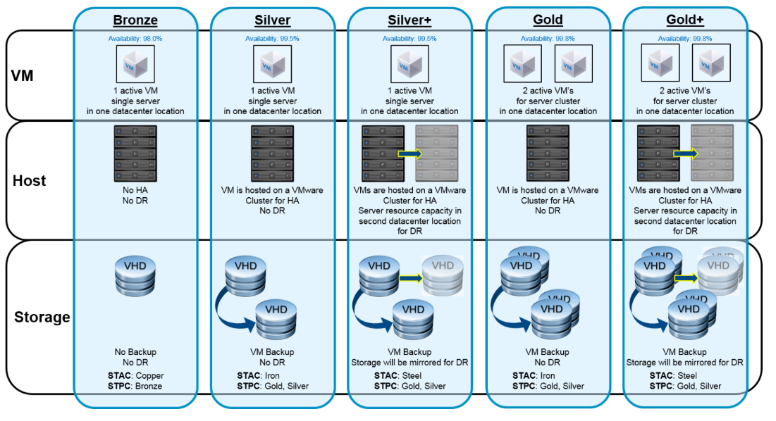
STAC = Storage Availability Class STPC = Storage Performance Class

4.8 Server Sizes
Each instance type includes one or more instance size, allowing you to scale your resources to the requirements of your target workload.
The Service offering for managed OS includes several different standard sizes. These can be extended with additional CPU and / or RAM. The following Table shows the combination of the
Types and the VM properties such as vCPU, vRAM and OS. In general the table provides an overview about the baseline level of CPU. The Performance values for the
VM are defined in the row by number of vCPU, vRAM per OS and furthermore by the Storage classes.
The customer starts with an Instance type and can scale up and down if necessary. The OS types on offer are Linux and Windows.

Instance Type | vCPU | vRAM (GB) | OS Linux | OS Windows
Tiny | 1 | 2 | X | --
Small_1 | 2 | 2 | X | X
Small_2 | 2 | 4 | X | X
Medium_1 | 4 | 8 | X | X
Medium_2 | 4 | 16 | X | X
Large_1 | 8 | 16 | X | X
Large_2 | 8 | 32 | X | X
​ ​ ​ ​
Slice CPU | 2 | -- | Range from 2 to 16 in total
Slice RAM | -- | 2 | Range from 2 to 128 in total

Instance Type of Server as VM

4.9 Server Data Disks

VM disks → DataVolumes → PersistentVolumes For Data
Features & Functions | Provides Virtual Machine Disk (LUNs) to store your data.
Eligibility & Prerequisites | Service available for all existing VM's. Disk is always dedicated and stored with respective VM on the same Storage Class and configured with respective IOPS.
​Size | Multiplication of 50 GB, up to 1 TB.
​Performance Class | ​Same as Server Class.
​Availability Class | Same as Server Class​.

4.10 Server Operating Systems

Vendor | ​Operating System | ​OS Parameter | ​Release | ​Release Status | ​End of Mainstream Support | ​End of Patch Support (EoL) | ​End of Platform operation
​Microsoft | ​Windows Server 2016 | ​ - User Interface: English  - for x86 processors  - 64-bit architecture  - 100GB OS dedicated partition | ​N - 1 | ​Released | ​01.11.2022 | ​12.01.2027 | ​​11.08.2026
​Microsoft | ​Windows Server 2019 | ​​ - User Interface: English  - for x86 processors  - 64-bit architecture  - 100GB OS dedicated partition | ​N | Released | ​09.01.2024 | ​09.01.2029 | 08.08.​2028
​Microsoft | ​Windows Server 2022 | ​​ - User Interface: English  - for x86 processors  - 64-bit architecture  - 100GB OS dedicated partition | ​N | Released | ​09.01.2024 | ​09.01.2029 | 08.08.​2028
​Oracle | ​Oracle Enterprise Linux 8 | ​- User Interface: English  - for x86 processors  - 64-bit architecture  - 50GB OS partition | ​N | ​Released | ​July 2029 | ​Not defined yet | 31.12.2028
​Oracle | ​Oracle Enterprise Linux 9 | ​- User Interface: English  - for x86 processors  - 64-bit architecture  - 50GB OS partition | ​N | ​Released | ​30.06.2032 | ​Not defined yet | 30.06.2035

End of Vendor Support - After this date the vendor no longer: accept support calls, supplies non-security hotfixes, no long accepts requests for new features and design changes.
End of Patch Support - The Date until security and critical patches are still being supplied.
We offers N Support until Vendor Support is discontinued and N -1 until Security and critical patches are no longer available. Version which is marked as Out of support is fully managed by server owner including patch, vulnerability management. Be aware however that Vendor support calls and feature requests outside of the Vendor Support period are not possible. The platform does not provide any SLA for those products.
DN Engineering team recommends always to choose Version N.

* we will not support outside of N -1. This means that the OS can no longer be provisioned or managed.

* You are to ensure the migration in your architecture to either N or N -1.
Currently only one Version of Linux is being offered. This is pending a change of Linux distribution.
RHEL 7.* will still be available but with an expected higher OS License Cost.

4.11 Storage
The storage services provides additional Storage to Hostsystems. The currently available services are designed to provide storage for Database applications and File sharing, they are highly scalable in capacity and throughput performance.
Additional VMDK disks are not part of this service.
Delivers various storage classes for different demands.

​Storage Classes | ​Description | Class types​
​STAC | ​Storage Availability Classes | ​Copper, Iron, Steel
​STPC | ​Storage Performance Classes | ​Bronze, Silver, Gold

4.12 Storage Availability Classes
Copper: Redundant storage system in 1st DC
- Operating time: Monday - Friday 5x9h (08:00-17:00)
- is directly attached to the storage controller. There are some restrictions for the HA scenario because in the case of Copper a multipath storage connection with
additional controller has to be established.
Iron: Redundant storage in 1st DC and backup to 2nd DC
- Operating time: Monday - Sunday 7x24h (00:00-24:00)
- is HA ready and connected with redundant metrics such as multipath and an additional controller to the local storage. This class is not ready for DR.
Steel: 2x Redundant storage in 1st+2nd DC's with async mirror and backup to 2nd DC
- Operating time: Monday - Sunday 7x24h (00:00-24:00)
- is HA and DR ready. The Recovery Point Objective (hereinafter called RPO) is technically defined via an asynchronous mirror between the two DCs for "Steel".
The recovery time is 8 hours in a case of DR.

The following overview shows the different classes and in which manner they are to be operated.

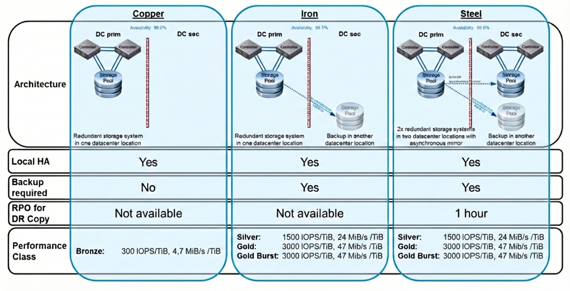

4.13 Storage Performance Classes

Storage Class:

Class Name | IOPs | Expected Service Tier to be Opted
Bronze | 300 | Bronze, Bronze+, Silver
Silver | 1500 | Silver+, Gold
Gold | 3000 | Gold+, Platinum

4.14 Backup
Backup Service Overview

The Backup Service for OpenShift Virtualization provides standardized and reliable data protection for virtual machines (VMs) operating within the platform. The service ensures that VM-level backups are performed and retained in alignment with the requirements of the respective environment.

Backup Schedule
Virtual machines are backed up at a minimum frequency of once per day. Environments with higher operational or application requirements may define and implement more frequent backup intervals as needed.

Backup Retention and Storage Tiers
Primary backup storage
Backups generated within the most recent two (2) days are stored on primary storage systems. This tier is intended to provide rapid access and support expedited recovery operations.
Secondary Storage
Backups older than two days are transferred to secondary storage. Retention on this tier follows the retention policy defined for the specific environment ensuring compliance with organizational or regulatory requirements.

The following items are explicitly out of scope for this service:
- Application‑consistent snapshots, including those requiring quiescing or coordination with guest applications.
- Database‑level backups or any backup mechanisms that require integration with database engines, plugins, or agents.

On-Demand Virtual Machine Snapshot

In addition to regular backup service above.
The service includes single Virtual Memory Snapshot creation of all local disks without Memory (RAM) which is available for recovery up to 7 days (01:00 CEST) after snapshot creation.

Security Concept

Define the overall security architecture and compliance alignment.
Provides a comprehensive view of security, including access control, audit logging, and compliance mapping.

It ensures the service is resilient and audit-ready.
Requirements:
- Access control strategy (RBAC)
- Audit logging and retention policies
- Integration with SIEM/SOC
- Mapping to compliance frameworks, which controls are accounted for (ISO 27001, PCI DSS)
- Data protection and privacy controls

RBAC / Access Concept
Control access based on roles and responsibilities.
Defines roles, access workflows, least privilege enforcement, and periodic review definitions.
It ensures secure and appropriate access to service components.

Requirements:
- Role definitions (e.g., Admin, Operator, )
- Access request and approval workflow
- Least privilege enforcement
- Periodic access review definition
- Emergency access procedures (Break Glas)

a) Operations Role
- Scope: Cluster or Datacenter level
- Permissions:
  - Power operations (Power On/Off, Reset)
  - VM console access
  - Snapshot management
  - Basic VM configuration (CPU/RAM changes)
  - No access to networking/storage configuration

b) Administrator Role
- Scope: Same as Operations Role, plus:
  - Create/Delete VMs
  - Manage resource pools, Clusters, Namespaces, Datastores
  - Assign permissions to team members (within their scope)

c) Read-Only Role
- For auditing or monitoring purposes only.

Access Role: Administrators
- Engineering Team
- Virtualization Team

Access Role: Operations team
- Database Team
- Linux Team
- Windows Team

Dependencies
The service is dependent on AD authorization and Jumps servers access, which provides web access for the OPS Team.

Contacts

[Insert statement regarding whom to contact if any issues or questions surrounding the subject matter of the document.]

Definition / Terms and Abbreviations
Term | Definition
[Document Control System] | [IT System to manage documents]
[DN] | [Diebold Nixdorf]
AD | Active Directory
OP | Operation teams (Linux, Windows, Backup, Storage)
OC | Red Hat OpenShift command-line interface (CLI)
OCP | Red Hat OpenShift Container Platform
namespaces | A namespace isolates specific system resources that are visible to all processes. Inside a namespace, only processes that are members of that namespace can see those resources
pod | One or more containers with shared resources, such as volume and IP addresses, running in your OpenShift Container Platform cluster. A pod is the smallest compute unit defined, deployed, and managed.

Employee Roles and Responsibilities
Role | Responsibility
[Quality Management] | [Controls and reviews the level of quality.]

Related Documents / References
Title | Number

History
Revision | Date | Comment | By
[0.1] | 15.12.2025 | [First draft version] | Stuart Evans

- Server Tier Classes
7 different Server Tier Classes:

Bronze: Simple VM with low requirements e.g. for Testing.
- Operating time: Monday - Friday 5x9h (08:00-17:00)
- VM is hosted on a random Host in a VMware Cluster, without any HA or DR features.

Silver: One VM for productive usage with HA and Backup features.
- Operating time: Monday - Sunday 7x24h (00:00-24:00)
- VM is hosted on a random Host in a VMware Cluster.

Silver+: One VM for productive usage with HA, Backup and Disaster Recovery Support.
- Operating time: Monday - Sunday 7x24h (00:00-24:00)
- VM is hosted on a random Host in a VMware Cluster.
- With DR capabilities.

Gold: 2x active VMs for Cluster Services with HA and Backup.
- Operating time: Monday - Sunday 7x24h (00:00-24:00)
- 2 active VMs hosted on separate Hosts in a VMware Cluster.
- Cluster service will be provided by application.
Gold+: 2x active VMs for Cluster Services with HA, Backup and Disaster Recovery Support.
- Operating time: Monday - Sunday 7x24h (00:00-24:00)
- 2 active VMs hosted on separate Hosts in a VMware Cluster.
- Cluster service will be provided by application.
- With DR capabilities.

Gold-scale: Scalable number of active VMs for Cluster Services with HA, Backup.
- Operating time: Monday - Sunday 7x24h (00:00-24:00)
- 3 → 10* active VMs hosted on separate Hosts in a VMware Cluster. (* up to the number of Worked Nodes)
- Cluster service will be provided by application.

Gold-scale+: Scalable number of active VMs for Cluster Services with HA, Backup and Disaster Recovery Support.
- Operating time: Monday - Sunday 7x24h (00:00-24:00)
- 3 → 10* active VMs hosted on separate Hosts in a VMware Cluster. (* up to the number of Worked Nodes)
- Cluster service will be provided by application.
- With DR capabilities.

