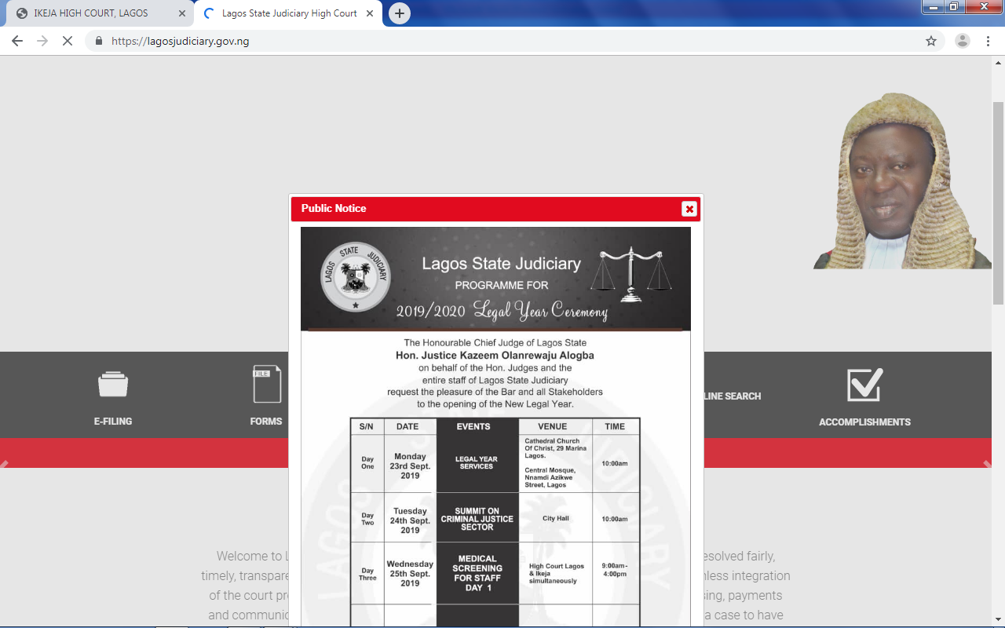

**Noted**

* **Read more page theres more to be done and the image changed**

**(Kindly get me replacement for those images)**

**Get one na**

**I don’t know what your supervisor will like… just google it and forward it to me.**

**Still expecting this pls**

* **No epayment drop down**

**(Will be added, but I’m not going to implement the e-payment gateway, you will just have a dummy interface for that)**

**Why**

**It brings complexity .. Well, if you want it, go to pay stack and create an account, and send me the API key**

**Done**

* **No media drop down**

**(What is going to be the content?)This will contain the recordings accessible to only people who have ids**

**How will the system get these files?**

**I don’t think this is needed, but if it is, I’m still expecting answer to this**

* **Handled cases should be called something else**

**(Done) thanks**

* **There should be place called docket a list of cases for trial or people having cases pending**

**(On the front end or the admin area?)**

**Front end handled and controlled by admin**

**I will look at the possibility**

**Will be ready with the next release**

* **For more** [**https://lagosjudiciary.gov.ng/**](https://lagosjudiciary.gov.ng/)

**(Do you want the replicate of this website? Or what are the area you want me to look into?)**

**No but their options abi drop down are useful too**

**Hmmmmm… what are the links you want to add?   
  
I don’t think this is really necessary, but if it is, what are the links you want to add**

* [**calendar**](https://dictionary.law.com/Default.aspx?selected=116) **1) n. the list of cases to be called for trial before a particular court; 2) v. to set and give a date and time for a case, petition or motion to be heard by a court. Usually a judge, a trial setting commissioner, or the clerk of the court calendars cases.**

**(Cases in the admin area already handle this, it allows you to filter cases base on the date… Adding calendar wasn’t in the features before…)**

* **The template showing there should be removed**

**(Can you get me words to replace them or I should just remove them… Note: removing them will make those pages look blank)**

**Just replace with a name you think our supervisor wont have issues with.**

**I don’t know the name your supervisor won’t have issue with**

**Still expecting this**

* **Some links showing error page like cases uder case mgt**

**(Oh yeah… Sorry for this, will rectify it… Lawyer and judge too is affected)**

**Done**

* **No abbreviation**

**(Explain this pls)**

**You abbreviated some words**

**It’s to make it fit to the design…   
  
Expecting your feedback on this**

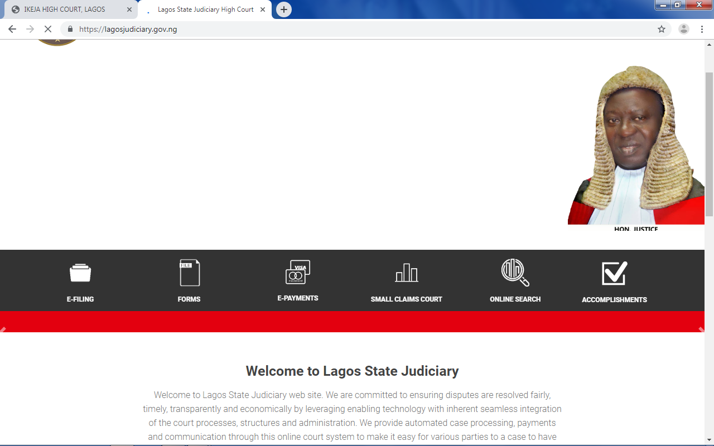

**The first page should have a slide show of images and there should be the list like**

**(The layout I use doesn’t have provision for carousel or slider)**

**(Kindly crop the website and mark where this list should be added, and retype the content in a separate document exactly how you want it to appear on the website)**

**I don’t think all these are required…**

**E-Filling System (EFS)**

**Queue management system (QMS)(this should be names used)**

**Court Recording and Transcribing (CRT)**

**I mean the areas above should be the names**

* + 1. **Electronic Filing System (EFS)**

**This basically allows for filing cases electronically i.e via the internet where legal firms are allowed to file their case online by submitting applications or summons. Court issues the case number online or Id number and all documents will be submitted online. Creating an E-filing system requires a lot of work, The initial phase is installed but still handled partially in a manual way, the phase registers the initial civil filing, enters the relevant information into the database, assigns a case number, and adds scanned copies of the accompanying documents, calculates fees and once the fees are paid(by transfer or cash with evidence of payment), issues a writ of summons for delivery by the attorney (or if s/he wishes by the court for an additional fee). This electronic filing provides forms to the filer which allows data to be extracted automatically and also allows registration of digital signature. As stated earlier EFS allows electronic payment of court fees (filing fees, service fees and additional filing fees) and submission of documents online. The case number generated has to be unique and would feature the year, the court or intake office, and the sequential number, based on issue and category of the case, a fourth figure corresponding to the general matter (Civil, Family, Commercial, Criminal, etc.) could be added, but it is really not necessary, however, it might help in organizing the e-archive. With this system in execution, summons are filed by a lawyer or individual through the e-Filing System and all necessary documents are prepared in softcopy and submitted online.**

**In Previous systems the lawyers have to call the registrar for the status of their case filing but using the e-Filing, the system will send notification of any case filing status to the lawyers' email immediately upon successful registration in the e-Filing System (Saman & Haider, 2013).**

* + 1. **Queue Management System**

**Queue Management System (QMS) is a system that allows the queuing process of daily court transaction, be made automated a when lawyers/counsels register their case number in a kiosk system for daily case management. Instead of keeping lawyers waiting, the queue system facilitates holding of hearings by registering the arrival of attorneys, the day the event is scheduled and showing them where they stand in the queue. SMS as well as calls can be put through to know about current situation of cases pertaining to them. Attorneys arriving for a case management or chambers matter register in the court building, after checking in, the hearing is placed on queue. This avoids the problem of re- scheduling of a hearing because one of the lawyers has not appeared (Saman & Haider, 2013).**

**3.1.3 E-Court Information System(this one can be called something else just as you have it)**

**E-Court Information System is a system that allows cases be managed electronically via the internet without using paper files. For cases that need for a full trial, all important information is passed through the system. Some other cases that need not to be heard before judges are managed by the Admin using this system and decisions made are recorded immediately in the presence of lawyer of both parties (plaintiff and defendant). The system functions are:**

**1. Assigning cases to judges**

**2. Scheduling hearings and other events (which lawyers ignore at the risk of a case being struck out or suffering a default judgment) and**

**3. Setting and tracking performance targets.**

**The system provides opportunities for electronic workspace, access control and administration for security purposes, dashboard and statistical analysis (Saman & Haider, 2013).**

**3.1.4 Court Recording and Transcribing (CRT)**

**Court Recording and Transcribing (CRT) is a modern intelligent system to record either audio or video format of the whole process of hearing before judges in the open court this system provides long term preservation of actual presentation of cases. This application also allows for automated transcription be made easily. Court recording offers several advantages, like allowing the investigation of cases by professionals after they review the facial expression of the witnesses or the accused while the hearing is going on, it will be kept as evidence in a case where the accused or defendant decides to be irregular with words, Since the recording is regarded as public document, lawyers can have a copy of the recording to bring back to their office**

**Data Mining: this is whwere handled cases will be and previous cases it will sepaerated according to the type of case**

**Listed below:**

* [**Civil cases**](http://www.localcourt.justice.nsw.gov.au/Pages/cases/civil_cases.aspx)
* [**Criminal cases**](http://www.localcourt.justice.nsw.gov.au/Pages/cases/criminal_cases.aspx)
* [**Bail**](http://www.localcourt.justice.nsw.gov.au/Pages/cases/bail.aspx)
* [**Apprehended violence orders**](http://www.localcourt.justice.nsw.gov.au/Pages/cases/avo_procedures.aspx)
* [**Family law**](http://www.localcourt.justice.nsw.gov.au/Pages/cases/family_procedure.aspx)
* [**Appeals**](http://www.localcourt.justice.nsw.gov.au/Pages/cases/appeals_and_reviews.aspx)
* [**Residual jurisdiction cases**](http://www.districtcourt.justice.nsw.gov.au/Pages/case_types/residual_jurisdict.aspx)
* [**Work health and safety cases**](http://www.districtcourt.justice.nsw.gov.au/Pages/case_types/whs_cases.aspx)
* **Child Custody**
* **Child Support**
* **Debt Collection**
* **Divorce**
* **Domicile**
* **Emancipation**
* **Eviction**
* **Housing**
* **Name Change**
* **Personal Protection**
* **Setting Aside an Adult Conviction**
* **Setting Aside a Juvenile Adjudication**
* **Small Claims**

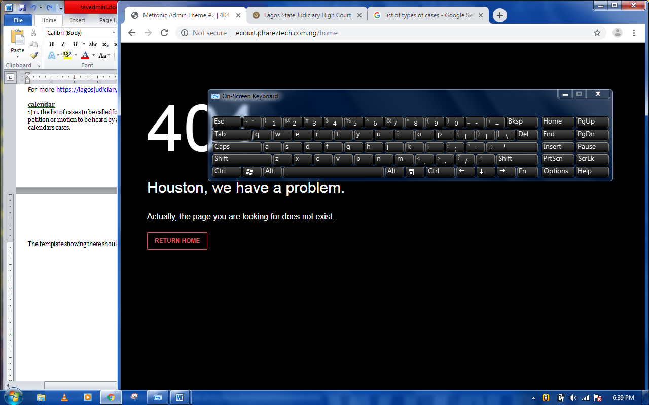

**The link is invalid… the home is not routed to any page, but I can if you need it…**

**Please do help out**

**The link itself take you to the homepage**

**Done**

**OUTPUT DESIGN**

**The output of a computerized system varies depending on the input design and processing algorithm. The output design of the proposed E-justice information system incorporating data mining is the end product of the input data which has been processed. The system is designed in such a way that it efficiently provides output to the user promptly and in well-organized manner. The outputs from the application are provided in module:**

* **Summons/Orders : shows writ of summons and court order**
* **Messages: Show user message log.**
* **User Profile: Show user profile.**
* **Uploaded documents**
* **General information**
* **Notes and attachments**
* **History of cases**
* **Portfolio, Dashboard screen and statistical analysis**
* **List of tasks and case details and other output modules.**

**3.6.2.2 INPUT DESIGN**

**The input design considers the data, method of data entry, extraction of data and preparation of input data. The system is designed to accept several input details efficiently through input forms and user click. The data captured through the user keystrokes and clicks are received by specific modules on the system and relayed to the back-end of the system processing. This project contains different forms which serves different purposes. The input is designed to validate the data entry. The various forms include:**

* **Edit Profile**
* **Send Message**
* **Upload form**
* **Create client info(user) Form**
* **Create case Form**
* **Update & Modify Form**
* **E-payment Form**