24.6.2026

Resources
https://extranet.who.int/prequal/
https://media.path.org/documents/TS_update_san_pad.pdf
https://www.linkedin.com/pulse/prequalification-health-products-safe-medicine-s0sve/
WHO compendium of innovative health technologies for low-resource settings 2024
https://iris.who.int/server/api/core/bitstreams/afc740ad-88d1-4595-bab3-f5a82a6ba057/content

www.develop-hta.com
contact@develop-hta.com

Contents
Website 3
Home 3
What we do 3
About us 4
Mission/Vision 4
Our Story 4
Knowledge Hub 5
HTA Frameworks 5
Success Stories 5
Experts network 5
News 5
About us 5
Public Advisory Division (Non-profit Core) 5
Consultancy Division (Mission-Driven Consultancy) 5
Target Stakeholders 6

Website

Home


We empower Sub-Saharan healthcare systems by bridging global HTA standards with local realities.

What we do
We make Health Technology Assessment accessible across Sub-Saharan Africa and...
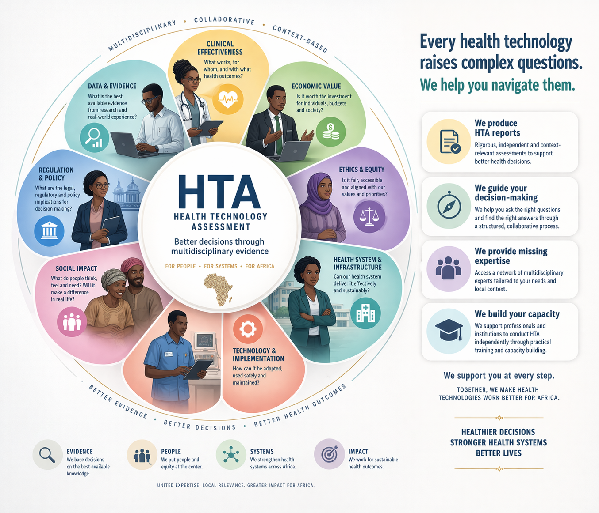

About us

Mission/Vision
....

Our Story
We are Marina, a medical doctor, and Jani, a biomedical engineer. We met through the network of the HTAi Interest Group on Developing Countries, brought together by a shared professional interest in Health Technology Assessment (HTA) and its potential in low-resource settings.
Every great mission starts with a connection.
We had a common dream: to empower Africa through HTA.
We realized that global standards are only as good as their local application. From that vision, this platform was born—not just as a technical repository, but as a bridge. Our goal is to ensure that every medical technology reaching African soil is safe, effective, and sustainable, helping local leaders make informed choices for their communities.

Knowledge Hub

HTA Frameworks

Success Stories

Experts network

News

Contact

*PHASE II (After registration):

About us
We combine a European-based non-profit core, focused on public interest and equitable access to HTA, with a mission-driven consultancy based in Sub-Saharan Africa, delivering services, expertise, and capacity building on the ground.

We are a non-profit organization committed to making Health Technology Assessment (HTA) accessible across Sub-Saharan Africa.
Our organizational model is hybrid, combining public-interest goals with operational sustainability:

Public Advisory Division (Non-profit Core)
A non-governmental organization (NGO) / foundation / non-profit institute registered in ...(Europe), dedicated to advancing equitable access to HTA and supporting evidence-informed health policies.

Consultancy Division (Mission-Driven Consultancy)
A consultancy arm (or spin-off entity), registered in ...(a Sub-Saharan African country), delivering tailored HTA services, technical support, and capacity building to local stakeholders.

Together, these two components allow us to maximize impact while ensuring long-term sustainability and strong local engagement.

Target Stakeholders
- Healthcare Organizations
Who
- Public and private hospitals;
- Faith-based healthcare providers;
- Health NGOs.
We can support by
- Prioritizing technology investments;
- Comparing alternative technologies or service models;
- Strengthening grant and donor funding applications through HTA-informed evidence;
- Supporting internal decision-making via structured data collection and scenario modeling.
- Public Institutions
Who
- Ministry of Health;
- National Health Insurance Fund;
- Emerging HTA units
We can support by
- informing coverage, reimbursement, and procurement decisions;
- providing HTA tools that are usable even where formal HTA structures are not yet established;
- supporting institutional learning and capacity strengthening.
- providing structured advisory inputs for technology adoption

- Local Health Industry
Who
- Manufacturers/importers of medical devices, diagnostics, and supplies
- Digital health startups
We can support by
- Demonstrating value for money for technologies
- Preparing HTA-informed briefing dossiers for Ministry of Health, NHIF, and donors
- understanding of decision-making processes through:
  - identification of relevant questions,
  - structuring evidence needs,
  - improving alignment between technology design and payer expectations.

https://webmail-oxcs.networksolutionsemail.com/appsuite/?user_domain=mail.develop-hta.com#!!&app=io.ox/mail&folder=default0/INBOX FrRKwfVZ4Q$J3K@

