The format of data:
Each column is one channel data. The first line of the text file should be four numbers. First is the sampling rate, second is the number of columns, third and fourth are zeros.

Basic operations in NSPL
- Run matlab
- Set the directory to ‘D:nspl’
- type ‘nspl’ in the command window and click ‘return’ button.
- Then you get the interface as
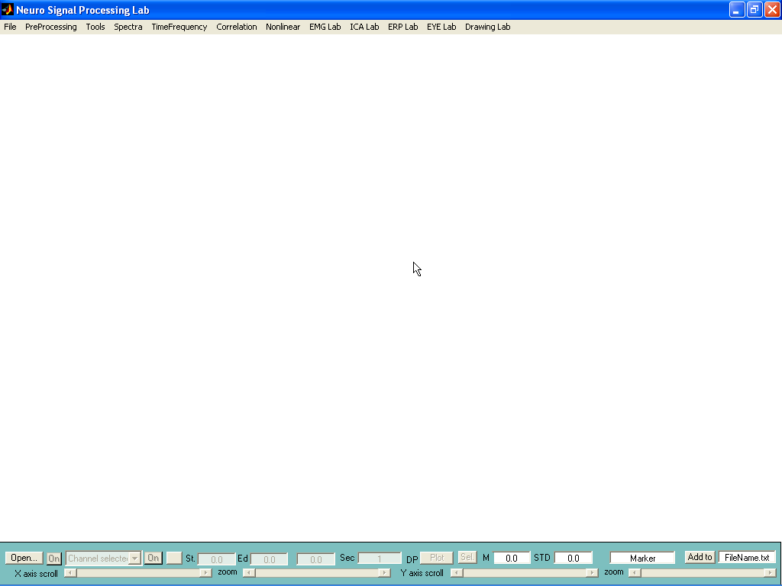
- Introduction for the buttons.
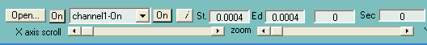
  - Open button: open file
  - Left ‘On’ button: display or hide all channels by toggle mode
  - ‘Channel1-On’ list: select channel for relevant manipulation
  - Right ‘On’ button: display or hide selected channel in (3) by toggle mode
  - ‘St box’: start time of a selected data segment
  - ‘Ed box’: end time of a selected data segment
  - next two boxes are the length of selected data segment in units of seconds and data points.
  - X axis scroll: scroll data in x axis direction
  - Zoom bar: zoom the data in x axis direction

  - Plot button: plot the signals, see next.
  - ‘Sel’ button: select data by click left mouse button.
  - ‘M’: mean value of the selected channel in (3)
  - ‘STD’: standard deviation value of the selected channel in (3)
  - ‘Marker’ box: used for typing a note and save it together with mean and STD values into a file named in the next box.

2. Plot signals.
Font size
The range in x axis
The range in y axis

Draw or not the axis and labels.

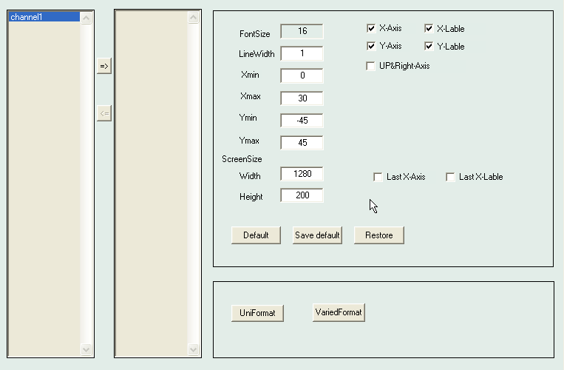
click: the buttons of ‘uniformat’ and ‘variedformat’ to plot the data. for instance:
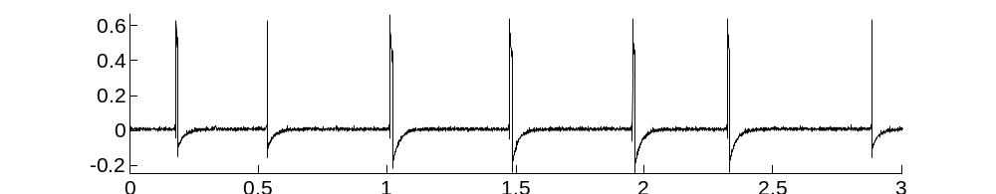
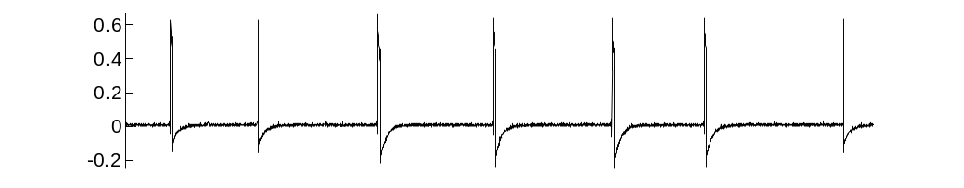
Denoise by band-stop and band-bass filtering

- Open data in NSPL, Select the data segment to process by setting the starting time (St.) and ending time (Ed.)
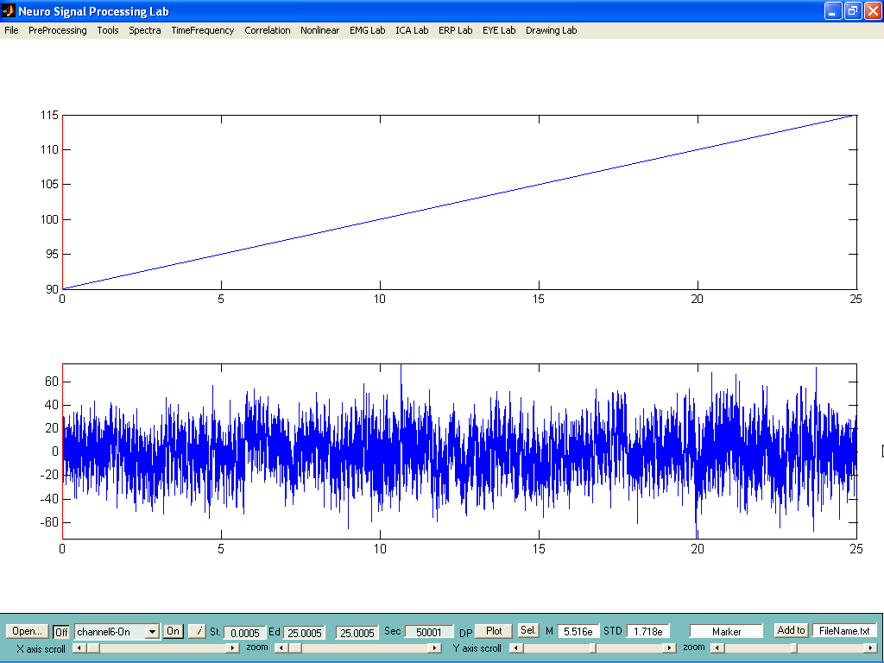
- Click menu item ‘preprocessing’-‘filter’, select the channel or channels to be filtered
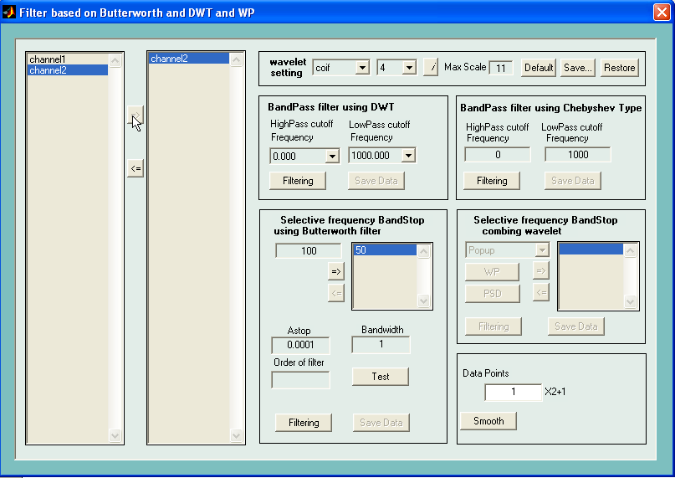
- to filter the 50Hz noise using Band Stop Filter,
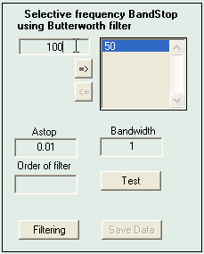
Click ‘Filtering’ and ‘Save Data’, to save the filtered signal into another file.
You can add several bands. If the noise is not removed completely, increase the value of ‘Astop’.

- To filter the high frequency or low frequency noise using Band Pass filter.
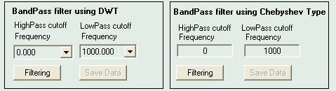
The signal between the high pass cutoff and low pass cutoff frequencies is kept and others are filtered out.

An example for noise removing:
- The settings for removing noise:
  - step one: identify the frequency of the noise from power, 50Hz, 100Hz, etc.
  - Step two: remove the 50Hz, 100hz, 150hz using band stop filter, the parameters are: Astop: 0.02, BandWith: 2
  - Step three: check the power spectra of the filtered data to check the effect of filtering. If there is still noise left, increase Astop and repeat step two.
  - Filter the data using band pass filter using Chebyshev Type. The High pass cutoff frequency is 0, and low pass cut-off frequency is 195.

Causality analysis
Click menu: ‘correlation’-‘causality’
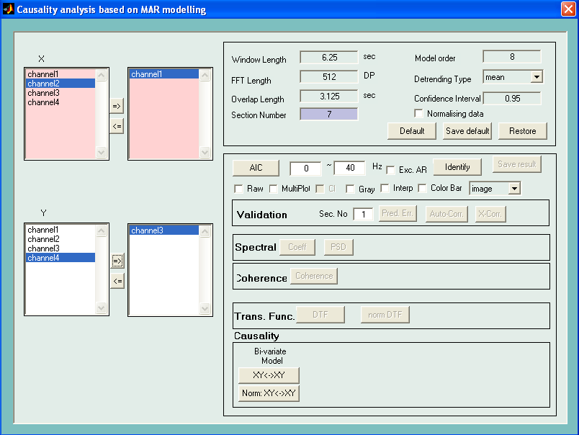

- Select one or more channels at X and Y boxes.
- set window length of each data segment from which a spectra will be obtained and the final result is the average of the spectra from all of the data segments
- FFT length is the number of data point in each spectra
- overlap length is the overlap between two adjacent data segements
- model order is the order of AR model
- detrending type is the way to remove baseline floating
- normalising data option is to normalise the data with unit variance
- AIC button is used to get the AIC curve. The following two boxes are used to set the interested frequency range.
- Identify button is for identify the model parameters
- spectral: coef button is used to get the model coefficients in Matlab Command window, PSD is to get the power spectra and cross-spectra. There will be four windows appearing. First and second are the time-varying result of power spectra and phase. Third and fourth are averaged result
- coherence button is to get the coherence result
- DFT is to get the transfer function. Norm DFT is to get the normalised transfer function.
- XY-XY button is to get the causality between each pair of data. Norm XY-XY is to get the normalised causality.

