Original_data=Original_data+random('Normal',0,1,1,10000);
Original_data(2,:)=zeros(1,10000);

rand1=random('Normal',0,0.8,1,length(Original_data));
rand2=random('Normal',0,0.8,1,length(Original_data));

for i=13:length(Original_data)
Original_data(2,i)=0.4*Original_data(1,i-3)-0.6*Original_data(1,i-8)+0.6*Original_data(1,i-12)-0.9*Original_data(2,i-1)+rand1(i);
end

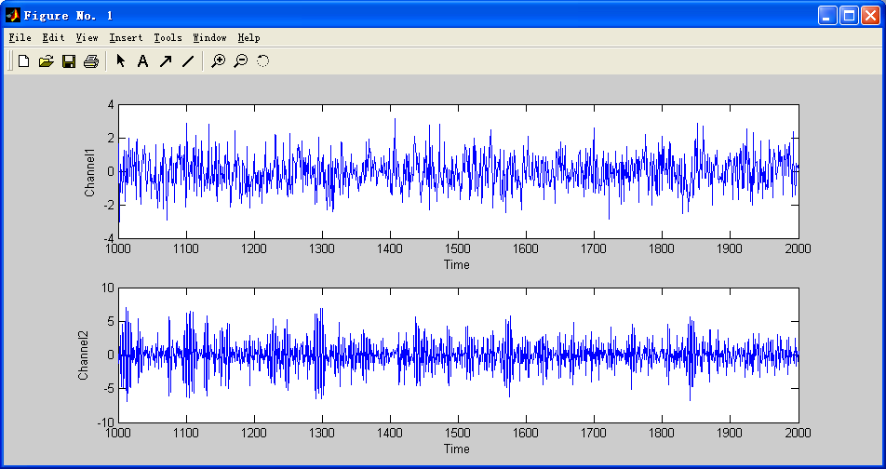
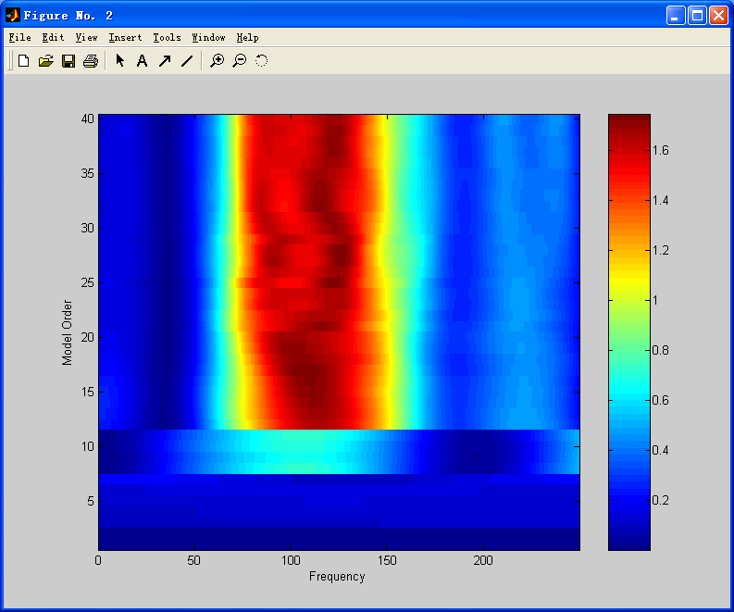

Original_data=zeros(1,10000);
Original_data=0.9*sin((1:10000)/19);
Original_data=Original_data+random('Normal',0,1,1,10000);
Original_data(2,:)=zeros(1,10000);

rand1=random('Normal',0,0.8,1,length(Original_data));
rand2=random('Normal',0,0.8,1,length(Original_data));

for i=13:length(Original_data)
Original_data(2,i)=0.4*Original_data(1,i-3)-0.6*Original_data(1,i-8)+0.6*Original_data(1,i-12)-0.9*Original_data(2,i-1)+rand1(i);
end
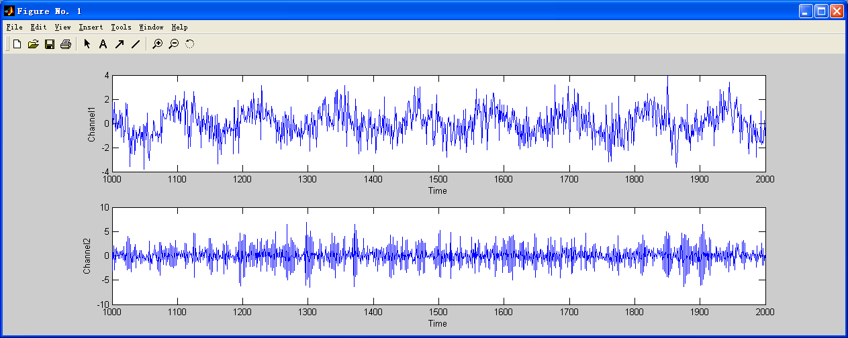
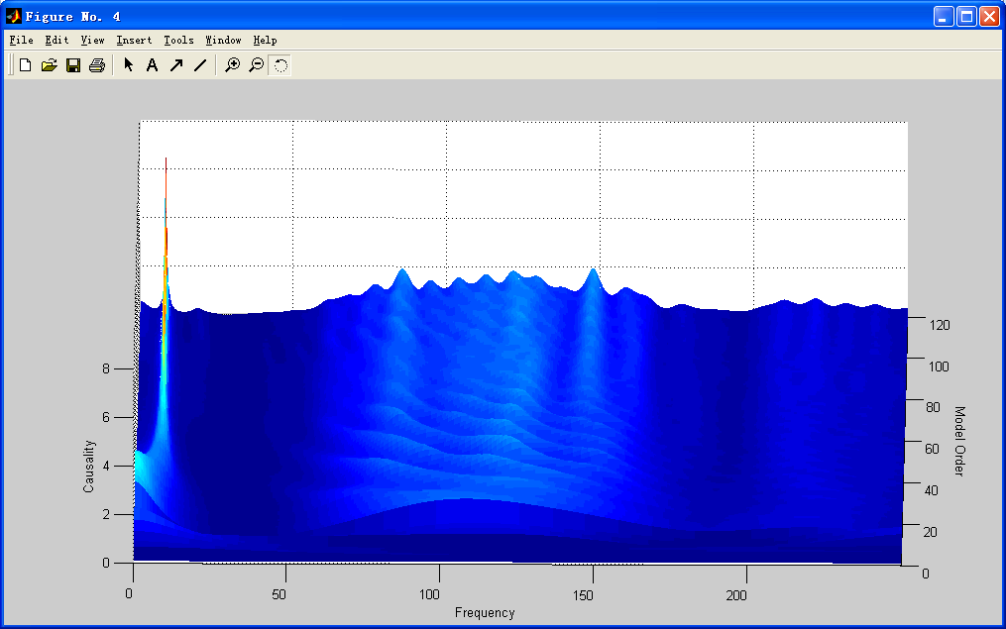
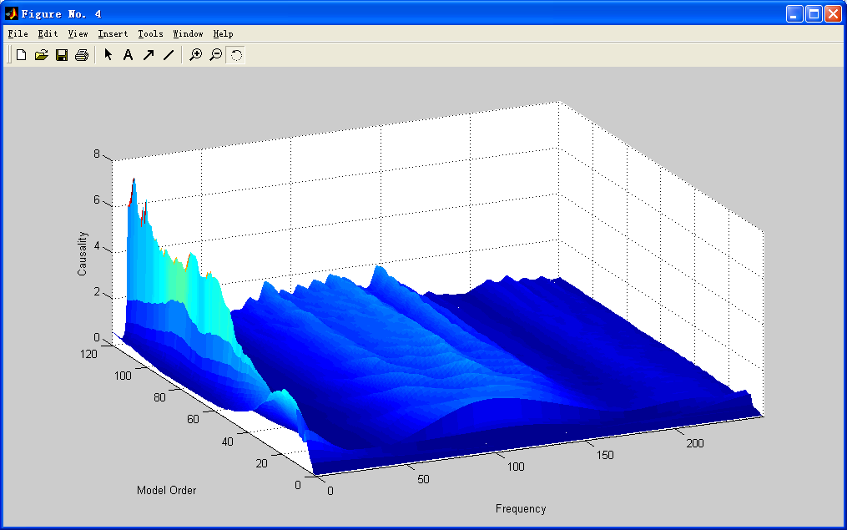
Original_data=zeros(1,30000);
% Original_data=0.9*sin((1:10000)/19);
Original_data=Original_data+random('Normal',0.03,0.02,1,30000);
Original_data(find(Original_data<=0))=[];
Original_data=cumsum(Original_data);
Original_data=sin(Original_data(1,1:10000)*2*pi)+random('Normal',0,0.5,1,10000);
Original_data(2,:)=zeros(1,10000);
