Original_data=zeros(1,30000);
Original_data=Original_data+random('Normal',0.008,0.004,1,30000);
Original_data(find(Original_data<=0))=[];
Original_data=cumsum(Original_data);
Original_data=sin(Original_data(1,1:10000)*2*pi)+random('Normal',0,0.5,1,10000);
Original_data(2,:)=zeros(1,10000);
rand1=random('Normal',0,0.5,1,length(Original_data));
rand2=random('Normal',0,0.8,1,length(Original_data));
for i=13:length(Original_data)
Original_data(2,i)=0.5*Original_data(1,i-12)-0.9*Original_data(2,i-5)+rand1(i);
end
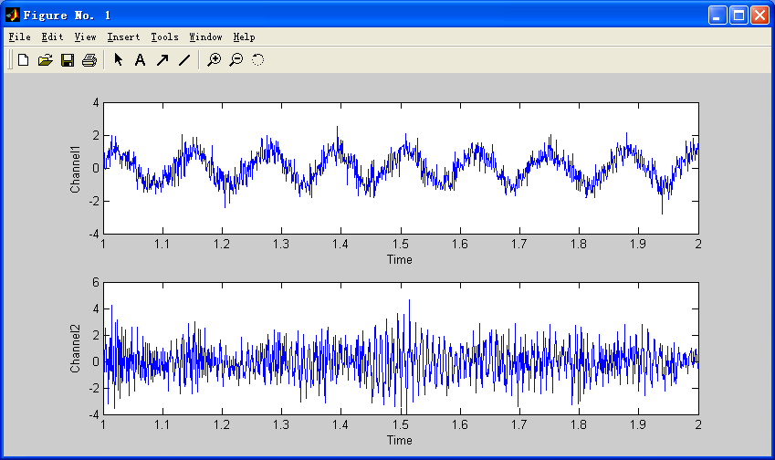
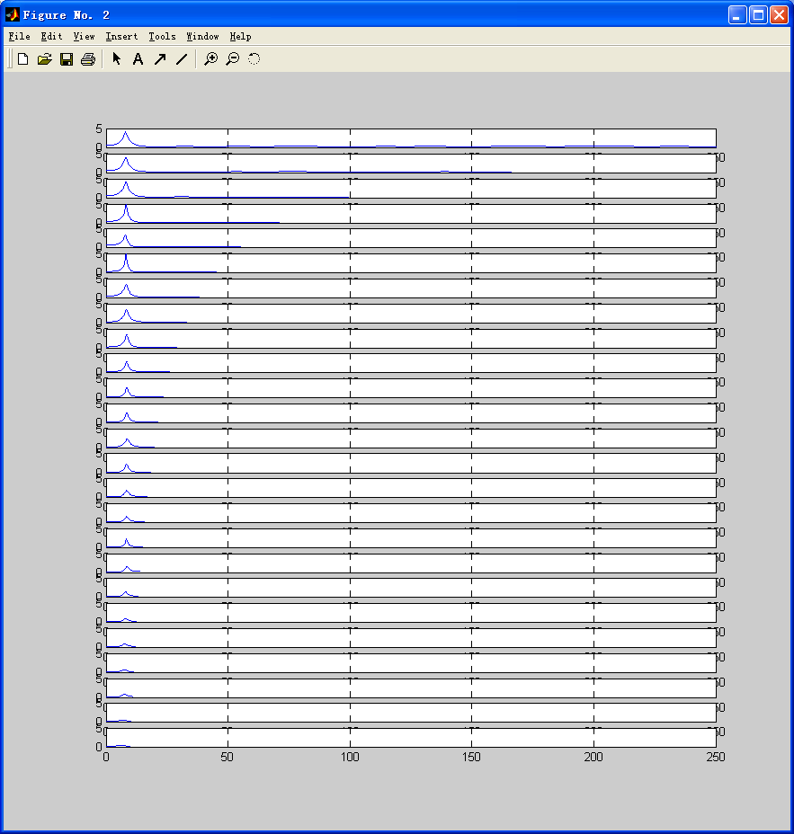
Original_data=zeros(1,10000);
Original_data=Original_data+random('Normal',0,1,1,10000);
Original_data=sin(Original_data(1,1:10000)*2*pi)+random('Normal',0,0.5,1,10000);
Original_data(2,:)=zeros(1,10000);
rand1=random('Normal',0,0.8,1,length(Original_data));
rand2=random('Normal',0,0.8,1,length(Original_data));
for i=13:length(Original_data)
Original_data(2,i)=0.6*Original_data(1,i-8)+0.6*Original_data(1,i-12)-0.9*Original_data(2,i-1)+rand1(i);
end
