Twitch Chat Bot — User Guide
This guide describes TwitchChatBot version 3.0.2 and explains the five tabs in the Windows desktop application and its main controls.
Related documentation: README | Configuration | Twitch | AWS Polly | Streamlabs | OpenAI
Before you start: Configure your Twitch channel and the optional services you plan to use. Test features can still invoke live services and may incur OpenAI or AWS Polly charges. Never put access tokens or API keys in screenshots, logs you share, or your repository.

Getting started
- Launch the Windows application using the documented installation or build instructions in the README.
- Check your configuration before connecting to Twitch.
- Click Start Bot to start the normal bot session.
- Use Stop Bot to request a stop of the current bot session.
Test Bot starts a testing-mode session but is not an offline sandbox. It can still connect to Twitch and third-party services, send real chat messages, trigger overlays, and incur external API charges. Do not confuse Test Bot with the individual controls on the Testing tab.
The Start Bot, Test Bot, and Stop Bot controls remain visible at the bottom of the window on all tabs. During startup, the start controls are disabled to prevent overlapping attempts. The enabled buttons reflect the controller's startup state, which does not guarantee every optional external provider is ready.

Main Chat
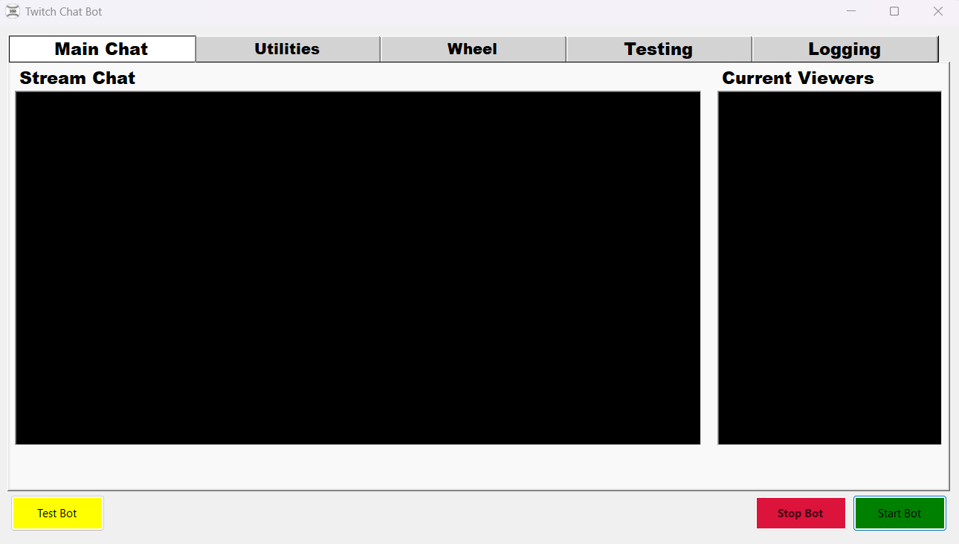
Main Chat tab showing Stream Chat and Current Viewers
The Main Chat tab provides two read-only displays:
- Stream Chat shows messages received through the bot's configured Twitch chat connection.
- Current Viewers shows viewer and role information available through the application's viewer-tracking mechanisms. Treat this as an application display, not a guaranteed complete list of everyone watching.
These are display areas, not message-composition fields. Use the persistent controls at the bottom to start or stop the bot.

Utilities
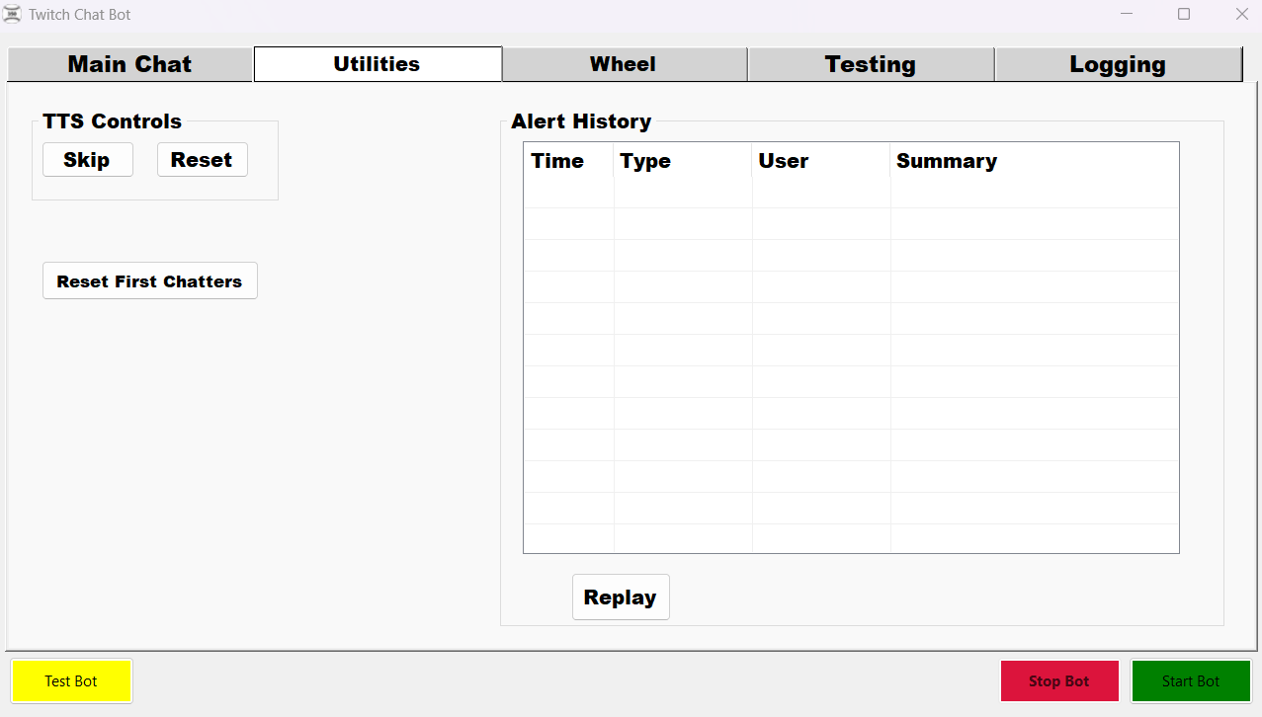
Utilities tab with TTS controls, first-chatter reset, and Alert History

TTS controls
- Skip stops the current TTS message, including audio already playing in connected current-version alert overlays. Later queued TTS is preserved.
- Reset stops current TTS and clears pending TTS. It is intended to leave non-TTS alerts unaffected and allow new speech afterward.
If Skip or Reset does not affect OBS audio after an application update, refresh the OBS Browser Source cache to load the current alerts.html. A stale overlay may lack the required cancellation handlers.

First chatters
Reset First Chatters clears the current in-memory first-chatter tracking. Use it only when you intentionally want the application to regard chatters as eligible for first-chat processing again.

Alert History
The list displays Time, Type, User, and Summary for recorded alerts. Select a record and click Replay (or double-click a record) to replay it.
Important: Replay is not necessarily a visual-only preview. Depending on the alert configuration it may invoke TTS, commands, or other integrated behavior. The history is a bounded in-memory collection rather than a permanent audit log.

Wheel
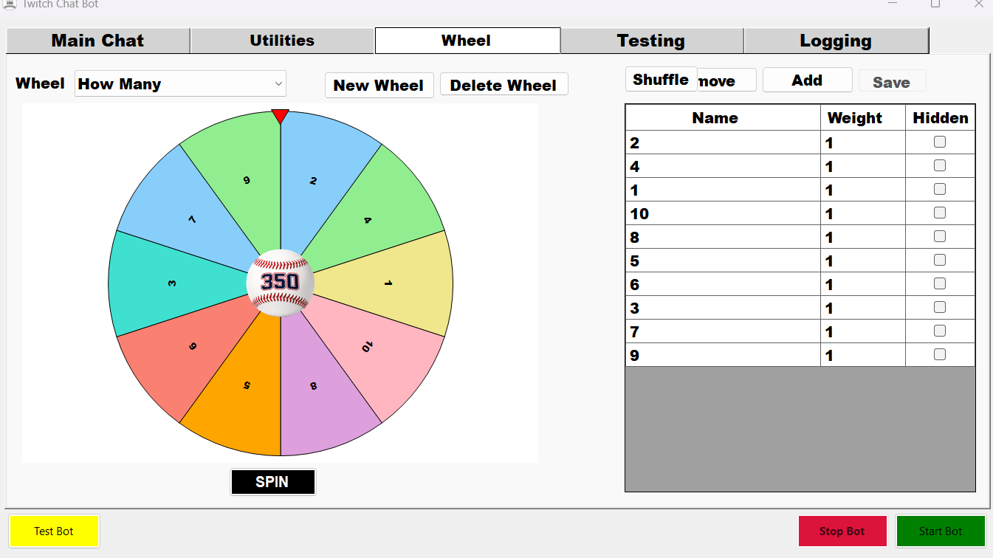
Wheel tab showing the completed wheel, shared center branding, and editable entry grid
- Choose an existing wheel in the Wheel dropdown or click New Wheel to create one.
- Edit entries in the grid on the right:
- Name is the text shown for the entry.
- Weight is a positive number controlling its relative chance of selection. Larger numbers are more likely to win.
- Hidden excludes an entry from selection and the visible wheel.
- Click Add Entry to stage a new row, or Remove Entry to stage removal of the selected row.
- Click Save to persist changes. Invalid names, weights, or duplicate names are rejected without partially saving the wheel.
- Click Shuffle to randomize entry order and persist the updated order.
- Click SPIN to choose a weighted winner and display the result. Confirming the result can dispatch the entry's configured alert.
Unsaved edits: Spin and Shuffle prompt you to Save, Discard, or Cancel/Keep Editing. An unsuccessful save prevents the requested action and preserves your edits. The wheel cannot spin if there are no eligible, non-hidden entries.
Delete Wheel permanently deletes the selected wheel after confirmation. Use it carefully.

Optional center branding image
You can display one center branding image shared by every wheel, such as your channel logo or emote. The image is not configured separately for each wheel; there are no Choose/Clear Image buttons on the Wheel tab. The branding appears at the center of the wheel, stays stationary during spinning, preserves its aspect ratio, and is displayed at 20% of the wheel diameter. It does not change entry weights or who wins.
To configure it, open your local application configuration and set UiMedia:WheelCenterBranding, for example:
"UiMedia": {
"WheelCenterBranding": "Wheel/centerWheel.png"
}
- Supported: .png, .jpg, .jpeg; transparent PNGs are supported. GIF is not supported.
- Relative path: Resolved beneath the folder configured by MediaBase:TwitchAlertsFolder. The example above points to a file inside that media folder's Wheel subfolder.
- Absolute path: Also supported, but avoid publishing personal paths in the repository or screenshots.
- Change the image: Replace the referenced image file or change the WheelCenterBranding value to another supported image path.
- Remove the image: Set WheelCenterBranding to an empty string (""). Without a configured, readable image, the wheel displays normally without center branding.
- Apply the change: Restart the application. You do not need to recompile it.
The public appsettings.example.json intentionally leaves the setting empty. Edit your local configuration rather than committing personal image paths or credentials. See Configuration for the complete configuration conventions.

Testing
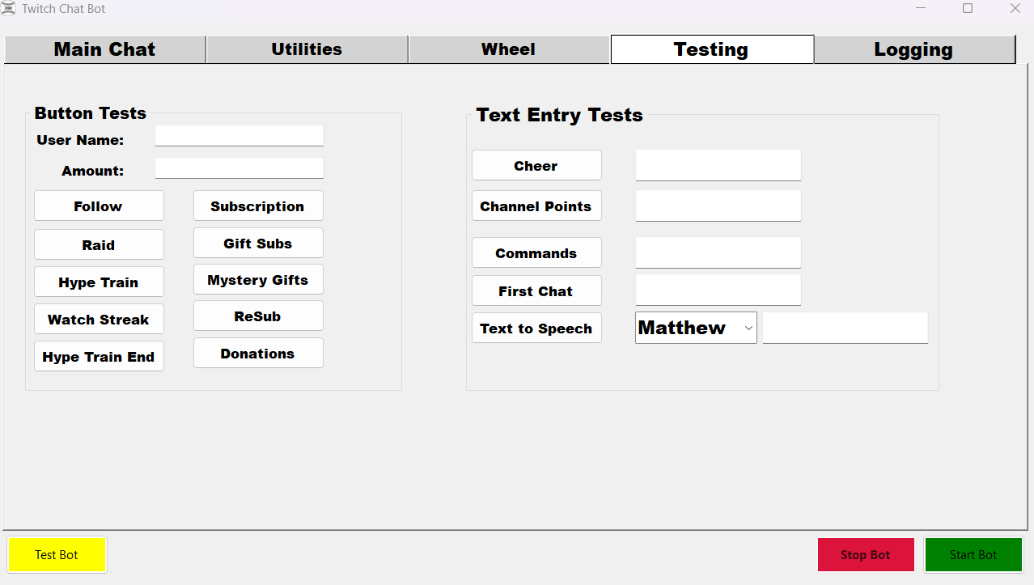
Testing tab with Button Tests and Text Entry Tests
The Testing tab contains Button Tests on the left and Text Entry Tests on the right. These controls exercise real application paths; they are not isolated from production integrations. Test actions can trigger alerts, chat, persistence, third-party API requests, and paid TTS or AI generation. Each action has short repeat-click protection, not a permanent duplicate filter.

Button Tests
Set User Name and Amount as appropriate, then click the test you want to run:
Test | Input / behavior
Follow | Simulates a follow using User Name
Subscription | Simulates a subscription using User Name
Raid | Uses User Name and Amount as a positive viewer count
Gift Subs | Uses User Name as the gifter and Amount as the recipient username
Hype Train | Simulates Hype Train start
Mystery Gifts | Uses Amount as the positive number of gifted subscriptions
Watch Streak | Uses User Name and Amount as a positive streak count
ReSub | Uses User Name and Amount as positive resubscription months
Hype Train End | Simulates the configured end-of-train event
Donations | Uses User Name and Amount as a positive decimal donation value
Amount is context-dependent. For example, it means viewers for Raid but months for ReSub and a username for Gift Subs. Invalid numeric values receive nonmodal validation feedback and are not submitted.

Text Entry Tests
Test | Input / behavior
Cheer | Enter a positive whole number of bits
Channel Points | Enter a configured reward title
Commands | Enter the command name, without a leading `!`
First Chat | Enter the username for a simulated first-chat event
Text to Speech | Select a voice and enter the speech text
A blank required input is rejected. Some actions may have no visible result if the corresponding alert, reward, or service is not configured or the event is not eligible.
AI and TTS fallback: For eligible ReSub, Mystery Gifts, and Watch Streak events, the application can use a configured or default fallback spoken message when AI text generation returns no usable text. This does not make external requests free, nor does it mean speech plays when TTS is unavailable.

Logging
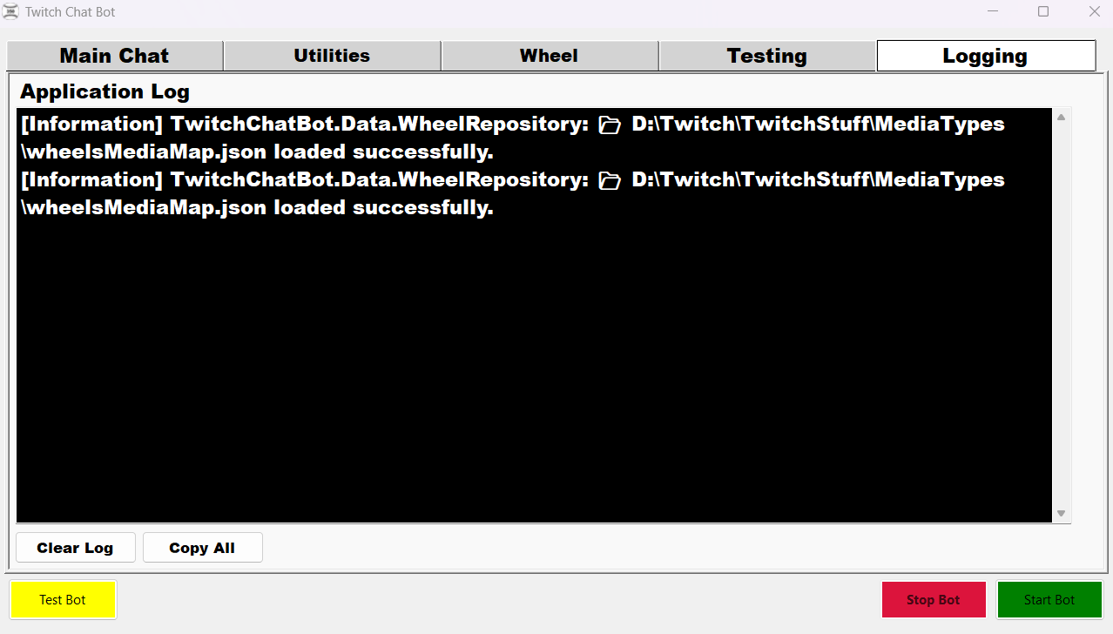
Logging tab showing Application Log and Clear Log / Copy All
The Application Log displays diagnostic messages and service information.
- Clear Log removes the text currently shown on screen. It does not turn off logging or prevent subsequent messages from appearing.
- Copy All copies the visible log text to the clipboard, making it easier to share an error report.
New log messages can appear after you clear the display. Review copied logs for sensitive local paths or other information before sharing them.

Troubleshooting
Problem | What to check
Bot does not connect | Review Application Log and your configured Twitch credentials/permissions; a started controller does not guarantee each provider is ready
OBS alert audio does not respond to Skip/Reset | Refresh the OBS Browser Source cache, verify its URL and port, and ensure it is connected to the current bot instance
Testing button appears to do nothing | Check required inputs and application logs, then confirm the corresponding integration or alert configuration exists
Unexpected repeated alert | Avoid intentionally clicking a test again after its short repeat-click interval; tests accept subsequent deliberate submissions
TTS does not play | Verify AWS Polly configuration and the overlay connection; use logs to diagnose service errors
Wheel changes are missing | Save staged entry edits; when prompted during Spin/Shuffle, choose Save to use the new values
For integration-specific configuration, consult Configuration. This guide describes observed UI behavior; optional integrations only function when configured and available.

