Planning and Environmental Linkage Study for

Tanglefoot Trail Extension

From New Albany to Ripley
Appendix A: Environmental Constraints Report
June 2026

FMS RAI-0320-00(036) LPA/109520-711000
Union and Tippah Counties, MS

Executive Summary
The Environmental Constraints Report is an appendix to the Planning and Environmental Linkages (PEL) study for the Tanglefoot Trail Extension Project that extends from New Albany (Union County) to Ripley (Tippah County) in Mississippi. This report identifies and evaluates natural, cultural, socioeconomic, and infrastructure-related constraints that may influence the planning, design, and implementation of corridor improvements. By incorporating environmental considerations early in the project development process, the study supports informed decision-making, regulatory compliance, and community engagement before advancing to future project phases.
A review of natural and ecological resources within the corridor revealed wetlands, floodplains, and streams that require consideration under the Clean Water Act (CWA) Sections 401, 402, and 404. Several portions of the corridor fall within Flood Zone AE, including designated Regulatory Floodways, which may necessitate hydrologic studies and stormwater management solutions to mitigate flood risks. While no 303(d) impaired waters exist within the corridor, some streams flow downstream into Sowashee Creek, which remains on the Mississippi Department of Environmental Quality (MDEQ) 303(d) list for water quality impairments. Best Management Practices (BMPs) will be necessary to control sedimentation, runoff, and pollutant transport into these downstream waterbodies. Consultations with the U.S. Fish and Wildlife Service (USFWS) and the Mississippi Department of Wildlife, Fisheries, and Parks (MDWFP) confirmed that no critical habitat or suitable habitat for federally protected species exists within the corridor. However, coordination will continue as project development progresses.
Cultural and historic resources were also assessed to ensure compliance with Section 106 of the National Historic Preservation Act (NHPA) and the Mississippi Antiquities Law. The Mississippi Department of Archives and History (MDAH) State Historic Preservation Office (SHPO) inventory identified six previously recorded archaeological sites and three architectural resources near the corridor, though none are currently eligible for listing on the National Register of Historic Places (NRHP). If right-of-way (ROW) acquisition or ground disturbance is required for the project, additional cultural resource surveys and coordination with SHPO may be necessary.
The corridor serves several critical community resources, including two fire stations, one school serving pre-kindergarten through 12th grade, and multiple state-licensed childcare centers, all of which rely on North Hills Street for emergency response and daily access. Additionally, healthcare facilities, assisted living centers, and specialty medical providers are heavily concentrated in the commercial district between 35th Avenue and 18th Avenue, making this section particularly sensitive to changes in traffic flow and access. Ensuring uninterrupted emergency access and safe travel conditions will be critical throughout project planning.
An analysis of demographic data characterized the communities near the study corridor. Transportation improvements should be designed to enhance safety, connectivity, and accessibility for all users. Additionally, project planning should incorporate public engagement strategies that provide opportunities for input from all communities along the corridor.
The utility and infrastructure assessment identified multiple natural gas pipelines, electrical transmission lines, and an electricity substation along the corridor. Coordination with utility providers will be necessary to avoid service disruptions and maintain safety during construction. The Meridian Water Treatment Plant, which houses three permitted public water supply wells, is located near the corridor, emphasizing the need for protecting groundwater resources and preventing contamination.
A limited hazardous materials review identified 20 sites within the corridor, with four moderate-risk sites due to underground storage tanks (USTs) and past fuel leaks. While no Superfund sites were identified, coordination with MDEQ will be required to assess remediation needs before construction. Additionally, a review of the Mississippi State Oil and Gas Board (MSOGB) records confirmed that no active oil wells exist within the corridor.
The findings from this study provide a comprehensive baseline for understanding potential environmental constraints along the North Hills Street Corridor. These considerations will inform future NEPA documentation, permit applications, and engineering design, ensuring that environmental resources are proactively addressed as project planning advances. By integrating early coordination with resource agencies, stakeholders, and the public, the study will support a balanced approach to mobility improvements, environmental protection, and community priorities.

Table of Contents
Executive Summary i
1 Introduction 1
1.1 Relationship with the PEL Study 1
1.2 Scope and Study Corridor 1
2 Methodology 3
2.1 Data Collection and Sources 3
2.2 Mapping and Analysis Procedures 3
2.3 Limitations and Data Gaps 3
3 Environmental Constraints Inventory 4
3.1 Natural and Ecological Resources 4
3.1.1 Wetlands and Waterbodies 4
3.1.2 Floodplains and Floodways 6
3.1.3 Water Quality 8
3.1.4 Protected Species and Critical Habitat 9
3.2 Cultural and Historic Resources 9
3.2.1 Archaeological Sites 10
3.2.2 Historic Structures and Districts 11
3.3 Community Resources 11
3.3.1 Fire/EMS Stations 11
3.3.2 Government Buildings 13
3.3.3 Education Facilities 14
3.3.4 Health Care Facilities 15
3.3.5 Places of Worship 17
3.3.6 Parks and Recreation Areas 17
3.4 Utility and Infrastructure Considerations 18
3.4.1 Public Water Supply 18
3.4.2 Utility Infrastructure 18
3.4.3 Energy Infrastructure 19
3.4.4 Airports 20
3.5 Contamination Risks 20
3.5.1 Hazardous Materials Sites 20
3.5.2 Oil Wells 21
3.6 Socioeconomic and Business Considerations 22
3.6.1 Demographic Characteristics 22
3.6.2 Local Businesses and Economic Nodes 23
4 Conclusion and Next Steps 24
5 References 26

LIST OF FIGURES
Figure 1. Wetlands and Waterbodies in and near the Study Corridor 5
Figure 2. FEMA Flood Zones in and near the Study Corridor 7
Figure 3. Streams and 303(d) Impaired Waters within the Subwatersheds of the Study Corridor 8
Figure 4. Cultural Resources Sites in or near the Study Corridor 10
Figure 6. Fire Stations in or near the Study Corridor 12
Figure 5. Government Offices near the Study Corridor 13
Figure 7. Schools and Childcare Facilities in or near the Study Corridor 14
Figure 9. Health Care Facilities near the Study Corridor 15
Figure 8. Places of Worship in or near the Study Corridor 17
Figure 10. Public Water Supply Wells near the Study Corridor 18
Figure 11. Energy Infrastructure near the Study Corridor 19
Figure 12. Hazardous Waste Sites near the Study Corridor 21
Figure 13. Census Tracts along the Study Corridor 22

LIST OF TABLES
Table 1. Descriptions of Wetlands and Waterbodies Present within the Study Corridor 5
Table 2. FEMA Flood Zones within the Study Corridor 6
Table 3. Income Demographics of Census Tracts along the Study Corridor 22
Table 4. Demographic Composition of Census Tracts along the Study Corridor 23

LIST OF ATTACHMENTS
Attachment A: Environmental Constraints Maps
Attachment B: Hazardous Materials Report
Attachment C: Agency Consultation Letters

Introduction
This Environmental Constraints Report is an appendix to the Planning and Environmental Linkages (PEL) study for the Tanglefoot Trail Extension Project from New Albany (Union County) to Ripley (Tippah County), Mississippi. This report aims to identify, document, and visually represent environmental resources and potential constraints that may influence the planning, development, and ultimate design of the trail corridor. By highlighting these issues early in the planning process, this report supports informed decision-making and helps ensure that environmental considerations remain central to trail corridor planning.

Relationship with the PEL Study
This report is an integral component of the broader PEL process, which emphasizes early and continuous coordination among planners, resource agencies, stakeholders, and the public. By presenting a clear, visual depiction of environmental constraints, this report enables the PEL team and decision-makers to consider the interplay of mobility needs and resource protection before specific design solutions are finalized. The resulting corridor recommendations, informed by early resource identification and analysis, are more likely to be feasible, cost-effective, and sensitive to environmental and community values, easing the transition into future NEPA documentation and review.

Study Area
Five trail route alternatives were developed and evaluated as part of this study, each extending from the existing Tanglefoot Trail terminus in New Albany northward to downtown Ripley. The alternatives are summarized below and shown in Figure 1.
Alternative 1A is the railroad corridor alternative, following the Ripley and New Albany (RNA) Railroad right-of-way for the majority of the alignment. This alternative represents the most direct route between New Albany to Ripley, minimizing road crossings and avoiding departures from the existing rail corridor.
Alternative 1B is a variation of Alternative 1A that incorporates an additional segment along Town Creek in Ripley, providing enhanced on-trail connectivity within the city prior to reaching the northern terminus.
Alternative 2 is the State Route (SR) 15 corridor alternative, following the highway right-of-way with dedicated connections to key community destinations in Blue Mountain, including Blue Mountain High School and the BMC Sportsplex. Through Ripley, the route forms a loop before converging at the northern terminus in downtown Ripley, providing the greatest degree of community connectivity among the alternatives evaluated.
Alternative 3 is a hybrid alignment that shares the SR 15 corridor with Alternative 2 south of Blue Mountain, then transitions east along the SR 15 bypass through the midsection of the corridor. This alternative provides greater physical separation from highway traffic compared to Alternative 2 while retaining trail access to Blue Mountain community facilities and continuing northward to Ripley via Town Creek.
Alternative 4 is the nature corridor alternative, departing most substantially from the highway and railroad alignments to follow Jasper Creek through the rural midsection. This alignment offers the most scenic trail experience; however, it requires multiple stream crossings and involves the greatest structural complexity and potential environmental impacts of the alternatives considered.

Methodology
This section describes the data collection, analysis, and mapping techniques used to identify environmental constraints within the five trail alignments. The methodology emphasizes early coordination with resource agencies, reliance on reliable geospatial data, and a systematic approach to identifying environmentally sensitive areas that may influence project decisions.

Data Collection and Sources
The environmental constraints analysis relied on publicly available geospatial datasets, agency-provided records, and aerial imagery to assess natural, cultural, socioeconomic, and infrastructure-related resources within the study corridor. Data sources were integrated into a Geographic Information System (GIS) for spatial analysis and visualization. Resource-specific datasets are referenced within each respective section of this report.

Mapping and Analysis Procedures
Environmental constraints were mapped and analyzed using ArcGIS Pro 3.4.1, integrating multiple datasets to assess potential impacts and regulatory considerations. The following procedures guided the analysis:
Base Mapping: Aerial imagery and topographic data were used to establish a reference map for overlaying environmental resource data.
Feature Overlays: Resource-specific datasets (e.g., wetlands, floodplains, historic sites, contamination risks) were layered onto the reference map. Each dataset was reviewed for accuracy, completeness, and spatial alignment. Majority of datasets were obtained from Mississippi Automated Resource Information System (MARIS).
The resulting maps (see Appendix A) provide both an overall view and sectioned panel maps for detailed analysis.

Limitations and Data Gaps
While this analysis incorporates the most current and reliable data available, certain resources may not be fully captured through desktop review alone. Further field surveys or investigations and agency consultations may be required. This approach ensures that future NEPA-level analyses can build upon and refine the baseline established here.

Environmental Constraints Inventory
This section presents the identified environmental constraints within the five trail alignments, arranged by resource category (i.e., natural and ecological resources, cultural and historic resources, community resources, utility and infrastructure considerations, contamination risks, and socioeconomic and business considerations). Sections 3.1 through 3.6 detail each resource category with corresponding maps that illustrate the location and extent of identified constraints.
In addition, a series of environmental constraints maps has been developed and included in Appendix A. These maps are structured as follows:
- The Overall Environmental Constraints Inventory Map provides a comprehensive view of all environmental features along the corridor.
- The Panel Index Map divides the corridor into five sections, establishing a reference framework for more detailed analysis.
- Five Panel Maps correspond to each corridor section, illustrating detailed environmental constraints at a localized scale.

Natural and Ecological Resources

Wetlands and Waterbodies
To identify and classify these wetlands and waterbodies, this assessment used the U.S. Fish and Wildlife Service (USFWS) NWI data and aerial imagery to identify and refine the assessment of wetlands and waterbodies within the study corridor (USFWS, n.d.). The study area includes Jasper Creek, Tallahatchie River, Possum Creek, Guyton Creek, Brougher Creek, South Tippah Creek, and Town Creek, as well as unnamed tributaries. It also includes freshwater emergent wetlands, freshwater forested/shrub wetlands, and freshwater pond.
It is important to note that the wetlands displayed in the USFWS NWI do not define any federal, state, or local jurisdictional limits. Final determinations regarding wetland boundaries or regulatory oversight require site-specific field delineations and coordination with relevant agencies. Recognizing these features at an early stage allows the project team to incorporate strategies that avoid or minimize impacts and ensure compliance with applicable regulations as the corridor plan advances.

Alternative 1A
Alternative 1A generally parallels the Little Tallahatchie River along the eastern and southern banks near the southern terminus before crossing the river and continuing north along the eastern side of the Illinois Central Gulf Railroad corridor. In total, the alignment includes approximately 24 stream and drainage crossings. Depending on final design and hydraulic requirements, these crossings may require culverts, boardwalks, or bridge structures.
Alternative 1A primarily follows the existing railroad right-of-way (ROW), which minimizes new fragmentation of intact wetland systems by utilizing previously disturbed transportation corridors where practicable. However, because the alignment may traverse low-lying areas adjacent to the railroad corridor, wetlands, roadside ditches, and other drainage features are likely to occur throughout portions of the corridor.
Desktop review identified three freshwater emergent wetlands identified along the alignment. Aerial imagery indicated portions of these wetlands may have been historically disturbed or altered by agricultural activities and industrial development, including trucking operations and storage facilities.
Alternative | Stream Crossings | Freshwater Emergent Wetland | Freshwater Forested/Shrub Wetland | Freshwater Pond
1A | 26
1B | 31
2 | 31
3 | 39
4 | 40

Alternative 1B

Alternative 2

Alternative 3

Alternative 4

Floodplains and Floodways
Floodplains within the study corridor have been identified using georeferenced flood hazard data from the Federal Emergency Management Agency (FEMA) Digital Flood Insurance Rate Map (DFIRM) (FEMA, n.d.). These flood hazard areas are classified based on their likelihood of flooding and associated regulatory considerations.
The study corridor includes Flood Zones AE, AE Floodway, and X.
- Flood Zone AE, which represents areas with a 1% annual chance of flooding (100-year floodplain) and established Base Flood Elevations (BFEs), which are present in portions of the study corridor.
- FEMA designates Regulatory Floodways within Flood Zone AE as the most hydrologically active portions of the floodplain where development is highly restricted to prevent increased flood risks upstream. Within the study corridor, the Regulatory Floodway crosses at four locations, as detailed below:
  - Gallagher Creek – East of 36th Avenue and North Hills Street intersection (Location C in Figure 2)
  - Robbins Creek – Near 16th Avenue and North Hills Street intersection (Location D in Figure 2)
  - Robbins Creek – Near Highway 39 and North Hills Street intersection (Location E in Figure 2)
  - Tributary of McLemore Branch – Near Newell Road and North Hills Street intersection (Location F in Figure 2)
- Areas classified as Zone X (0.2% Annual Chance Flood Hazard) represent the 500-year floodplain, indicating moderate flood risk, while Zone X (Minimal Flood Hazard) includes areas with little to no risk of flooding.
Table 2 summarizes the flood hazard areas within the study corridor and are shown in Figure 2. Furthermore, these flood zones have been identified at six distinct locations within the study corridor.
Table 2. FEMA Flood Zones within each Trail Alignment
Trail Alignment | Flood Zone Classification | Estimated Acreage
Alternative 1A
Alternative 1B
Alternative 2
Alternative 3
Alternative 4

These flood hazard areas present important considerations for project planning and design. Development within the Zone AE Floodway is highly restricted and will require coordination with FEMA and local floodplain management authorities. Any modifications within the Zone AE floodplain will likely necessitate hydraulic and hydrologic studies to evaluate potential impacts and ensure compliance with FEMA’s floodplain development requirements. Engineering solutions such as elevated road profiles, culverts, or stormwater management systems may be needed to mitigate flood risks while maintaining roadway functionality.
While areas classified as Zone X (0.2% Annual Chance Flood Hazard) are subject to lower flood risks, consideration should still be given to drainage and stormwater management. Areas within Zone X (Minimal Flood Hazard) generally do not require floodplain permitting, but changes in runoff patterns due to roadway improvements should still be evaluated to prevent localized flooding.

Water Quality
The project corridor crosses four Hydrologic Unit Code (HUC)-12 subwatersheds, which are part of the broader hydrologic network in the region (USGS, n.d.):
- Loper Creek-Okatibbee Creek (031700010602)
- Lower Sowashee Creek (031700010503)
- Nanabel Creek-Sowashee Creek (031700010502)
- Upper Sowashee Creek (031700010501)
These subwatersheds contain various stream reaches, but no 303(d) impaired streams are directly within the study corridor (MDEQ, n.d.). However, some streams in the corridor flow downstream into Sowashee Creek, a Mississippi Department of Environmental Quality (MDEQ) 303(d)-listed waterbody for biological impairment. Total nitrogen (TN), total phosphorous (TP), and organic enrichment/low dissolved oxygen were identified as probable primary stressors contributing to the impairment. Figure 3 shows streams and 303(d) impaired waters within the subwatersheds of the study corridor.
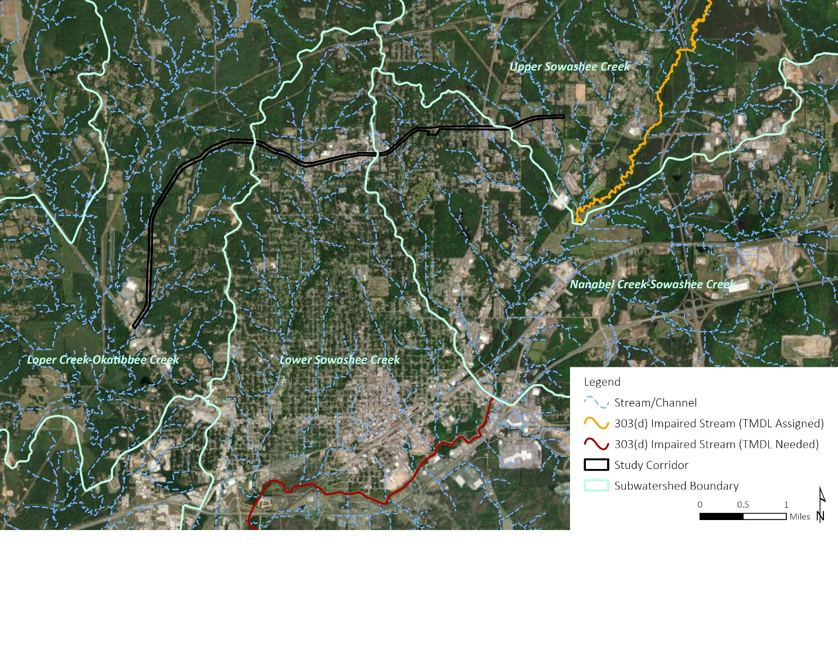
Figure 4. Streams and 303(d) Impaired Waters within the Subwatersheds of the Study Corridor
Two reaches of Sowashee Creek are relevant to downstream water quality considerations:
- The Sowashee Creek from headwaters in Meridian to the confluence with an unnamed tributary at MWS 4009 Boundary was previously listed as a 303(d) listed stream but has since been assigned Total Maximum Daily Loads (TMDLs) to regulate pollutant levels. With TMDL in place, this reach is under active monitoring to assess compliance with pollutant reduction targets. MDEQ will determine if water quality improvements meet designated standards through continued monitoring.
- The Sowashee Creek from the confluence with an unnamed tributary at MWS 4008 boundary to its confluence with Okatibbee Creek remains a 303(d) impaired waterbody, located within the Lower Sowashee Creek subwatershed.
Although the project corridor does not directly impact impaired streams, construction activities may contribute to sedimentation, stormwater runoff, and potential pollutant transport into downstream impaired waters. Best Management Practices (BMPs) for erosion and sediment control should be implemented to minimize potential water quality impacts and ensure compliance with MDEQ’s stormwater and water quality regulations. Early coordination with MDEQ will help confirm whether additional permitting or mitigation measures are necessary.

Protected Species and Critical Habitat
Early coordination with USFWS was conducted to assess potential impacts on federally listed species. In a letter dated January 22, 2025, USFWS confirmed that the project is within the range of the federally listed northern long-eared bat (Myotis septentrionalis). However, they determined that suitable habitat is not present, and therefore, impacts to federally listed species are not anticipated.
Additionally, the Mississippi Department of Wildlife, Fisheries, and Parks (MDWFP) was consulted regarding state-listed species. In a letter dated January 22, 2025, MDWFP identified six species of concern within a two-mile radius of the study corridor. They concluded that if BMPs are properly implemented, monitored, and maintained, particularly those aimed at protecting water quality, the project is unlikely to pose a threat to listed species or their habitats.
Based on these agency consultations, no significant impacts to federally or state-listed species are expected from the proposed project. However, continued coordination with USFWS and MDWFP will be maintained to ensure compliance with any applicable conservation measures or habitat protections as the project advances.

Cultural and Historic Resources
Cultural and historic resources are key considerations in transportation planning, ensuring compliance with Section 106 of the National Historic Preservation Act (NHPA) and the Mississippi Antiquities Law. Early coordination with the Mississippi Department of Archives and History (MDAH) – State Historic Preservation Office (SHPO) will help identify cultural resources and determine whether additional studies or mitigation measures are needed.
A review of MDAH Historic Resources Inventory Database records identified six previously recorded archaeological sites and three architectural resources near the study corridor, as shown in Figure 3. However, all have been determined to be ineligible for listing on the National Register of Historic Places (NRHP) by MDAH and SHPO. While these findings indicate a low likelihood of direct impacts, additional Phase I cultural resource surveys may be required if the project involves new ROW acquisition, structural modifications, or ground disturbance.
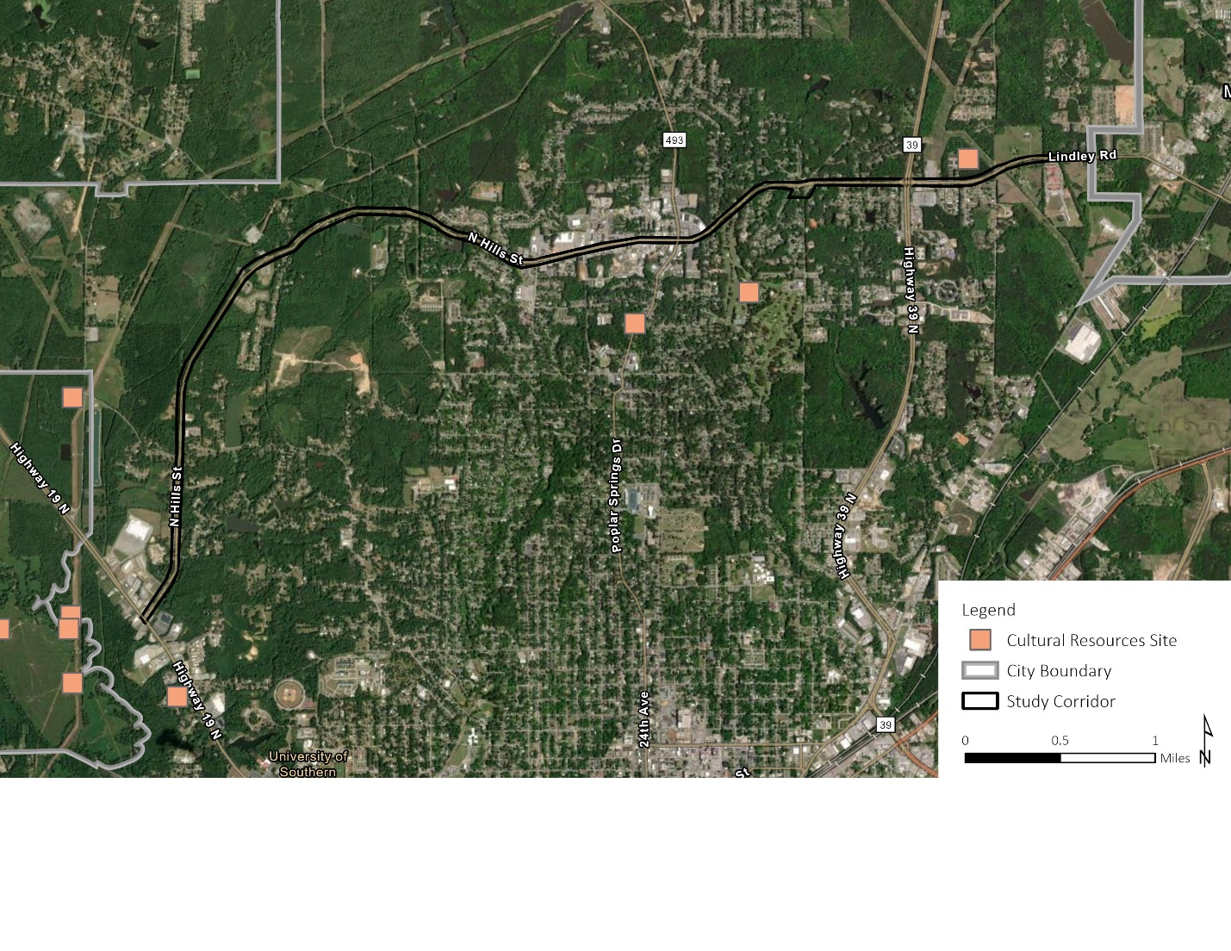
Figure 5. Cultural Resources Sites in or near the Study Corridor

Archaeological Sites
The Area of Potential Effects (APE) for archaeological resources includes areas subject to ground disturbance, such as new ROW, excavation zones, grading, and utility relocations. A review of MDAH records identified six previously recorded archaeological sites within the APE. One site is located north of the study corridor near the east terminus, but the extent of the site is unknown, and it may be adjacent to the proposed work area. Given this uncertainty, there remains a possibility that the site could be indirectly impacted by the project.
Although no significant archaeological resources have been identified directly within the study corridor, unanticipated discoveries during construction are always a possibility. If artifacts or human remains are encountered, the project must follow MDOT’s Redbook Specifications in accordance with 36 CFR 800.13 and comply with the Mississippi Unmarked Burial Law (§39-7-31, MS Code of 1972), requiring immediate coordination with SHPO and appropriate mitigation.

Historic Structures and Districts
The APE for architectural resources extends beyond the construction limits to consider visual, noise, and vibrational impacts on historic buildings and districts. Within the APE, three architectural resources meet the 50-year threshold for historic consideration, but none are listed on the NRHP or located within a designated historic district. These structures are not within or adjacent to the proposed work site, minimizing potential impacts.
However, if ROW expansion or structural modifications are planned, a historic architectural survey may be required. Additionally, the project corridor contains mid-to-late 1960s residential properties, particularly between Highway 19 and Bounds Road, that may warrant further evaluation.

Community Resources

Fire/EMS Stations
Two Meridian Fire Department Stations are located along the study corridor as shown in Figure 3. Both fire stations are situated at key intersections identified for potential geometric modifications and operational improvements:
- Fire Station No. 7 (910 North Hills Street) is located at the 10th Avenue intersection, where reconfigurations may be required to improve traffic flow, enhance safety, or create space for multimodal facilities.
- Fire Station No. 4 (5617 Firemans Cutoff) is located at the State Boulevard intersection, a triangular roadway configuration that may be realigned to improve connectivity and reduce congestion.
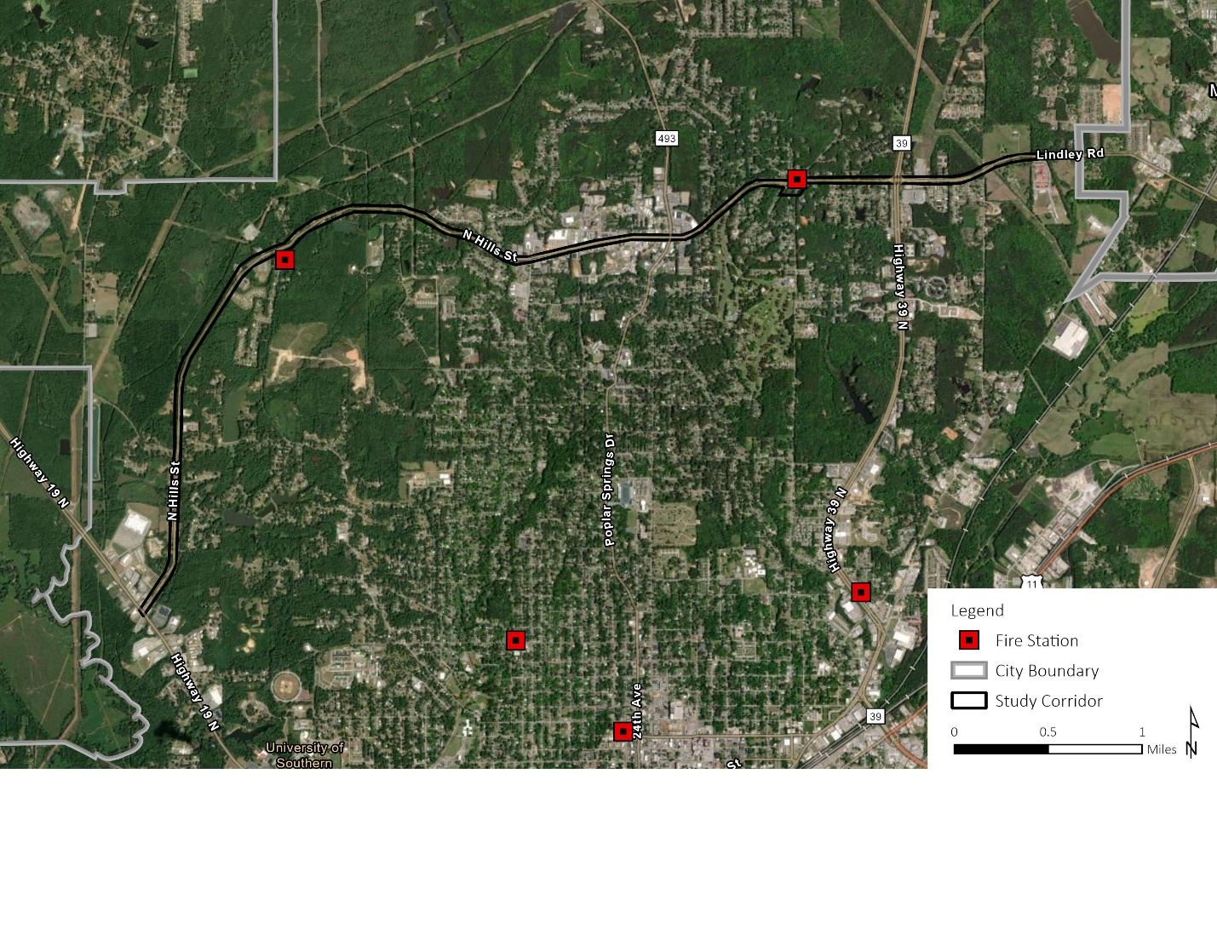
Figure 6. Fire Stations in or near the Study Corridor
Since fire stations are critical public safety facilities, any roadway improvements near these locations must ensure unimpeded access for emergency vehicles. Modifications to the 10th Avenue and State Boulevard intersections should be designed to avoid delays, with traffic signal priority measures considered to facilitate emergency response. Construction activities must also be planned to minimize temporary impacts, requiring early coordination with the Meridian Fire Department to address access needs and ensure that intersection realignments enhance both traffic efficiency and public safety.

Government Buildings
Two government offices are located near the study corridor and rely on North Hills Street for access:
- U.S. Postal Service – 5008 29th Avenue (north of the study corridor)
- Social Security Administration Office – 4717 26th Avenue (south of the study corridor)
Figure 5 shows the locations of these government offices in relation to the study corridor. Both facilities are situated near the commercial development section of the corridor, where traffic volume and accessibility are key considerations. Any modifications to North Hills Street should consider traffic flow impacts, driveway access, and potential detours to minimize inconveniences for government operations and the public.
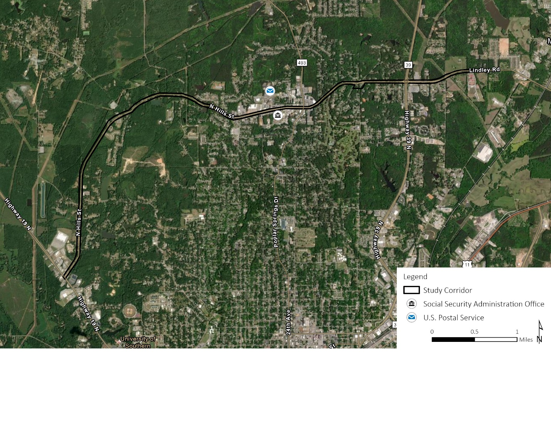
Figure 7. Government Offices near the Study Corridor

Education Facilities
Education facilities are important community assets that serve children and families within the project area. There is one high school and two state-licensed childcare facilities along the project corridor, as shown in Figure 4.
Lamar School, located at 544 Lindley Road, serves students from pre-kindergarten through 12th grade and has direct access to the project corridor, making traffic flow, safety, and accessibility key considerations for project planning. Any modifications to this section of the corridor should ensure safe school access, efficient traffic movement, and minimal disruptions to school transportation. Several state-licensed childcare facilities are located along the study corridor near the 35th Avenue/North Hills Street intersection, including the Northcrest Baptist Preschool (3412 North Hills Street) and First Step Learning Center (3401 North Hills Street).
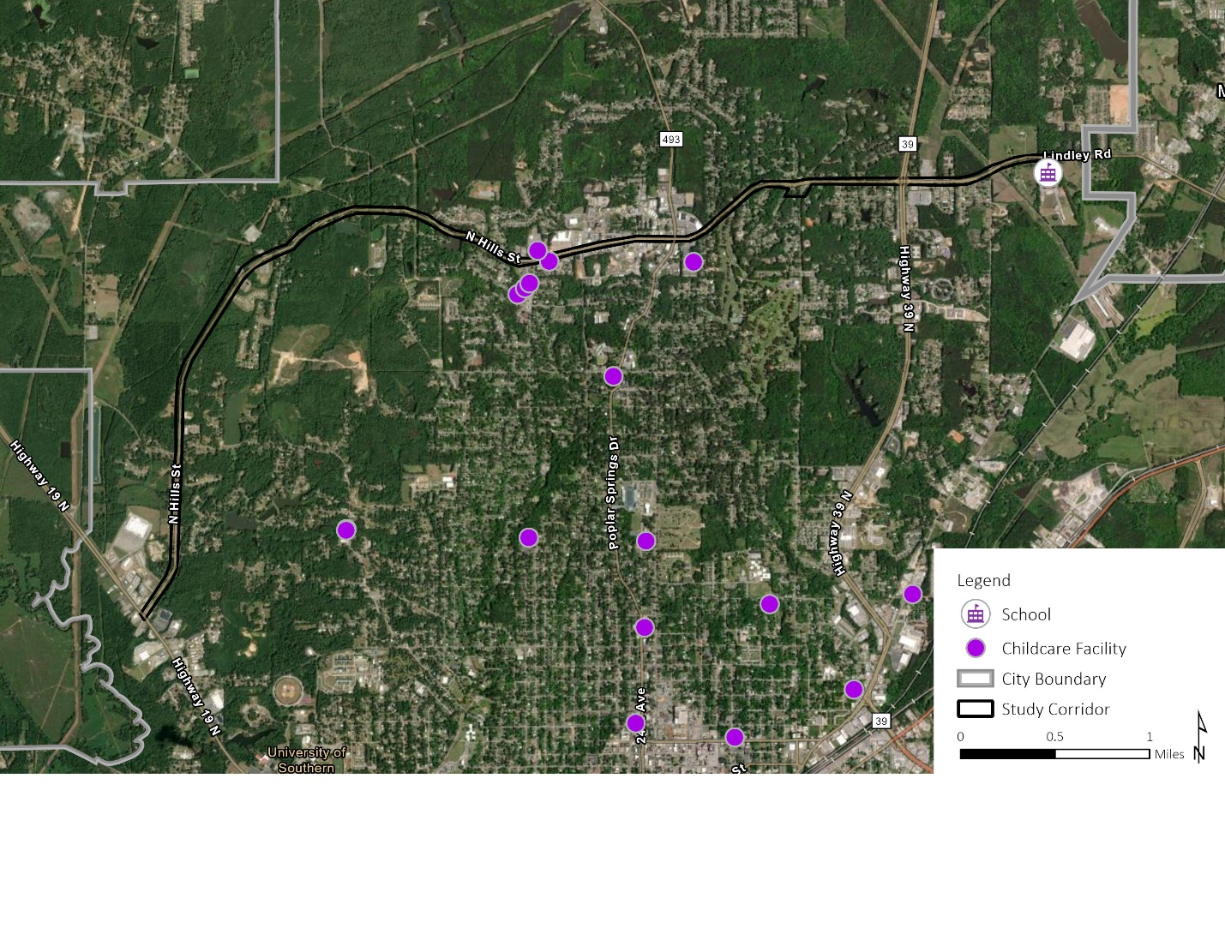
Figure 8. Schools and Childcare Facilities in or near the Study Corridor
Additional childcare facilities are situated just outside the study corridor, including Nino Creative Learning Childcare Center and Great Start Learning Center along 35th Avenue, as well as Kindercare Learning Center near Broadmoor Drive. While these facilities are not directly within project limits, they remain relevant because families and staff may rely on North Hills Street for daily travel. Any changes to traffic patterns, access points, or congestion levels within the corridor could affect commuting routes and travel times for those who use the roadway to reach these childcare centers.

Health Care Facilities
Several healthcare facilities are located within or near the study corridor, providing essential medical, rehabilitation, and assisted living services to the community. These facilities rely on North Hills Street for access and may experience increased sensitivity to changes in traffic flow, noise, and construction activity. Figure 9 illustrates the locations of healthcare facilities in relation to the study corridor.
The following list identifies key healthcare providers, but it does not represent all medical services in the area. Other healthcare providers, such as dental offices and veterinary hospitals, are not included in this section.
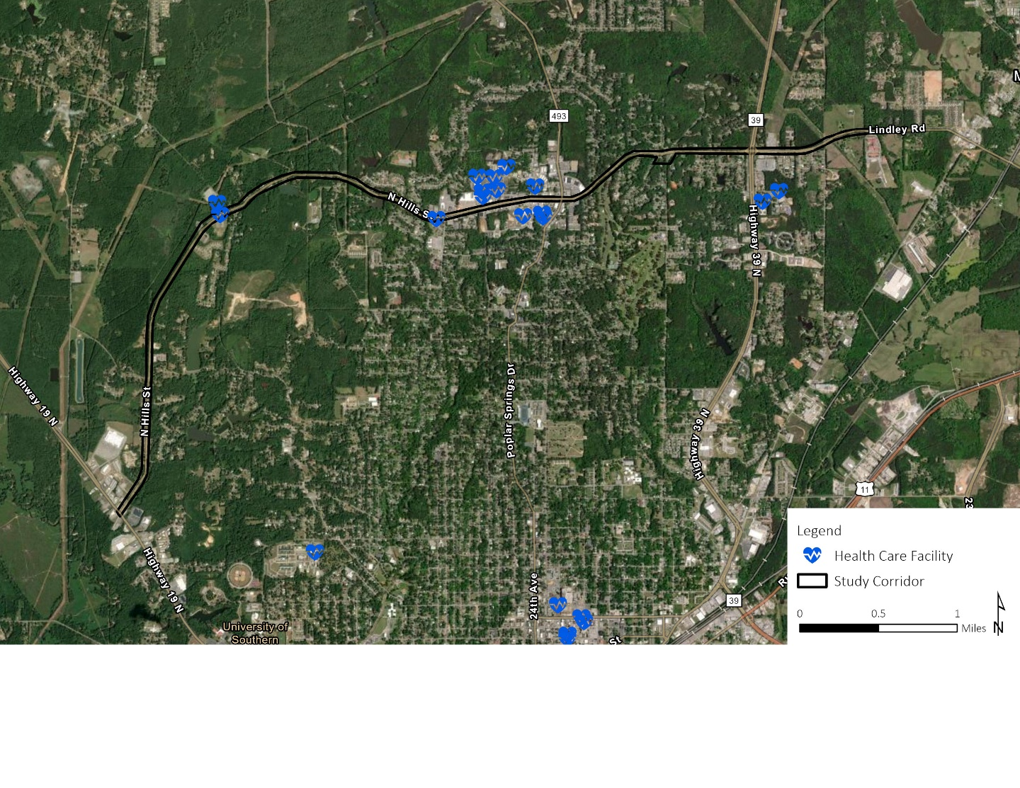
Figure 9. Health Care Facilities near the Study Corridor

Hospitals and Specialty Medical Centers:
- Cardiovascular Institute of the South – 4909 Great River Drive – Outpatient cardiovascular treatment
Medical Clinic:
- East Mississippi Medical Clinic – 4711 Popular Springs Drive – Inpatient and outpatient medical care
- Free Clinic of Meridian – 4707 Popular Springs Drive – Free medical services to uninsured and low-income individuals in the community
- Ochsner Health Clinic – 2800 North Hills Street – Outpatient primary and specialty care services
Home Healthcare and Hospice Services:
- Amedisys Home Health Care – 2900 North Hills Street – In-home medical care and rehabilitation services
- CenterWell Home Health – 2600 Old North Hills Street – Nursing, therapy, and home health services
- Gentiva Hospice – 4803 29th Avenue – Hospice care and palliative support
- Compassus – 2340 North Hills Street – Hospice care and palliative support
Assisted Living and Nursing Care:
- Brookdale Meridian Assisted Living – 4555 35th Avenue – senior assisted living facility
- Diversicare of Meridian – 4728 Highway 39 North –nursing and rehabilitation center
Behavioral and Mental Health Services:
- Caring Connections Adult Day Services (Inactive) – 5800 North Hills Street
- East Mississippi State Hospital – 5701 North Hills Street – Inpatient mental health services
- Mississippi Behavioral Health Services – 2803 Old North Hills Street – Outpatient mental health and counseling services.
- Alliance Health Center – 5000 Highway 39 North –Acute care psychiatric and substance abuse hospital
Specialty Medical Services:
- Meridian Plastic Surgery – 4715 24th Place – Cosmetic and reconstructive surgical services
Because these facilities serve medically vulnerable populations, project planning should emphasize uninterrupted access, emergency response coordination, and noise mitigation. Early coordination with healthcare administrators and emergency responders will help minimize disruptions and ensure that roadway modifications or construction activities do not impede critical patient care services.

Places of Worship
Three places of worship are located along the project corridor, as shown in Figure 5.
- Kingdom Hall of Jehovah's Witnesses – 6351 North Hills Street
- The Church of Jesus Christ of Latter-day Saints – 5805 North Hills Street
- Northcrest Baptist Church – 3412 North Hills Street
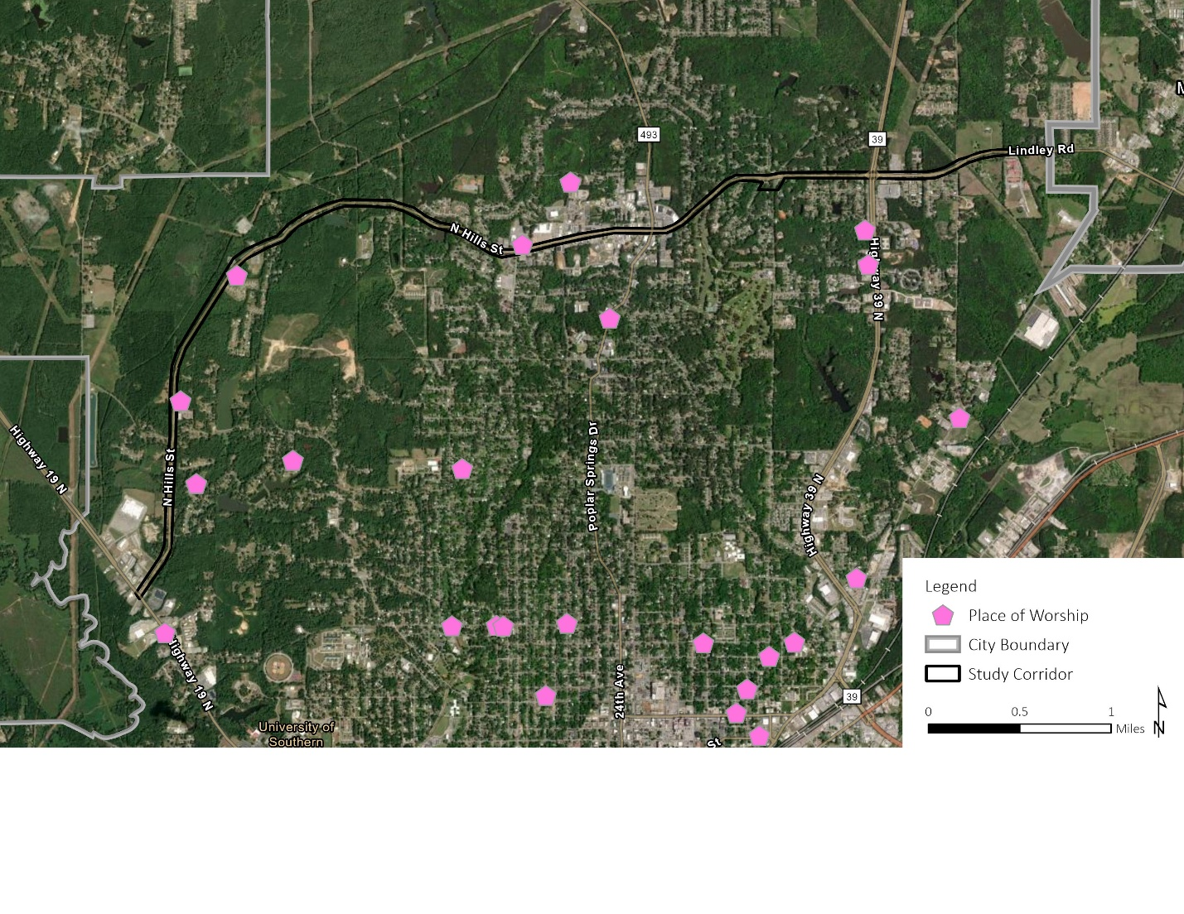
Figure 10. Places of Worship in or near the Study Corridor
These religious institutions serve as community gathering spaces and may experience high traffic volumes during worship services, events, and other activities. Any roadway improvements should consider safe access for congregants, adequate turning movements, and pedestrian safety measures. Additionally, construction activities should be planned to minimize disruptions to scheduled services and events.

Parks and Recreation Areas
There are no public parks, trails or recreation facilities within or adjacent to the study corridor. However, Northwood Country Club, a private recreation facility, is located south of the study corridor between 18th Street and 10th Avenue. The club features golf courses, with a portion adjacent to North Hills Street. While private recreational facilities are not typically included in PEL studies, their proximity to the corridor may be considered if the project affects access, noise levels, or visual aesthetics in the area.

Utility and Infrastructure Considerations

Public Water Supply
The Meridian Water Treatment Plant, located at 4609 48th Place, is a critical component of the public water supply system serving the region. The facility is situated southwest of the North Hills Street/King Road intersection. The water treatment plant also houses three Mississippi State Department of Health (MSDHP)-permitted public water supply wells. These wells are regulated to ensure compliance with public drinking water safety standards and play a vital role in supplying clean water to the community. Figure 10 shows the locations of the permitted wells.
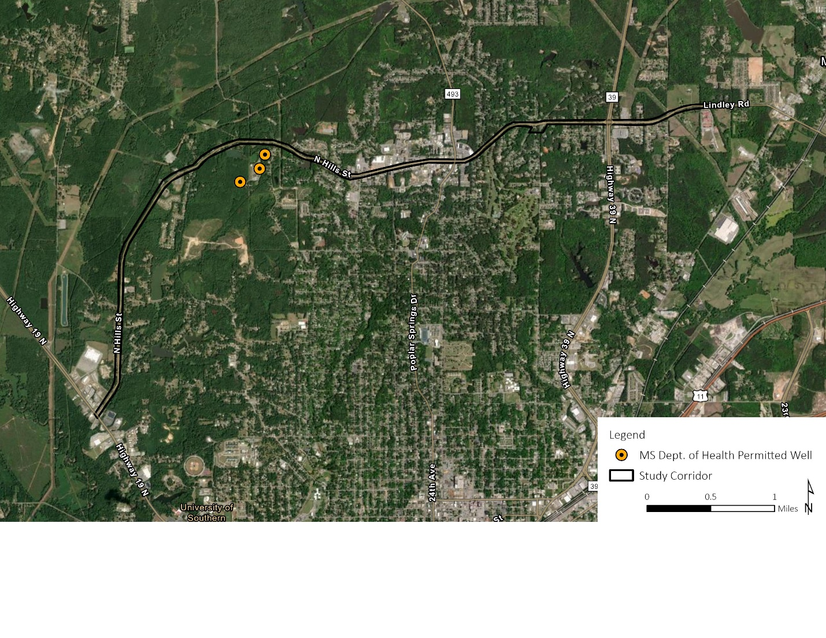
Figure 11. Public Water Supply Wells near the Study Corridor

Utility Infrastructure
The study corridor includes utility infrastructure assets, as shown in Figure 11. These facilities play a critical role in regional service distribution, and any roadway modifications should involve coordination with utility providers to prevent service disruptions and ensure safety during construction.
Four natural gas pipelines intersect the corridor:
- Tennessee Gas Pipeline crosses the study corridor twice between Bounds Road and State Boulevard (high-pressure interstate pipeline)
- Mississippi Valley Gas Company Pipeline crosses the study corridor west of King Road (likely a distribution pipeline for local service)
- Southern Natural Gas Company Pipeline crosses the study corridor at 13th Avenue (major natural gas transmission pipeline)
In addition, a refined petroleum pipeline, Kinder Morgan Plantation Pipeline, intersects the study corridor near 43rd Avenue.
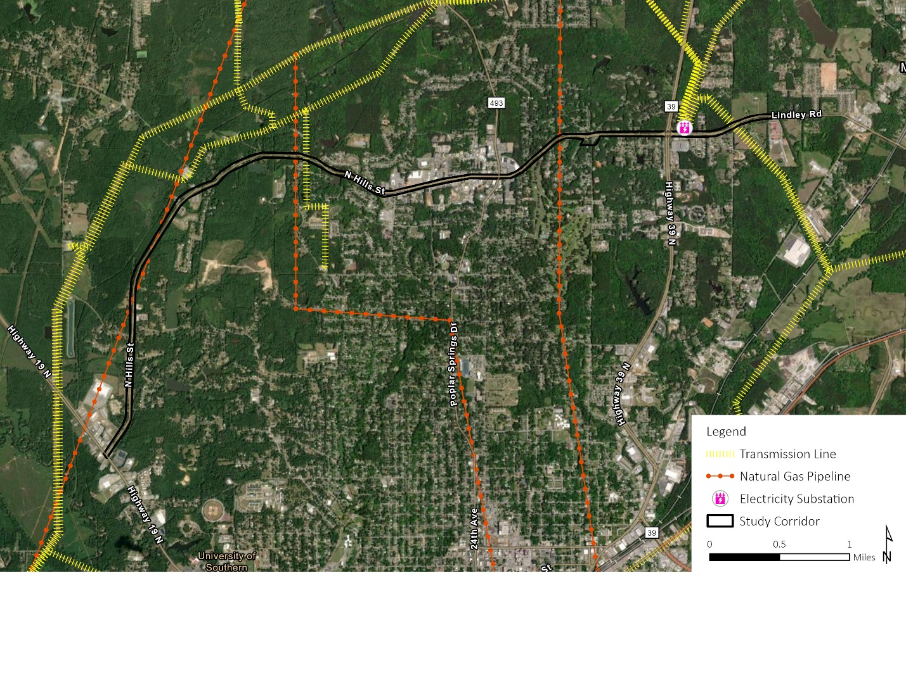
Figure 12. Energy Infrastructure near the Study Corridor

Energy Infrastructure
The study corridor includes energy infrastructure assets, as shown in Figure 11. These facilities play a critical role in regional service distribution, and any roadway modifications should involve coordination with energy providers to prevent service disruptions and ensure safety during construction.
Electric transmission lines cross the project corridor at three locations, serving as part of the regional electric distribution network. Mississippi Power Company transmission lines cross the corridor east of King Road and at the utility corridor near Newell Road. Mississippi Power Company operates an electricity substation located east of Highway 39 on the north side of North Hills Street.

Airports
No airports are present within the study corridor. The nearest airport is Meridian Regional Airport, located approximately 2.5 miles south of North Hills Street and Highway 19 intersection.

Contamination Risks

Hazardous Materials Sites
A review of federal and state regulatory databases identified 20 hazardous materials sites within the project corridor, with an additional 9 sites within 0.1 miles and 18 sites on adjoining or nearby properties. These sites were evaluated based on their potential to impact the North Hills Street project corridor through soil or groundwater contamination, regulatory status, and past environmental violations. No National Priorities List (NPL) Superfund sites were identified within or near the study corridor.
A risk assessment categorized four moderate-risk sites due to ongoing cleanup efforts, the presence of USTs, and proximity to excavation activities. Additionally, three low-risk sites were identified that are unlikely to pose environmental concerns based on their regulatory status. Figure 12 shows the locations of all seven sites. A detailed Hazardous Materials Assessment Report is provided in Appendix B.
Moderate-Risk Sites:
- Minit Mart/Chevron (2100 North Hills Street) – Potential contamination risk from past fuel leaks.
- North Hills Gas N Go (5609 North Hills Street) – Underground tanks may be located near a proposed roundabout.
- Dixie #20 (2216 Highway 19) – Previously an Exxon facility with documented environmental violations.
- CEFCO #518/Texaco (144 North Hills Street) – Ongoing remediation efforts adjacent to the roadway.
These sites require further coordination with the MDEQ to determine the extent of remediation and necessary precautions for construction.
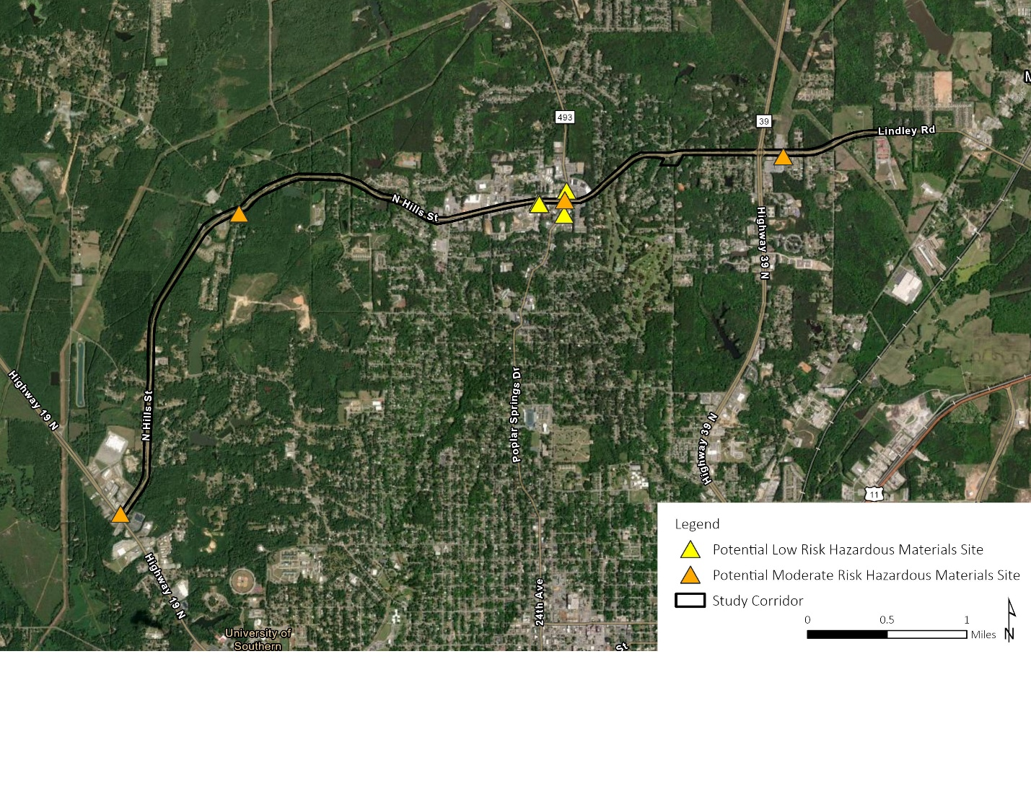
Figure 13. Hazardous Waste Sites near the Study Corridor

Oil Wells
No active oil wells have been identified within the project limits based on a review of Mississippi State Oil and Gas Board (MSOGB) Well Search (MSOGB, n.d.).

Socioeconomic and Business Considerations

Demographic Characteristics
The study corridor passes through five census tracts, as shown in Figure 10. Demographic data was obtained from U.S. Census Bureau for these areas.
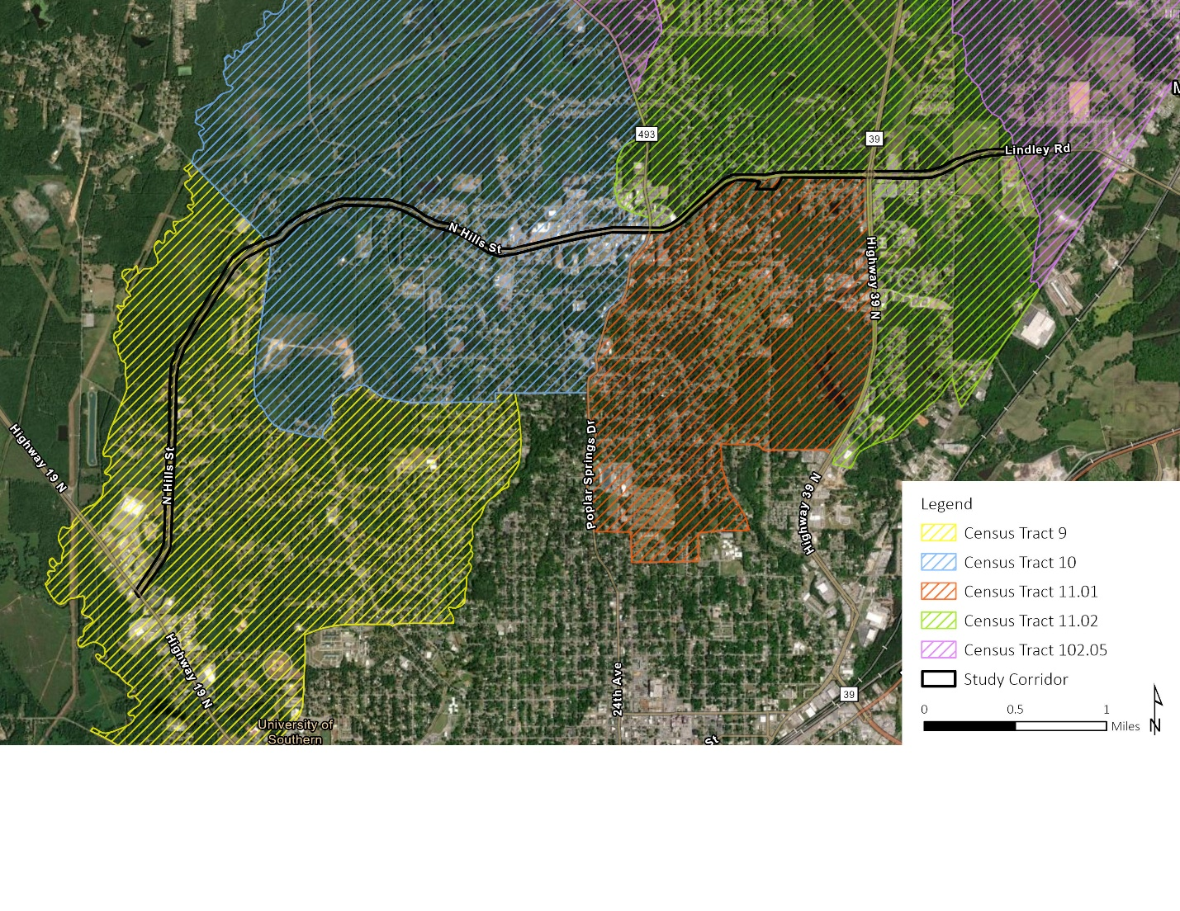
Figure 14. Census Tracts along the Study Corridor
Table 3 summarizes the percentage of households in each census tract that fall below the poverty line, as reported by the U.S. Census Bureau 2020 Decennial Census (U.S. Census Bureau, 2021).
Table 3. Income Demographics of Census Tracts along the Study Corridor
Census Tract | Population Below the Poverty Line
Census Tract 9 | 31%
Census Tract 10 | 22%
Census Tract 11.01 | 15%
Census Tract 11.02 | 6%
Census Tract 102.05 | 13%
Meridian (Citywide) | 32%
Lauderdale County | 26%

Households with lower incomes may have a higher reliance on multimodal transportation, such as walking, biking, or transit, to access employment, education, and essential services. Ensuring that transportation improvements support safe, affordable, and efficient travel options for all users will be important in meeting community needs.
Table 4 summarizes the demographic composition of census tracts along the study corridor sourced from the 2023 American Community Survey (ACS) 5-Year Estimates (U.S. Census Bureau, 2023). The table focuses on the largest population groups by race in the area, while groups representing less than 1% of the population, including American Indian and Alaska Native, Native Hawaiian and Pacific Islander, and some other races, are not shown. Census Tracts 9 and 10 includes a higher percentage of Black or African American.
Table 4. Demographic Composition of Census Tracts along the Study Corridor
 | Black or African American | Asian | White
Census Tract 9 | 78% | 0% | 17%
Census Tract 10 | 56% | 1% | 37%
Census Tract 11.01 | 34% | 2% | 60%
Census Tract 11.02 | 42% | 0% | 51%
Census Tract 102.05 | 32% | 0% | 59%
Meridian (Citywide) | 66% | 1% | 28%
Lauderdale County | 44% | 1% | 51%

The demographic composition of the study corridor highlights the need for transportation improvements that enhance mobility, promote safety, and support access to infrastructure.

Local Businesses and Economic Nodes
Local businesses and commercial districts along North Hills Street rely on consistent and efficient access to sustain economic activity. Construction staging, intersection reconfigurations, and capacity enhancements should be planned to minimize disruptions and ensure that businesses can continue operating effectively throughout the project.
The section between 35th Avenue and 18th Avenue is densely developed with commercial properties, retail centers, and service-based businesses. Additionally, Highways 19 and 39 serve as key economic access points, connecting regional traffic to businesses along North Hills Street. These corridors function as economic nodes, supporting local commerce and regional connectivity.

Conclusion and Next Steps
The Environmental Constraints Report provides a comprehensive assessment of the natural, cultural, socioeconomic, and infrastructure-related considerations along the North Hills Street Corridor. By identifying key environmental resources early in the PEL study, this report ensures that project planning integrates resource protection, regulatory compliance, and community needs from the outset.
The analysis highlights several critical environmental constraints that must be considered in future project phases. Wetlands, floodplains, and impaired waterbodies, present hydrologic and permitting considerations. Any impacts to wetlands and waterbodies will require Clean Water Act (CWA) compliance, including Section 401 and 402 permits from MDEQ and Section 404 permit from the U.S. Army Corps of Engineers (USACE). Potential impacts on water quality will require stormwater management strategies that align with MDEQ stormwater permits and National Pollutant Discharge Elimination System (NPDES) requirements.
Similarly, protected species and habitat considerations, though not currently identified as significant, will require continued coordination with USFWS and MDWFP to ensure compliance with Endangered Species Act (ESA) protections and best management practices to avoid potential impacts on sensitive species.
Cultural and historic resources identified along the corridor, including previously recorded archaeological sites and historic structures, may require further evaluation if ROW acquisition or ground disturbance is necessary. Early engagement with MDAH will ensure that any impacts are appropriately assessed and mitigated under Section 106 of the NHPA.
Community resources, including emergency services, schools, healthcare centers, and places of worship, are located throughout the corridor. The section between 35th Avenue and 18th Avenue is the most densely developed and contains a high concentration of healthcare facilities, educational institutions, and businesses. Project planning must maintain access to these essential services and minimize disruptions during construction.
The corridor contains utility and energy infrastructure, including natural gas pipelines, electrical transmission lines, and an electricity substation. Any modifications near these assets must involve coordination with utility providers to prevent service disruptions and ensure construction safety. The hazardous materials review identified moderate-risk underground storage tanks that require further assessment and coordination with the MDEQ.
These findings provide an early foundation for NEPA compliance and help refine transportation alternatives, impact assessments, and project designs. The PEL study will continue to incorporate interagency coordination, stakeholder engagement, and community outreach to ensure that proposed improvements align with environmental regulations, transportation goals, and community priorities.

References
FEMA. (n.d.). Digital Flood Insurace Rate Map. Retrieved January 15, 2025, from https://msc.fema.gov/portal/home
MDEQ. (n.d.). TMDL tool. Retrieved February 26, 2025, from https://opcgis.deq.state.ms.us/tmdltool/?find=MS107M3
MSOGB. (n.d.). MSOGB online database. Retrieved March 3, 2025, from https://ws.ogb.state.ms.us/MSOGBOnline/
U.S. Census Bureau. (2021). 2020 Decennial Census. Retrieved January 15, 2025, from https://data.census.gov/
U.S. Census Bureau. (2023). American Community Survey 5-year estimates (2018–2023). Retrieved January 15, 2025, from https://data.census.gov/
USFWS. (n.d.). National Wetland Inventory Wetlands Mapper. Retrieved January 10, 2025, from https://fwsprimary.wim.usgs.gov/wetlands/apps/wetlands-mapper/
USGS. (n.d.). National Hydrography Dataset. Retrieved January 12, 2025, from National Hydrography Dataset (NHD): https://www.usgs.gov/national-hydrography

ATTACHMENT A: PROJECT MAPS

ATTACHMENT B: HAZARDOUS MATERIALS REPORT

ATTACHMENT C: AGENCY CONSULTATION LETTERS

