Lecture 10: Recurrent Neural Networks

- Extra Credit: Train Game to enhance hyperparameter tuning abilities

- In 2014 ImageNet competition, batch normalization wasn’t invented yet so it was difficult to train these deep networks. They had to resort to some “hackery” to do this.

- Auxiliary classifiers and other “hacky” auxiliary layers were just implemented before batch normalization. Now that we have BN, we don’t need them anymore

I. “Vanilla” Neural Network vs Recurrent Neural Network

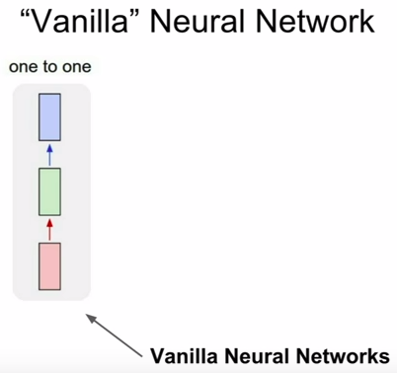

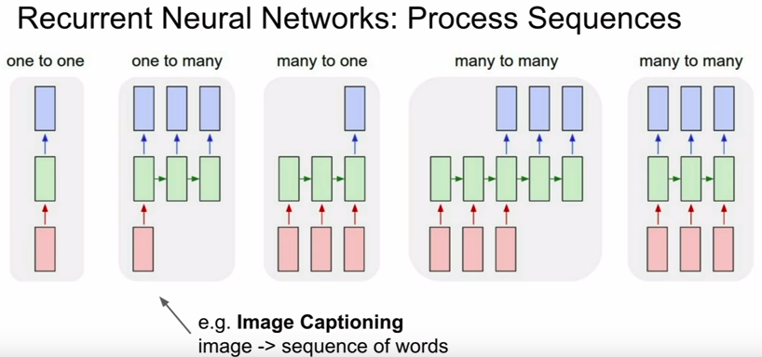
- with Recurrent Neural Networks, we’ll have more flexibility
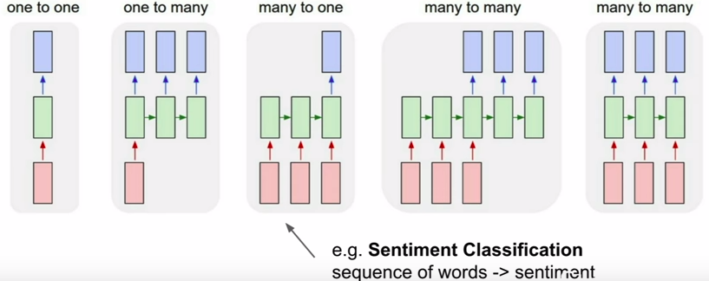

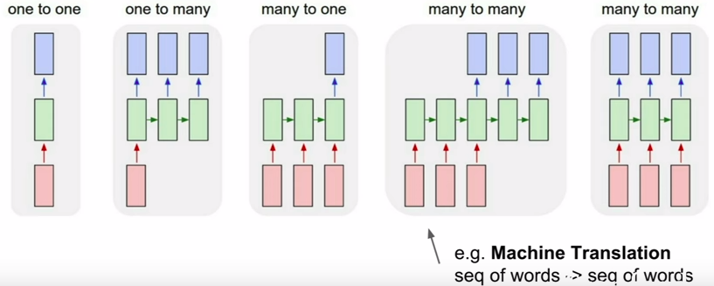

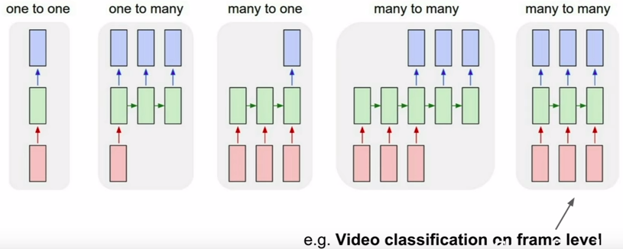

- Even for problems with a fixed size input and a fixed size output, recurrent NNs can still be useful

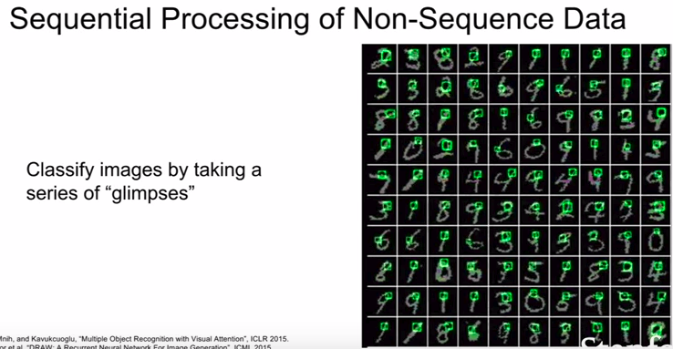
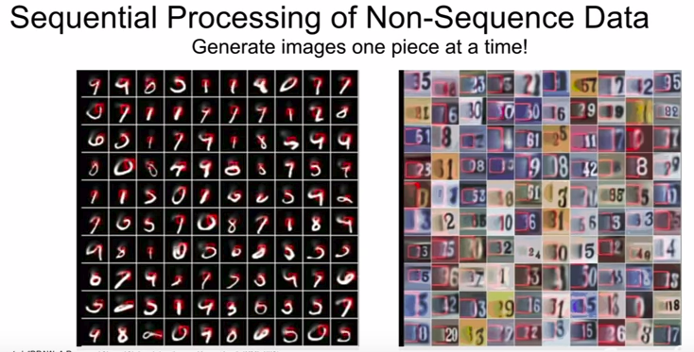
- even if our output is a fixed size image, we can have models that work overtime to compute parts of the output one at a time sequentially. We can use recurrent neural networks for this.

II. Recurrent Neural Network

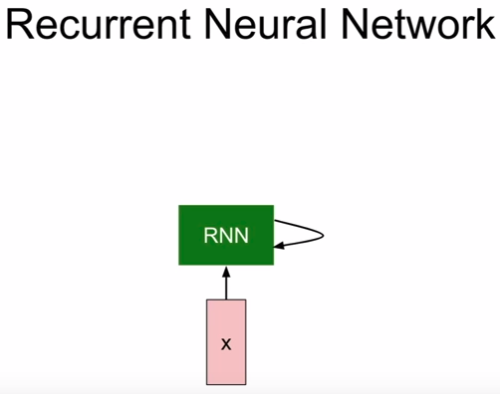

- an RNN has this little recurrent core cell

1. takes input x
2. feed into RNN
3. RNN has an internal hidden state that is updated everytime the RNN reads a new input,

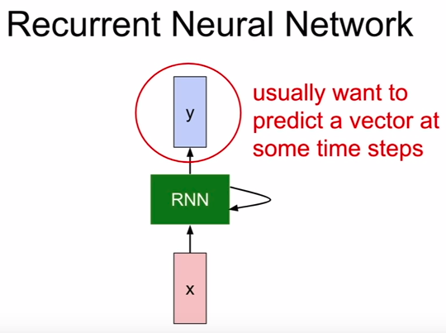

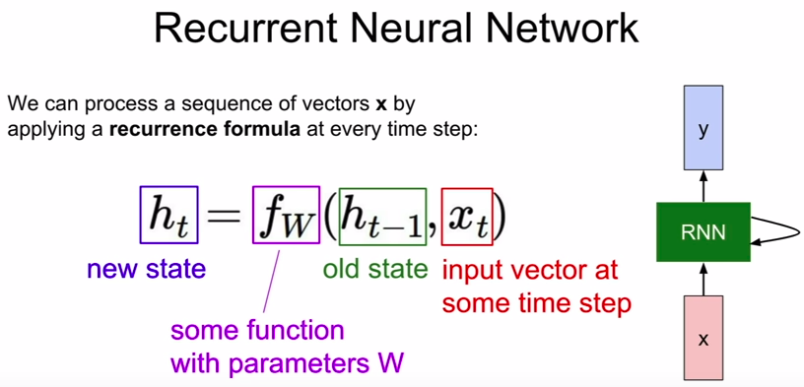


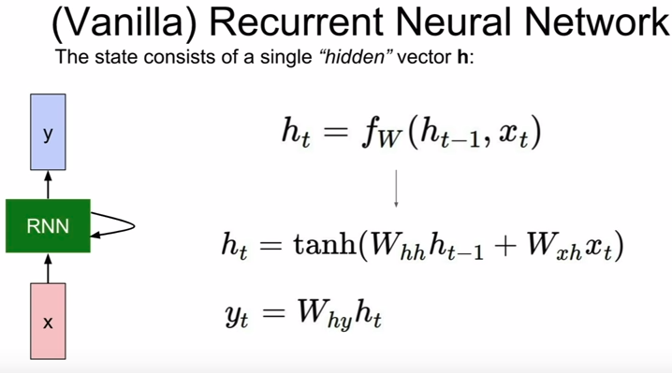
- simplest RNN you could think of

II. Two ways to think about RNNs

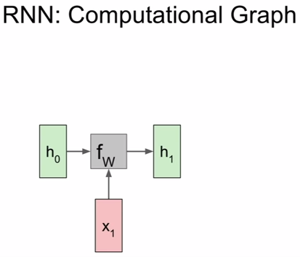

1. Having a hidden state that feeds back to itself recurrently (confusing)

2. Clearer to think about unrolling this computational graph for multiple time steps

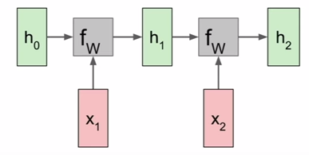

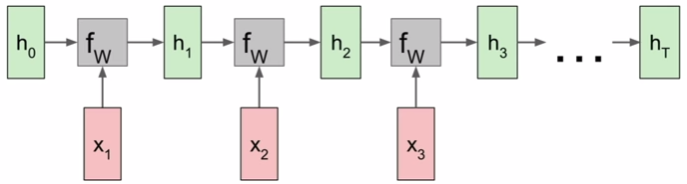

- this process will repeat over and over again as we consume all our inputs xt in our sequence of inputs

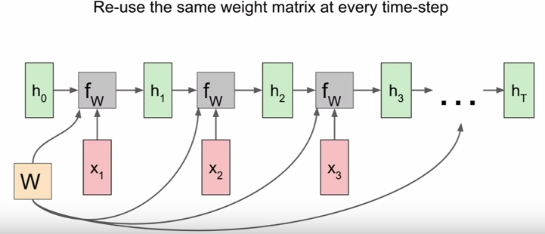

- with the weight matrix W

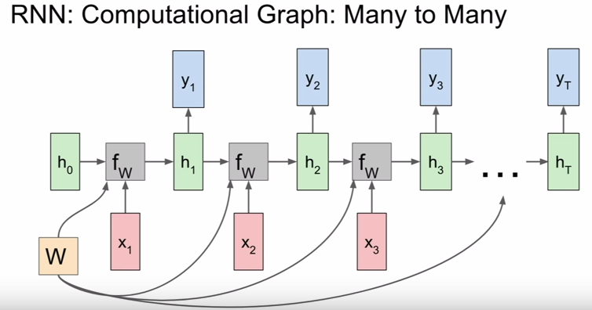
- we can write this yt in this computational graph

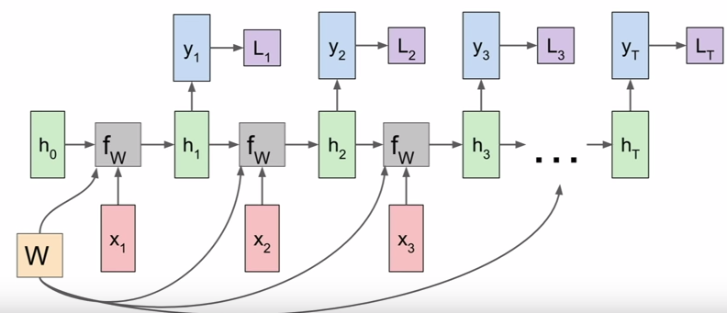
- we can also make the loss more explicit

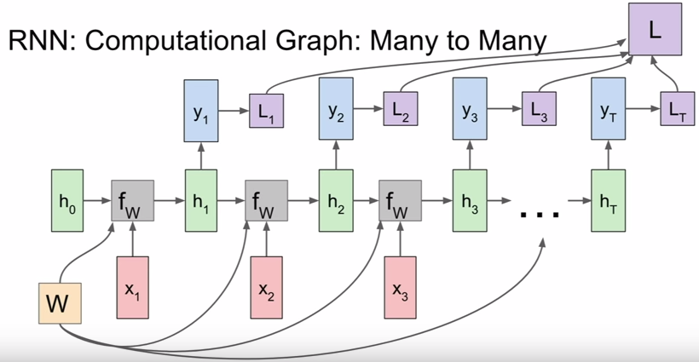
- sum of loss W

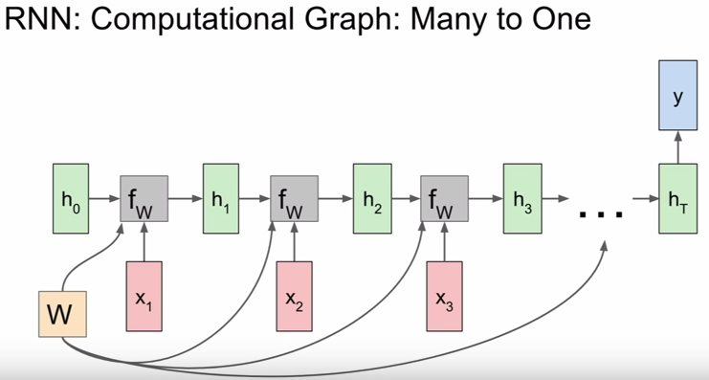
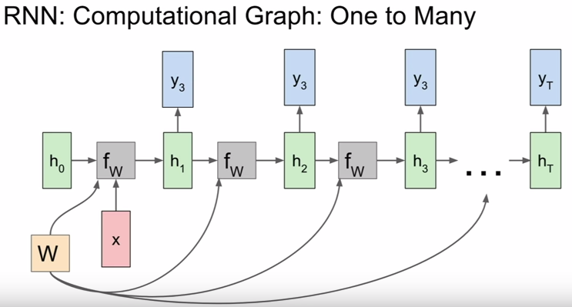

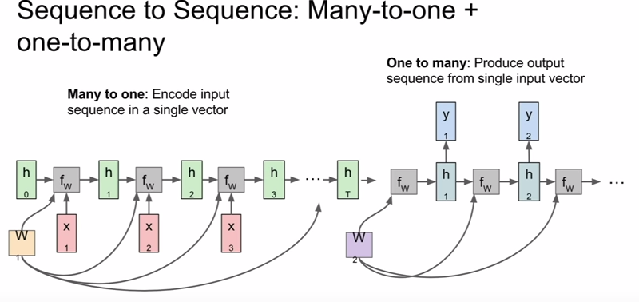
- something used for machine translation

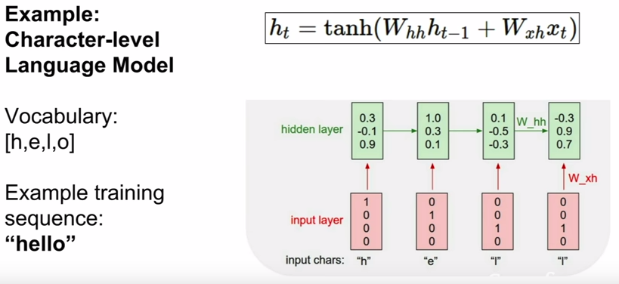
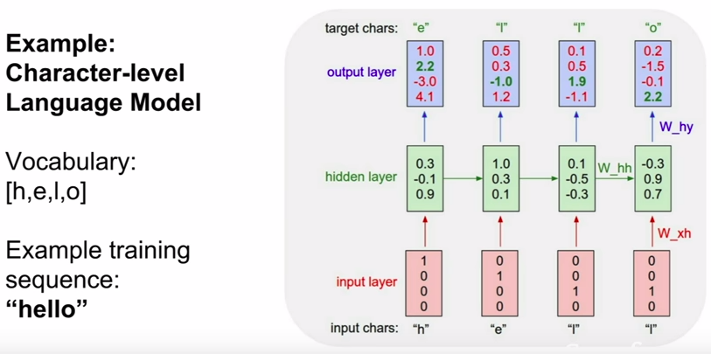

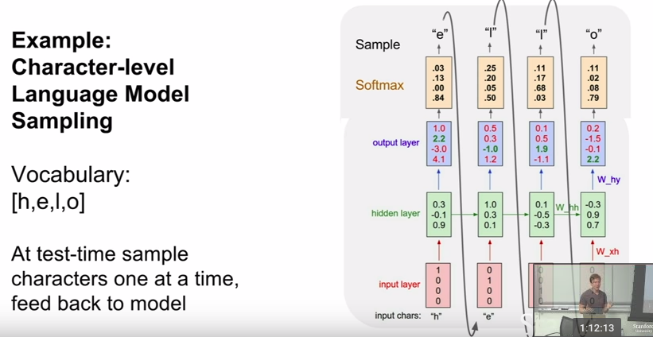

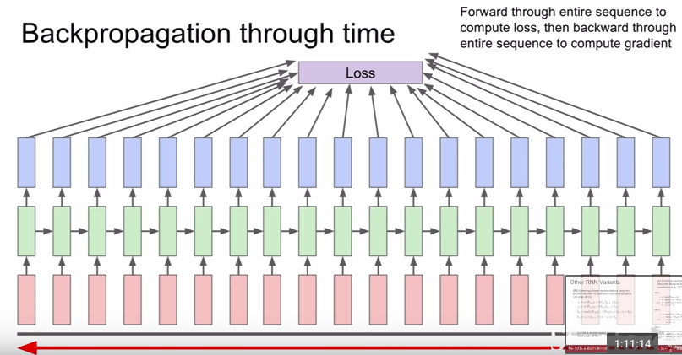
- this can be problematic on very long sequences (e.g. training on the entire text of wikipedia)
- very slow and takes a lot of memory

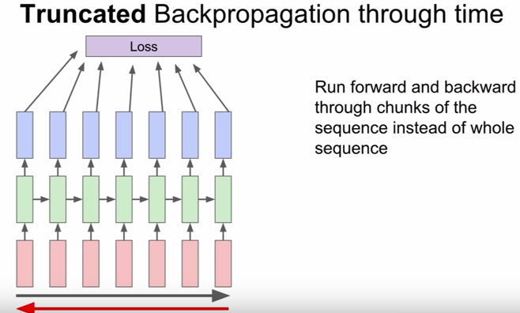

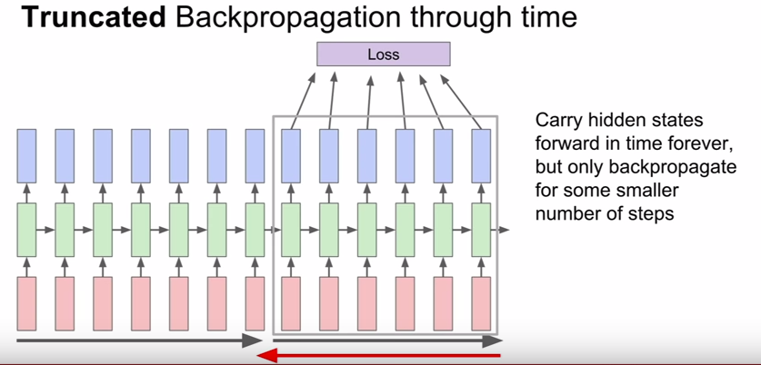
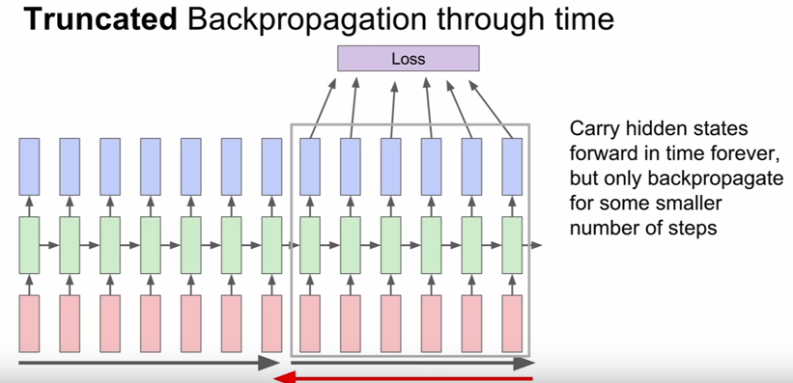

- you can think of this as being similar to SGD

- checkout https://gist.github.com/karpathy/d4dee566867f8291f086

III. Fun examples of recurrent neural network language model

1. Shakespeare example

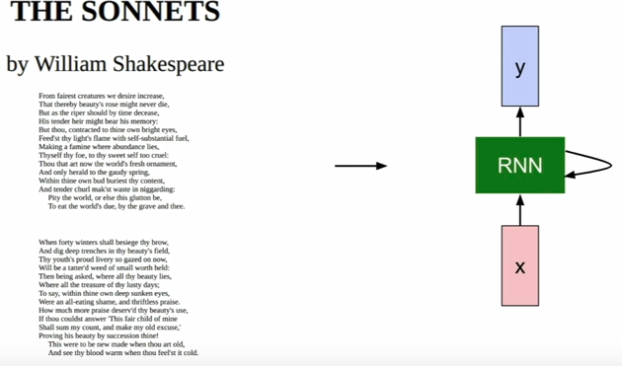

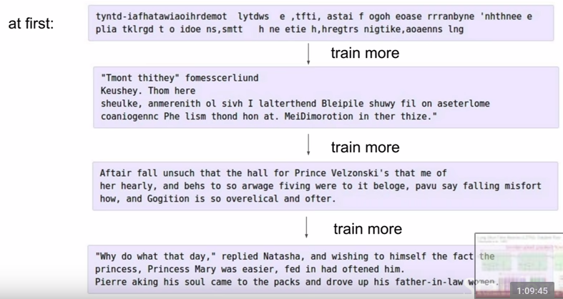



2. Algebraic topology example

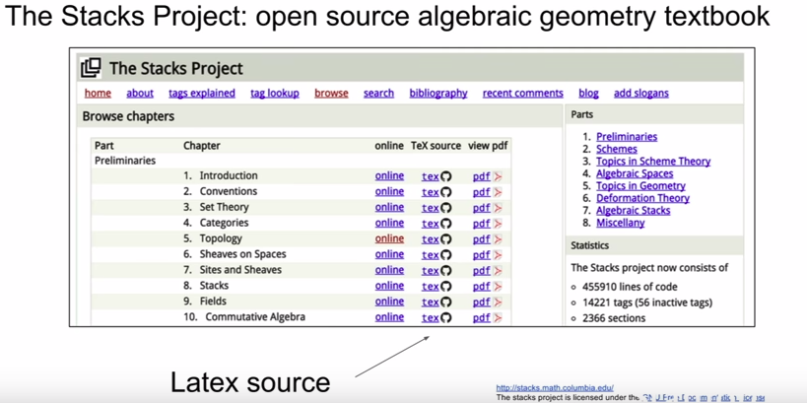
- a bunch of LaTex files of heavy mathematics

- since LaTeX is plain text, we could train our model using it

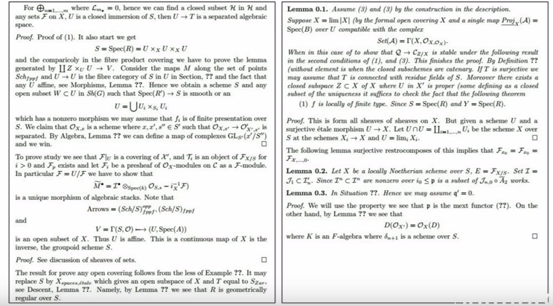
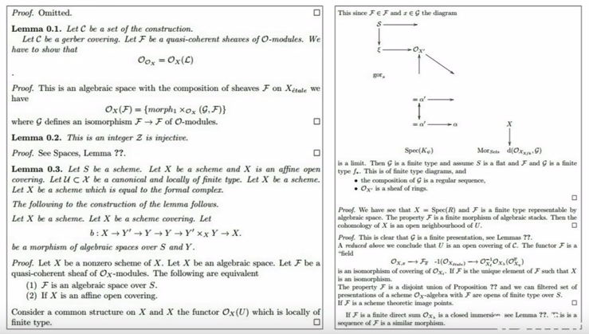
- it makes proofs

- tries to make diagrams

- sometimes omits proofs

3. Training through entire source code of Linux kernel

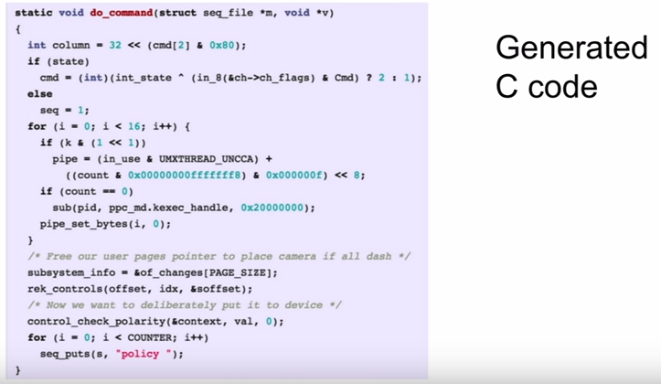

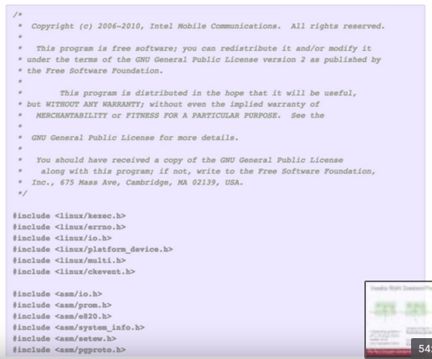
- even knows to declare GNU License
- during training, all we ask this model to do is to try to predict next char in the sequence, we don’t even tell it about the structure. Very impressive.

IV. Image Captioning (since this IS a computer vision class)

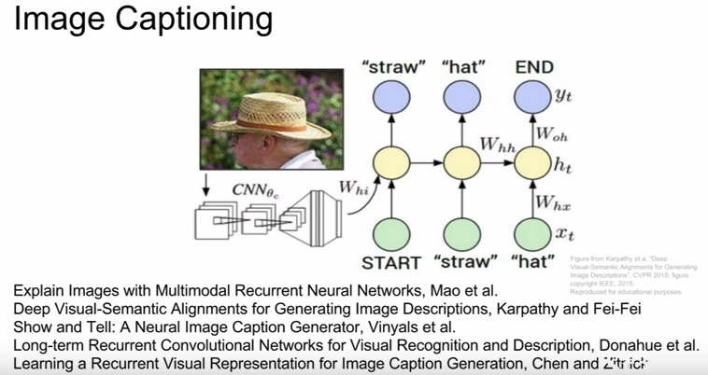

- the caption is this variably length sequence that might have differing number of words for different captions, a natural fit for a recurrent neural network language model

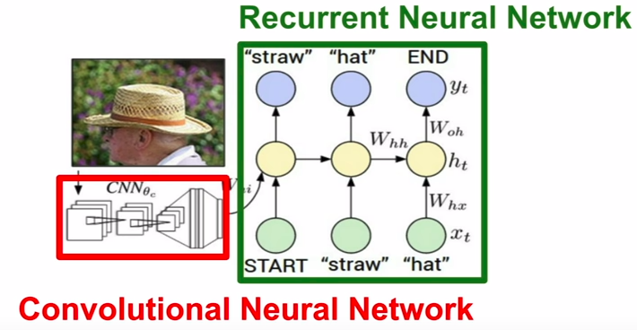
- some ConvNet takes image as input

- produces summary vector of the image

- feeds into first timestep of the recurrent language model

- it then produces words of the caption one at a time

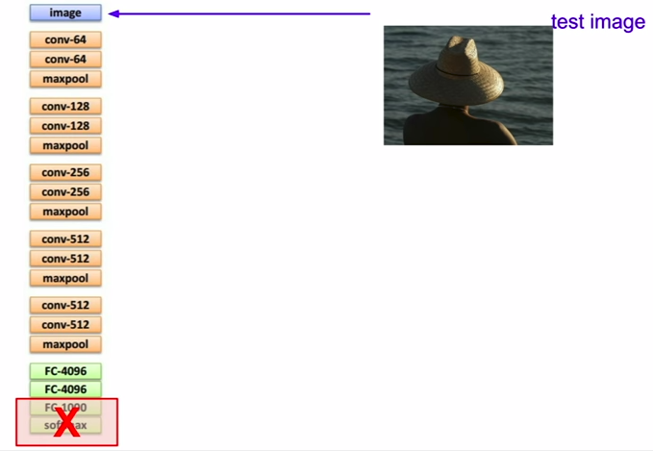

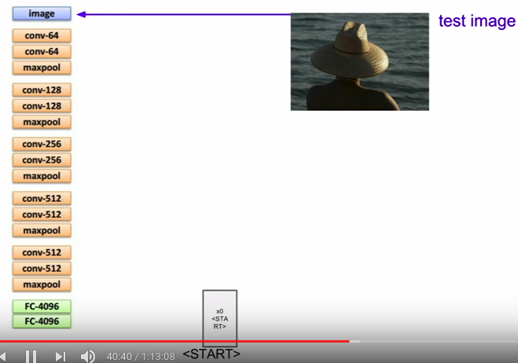
- take out the softmax scores
- instead, take these 4096 models to summarize the whole content of the image

- now, remember we need to seed the language model with an initial input to tell it to start generating text

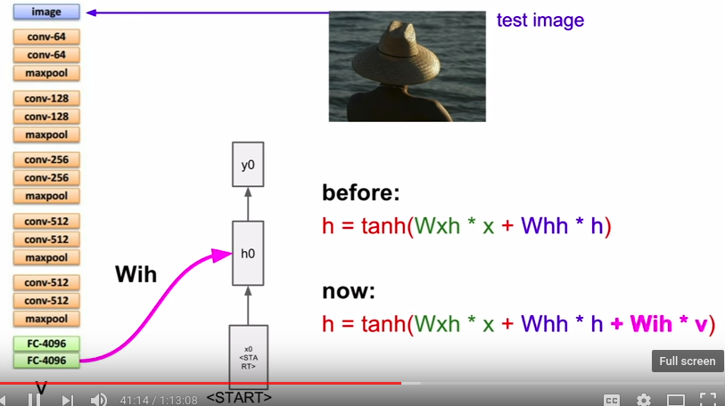
- need to incorporate image information so a good way is to add this 3rd weight matrix that adds in this image information every time step to compute the next hidden stage

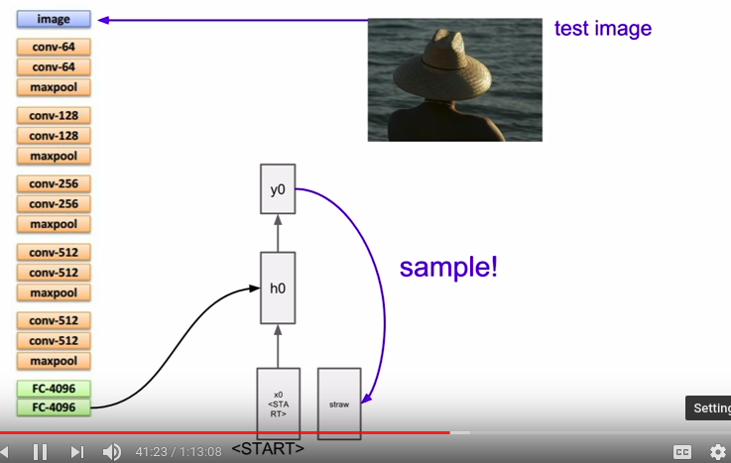
- compute distribution over all scores in our vocabulary

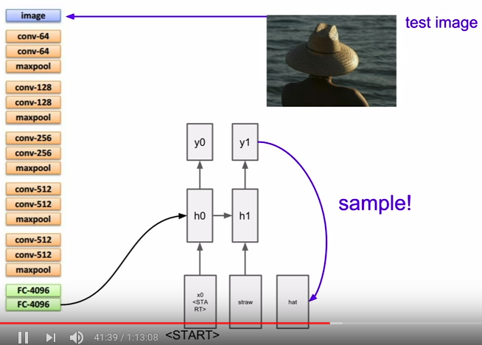

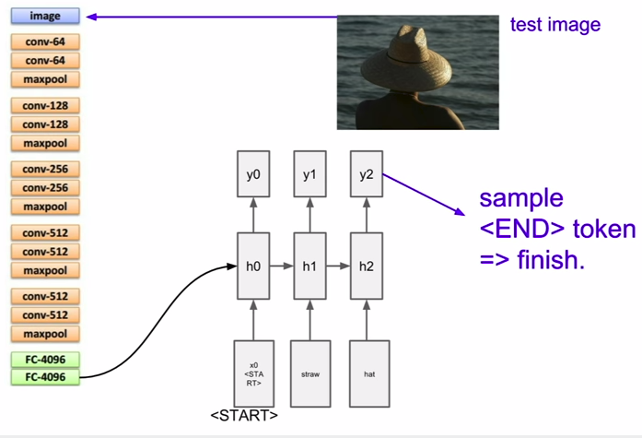

- end token is kind of a period to a sentence

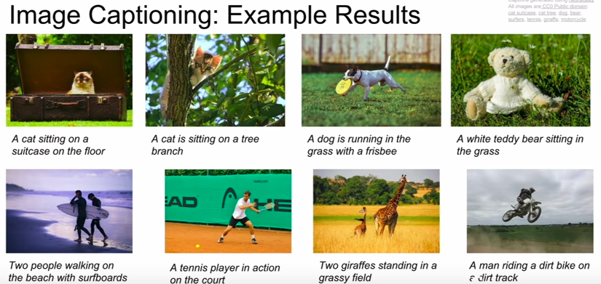

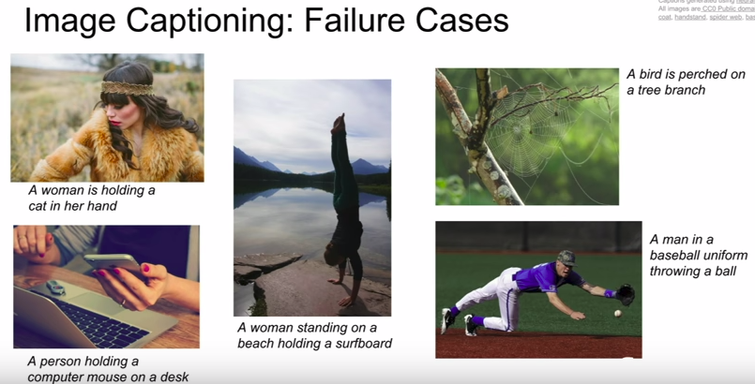
- did not work well because these images are different from training data

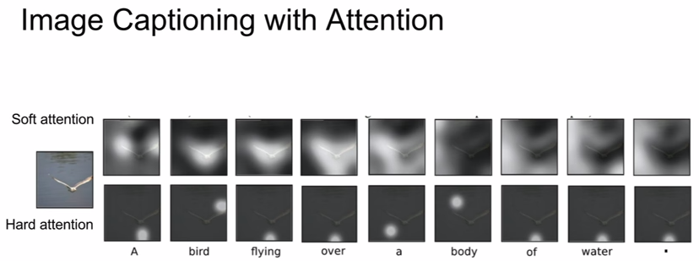

V. Other ideas

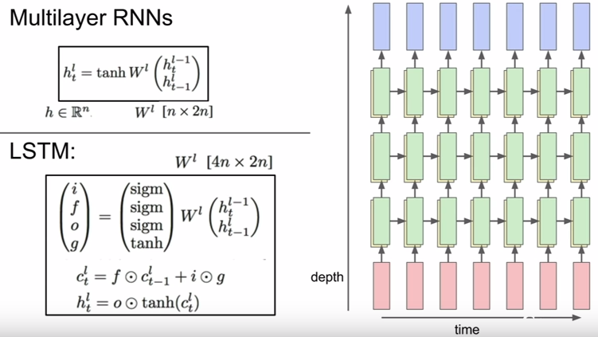

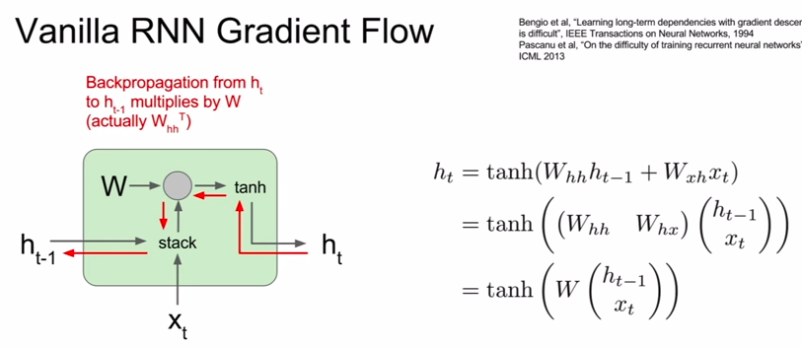
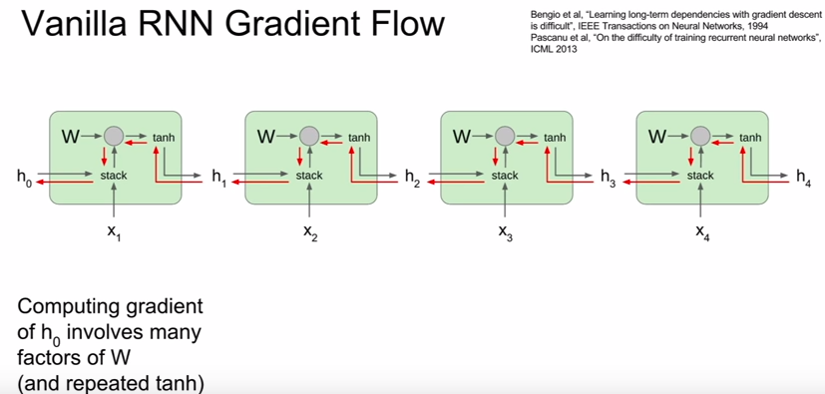
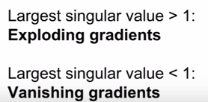

solutions for exploding gradients:
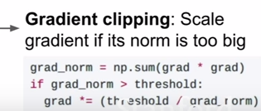

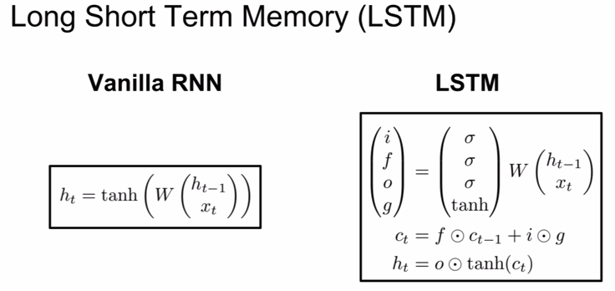
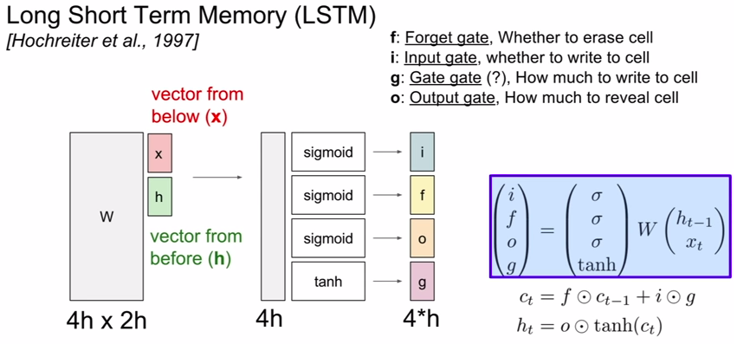

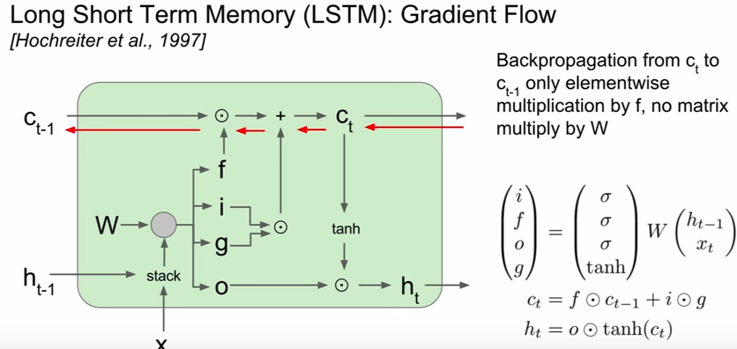
- a lot nicer than the vanilla RNN:

1. forget gate is now an element-wise multiplication an not matrix multiplication

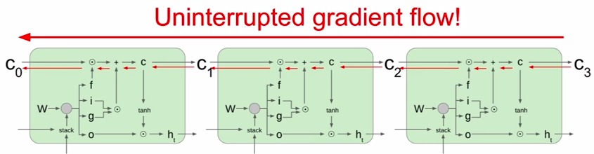

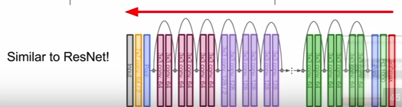

VI. Summary



