Lecture 11: Detection and Segmentation

- So far, we’ve been talking about image classification

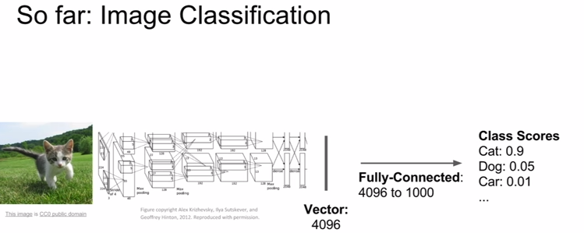
- we’ll talk about:

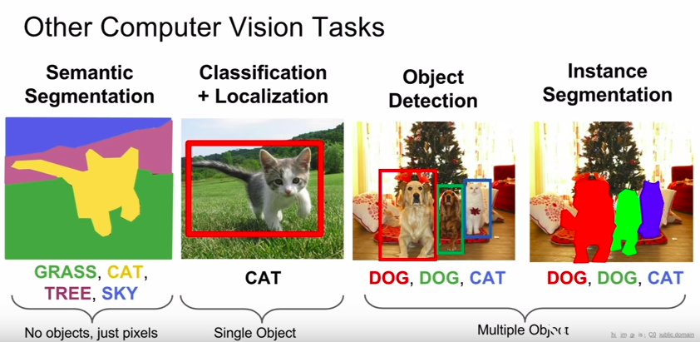

I. Semantic Segmentation

- label each pixel in the image with a category label

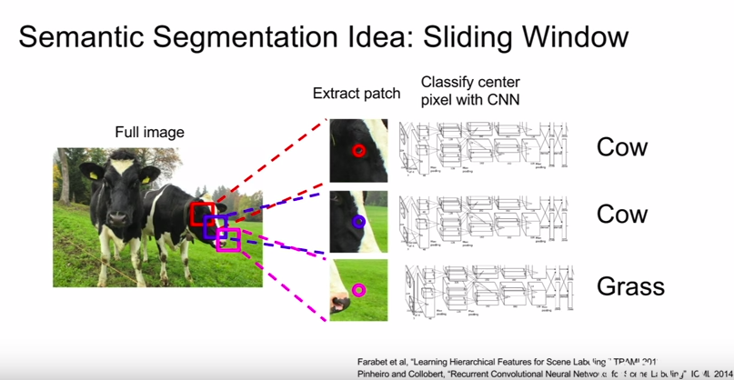



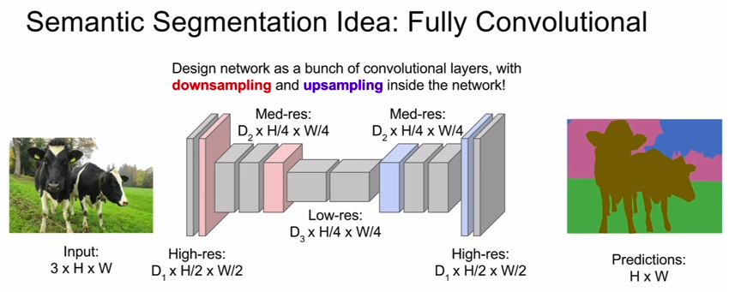

Possible solution:

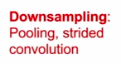
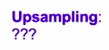

In-network upsampling: “Unpooling”

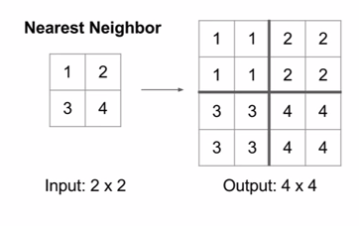
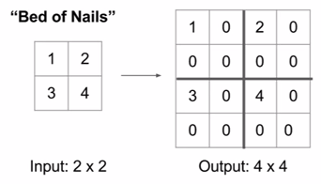

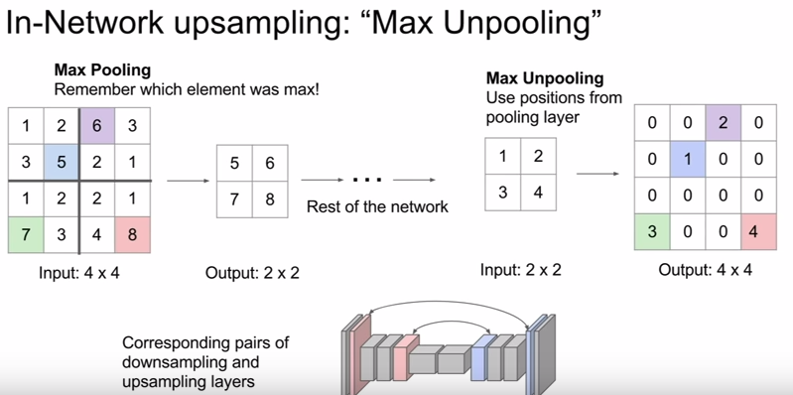

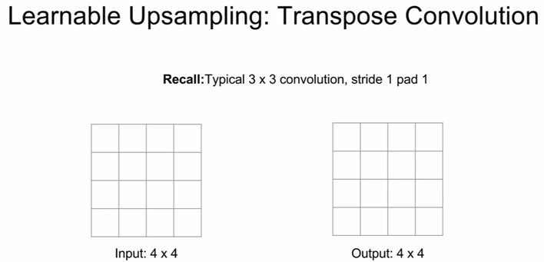
- transpose convolution lets us apply a “learnable” upsampling

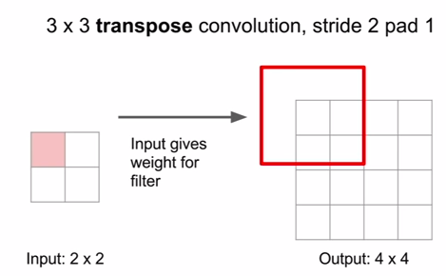

- to do transpose convolution is sort of the opposite of stride convolution

- rather than taking an inner product without filter and the input, we instead take the value of the output feature map at that upper left corner, and there will be some scalar value in the upper left corner, then multiply the filter by that scalar value and then copy those values over to this 3x3 region in the output
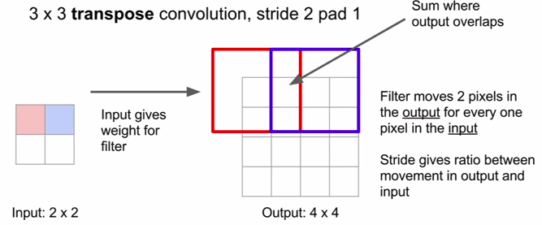
- the tricky part is sometimes these receptive fields can overlap, what we do is just sum the results in the output

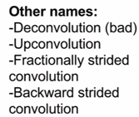

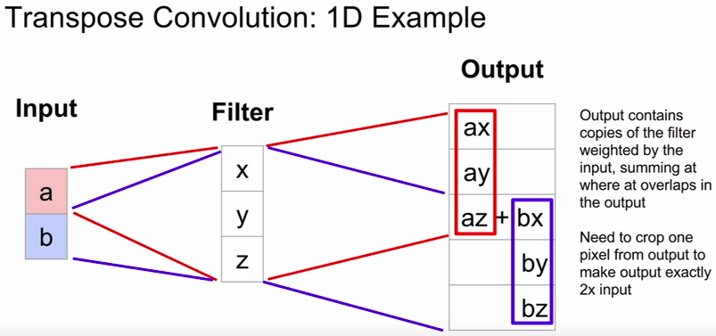

- where does the name “transpose convolution” come from?

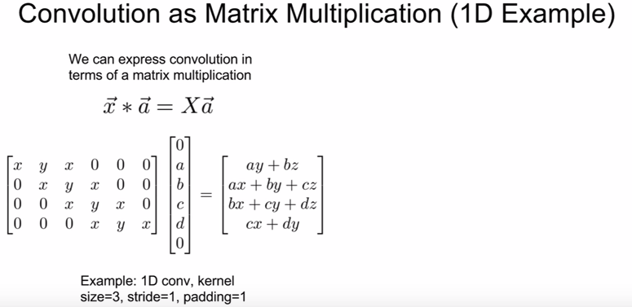
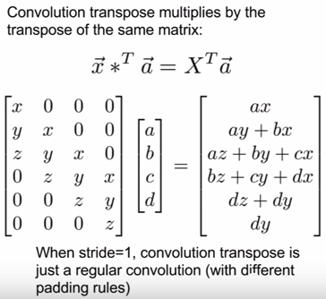

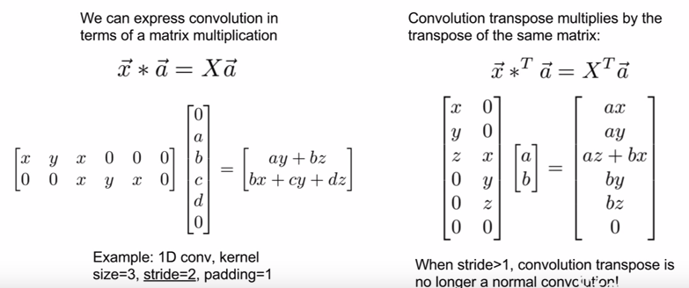

II. Classification + Localization

- in addition to classifying the image in a category, we also locate the object in the image and maybe draw some bounding boxes

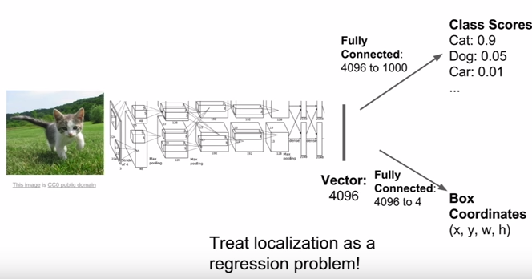

- we’ll have a FC layer going directly to our class scores and another one that goes from that vector to 4 numbers where the 4 numbers are like the h, w, and the x and y positions of that bounding box

- thus, our network will produce these 2 different outputs: 1. class scores, 2. four numbers describing the bounding box

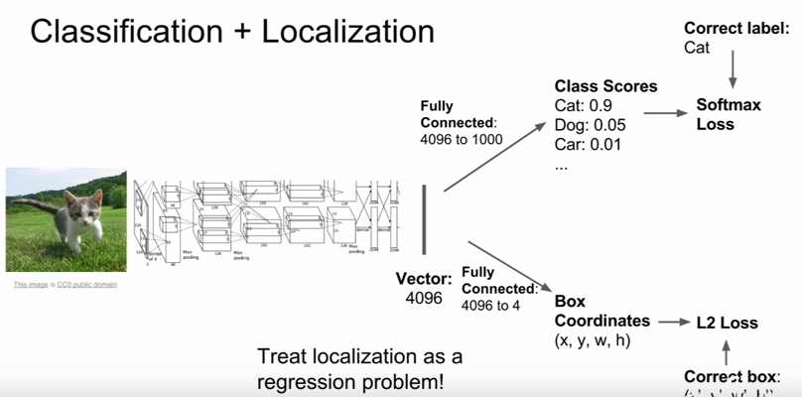
- we’ll use 2 loss funcs

- softmax which we compute using the ground-truth category label and the predicted class scores

- some loss that gives us some measure of dissimilarity between our actual coordinates of our bounding box over the predicted coordinates of our bounding box. Could use L2 loss usually

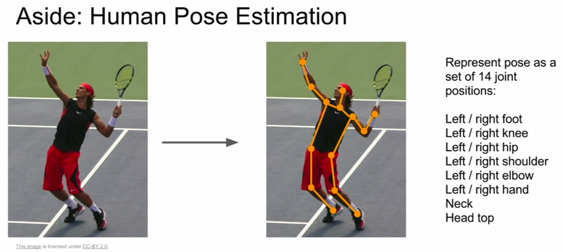

- this localization idea can also be applied to a lot of different ideas besides just classification + localization. For example, human pose estimation

- predicts the pose of a human, where his arms, legs, etc.

III. Object Detection

- VERY MEATY topic

- kind of a core problem in computer vision

- the idea is we start with some fixed set of categories we care about, now our task is that given our input image, everytime one of those categories appears in the image, we want to draw a box around it and then predict the category of that box

- different from classification + localization because there may be a varying number of outputs for an image

- challenging problem

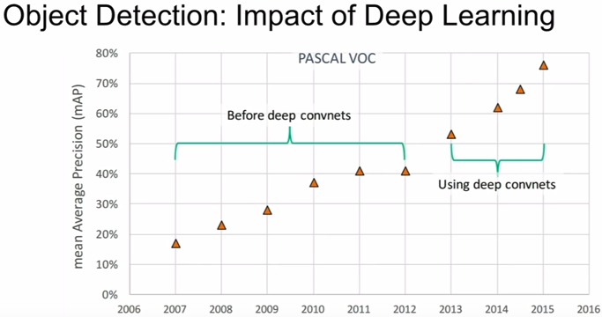

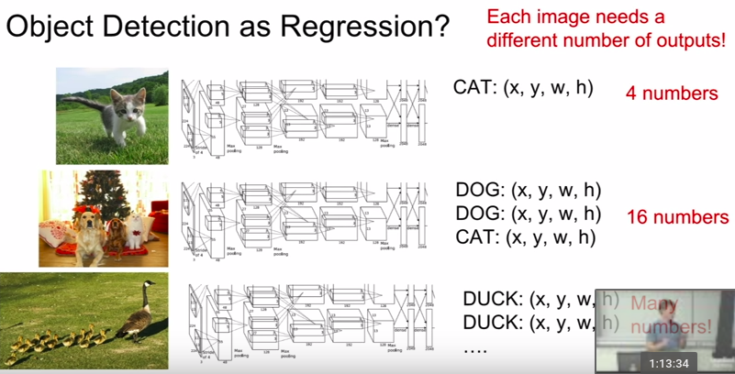

- difficult to think about object detection as a regression problem because number of outputs can vary

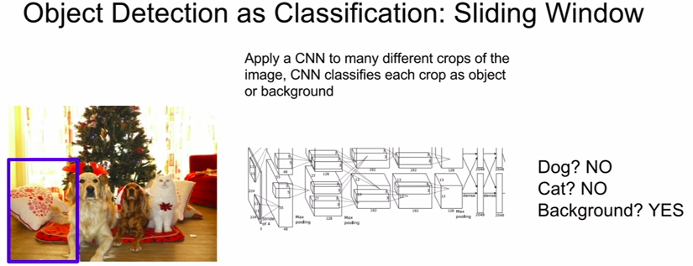

- take different crops of the input image and then we take that crop, feed it to our ConvNet

- then, our CNN does a classification decision on our input crop (e.g there’s no dog here, no cat here, etc.)

- in addition to the categories that we care about, we add an additional category called “background”
and now our network can predict “background” if it doesnt see any of the categories that we care about

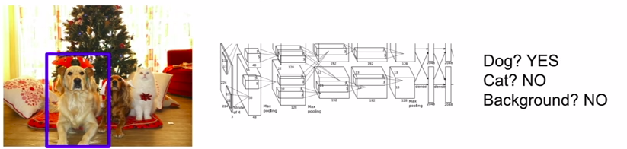
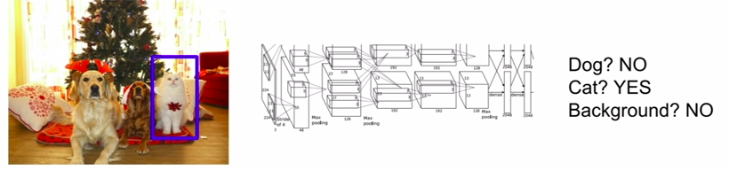
- Problem: how do we choose the crops?


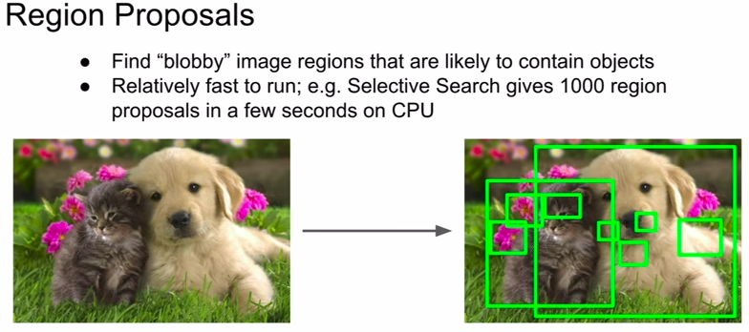
- given an input image, a region proposal network will then give you something like a 1000 boxes where an object may be present

- relatively fast-ish to run

- for example “selective search” gives you around 2000 region proposals after around 2 minutes

This idea all came together in a paper called R-CNN that does exactly that:

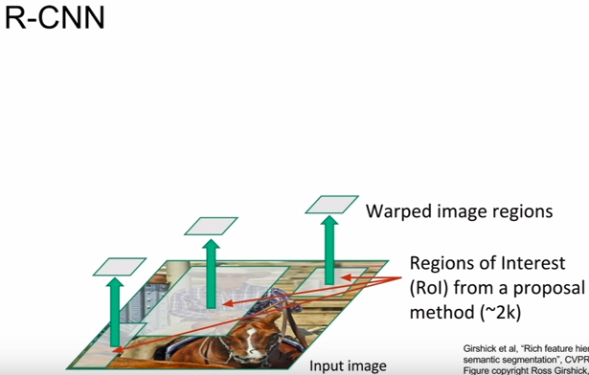

- problem is some regions will have different sizes

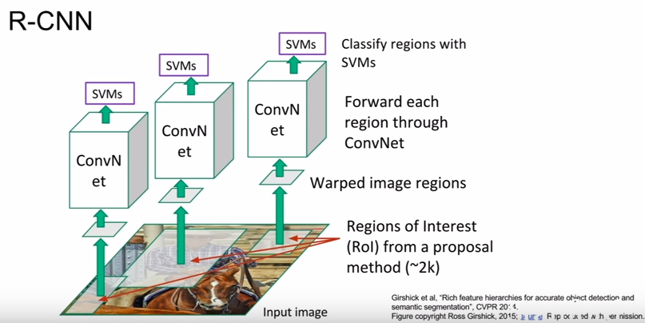
- warp each of them to the correct size and then forward to a ConvNet

- use SVM to classify regions

- In addition, R-CNN also predicts a regression/correction to the bounding box (4 numbers)

- the regions are NOT learned. They are hardcoded by an algorithm

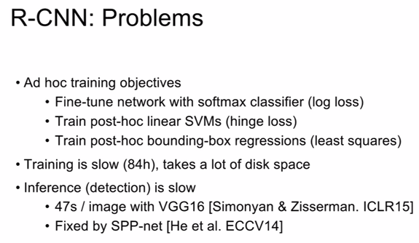

Thankfully we have Fast R-CNN:

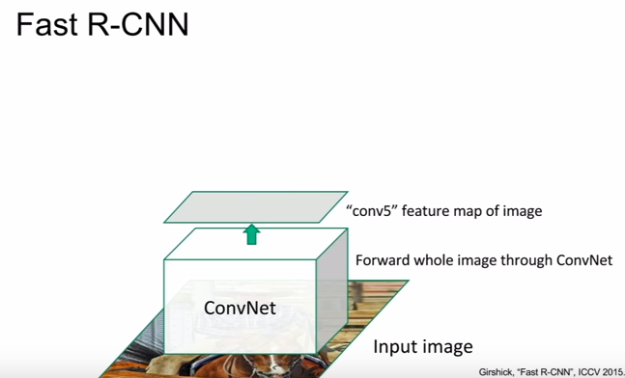
- rather than processing each ROI separately, instead we’ll run the entire image through some ConvNet layers all at once to give this high-res convolutional feature map corresponding to the entire image

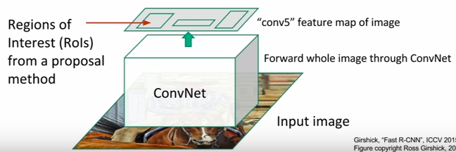
- we’re still using some region proposals from some fixed thing like selective search, but rather than cropping out the pixels of an image corresponding to the ROI, instead we imagine projecting those ROI into the convolutional feature map and take crops from there instead of directly from the image. This allows us to reuse these expensive convolutional computations.

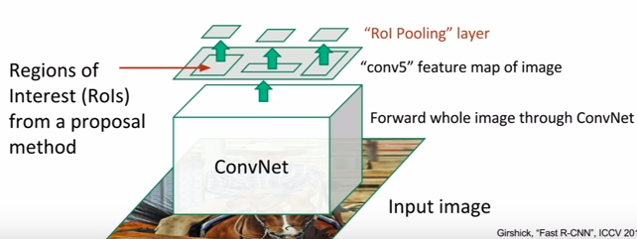
– BUT again, if we have some FC layers downstream, they are expecting some fixed-size input

- so, we use an “ROI Pooling” layer

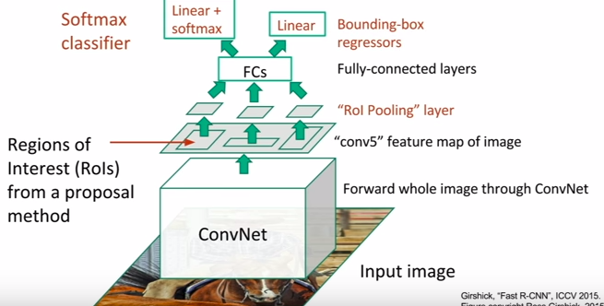

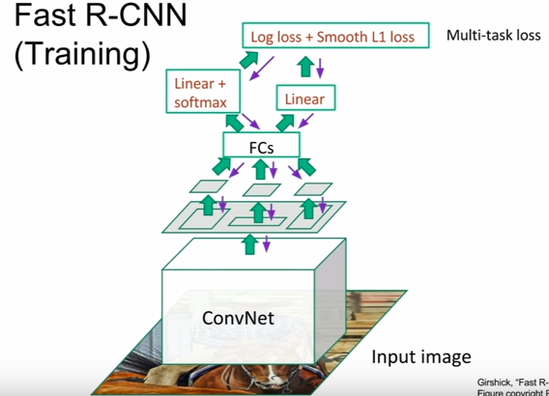

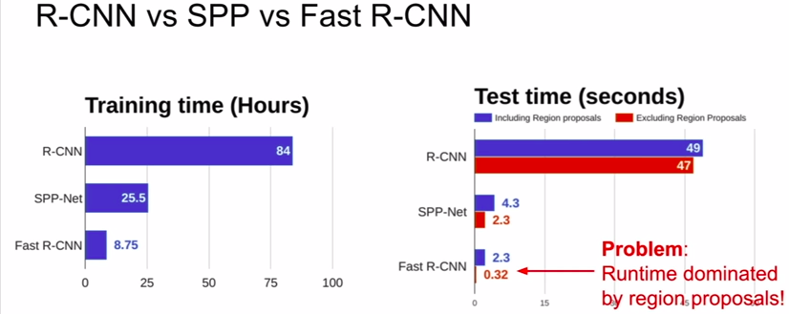

- problem: computing the region proposals using this fixed func was a bottleneck, so instead we’ll make the network itself predict its own region proposals using Faster R-CNN

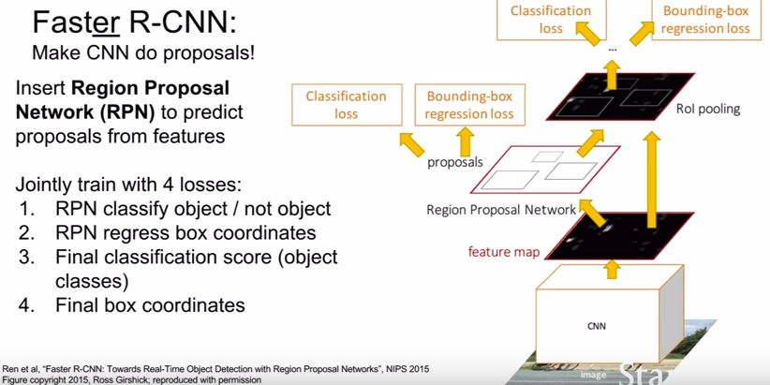

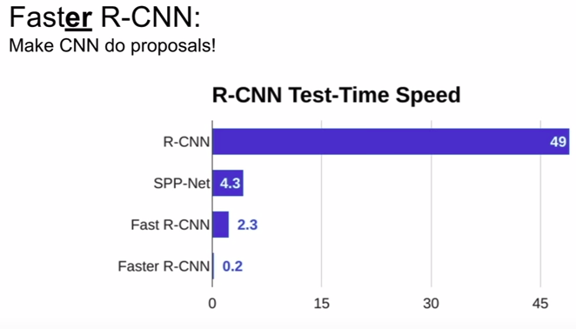

- so this whole family of R-CNN methods are “Region-based” methods for object detection since R stands for Region

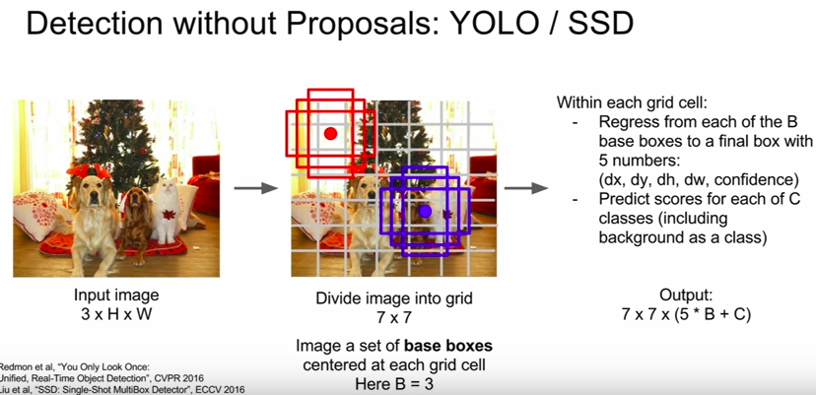
- another family of methods that you sometimes see for object detection, which are sort of all feed-forward in a single pass

- one of these is YOLO (You Only Look Once)

- another is SSD (Single Shot Detection)

- these two came out somewhat around the same time

- rather than doing independent processing for each of these potential regions, instead we want to try to treat this like a regression problem and just make all these predictions all at one with a big ConvNet

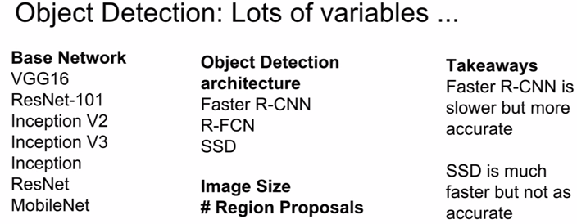

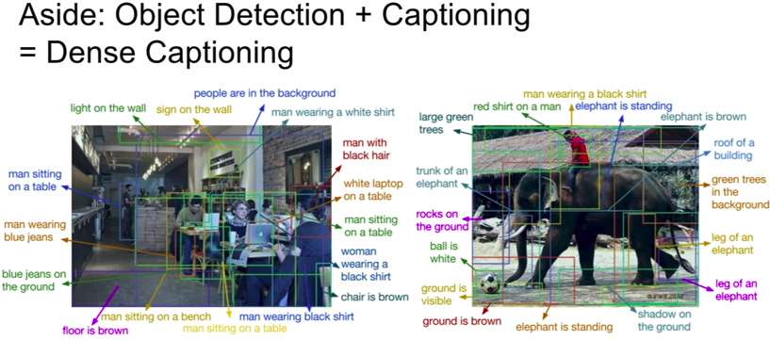

- the idea is you can kind of tie together a lot of these ideas and if oyu have some new problem like dense captioning, you can recycle all of the components you’ve learned from other problems like object detection and image captioning and kind of combine them together

IV. Instance Segmentation

- in some ways like the FULL problems

- given an image, we want to predict the locations and identities of objects in that image similar to object detection, BUT rather than just predicting a bounding box for each of those objects, instead we want to predict a whole segmentation mask for each of those objects and predict which pixels in the input image corresponds to each object instance

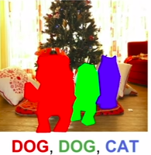

j
- kind of like a combination of semantic segmentation and object detection

- current state-of-the-art is this paper called Mask R-CNN

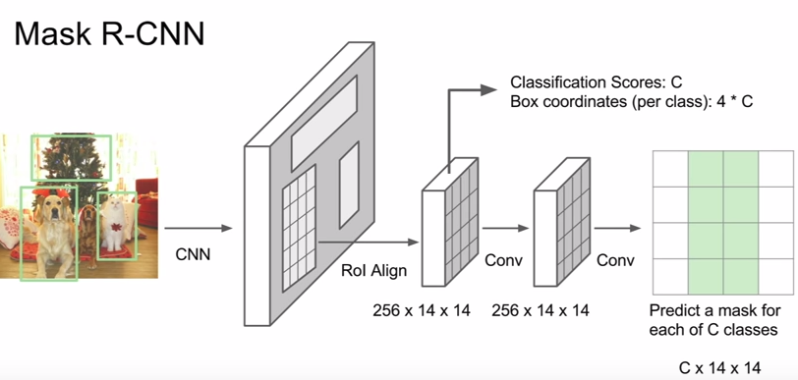

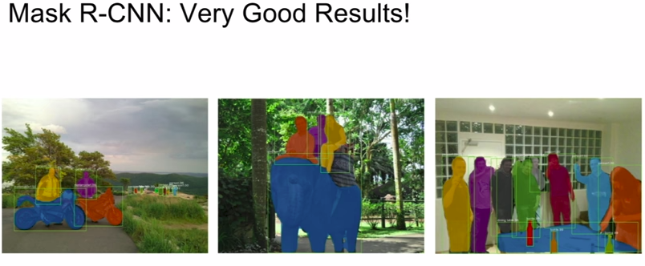
- unifies everything in this lecture

- also does pose estimation

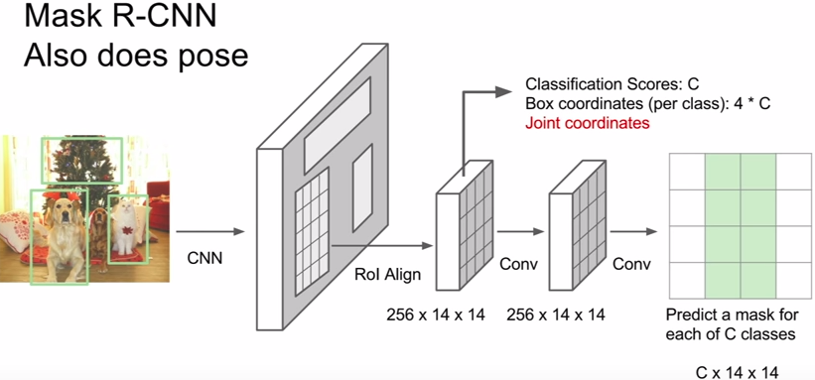
- the only addition we need to make is that for each of these region proposals, we add an additional little branch that predicts these coordinates of the joints for the instance of the current region proposals

- you can do mask r-cnn to do object detection, pose estimation, and instance segmentation

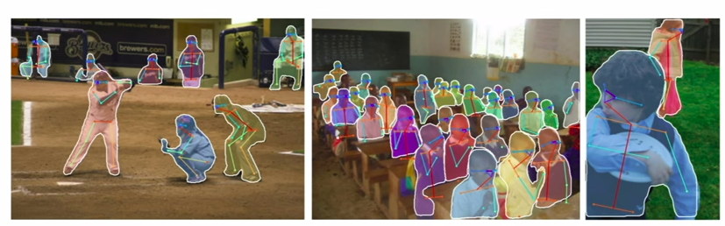
- works incredibly well

