Lecture 12: Visualizing and Understanding

- what’s really going on inside ConvNets?

- we’ve seen how to train them, how to stitch up different types of architectures to attack different problems

- but, we’ve so far seen ConvNets as a little bit of a black box

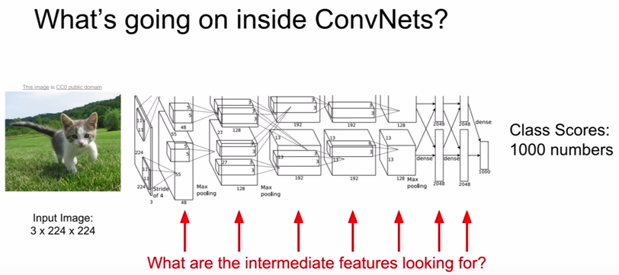
I. First Layer: Visualize Filters

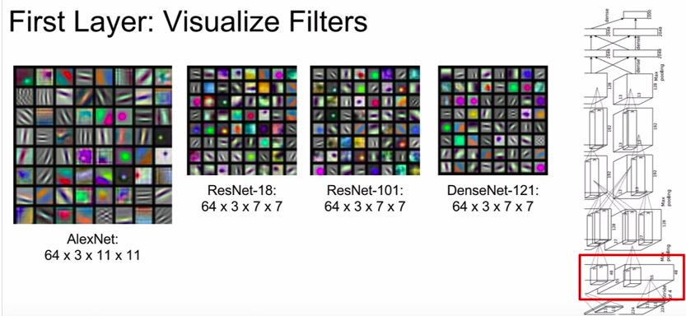
- in the first conv layer, it consists of convolutional filters 3x11x11 (AlexNet)

- gets slid on the input image and it gives us our outputs

- 64 of these filters

- we can get some sense for what these filters are looking for by visualizing the learned weights of these filters as images themselves

- so for each of those 11x11x3 filters in AlexNet, we can just visualize those filters as a little 11x11 images where the 3 channels give the RGB values

- goes back to Hubel & Wiesel’s observation that the human vision tends to look at oriented edges, since the results of visualizing the first conv layer look like oriented edges, bars of light and dark, and opposite colors

II. Can we do the same visualization for the intermediate conv layers?

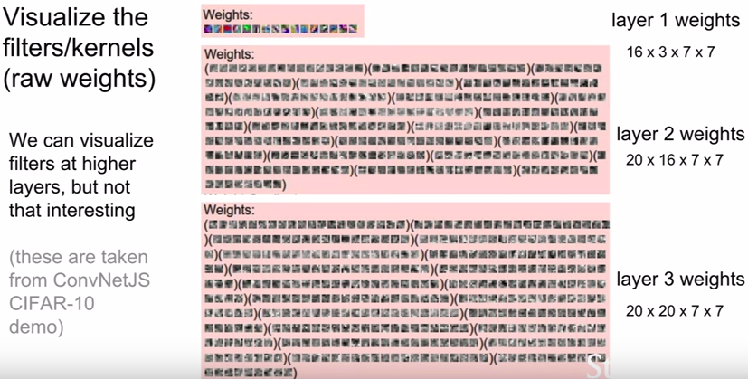
- a lot less interpretable

- because not directly connected to the input image. It takes output of the first layer instead.

- gives you a visualization of what type of activation pattern after the first layer convolution would cause the 2nd layer convolution to maximally activate

- but, not very interpretable because we don’t have a good sense for what those first layer convolutions look like in terms of image pixels

III. Last Layer

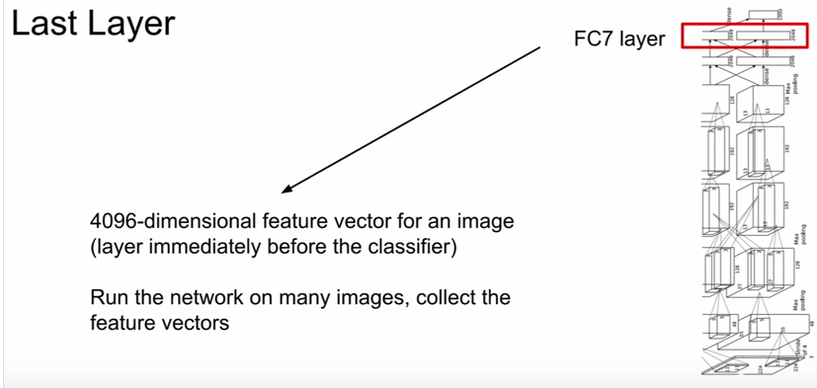

- usually a layer that dispenses the class score outputs (predictions)

-immediately before that layer, we often have a FC layer such as a 4096-dimensional feature vector for an image

- another route for tackling the problem of visualizing convnets is to try to understand what is happening at the last layer of our convolutional network. Take some data set of images run a bunch of images through our trained convolutional network, and record that 4096 vector for each of those images. And now go through and try to visualize that last layer rather than the first layer.

A. Nearest Neighbors

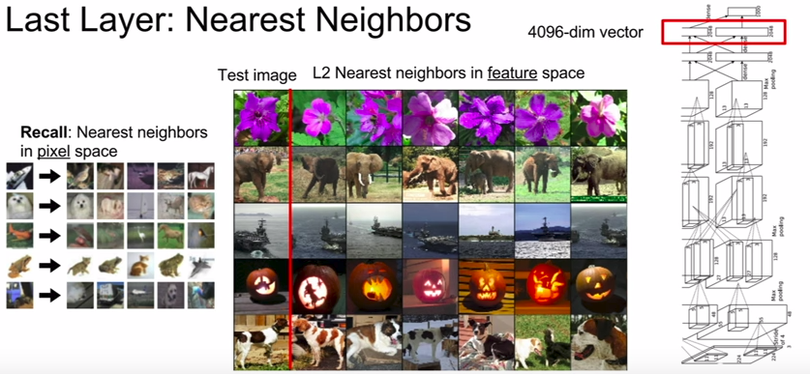
- one thing you might imagine is trying a nearest neighbor approach

- way back in the 2nd lecture we saw the graphic on the left where we were looking for nearest neighbors in pixel space between CIFAR-10 images. When you look at nearest neighbors in pixel space between CIFAR-10 images, you see that you get images that look similar to the query image (although they might not necessarily be the same objects)

- we can do the same type of visualization computing and visualizing these nearest neighbor images, but rather than computing the nearest neighbors in pixel space, instead we can compute nearest neighbors in that 4096 dimensional feature space which is computed by the convolutional network

- pixels are often different between the image and its nearest neighbors in feature space, however the semantic content of those images tends to be similar in this feature space.

B. Dimensionality Reduction

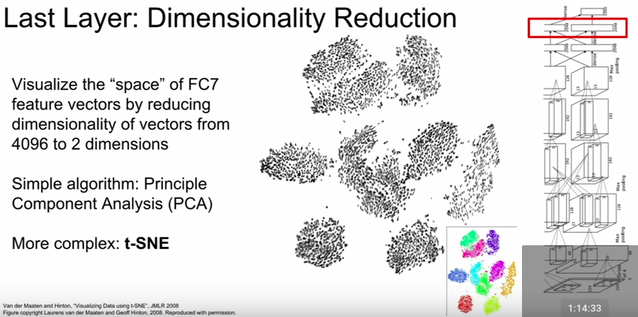

- t-SNE: t-distributed Stochastic Neighbor Embeddings which is a slightly more powerful method than PCA and is a non-linear dimensionality reduction method that people in deep learning often use for visualizing featues

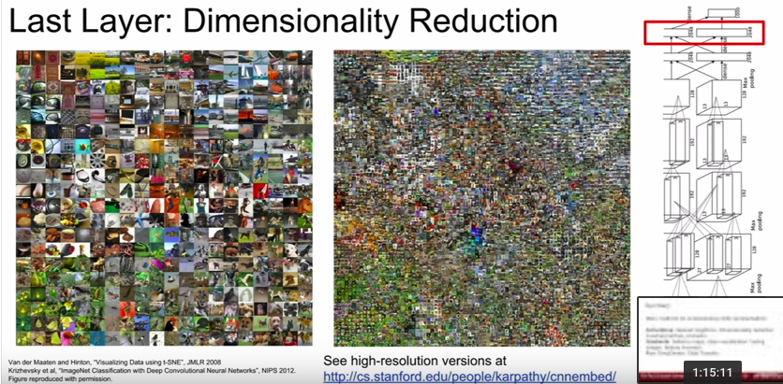

III. Visualizing intermediate layer

A. Visualizing Activations

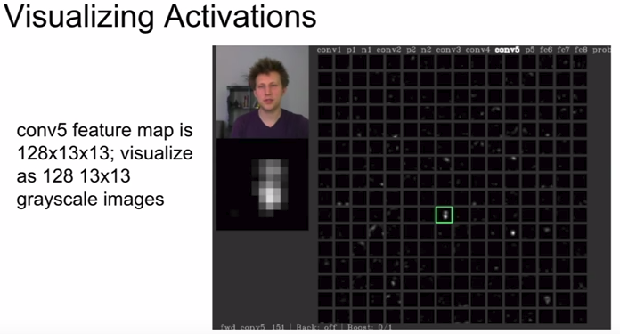
- the highlighted intermediate feature seems like it is activating on the portions of the feature map corresponding on the person’s face

- that portion of the feature maps may be looking for people’s faces

B. Maximally Activating Patches

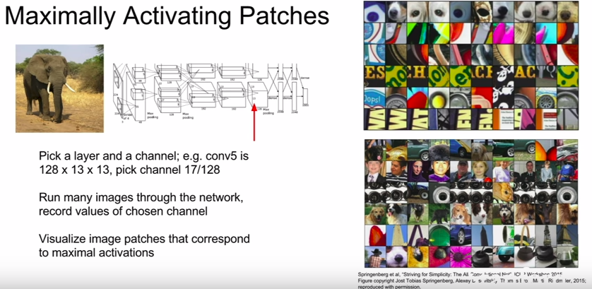

C. Occlusion Experiments

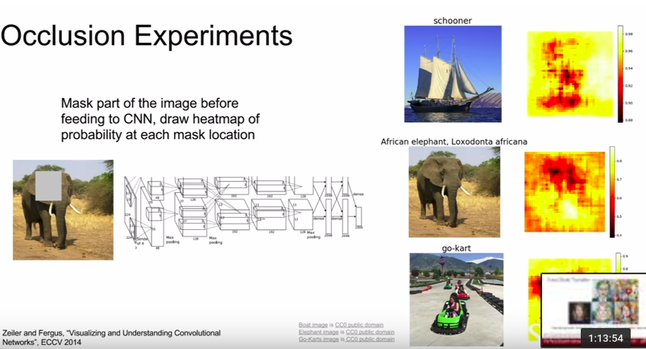
- figure out which part of the input images cause the network to make its classification decision

- take input image, block out some region in that image and replace it with a mean pixel value from the dataset, and then run that occluded image through the network. Then, record what is the predicted probability of this occluded image. Now, slide the secluded patch over every position in the input image and then repeat the same process

- finally, draw a heatmap showing what was the predicted probability output from the network as a function of which part of the image did we occlude

- the idea is that if we block out a certain part of the image and it causes the network score to change drastically, then maybe that part of the image was really important for the classification decision

D. Saliency Maps

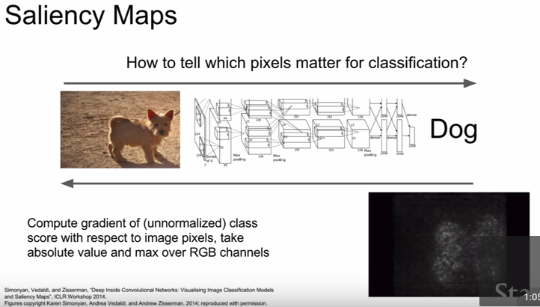
- compute the gradient of the predicted class score w.r.t. the pixels of the input image

- this will directly tell us in this sort of first order approximation sense, for each pixel in the input image, if we wiggle that pixel a little bit then how much will the classification score for the class change

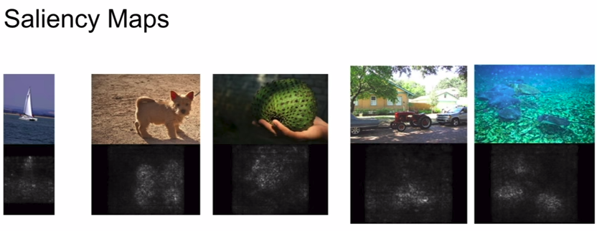
- do people use saliency maps for semantic segmentation? Yes! There’s this idea that maybe we can use saliency maps to perform semantic segmentation without any labeled data for these segments

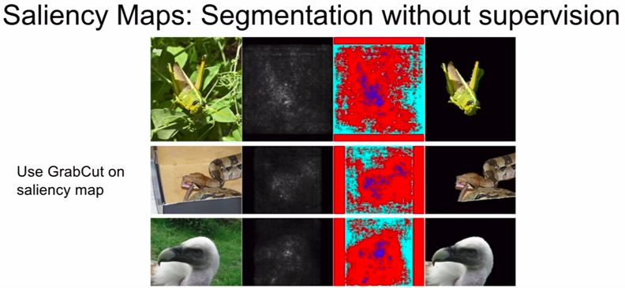
- however, this can be a little brittle and it will probably be much worse than a network that has access to supervision during training time

E. Guided Backprop

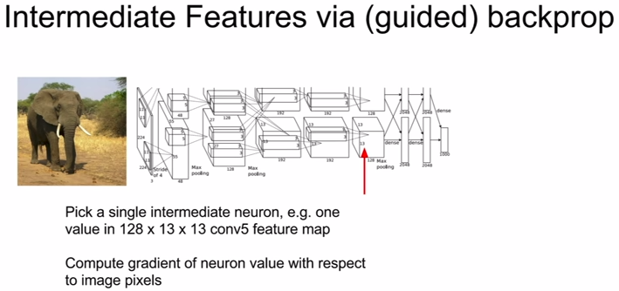
- rather than computing the gradient of the class scores w.r.t. the pixels of the image, you could compute the gradient of some intermediate value in the networks w.r.t. the pixels of the image

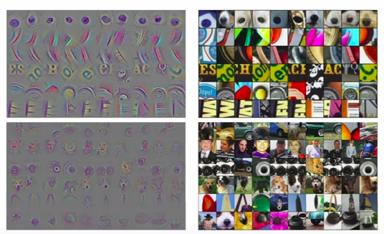
- saliency maps and guided backprops are always a function of an input image, but, if we remove this alliance with an input image and instead ask what type of input in general would cause this neuron to activate?

- we can figure this out using gradient ascent, which changes the pixels of some input image to cause this neuron value to be maximized

- in addition, we need a regularization term that prevents pixels of our generated image from overfitting to the peculiarities of that particular network

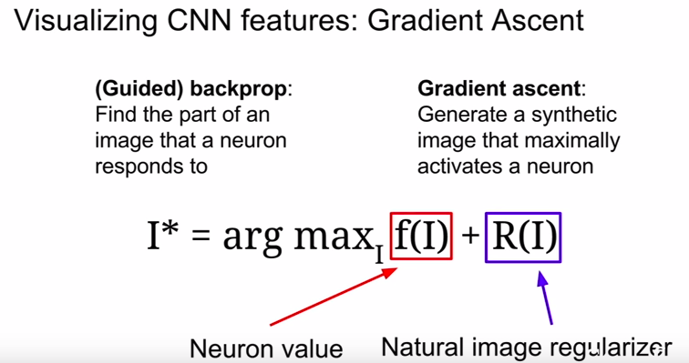

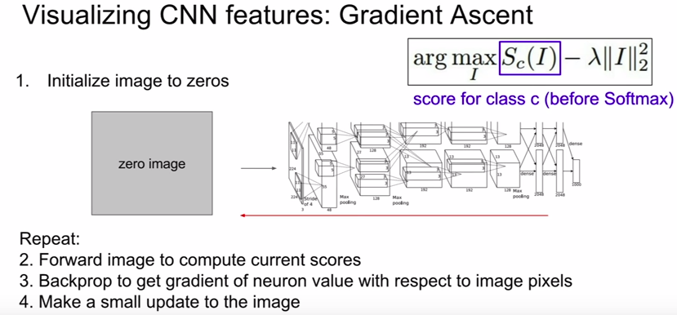

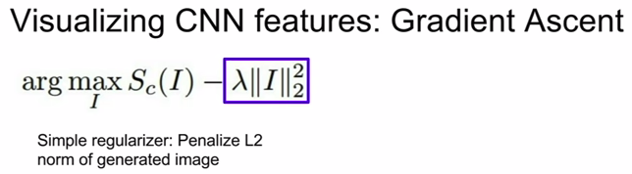

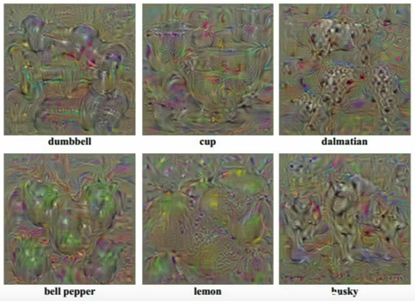

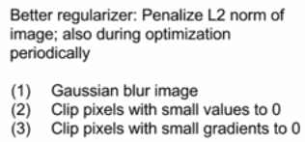

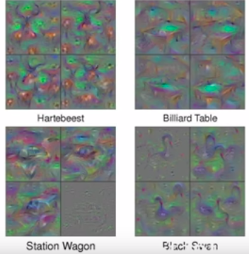

- with better regularizers, the visualizations becomes much better

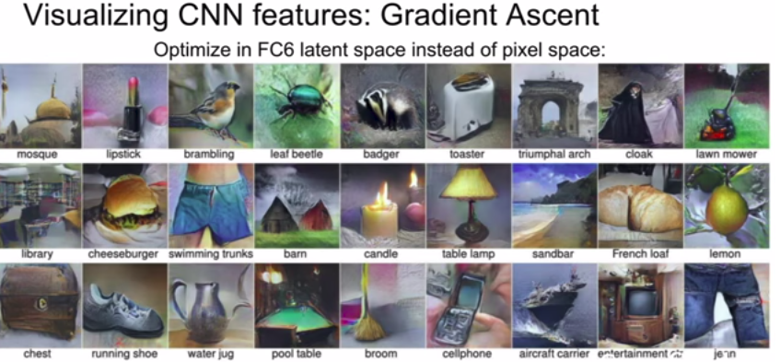

- with additional priors

F. Fooling Images/Adversarial Examples

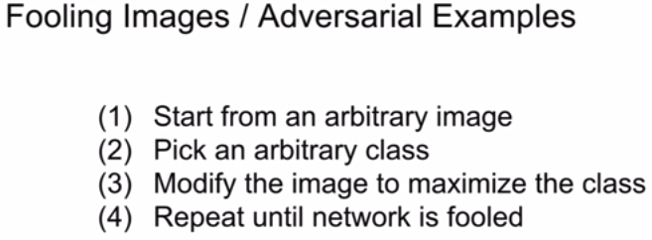
- pick a random image, maybe an elephant picture, and tell the network we want to maximize the score of koala bear instead

- so then what we’re doing is we’re trying to change that image of the elephant to instead cause the network to classify it as a koala bear

- you’d hope is that maybe that elephant would start morphing into koala bear and start sprouting cute ears, but that’s not what happens

- what you’ll find is that the image would still look like an elephant but it’s still classified as a koala bear
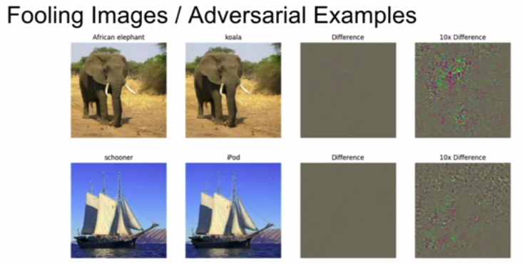
- What’s going on here? Ian Goodfellow will explain

IV. Others.

A. DeepDream
- almost entirely for fun

- generate cool images

- get some sense for what features these networks are looking for

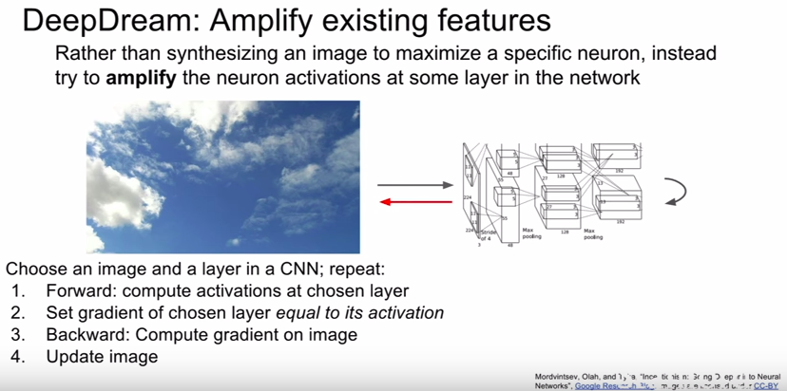
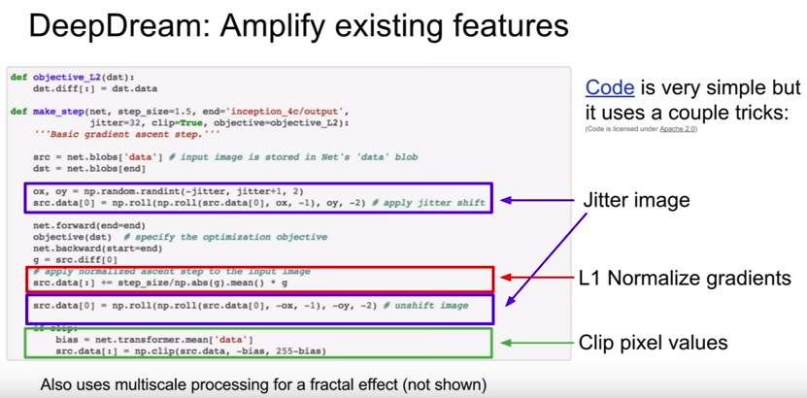

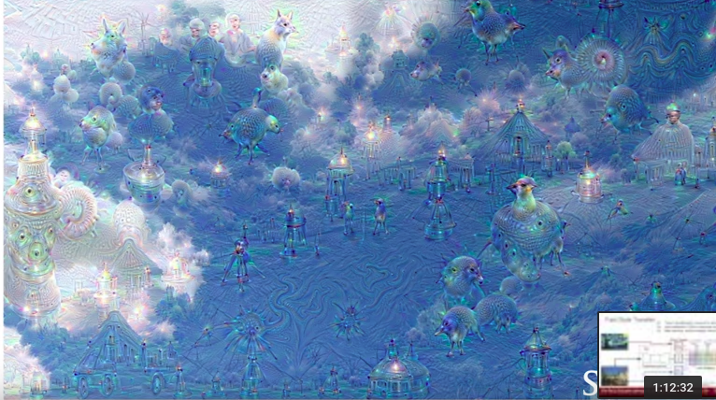
- the fact that dogs show up so much in these visualizations tells us a lot about the data on which this network was trained

- this was trained using ImageNet which has 200 dog categories

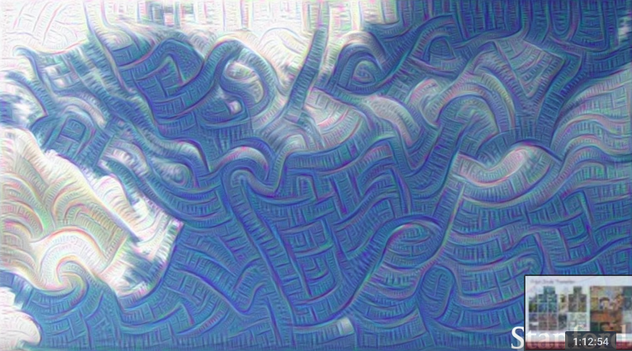
- this was trained on a lower layer, so we get a kind of sense that these layers look for edges etc.

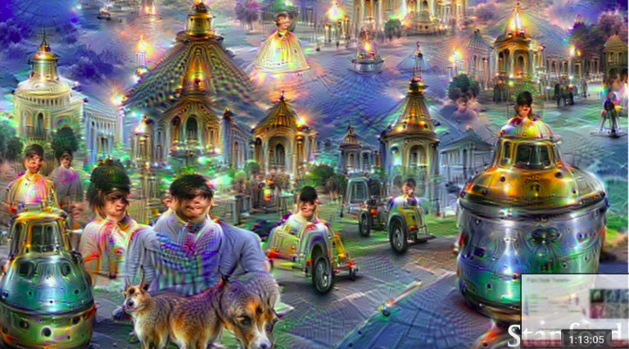
- multi-scale processing

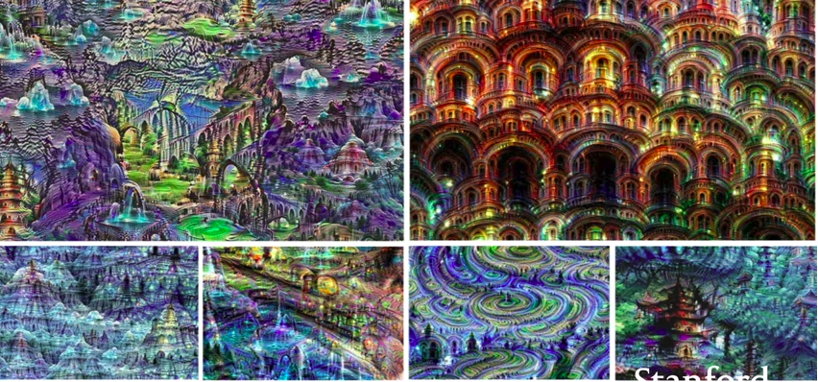

- MIT Places data set

B. Feature Inversion

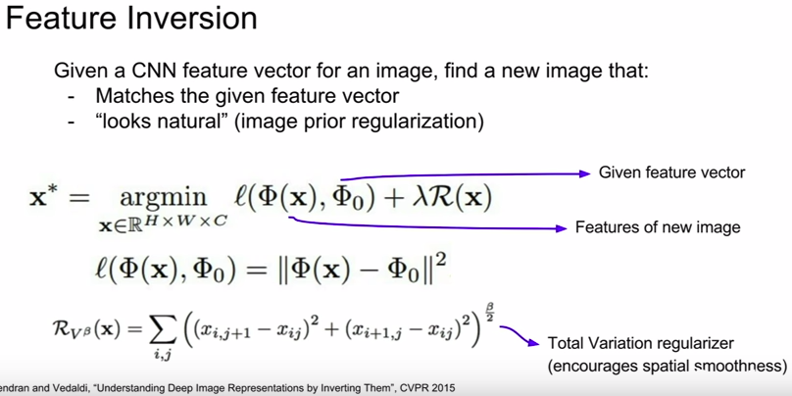
- reconstruct image from its feature representation

- depending on how the reconstructed image looks like, that will give us some sense for what type of info is captured on that feature vector

- we could do this again with gradient descent with some regularizer. But instead of maximizing some score, instead we want to minimize the distance between this cached feature vector and the computed features of our generated image

- another common regularizer you see here is the total variation regularizer that penalizes differences between adjacent pixels (left and right, top and bottom)

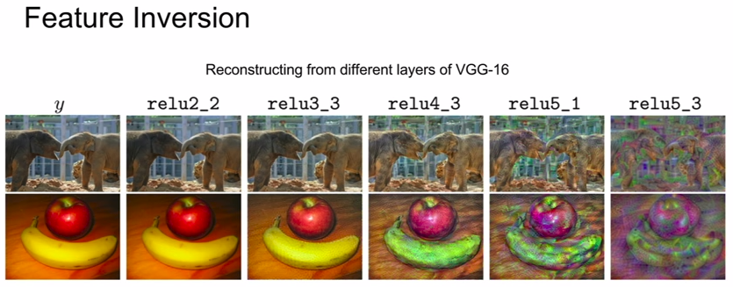
- in relu2_2 the image is almost perfectly reconstructed, we don’t throw away much pixel info

- as you get deeper, low-level detail information about what the pixel values are get thrown away

C. Texture Synthesis

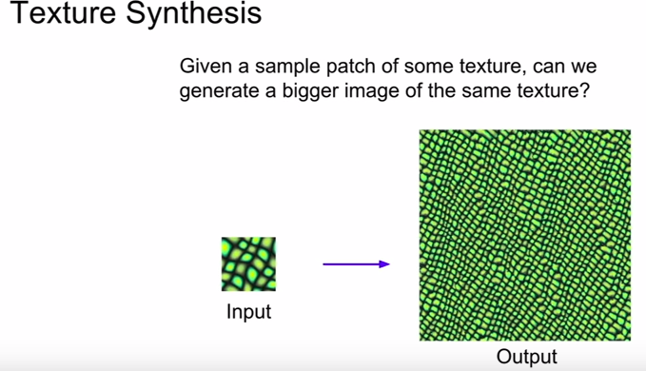
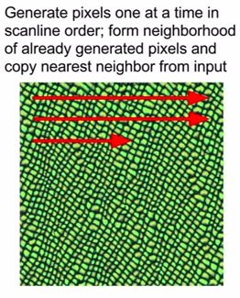

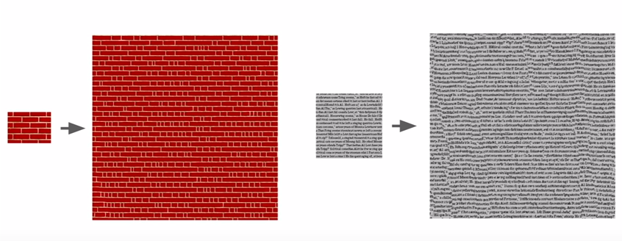

- pretty old problem in computer graphics

- a lot of classical algorithms for texture synthesis with no need for neural networks

- BUT, as we move to more complex textures, these kinds of simple methods of copying pixels from the input patch directly, tend not to work so well

- so in 2015, there was a really cool paper that tried to apply neural network features to this problem of texture synthesis


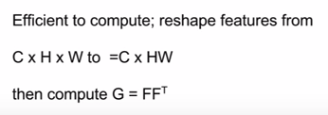
D. Neural Texture Synthesis

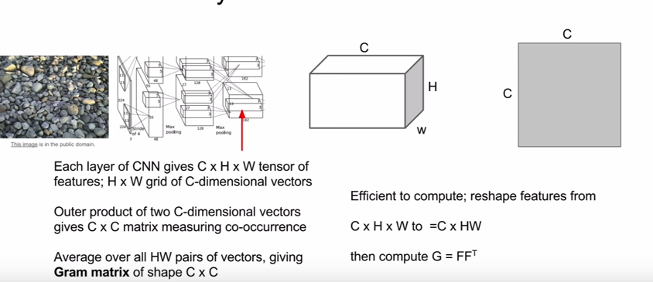

- take input texture and then pass it through some ConvNet and then pull out the convolutional features at some layer of the network

- this convolutional feature volume may be C x H x W at that layer of the networks

- we’re gonna use this activation map to compute a descriptor of the texture of this input image

- pick out two feature columns and each will be a C-dimensional vector

- take the outer product between these 2 vectors to give us a C x C matrix

- this matrix will now tell us something about the co-occurence of the different features at those 2 points in the image

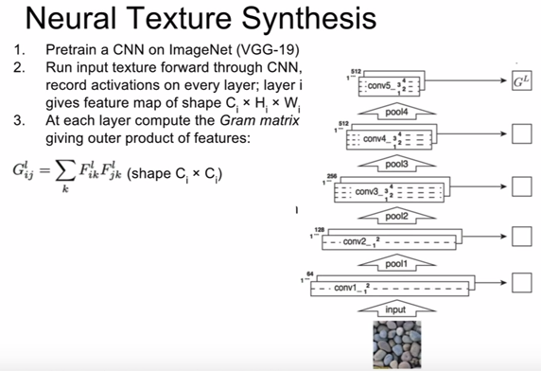
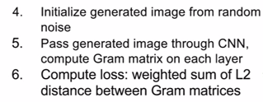
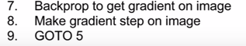

- kind of like gradient ascent

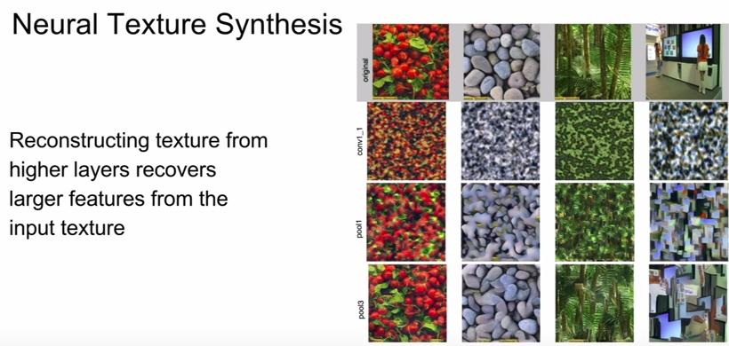

- better performance at deeper layers

- works very well although they’re quite different pixel-wise from the actual image

- then, they had a brilliant idea which is what if this texture synthesis approach to a piece of artwork? Set it equal to a piece of artwork instead of cranberries, rocks, etc.

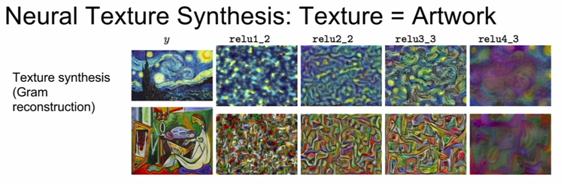
- something really interesting happens when you combine this idea of texture synthesis by gram matrix matching, with feature inversion by feature matching

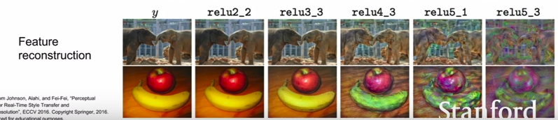
- we get this really cool algorithm called “style transfer”

E. Neural Style Transfer

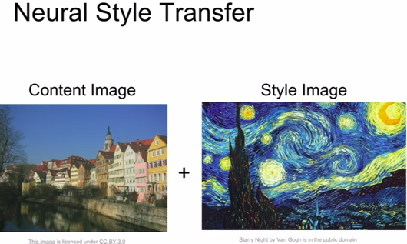

- take 2 images as input

- content image which will guide what we generally want out output to look like

- style image which is what style or texture we want our output to have

- generate a new image by minimizing the feature reconstruction loss of the content image, and the gram matrix reconstruction loss of the style image

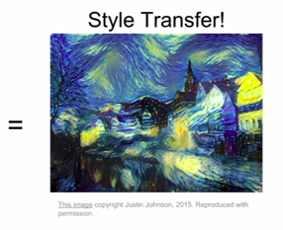

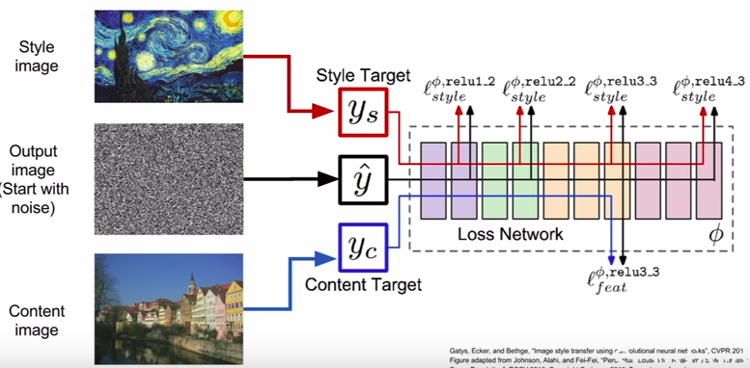

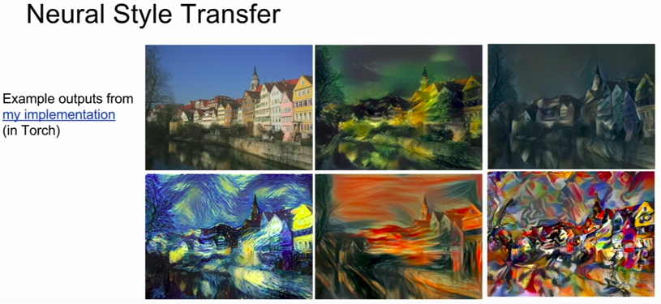

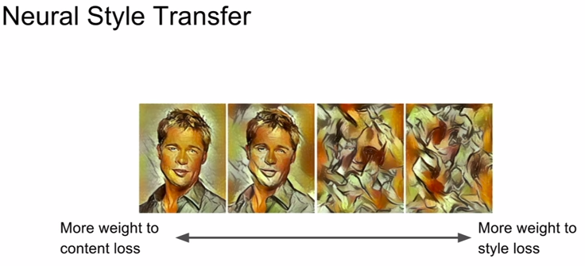
- also you could play around with the hyperparameters

- tradeoff between minimizing feature reconstruction loss of the content image, and the gram image reconstruction loss of the style image

- more control how much we wanna match our content vs how much we wanna match the style

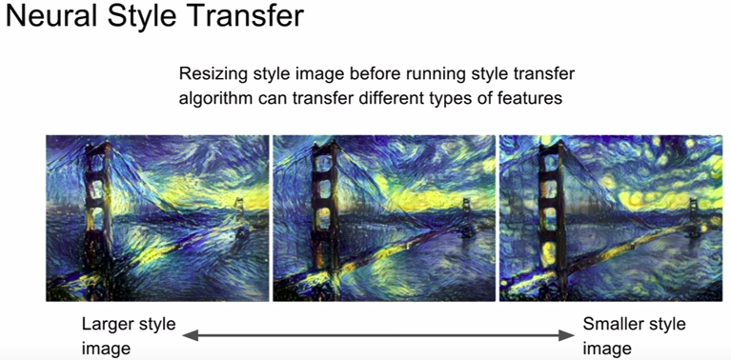

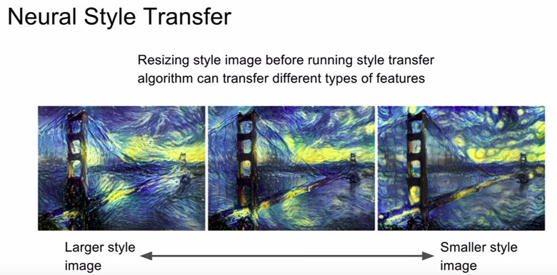

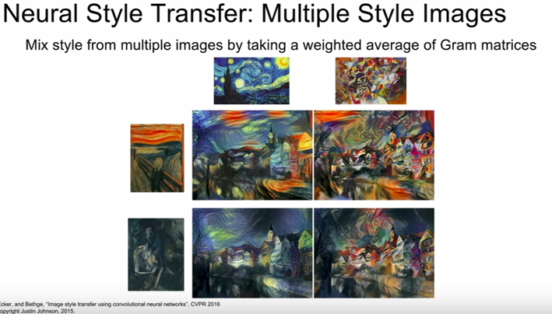
- we talked about this multi-scale processing for DeepDream and we saw how this can give you some really cool high-res results

- you can do a similar thing in style transfer as well

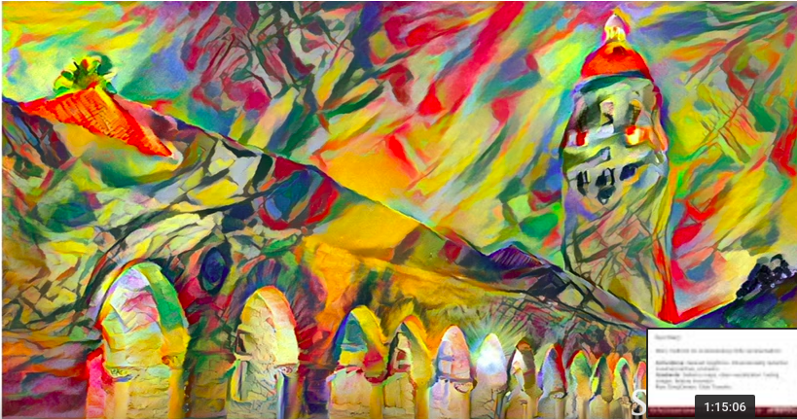

- high-res and took 4 GPUs to render

- you can also do joint style transfer and DeepDream at the same time. Now we’ll have 3 losses, the style, content, and DeepDream loss

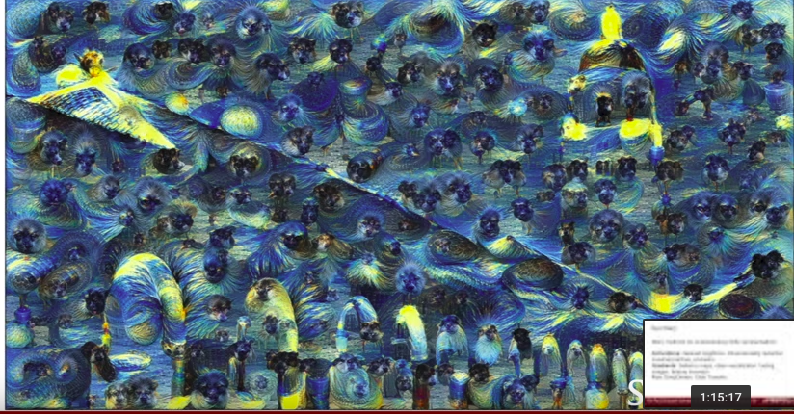

Problems: Style transfer requires many forward/backward passes through VGG; very slow!

Solution: Train another neural network to perform style transfer for us!



