Lecture 6: Training Neural Networks

A. Where we are now..

Mini-batch SGD

Loop:

1. Sample a batch of data
2. Forward prop it through the graph, get loss
3. Backprop to calculate the gradients
4. Update the parameters using the gradients

B. Overview

1. One time setup
activation functions, preprocessing, weight initialization, regularization, gradient checking

2. Training dynamics
babysitting the learning process, parameter updates, hyperparameter optimization

3. Evaluation
model ensemblers

C. Activation Functions

Sigmoid, ReLU, Leaky ReLu

1. Sigmoid Function

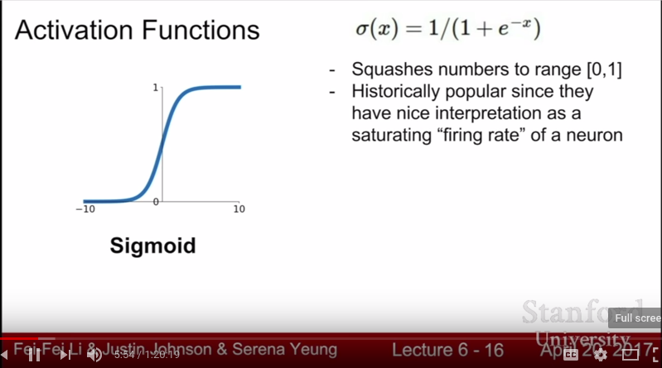

Problems:

a. Saturated neurons can “kill” the gradient
When x = -10 or x = 10 you get 0 slopee which “kills” the gradients

b. Sigmoid outputs are not zero-centered
What can we say about the gradients on w? Always all positive or all negative :(
(this is also why you want zero-mean data!)

c. exp() is a bit compute expensive

2. tanh(x)

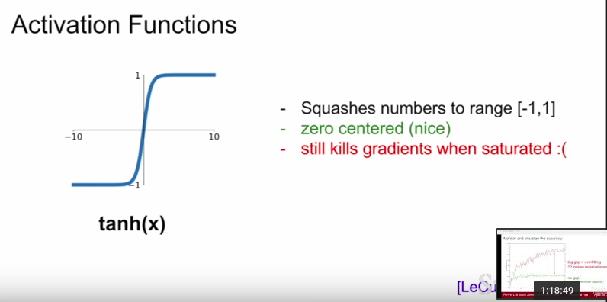

Problems:

a. still kills gradients when saturated :(

3. ReLU (Rectified Linear Unit)

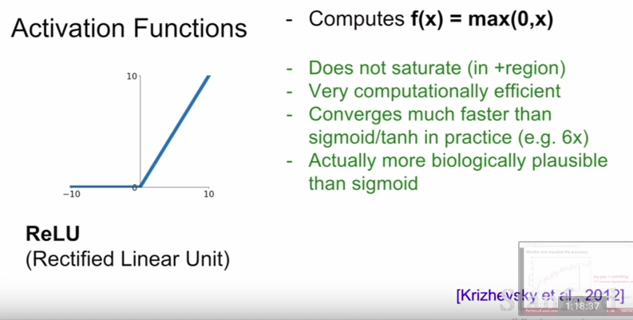

Problems:

a. Not zero-centered output
b. Killing the gradient in half of the function

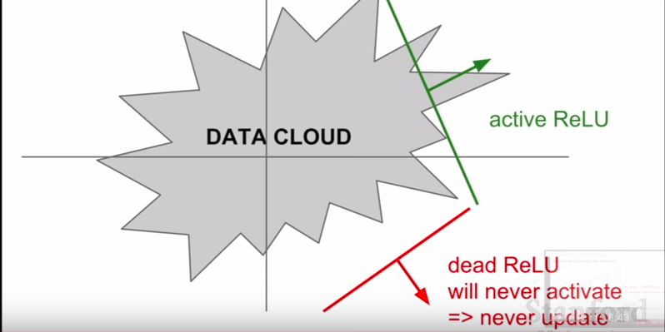
- dead ReLUs are caused by a not-ideal learning rate or weight initialization
- how can we tell if a ReLU will be dead or not?
- In practice, people like to initialize ReLU neurons with slightly positive biases (e.g. 0.01) to avoid dead ReLUs

4. Leaky ReLU

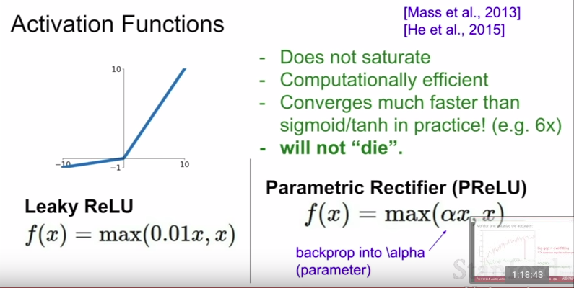

5. Exponential Linear Units (ELU)

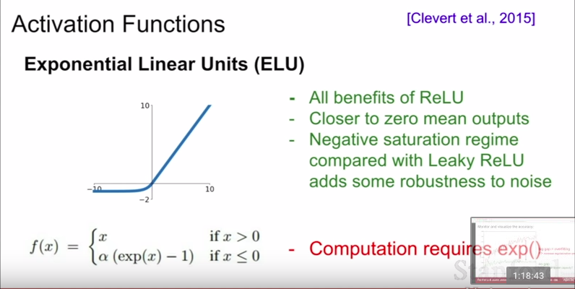

6. Maxout “Neuron”

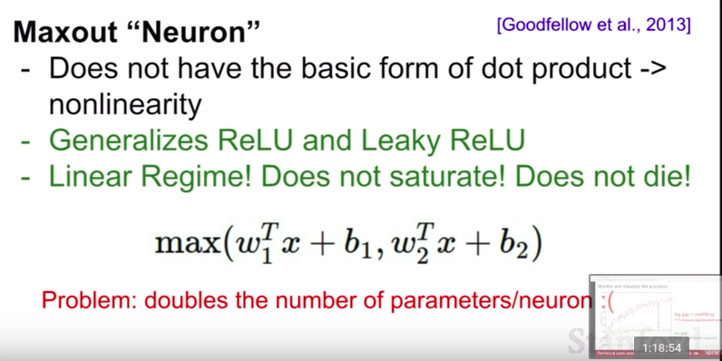

TLDR: In practice:

- Use ReLU. Be careful with your learning rates
- Try out Leaky ReLU/Maxout/ELU
- Try out tanh but don’t expect much
- Don’t use sigmoid

D. Data Preprocessing

- Generally, we always want to preprocess our data.
- Some standards are zero-meaning and normalizing input data
- Why do we want to do this?:

a. For zero-centering, our gradients can either be all-positive or all-negative
b. For Normalization, always want to normalize so each data point contribute similar levels. But this isn’t normally done on images because at each location you have relatively comparable scale and distribution.

- In practice, you may also see PCA and Whitening of the data
- Not common to normalize variance, to do PCA or whitening

TLDR: In practice for Images: center only

e.g. consider CIFAR-10 example with [32,32,3] images

- subtract the mean image (e.g. AlexNet)
(mean image = [32,32,3] array)

- subtract per-channel mean (e.g. VGGNet)
(mean along each channel = 3 numbers)

E. Weight Initialization

- What happens when W=0 init is used?

Answer: Every neuron will do the same thing and output the same things. This means they will also have the same gradients and they will update the same way. We dont want this cause the neurons will all be the same. We want the neurons to learn different things

- First idea: small random numbers (gaussian with zero mean and 1e-2 standard deviation)

W = 0.01 * np.random.randn(D,H)

Works ~okay for small networks but there will be problems on deeper network

e.g. 10-layer net with 500 neurons on each layer, using tanh non-linearities, and initializing as described in last slide

As these small numbers are multiplied, by the end all activations become zero
Q: think about the backward pass. What do the gradients look like?

Think about backward pass for a W*X gate. Gradients will be collapsing to 0 as well.

Q: if large numbers are used instead, will this solve the problem?

No, because output will be saturated and give a 0 gradient.

To solve this: we use Xavier Initialization

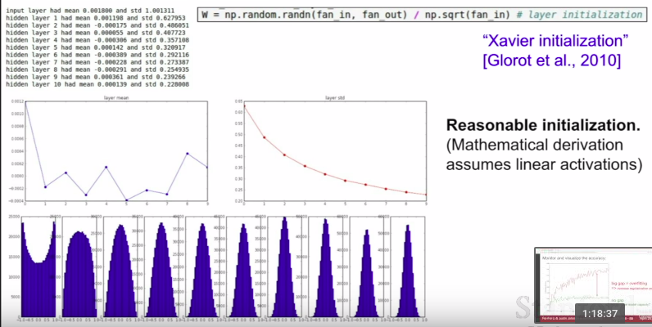
but when using the ReLU nonlinearity, it breaks.

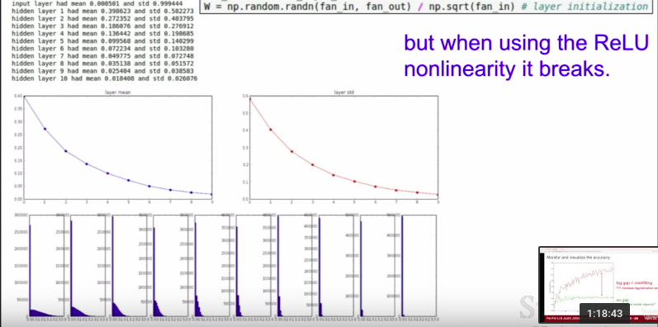
To solve this additional problem, we add a /2 because we are adjusting for the fact that half of the neurons get killed
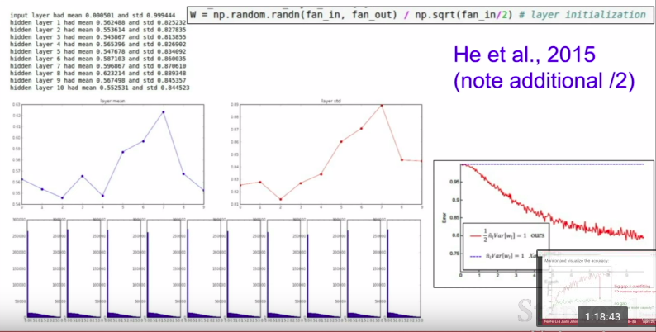
A good rule-of-thumb is to use the Xavier Initialization to start with,

F. Batch Normalization

- “you want unit gaussian activations? Just make them so.”

- consider a batch of activations at some layer. To make each dimension unit gaussian, apply:

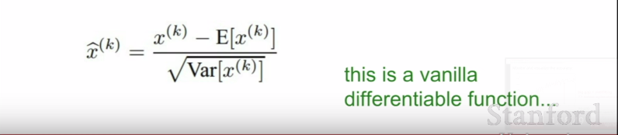
1. compute the empirical mean and variance independently for each dimension
2. normalize using the function above

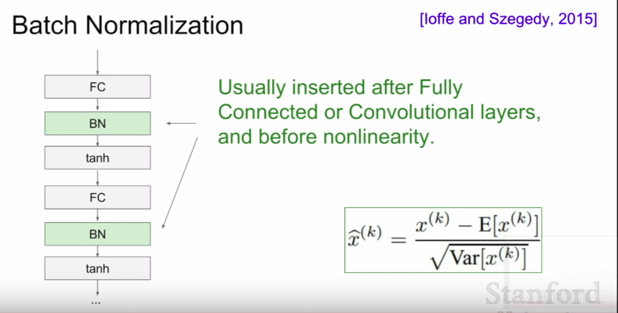
- Applying Batch Normalization layers are really important and useful

- Problem: do we necessarily want a unit gaussian input to a tanh layer?

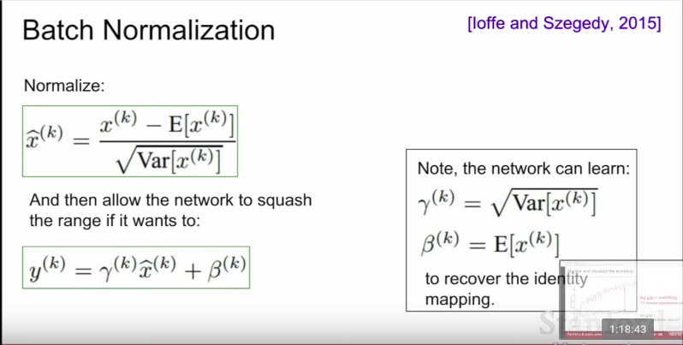

- To summarize:

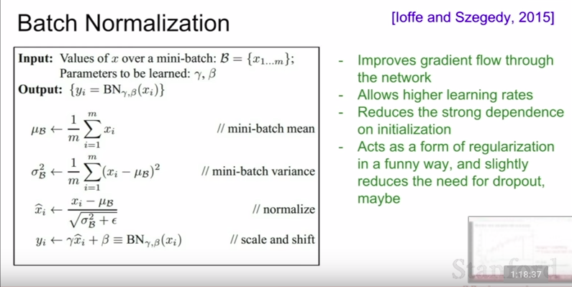
- this basically takes your data and turns it into a gaussian distribution

G. Babysitting the Learning Process

1. Preprocess the data
2. Choose the architecture
3. Double check that the loss is reasonable (sanity check, debugging technique)
a. First do this with disabled regularization
b. Then, crank up regularization and check if loss went up.
4. Do some sanity checks
a. start with a very small amount of data
b. take the first 20 examples from CIFAR-10
c. turn off regularization (reg = 0.0)
d. use simple vanilla ‘sgd’

Tip: Make sure that you can overfit very small portion of the training data
5. Let’s try to train now
a. Start with small regularization and find learning rate that makes the loss go down
tip: if loss is not going down: learning rate may be too low

Question: Notice train/val goes up to 20% though even when the loss was barely changing, what’s up with that? (remember this is softmax)

When we shift all of these probabilities in the right directions, now the accuracy can make a jump even though are loss stays the same.

tip: if cost gives you NaNs, it basically mean that your loss exploded and this is caused by a very high learning rate

Rough range for learning rate we should be cross-validating is somewhehre [1e-3 … 1e-5]

H. Hyperparameter Optimization

1. Cross-validation strategy

coarse → fine cross-validation in stages

First stage: only a few epochs to get rough idea of what params work
Second stage: longer running time, finer search (repeat as necessary)

Tip: for detecting explosions in the solver, if the cost is ever > 3 * original cost, break out early since it’s getting very big very quickly which is not right

Note: it’s better to optimize in log space

2. Hyperparameters to play with:

a. network architecture
b. learning rate, its decay schedule, update type
c. regularization

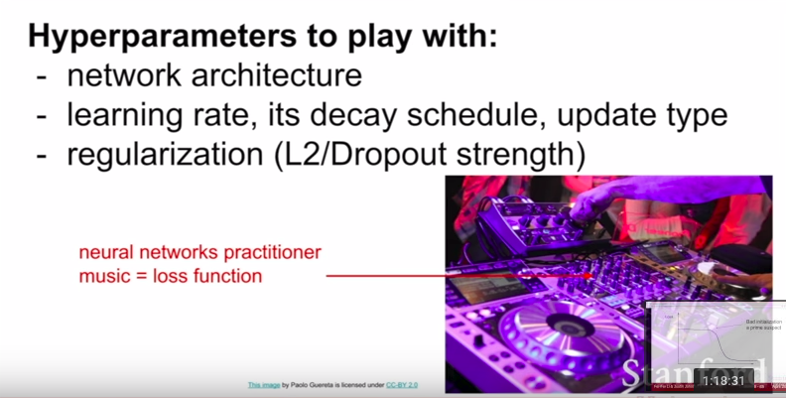
3. Cross-validation “command center”

- a lot of hyperparameter optimization in practice
- a lot of cross-validation

4. Monitor and visualize the loss curve

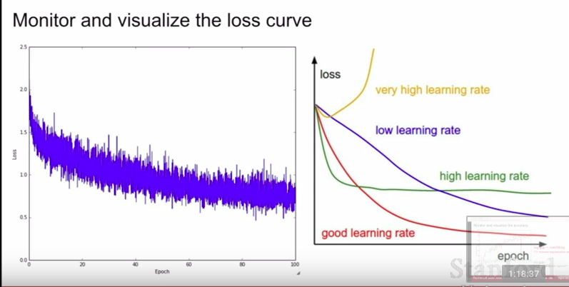
5. If you ever see loss curves that is flat for a while and then starts training all of a sudden:

a. bad initialization
b. big gap between training accuracy and validation accuracy is usually cause by overfitting
c. no gap, could potentially increase model capacity since you haven’t overfit yet

6. Track the ratio of weight updates/weight magnitudes

- ratio between the updates and values: ~0.0002 / 0.02 = 0.01
- want this to be somewhere around 0.001 or so

