Lecture 7: Training Neural Networks II

Additional Intuition:

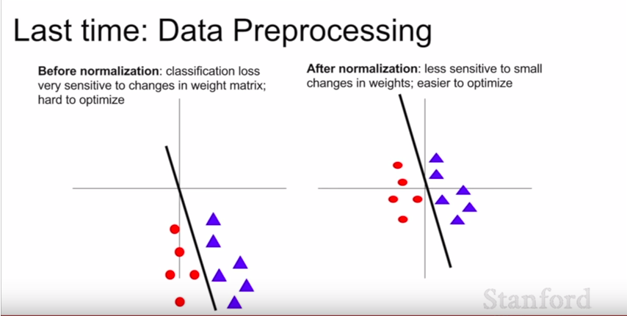

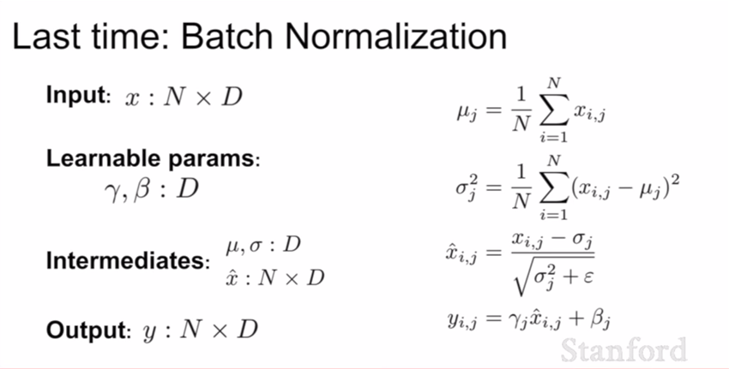
Tips:

1. Learning rate is the most important hyperparameter so you want to nail that one first

A. Problems with SGD

1. What if loss changes quickly in one direction and slowly in another? What does gradient descent do?

- Very slow progress along shallow dimension, jitter along steep direction.

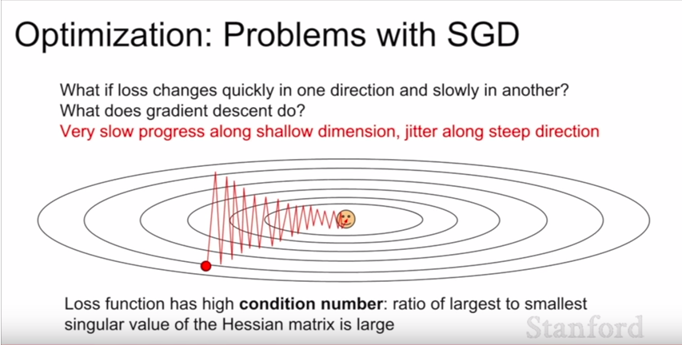

2. What if the loss function has a local minima or saddle point?

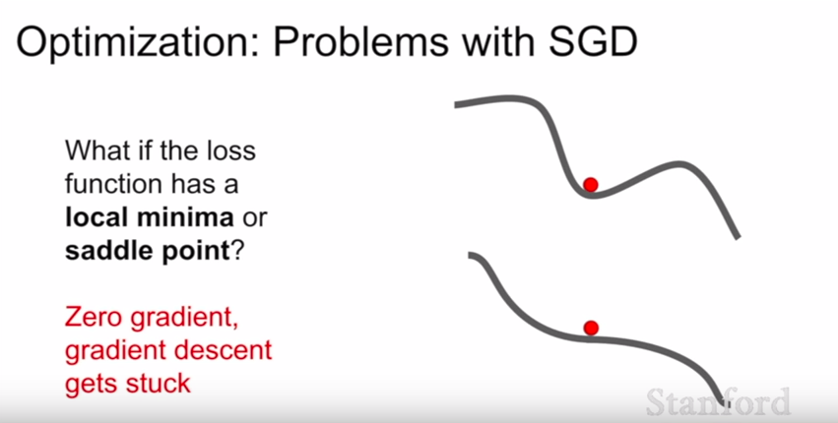

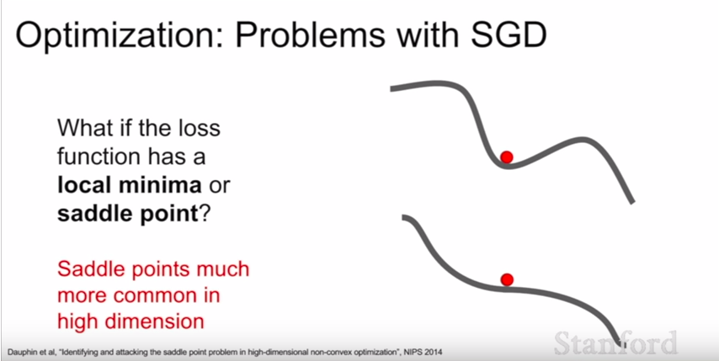
- problem more with saddle points rather than local minima

- btw, this also is a problem also near the saddle point. Regions around the saddle point have very low slopes

3. Our gradients come from minibatches so they can be noisy!

- vanilla SGD kind of meanders along the space and it will take a long time to reach the global minimum

B. Solutions to SGD problems

1. SGD + Momentum

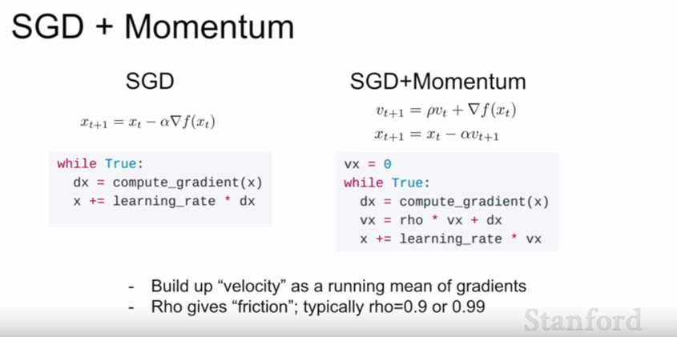
- we step in the direction of the velocity instead of the gradient
- we use Rho to decay our current velocity
- intuition is that when we plateau, we have collected this velocity going downhill and we can burst through the local minima or saddle point
- with velocity, just set initialize it to 0 all the time. “not even a hyperparameter, don’t worry”

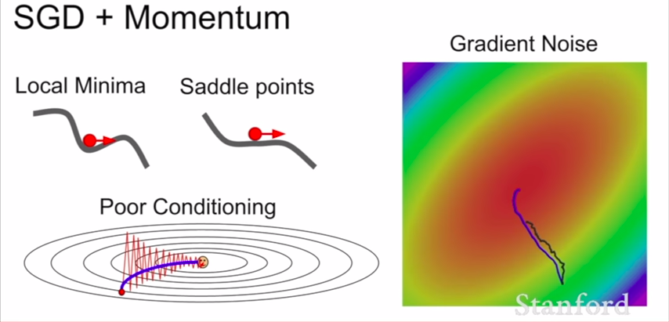
(black line is the vanilla SGD, blue line is SGD + momentum)

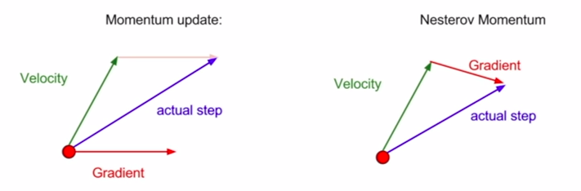
- with Nesterov Momentum, you’re kind of mixing information a little bit more

2. Nesterov Momentum

This Nesterov formulation is a little bit annoying, usually we want to evaluate our loss and gradient at the same point:

- We can solve this with a slight change of variables

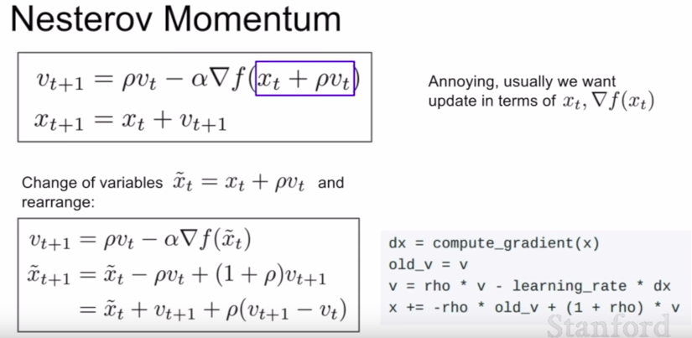

3. Ada Grad

- Keeps a running sum of all the squared gradients that you see during training
- when we update our parameter vector, we divide by this squared term
- we tend not to use AdaGrad for neural network problems

Q1: What does this do?

A: If we have two coordinates with a high and small gradient, so if we divide by the sum of the squared gradients with the small gradient, then we accelerate the speed along the slow dimension. Then, we divide by the sum of the squared gradients with the high gradient and we slow down the our progress along the wiggling dimension..

Q2: What happens to the step size over long time?

A: So the steps get smaller and smaller because we just continue updating our squared gradient estimates overtime which makes them bigger.

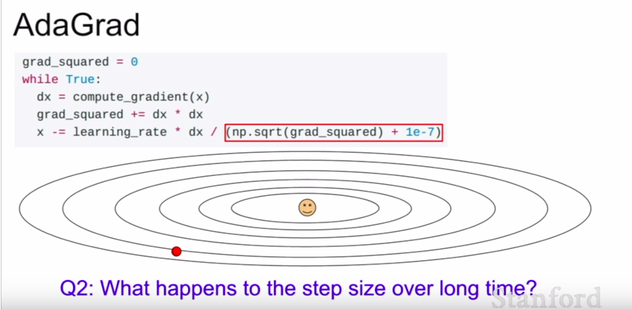

4. RMSProp

- Slight variation of AdaGrad
- we let that squared estimate decay so it doesn’t become oversized
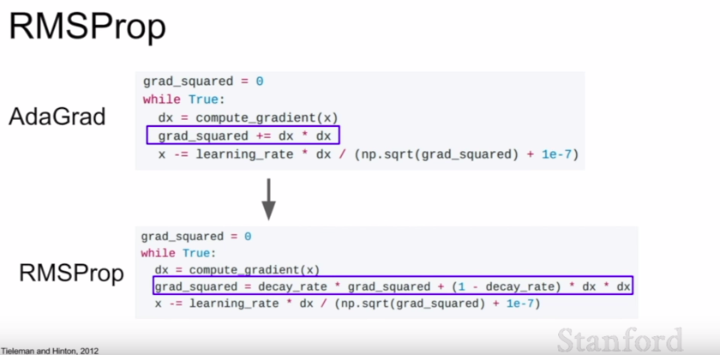

5. Adam

- sort of like a combination of the properties of momentum and AdaGrad/RMSProp
- we maintain an estimate of the first moment and the second moment
- Adam is really good and is a good place to start

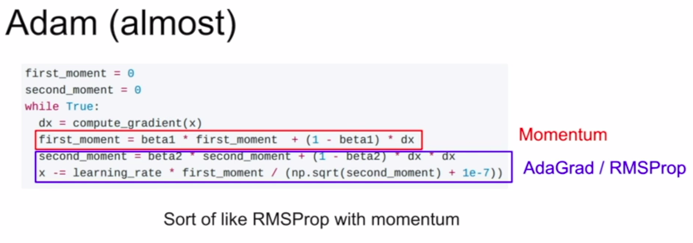
Q: What happens at first timestep?
A: At the beginning second_moment is 0, after one update of second moment, typically beta2 is something very close to 1. So after 1 update, our second moment is still very close to 0. So at update when you divide by the second_moment, we take a very big step.

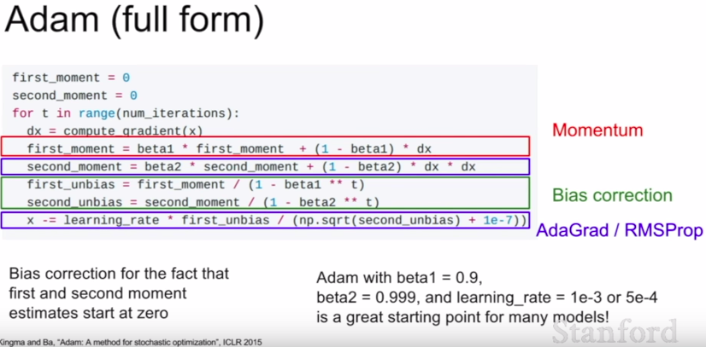

C. Learning Rate

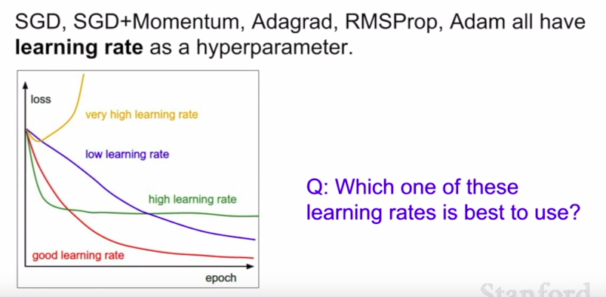
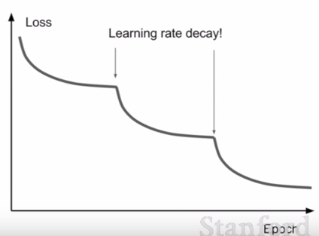
- this is kind of a trick question because you don’t actually have to stick to one learning rate for the whole training process
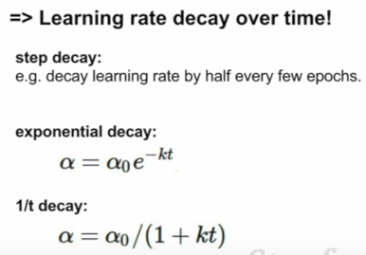

- more critical with SGD + Momentum, less common with Adam
- learning rate decay is kind of a second-order hyperparameter, you typically should not optimize this at the start. Just pick a good learning rate with no decay at the start. Try with no decay, see what happens and then kind of eyeball the loss curve and see where you’ll need decay

D. Second-order Optimization

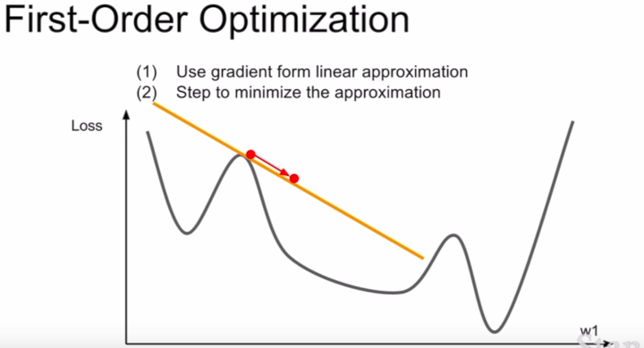
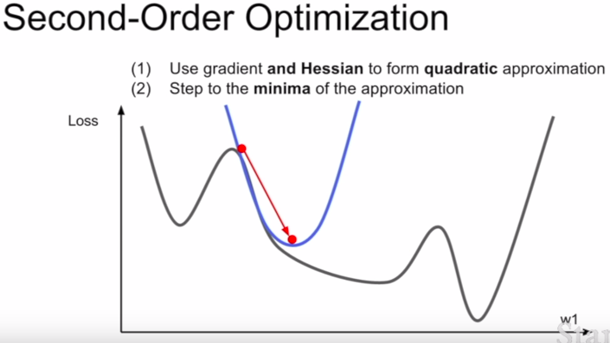

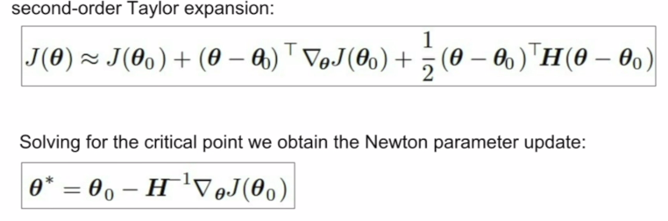
Q1: What is nice about this update?
A: It doesn’t have a learning rate cause we always step into the minimum

Q2: Why is this bad for deep learning?
A: Hessian has O(n^2) elements. Inverting takes O(n^3)
N = (Tens or Hundreds of) Millions

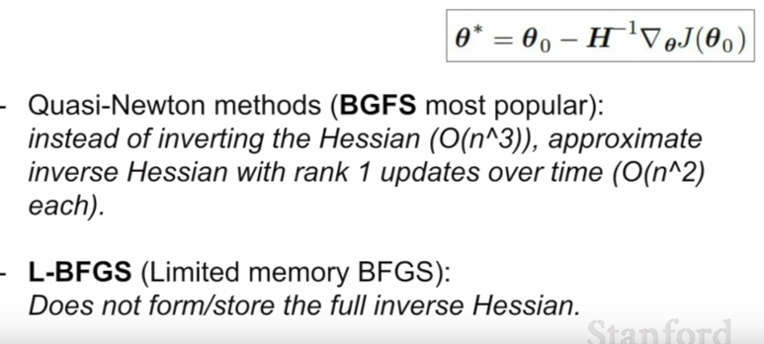
To solve this:

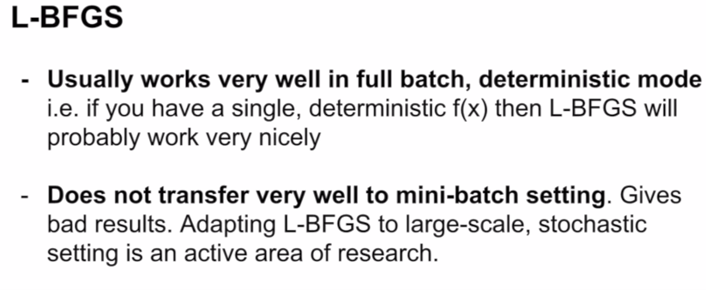
E. In practice

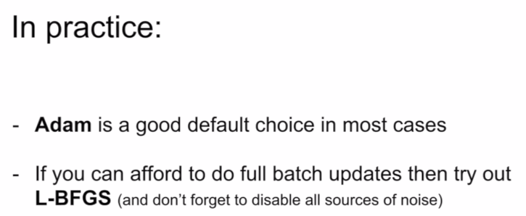

F. Beyond Training Error

- Better optimization algorithms help reduce training loss
- But we really care about error on new data – how to reduce the gap between training and validation?

1. Model Ensembles
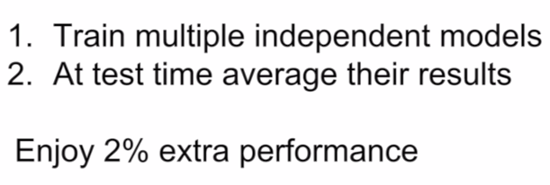

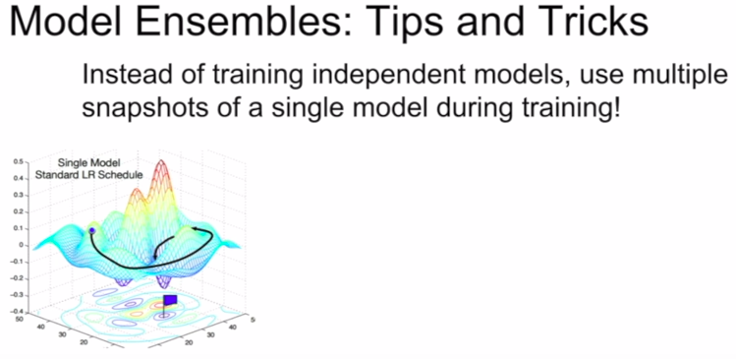

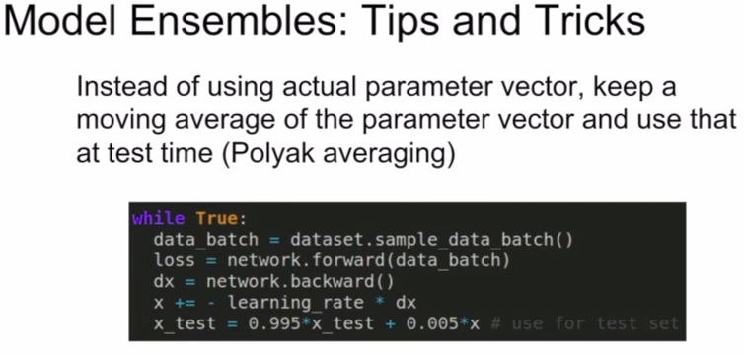
2. How to improve single-model performance? Regularization

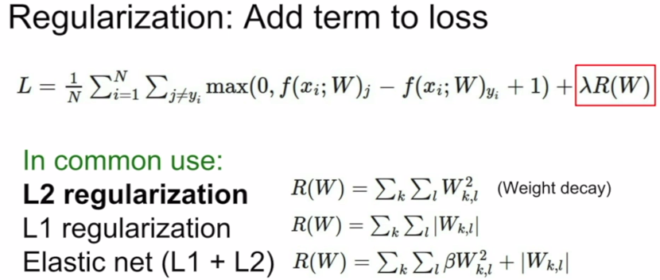
(L2 regularization does not make much sense for neural networks)

a. Dropout

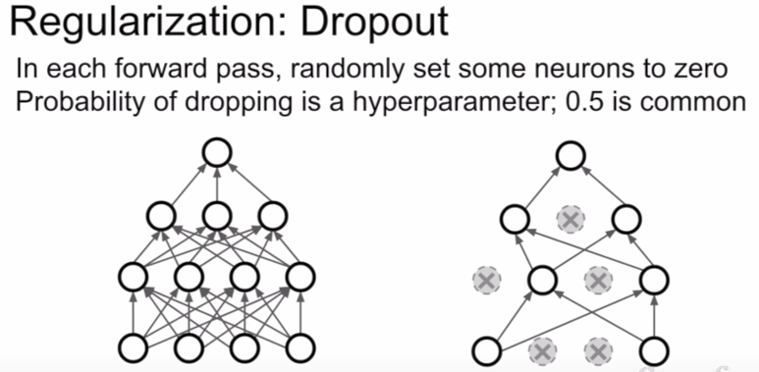

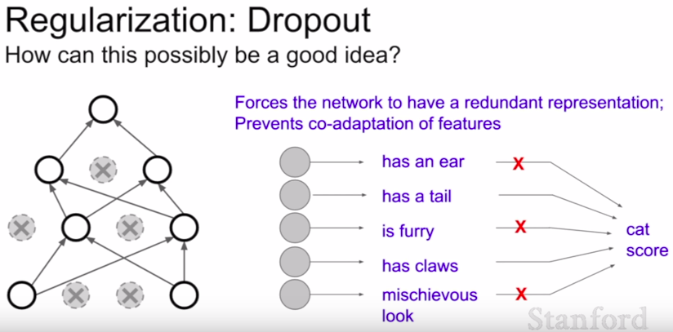

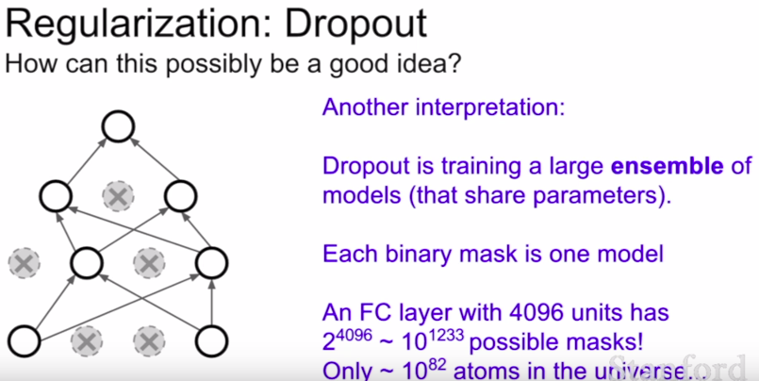
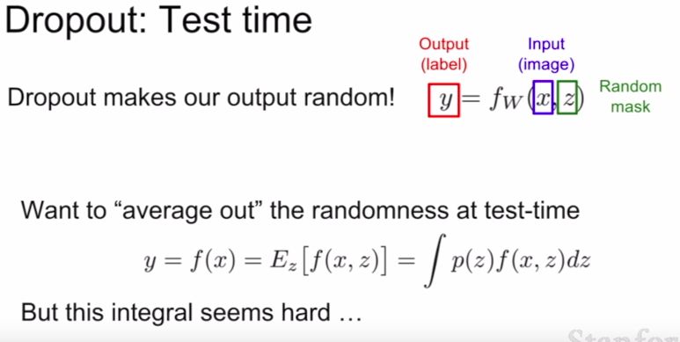

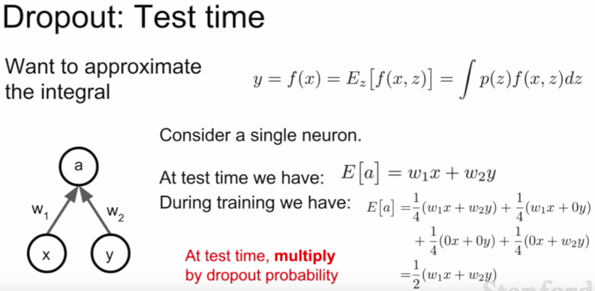

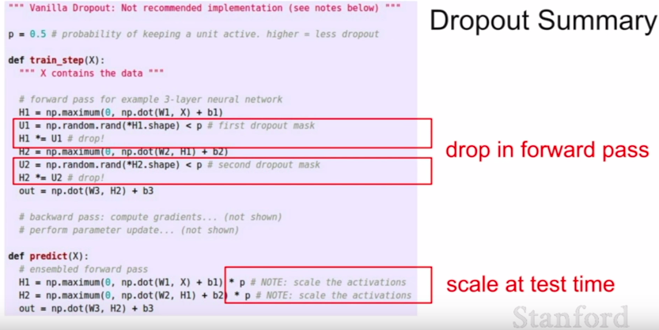

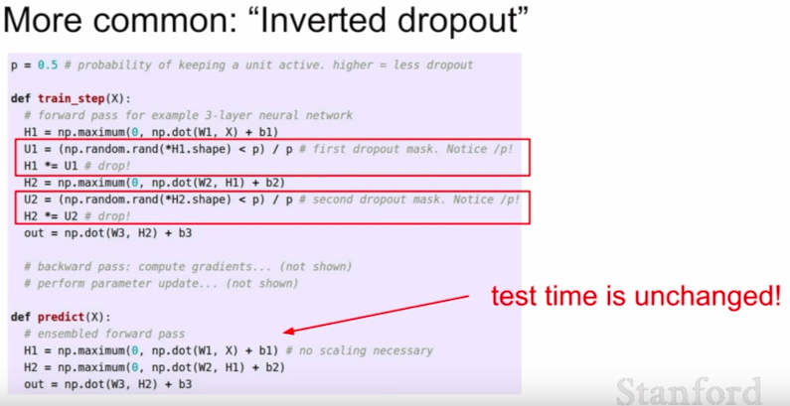
- with inverted dropout, you replace the multiplication by the probability to improve test time

3. A common pattern in regularization is the following:

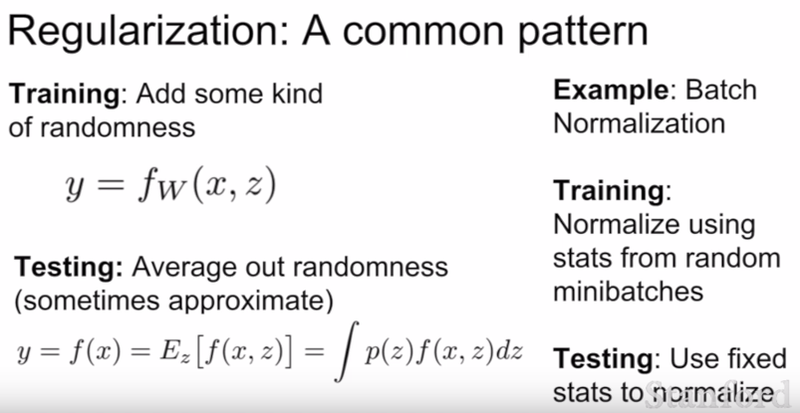
An example of a method that does this is Dropout, Batch Normalization, etc.

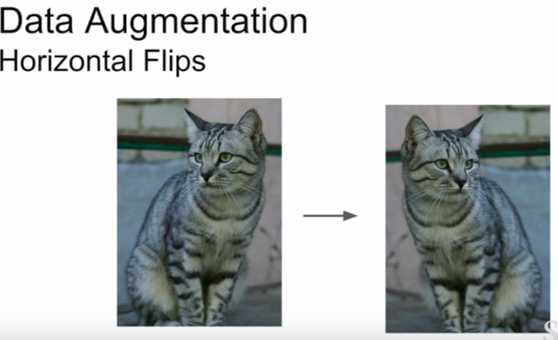

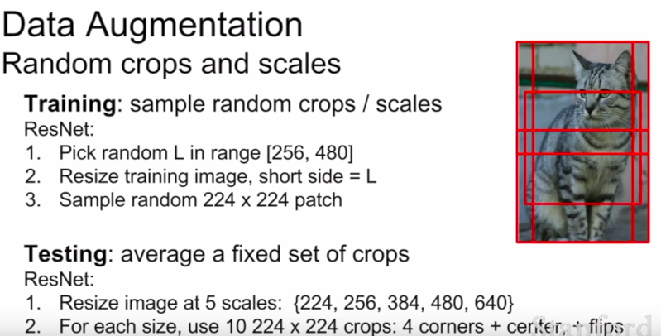

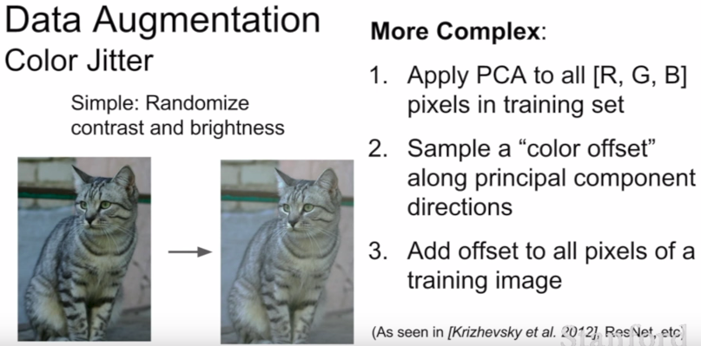

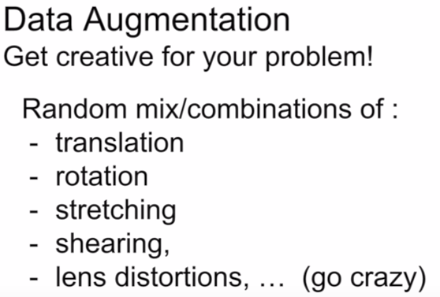

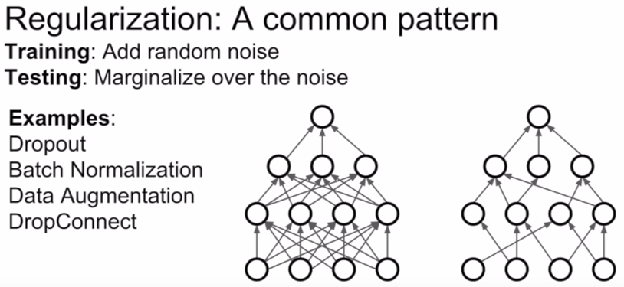
- In many cases, batch normalization is enough
- but if you see your network is still overfittiing you could add in dropout, data augmentation, etc.

G. Transfer Learning



