Lecture 8: Deep Learning Software

I. CPU vs GPU

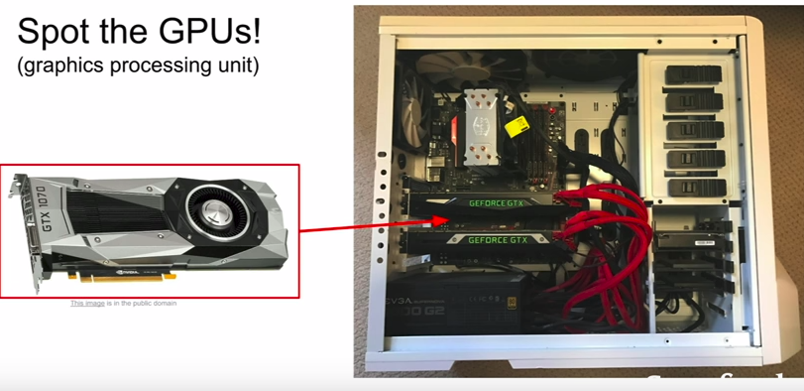
- GPUs created for image rendering
- NVIDIA vs AMD
- in Deep Learning, NVIDIA is preferred since they have come up with solutions in tailoring their hardware for deep learning

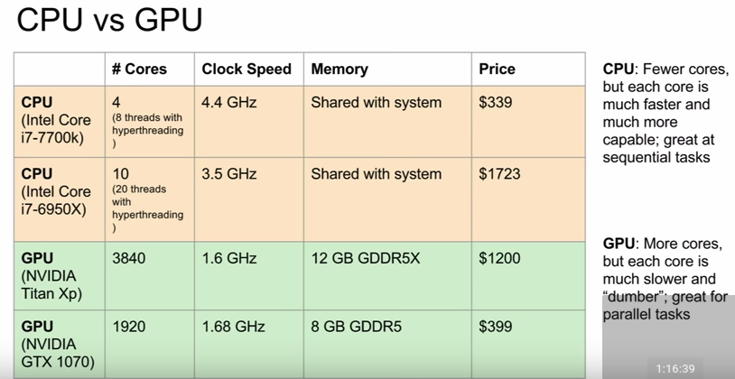
- CPUs may have cache but it’s relatively small
- GPUs have their own RAM built into the chip
- GPUs also have their own caching system
- CPUs are good for general-purpose processing
- GPUs are specialized for these parallel processes (e.g. Matrix Multiplication)

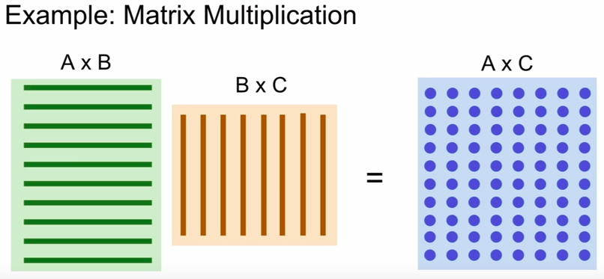
- With Matrix Multiplication, each dot under AxC is a dot product of a row in AxB and a column in BxC

- With a GPU you can compute these dot products in parallel really quickly, as opposed to a CPU that will have to compute sequentially

II. Programming GPUs

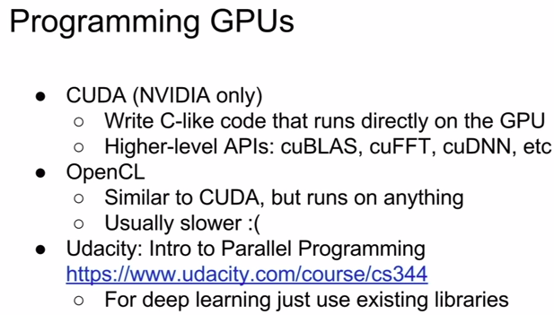

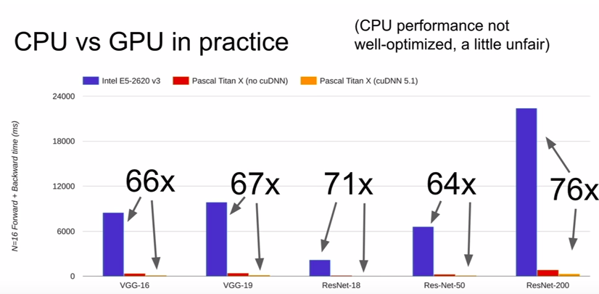

(Deep learning benchmarks can easily become unfair)

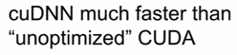

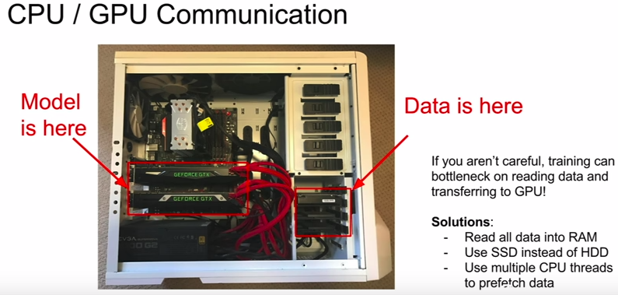

- biggest software solution is to setup pre-fetching on the CPU instead of a very slow sequential process (amateur mistake)

II. Deep Learning Frameworks

A. Introduction

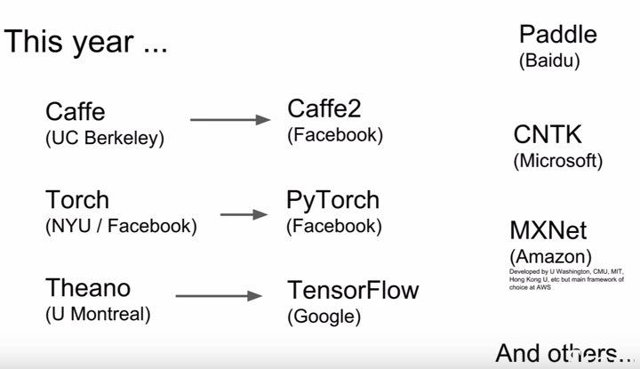
- first generation of frameworks were developed by academia
- next generations was developed by industry

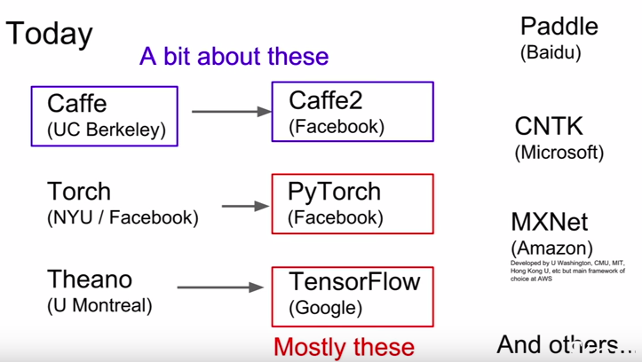

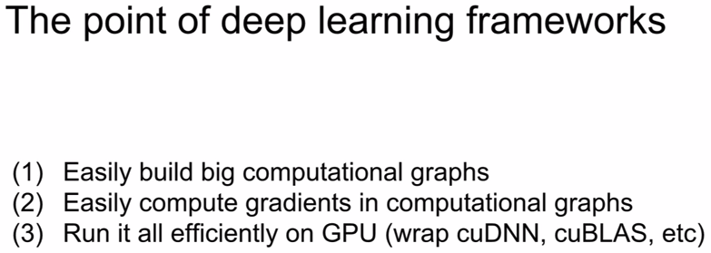

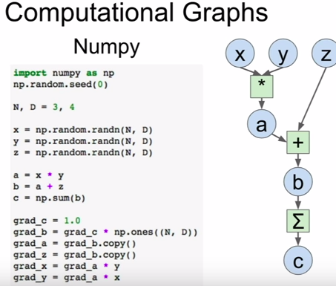

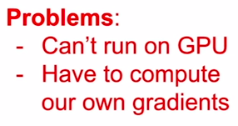

numpy problems :(

- the goal of most DL frameworks these days is let you write code in the forward pass similar to numpy but lets you run it on the GPU and computes the gradients for you

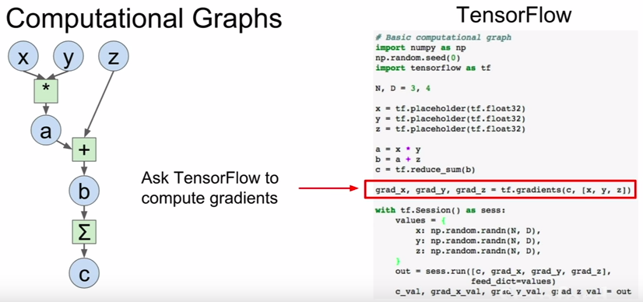
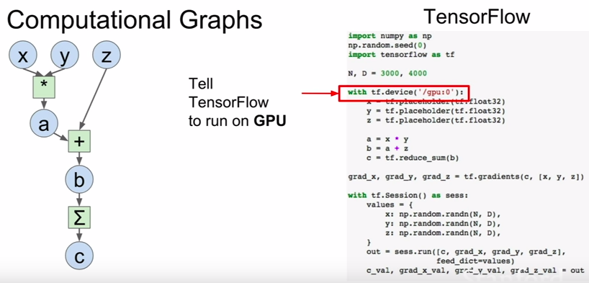
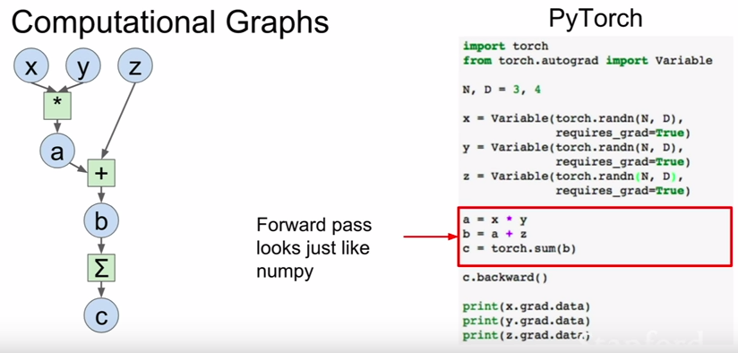
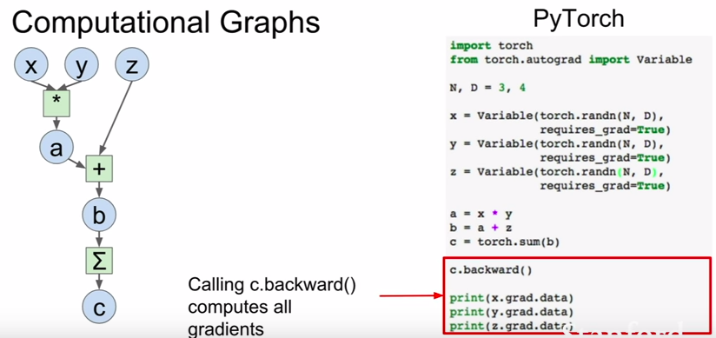
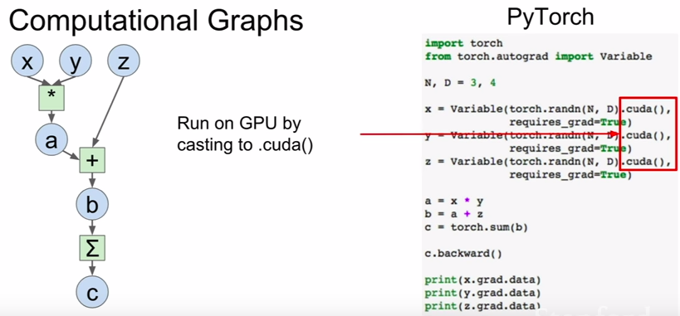

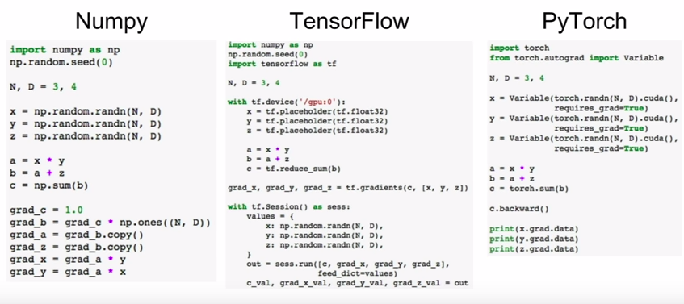

A. TensorFlow

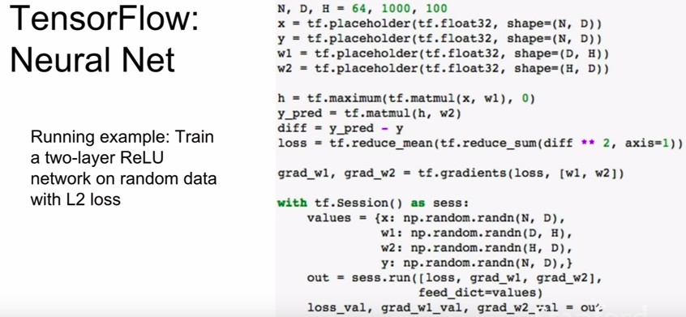
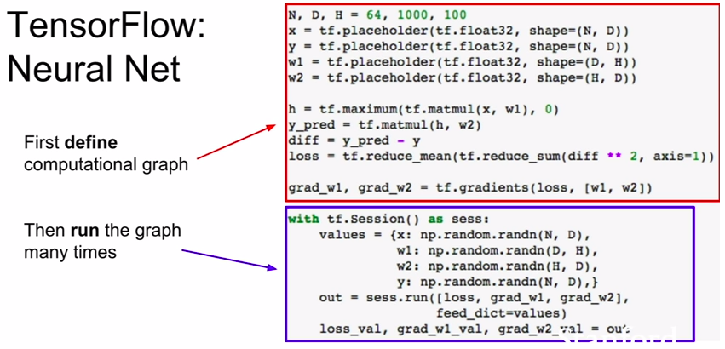
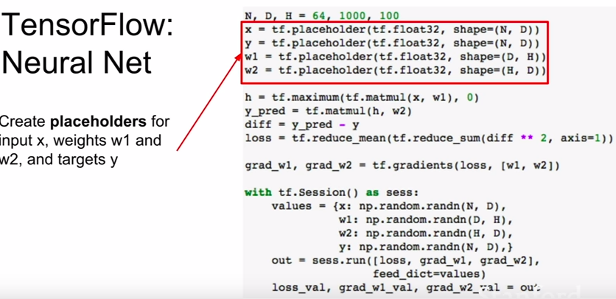

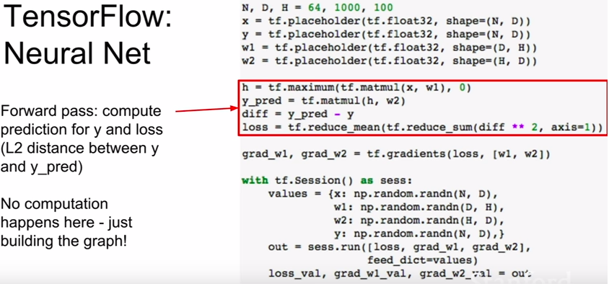
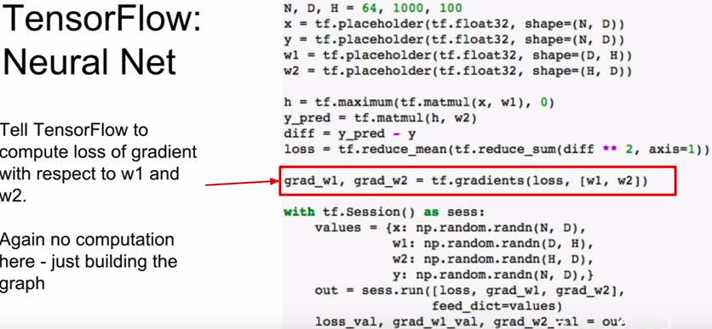

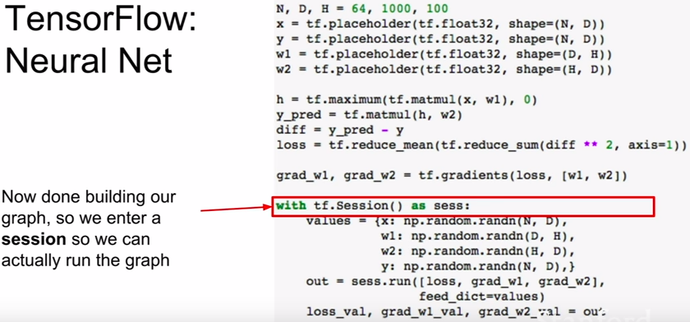

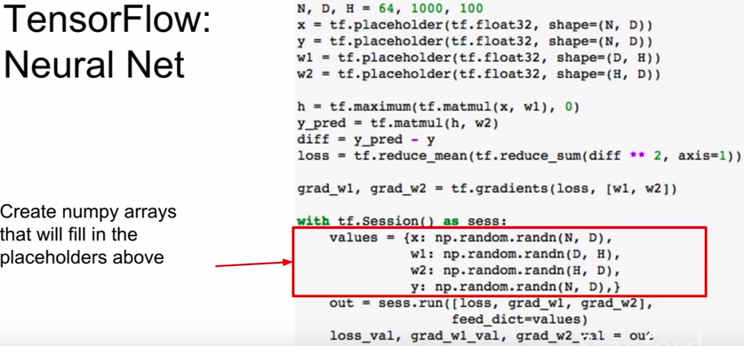

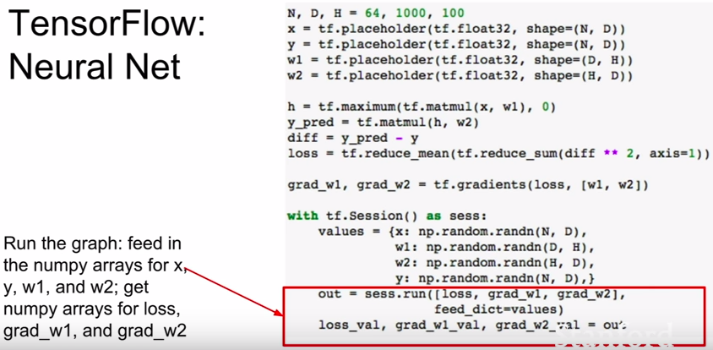

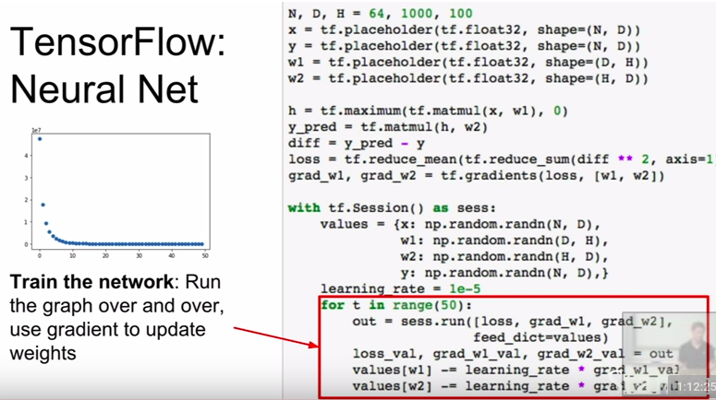

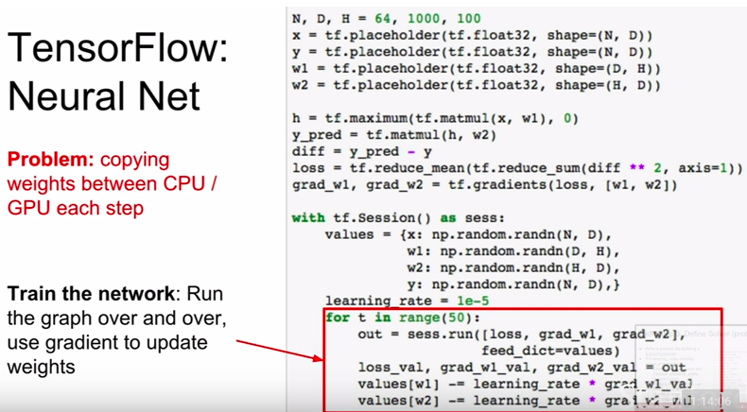
- super expensive and super slow because copying data from numpy to tensorFlow vice versa

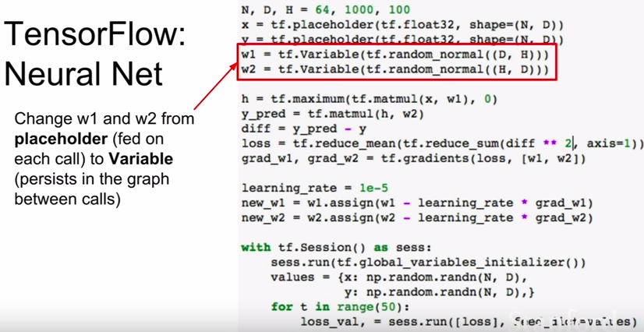
- but now since these Variables now live inside the graph, we also need to tell TensorFlow how they should initialized (cause before we initialized them in numpy outside the graph and fed into the graph)

- so we pass in a tf.random_normal expression

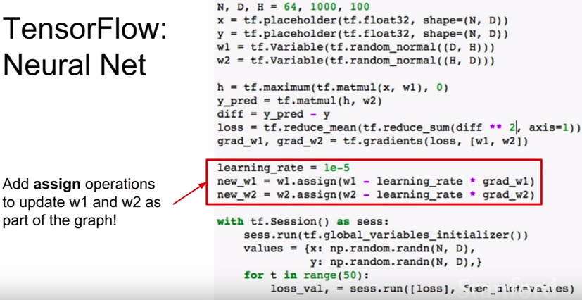
- updating the weights also needs to be done inside the computational graph

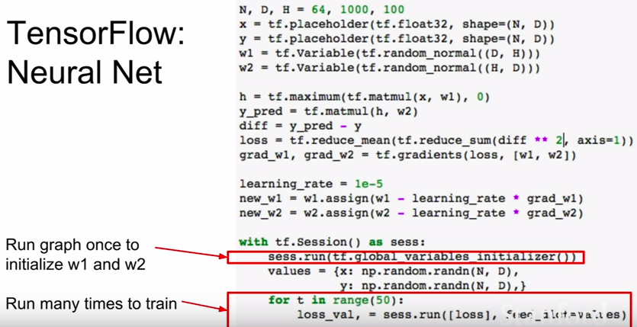
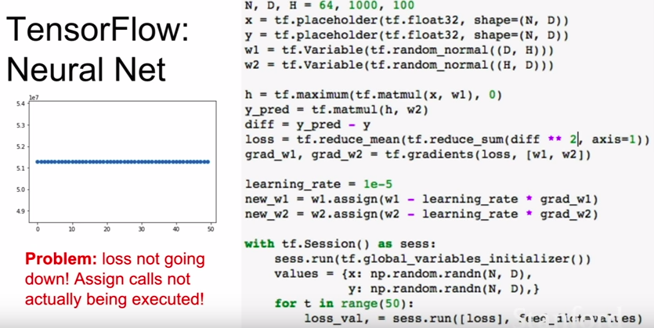
- problem is we did not explicitly tell TensorFlow to train using these new values of w1 and w2. All we told it to do was to compute the loss. TensorFlow is smart and it knows that doing these update operations are not necessary to compute the loss.
- Solution is to explicitly tell TensorFlow to perform those update operations
- one thing we could do is to tell TensorFlow to produce these w1,w2 values as outputs
- BUT this is a problem since these w1 and w2 values are big tensors and we will encounter this copying problem between CPU and GPU again
- To solve this:

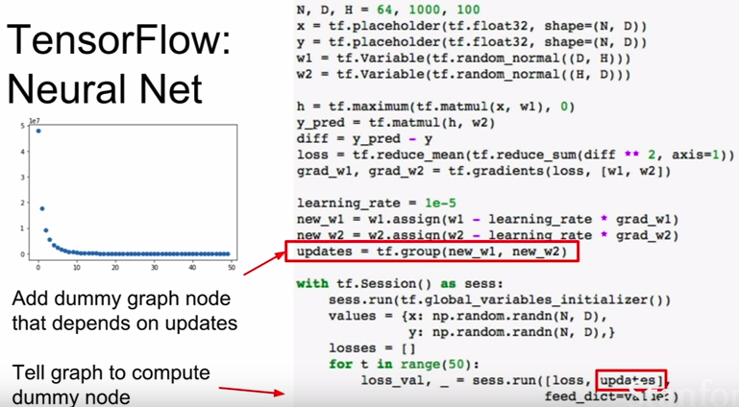
- this ensures that when we run the “updates” node, the update operations will also run and will run in the GPU. Note that “updates” is just a dummy node and just return None, but it does run th update operations since it depends on these operations.

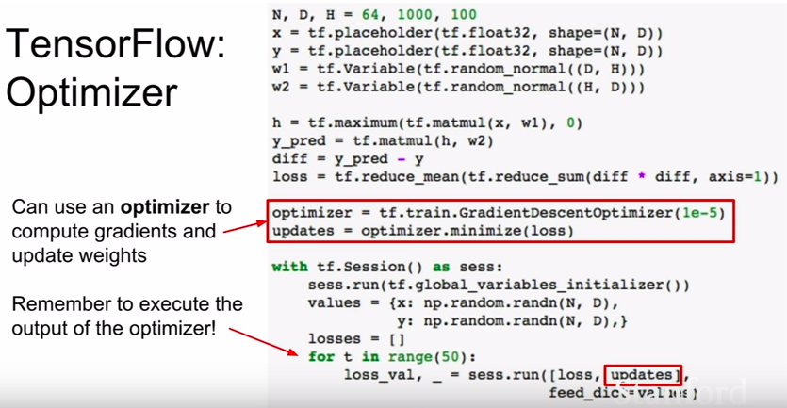
- we could use an optimizer to avoid using these weird assign and tf.group operations which are kind of a pain

- this is TensorFlow magic and does all of these things for us

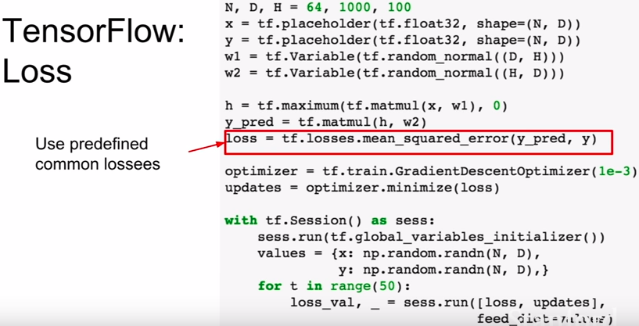
- we could also use the built-in convenience functions to compute the L2 loss for us instead of us computing it explicitly

- this basic way of working of having these variables and having inputs and outputs and combining them all together and making sure to initialize weights with the right shapes, etc.

- these are higher-level libraries that handles these for us:

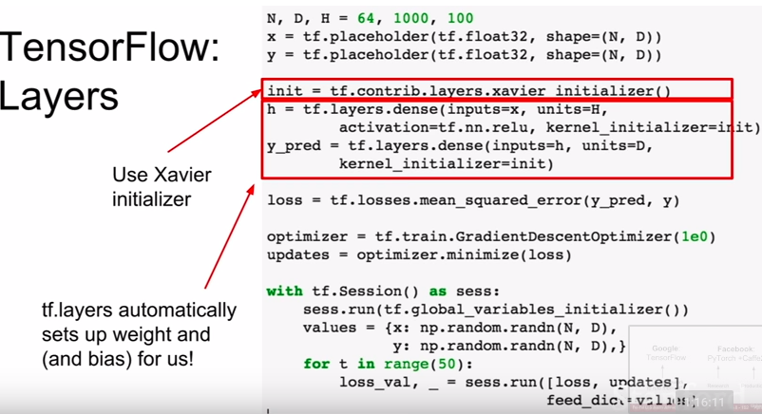

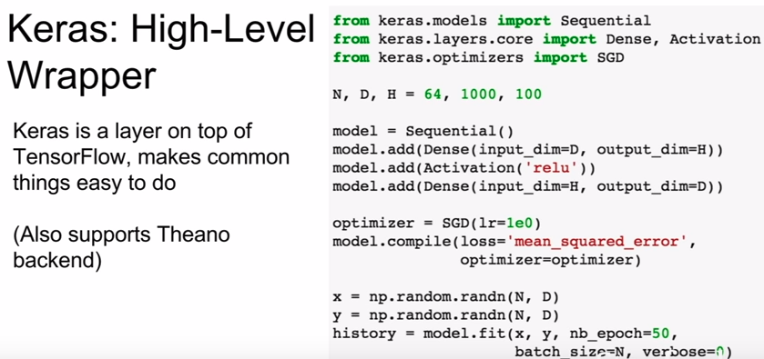
- Keras helps you build computational graphs easily

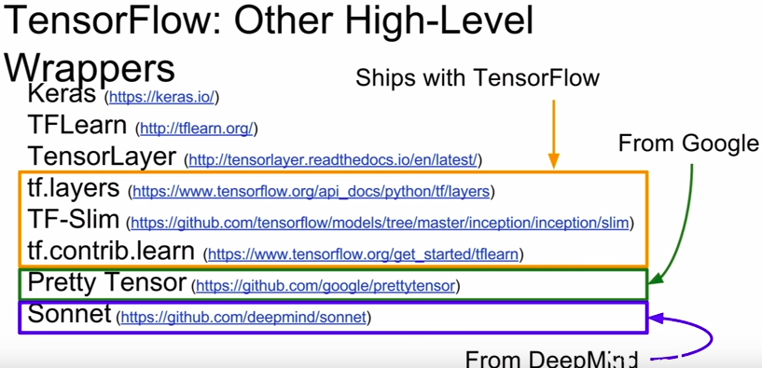

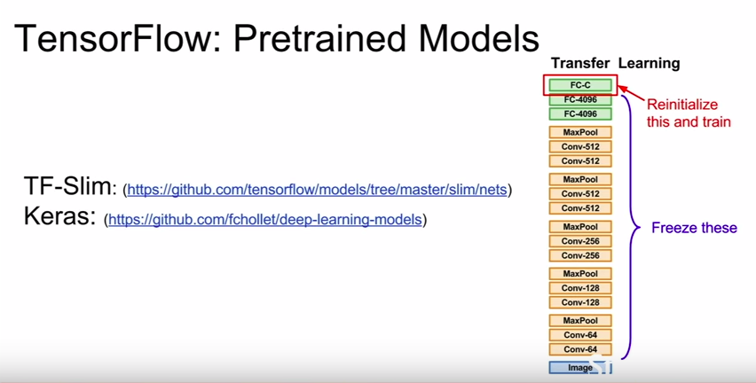

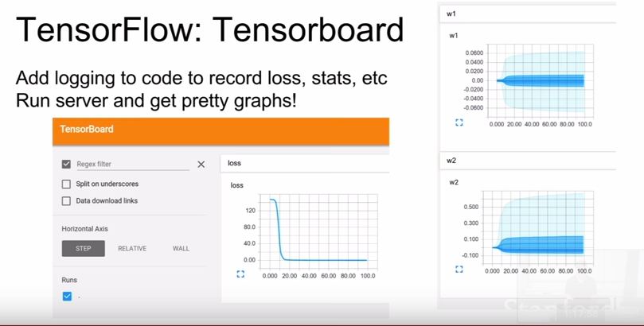

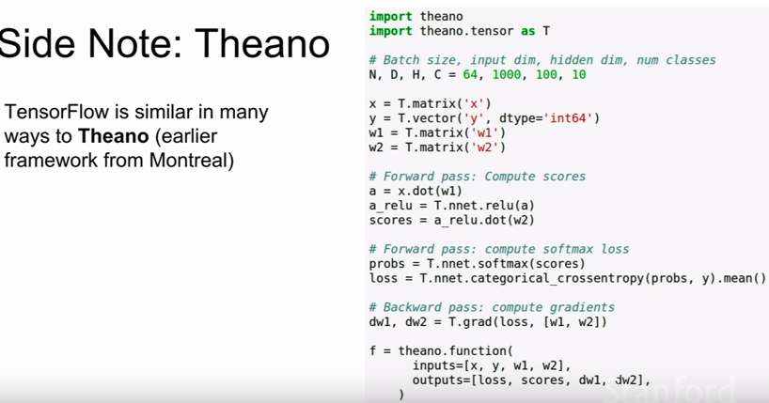

B. PyTorch (Facebook)

- Three levels of abstraction:

1. Tensor: Imperative ndarray, but runs on GPU (like a numpy array in TensorFlow but this runs on the GPU)

2. Variable: Node in a computational graph; stores data and gradient (tensor, variable, placeolder in TensorFlow)

3. Module: A neural network layer; may store state or learnable weights (tf.layers, or TFSlim, or TFLearn, or Sonnet in TensorFlow). The good thing about the module object is that it ships by default with PyTorch and therefore, there’s not much options and confusion unlike in TensorFlow.

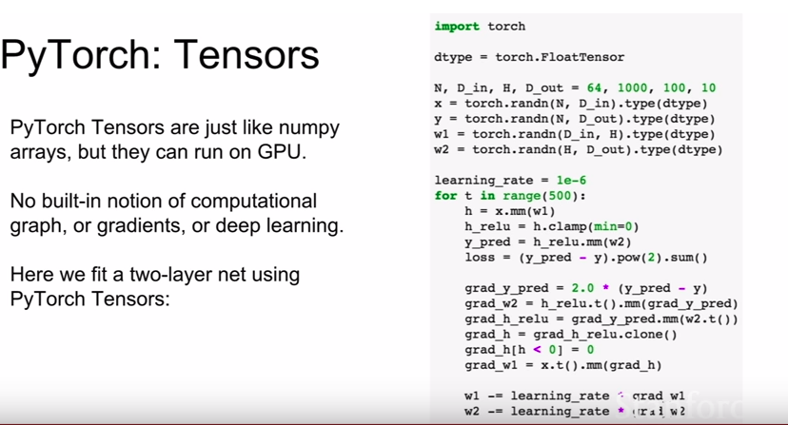

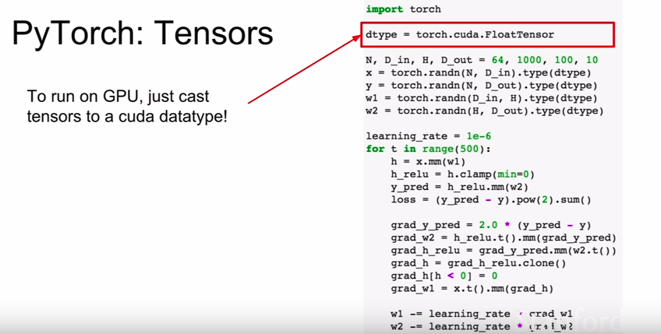
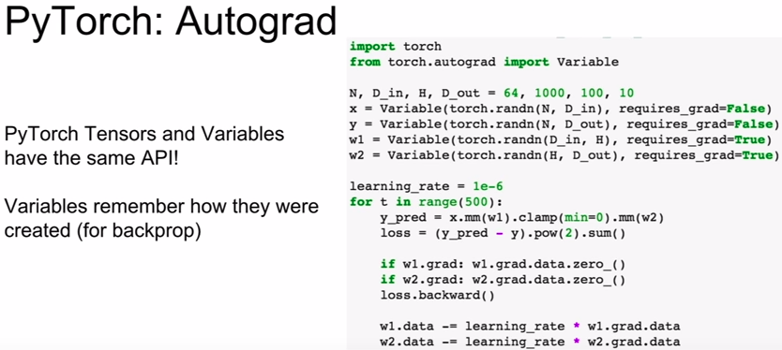

- one thing to note about PyTorch vs TensorFlow, is that in TensorFlow we were building up this explicit graph and then running the graph many times. In PyTorch we build a new graph everytime we do a forward pass which makes the code look cleaner

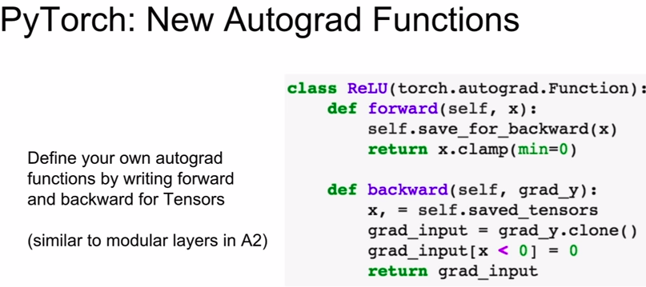
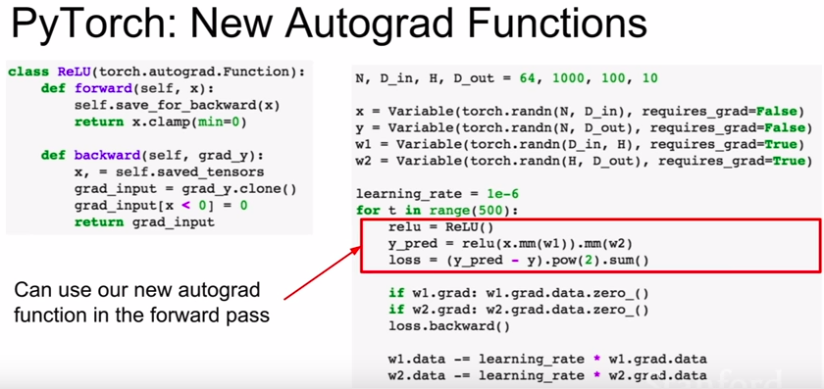
- most of the time you wont need to define your own Autograd functions and you will already have all you need defined for you.

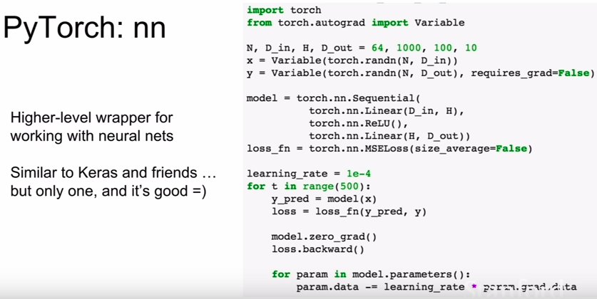
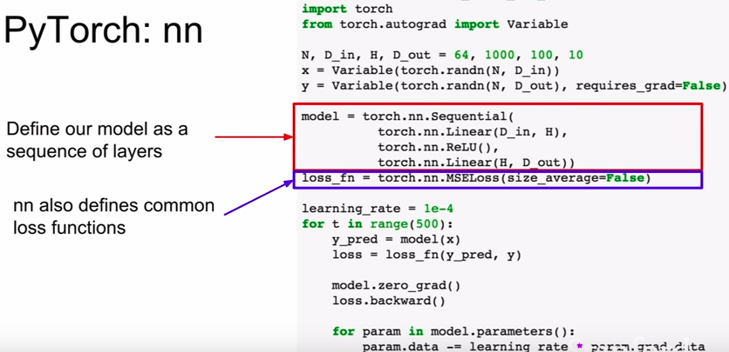

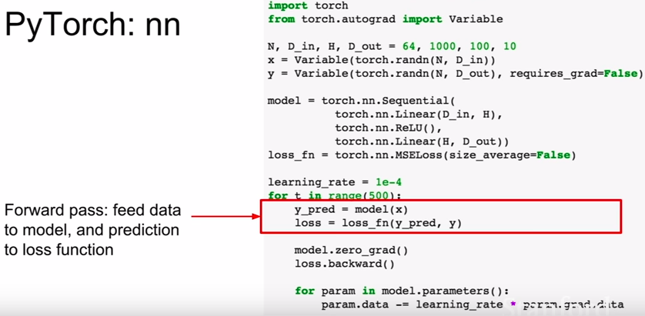
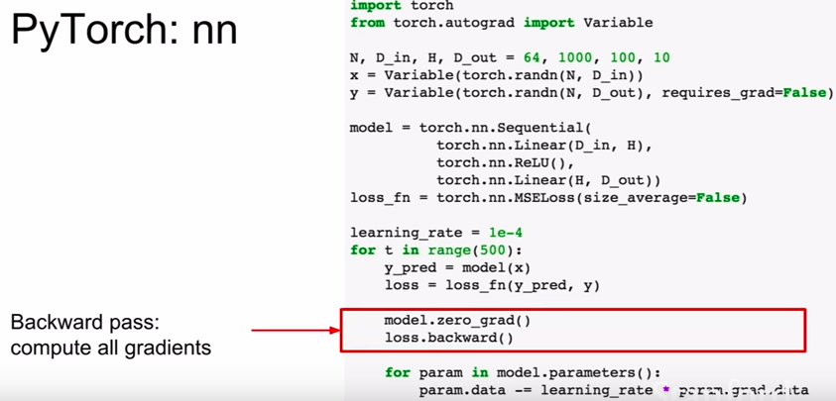

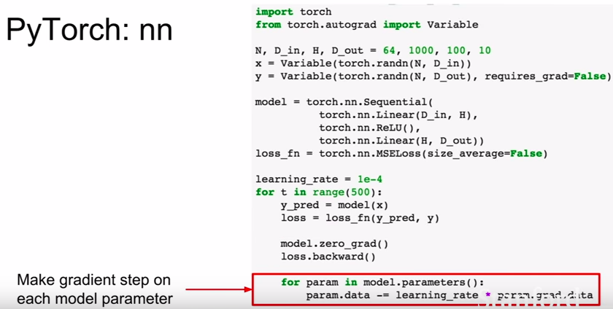
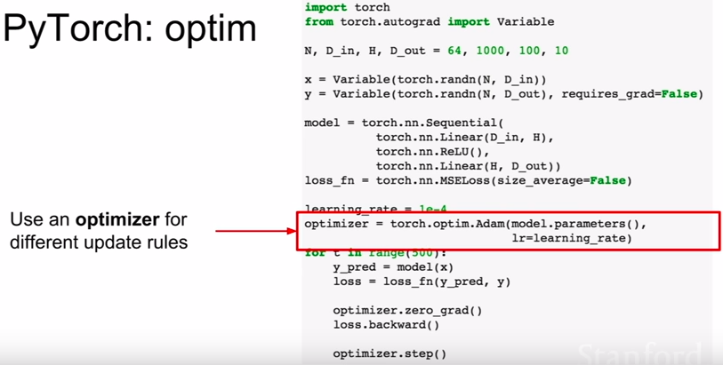

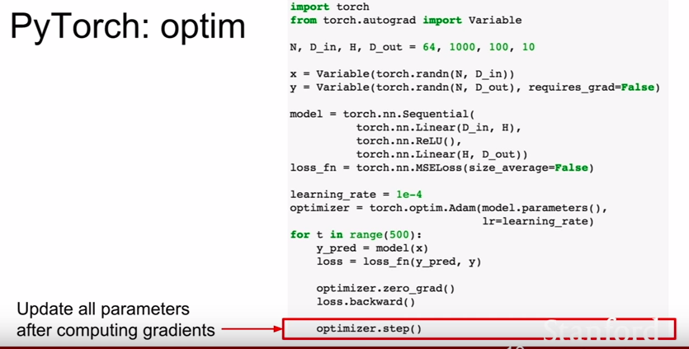

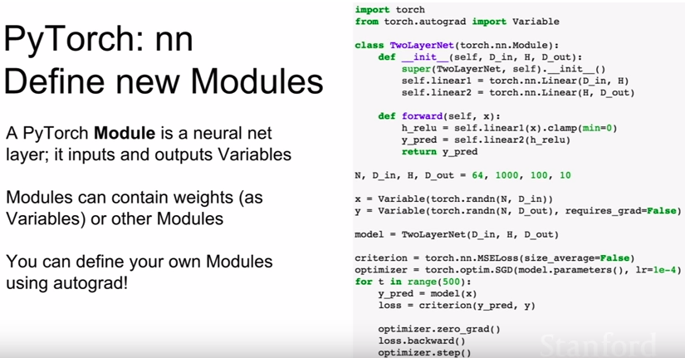
- you will commonly define your own nn modules in PyTorch

- this is your own class that defines your entire model as a single new nn module class

- a module is a nn layer that can contain other modules or trainable weights and other states

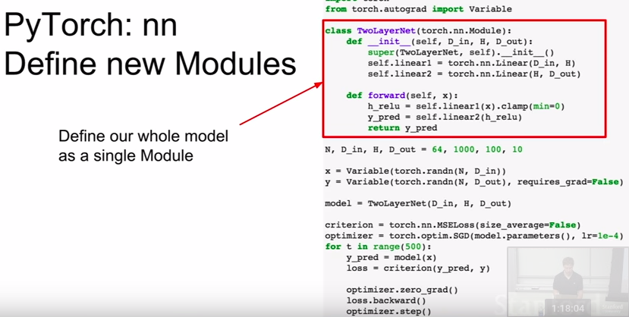
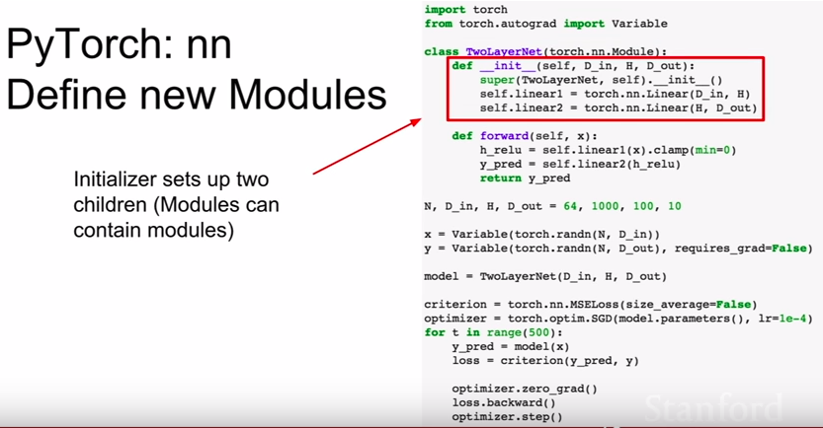

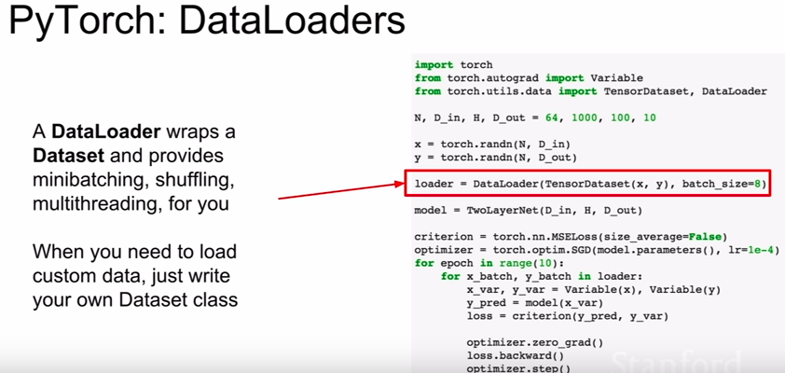
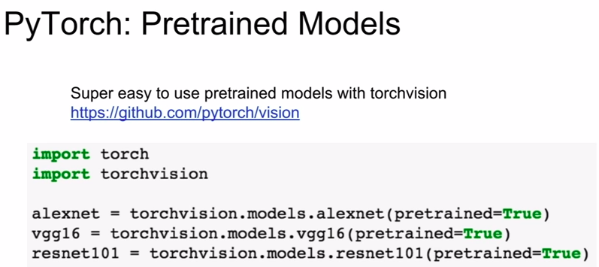
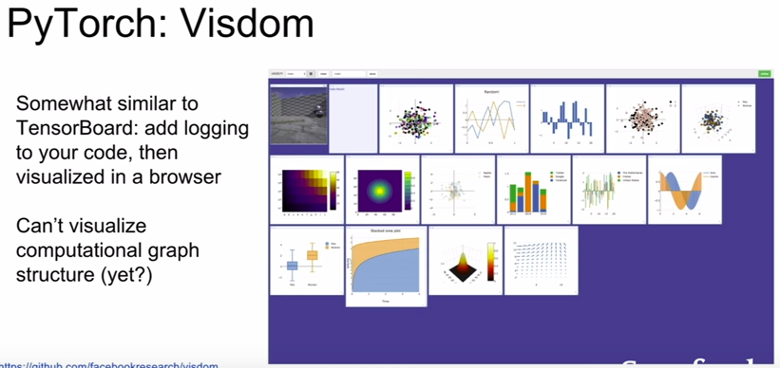

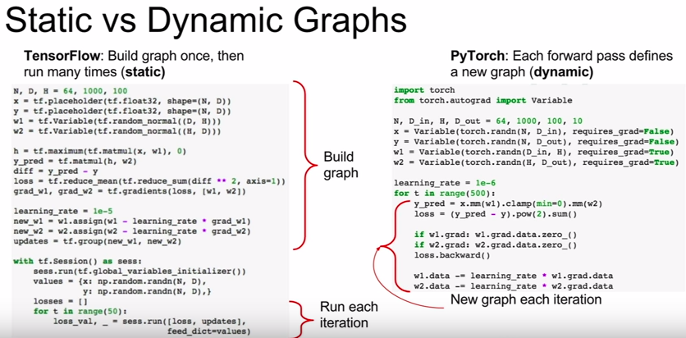

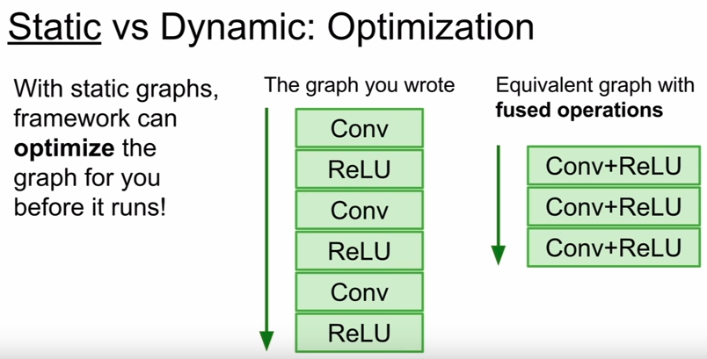

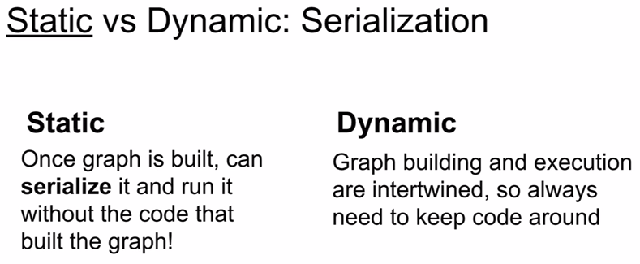

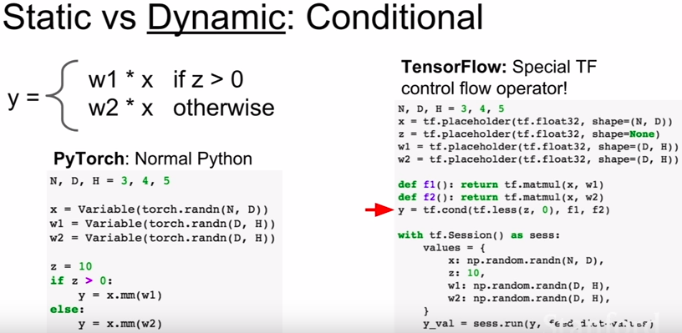

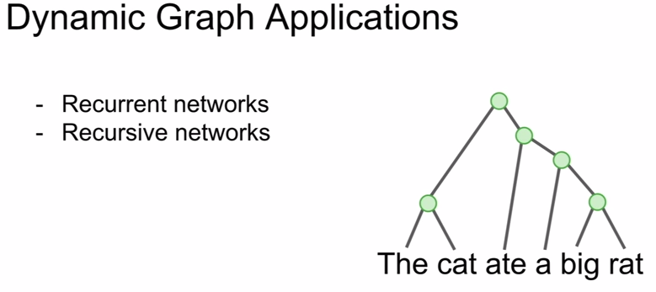

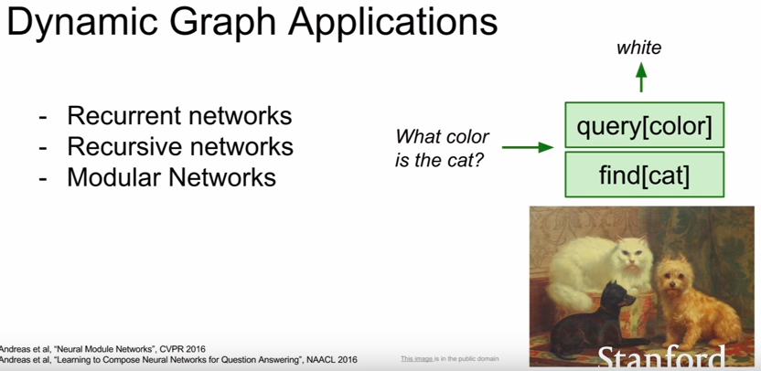

C. Caffe

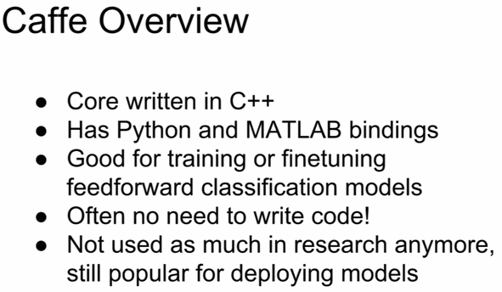

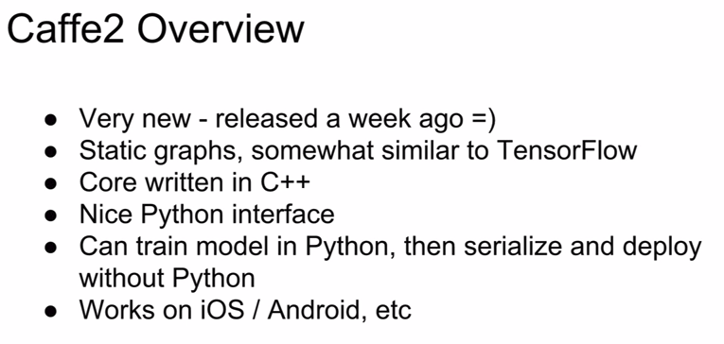

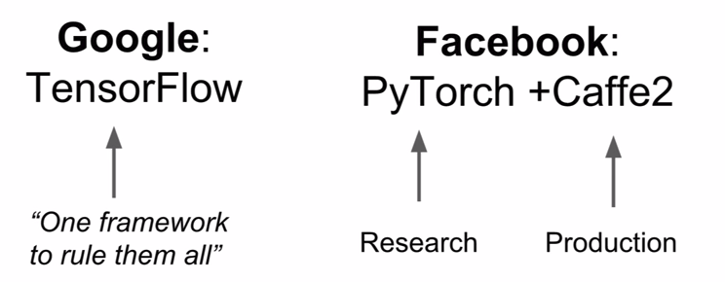
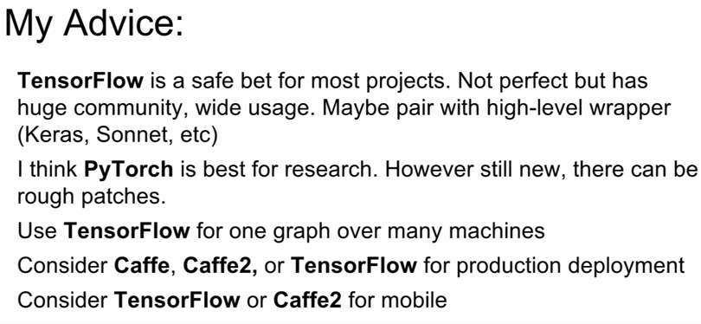
- Caffe2 was made by Facebook

