Neural crest cells (NCC) are a pluripotent, vertebrate specific cell type that migrate from the edges of the neural plate and migrate to form many cells including cells involved in craniofacial development. Cranial neural crest cells, derived from NCC, form neurons, bones, and connective tissue in the vertebrate head.

**Background**

Birth defects can be caused by teratogens introduced to embryos during development and may be exacerbated by gene-environment interactions. Teratogens are environmental inputs that cause abnormal development in embryos. Sensitivity to teratogens is high in early developmental stages when organs are forming.

Neural crest cells (NCC) are a pluripotent cell line that migrate from the dorsal neural tube to form many cells including Cranial NCC involved in craniofacial development. Cranial NCCs condense into pharyngeal arches and defines the face and generates facial skeletal and cartilage elements. The first pharyngeal arch creates the midline facial skeleton, mandible, maxilla, and the palatal skeleton. Cranial NCC that migrate into the first pharyngeal arch generate many cell types including osteoblasts and chondrocytes. Sonic hedgehog (Shh) is a secreted protein that acts as a morphogen in many developmental pathways, namely those involved in craniofacial development. *Shh* produced by the epithelium of the first pharyngeal arch induces the differentiation of cranial NCC into midline cells of the face and promotes chondrogenesis. Chondrocytes in the first pharyngeal arch generate Meckel’s cartilage which elongates and ossifies to form the mandible (Billmyre 2015). *Shh* is necessary for the condensation and differentiation of Meckel’s cartilage in the first pharyngeal arch and disruption of Shh leads to hypoplasia of facial cartilage.

**Results**

To determine the effects of cyclopamine of craniofacial cartilage development, we exposed zebrafish embryos to cyclopamine. First, we treated approximately 30 wild type embryos with 25uM cyclopamine. The toxin was removed after 24 hours and replaced with fish water. The embryos were fixed at 97 hours post fertilization (hpf) and stained with Alcian Blue to observe cartilage. We found that wild type embryos exposed to 25μM cyclopamine lacked craniofacial cartilage (Fig. 1). This indicates 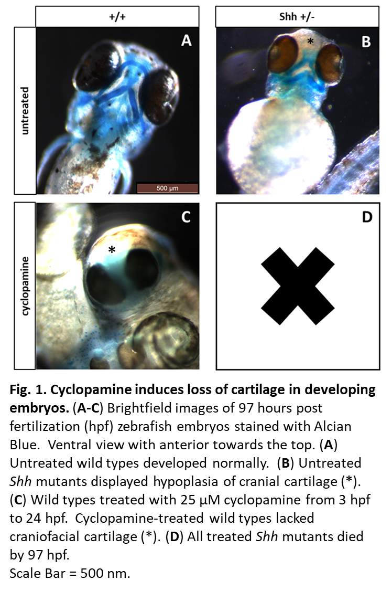that cyclopamine disrupts the development of cartilage in zebrafish. Wild type untreated embryos developed normally.

*Shh* mutants were treated with cyclopamine to determine how craniofacial development was affected. The *Shh* zebrafish line used in this experiment was homozygous lethal so the *Shh* mutants used were hypomorphic.